Map of Sponsored Walk
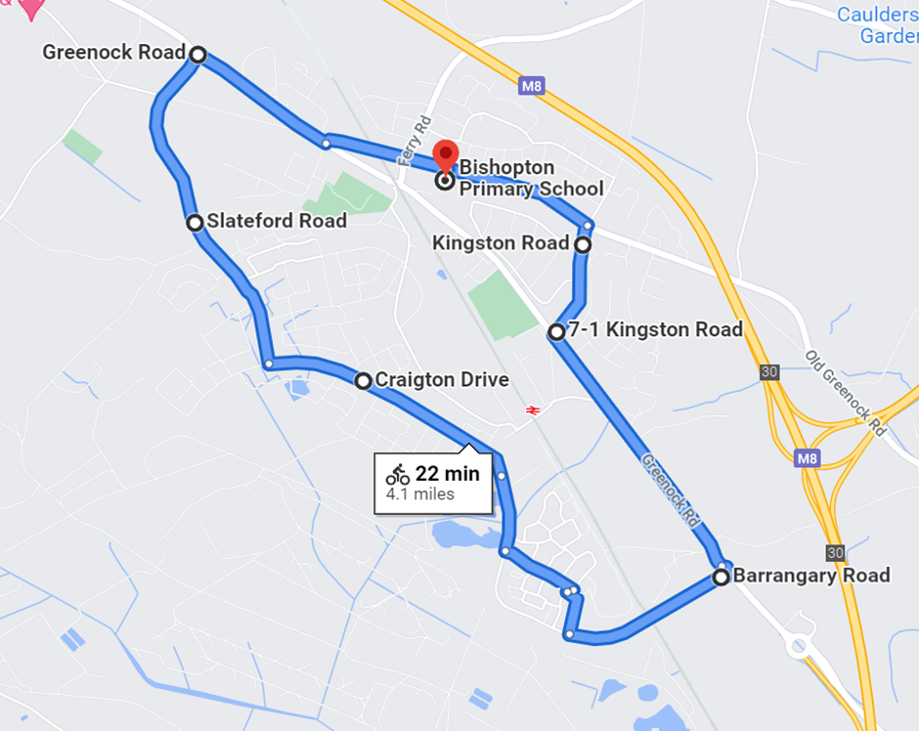
Start – Bishopton Primary School. Walk towards Kingston Road, turn right down Kingston Road to the bottom. Cross at the lights and follow the road to the roundabout. Cross the road and follow Barrangary road to Sainsburys. Turn on to Craigton Drive and continue along the road until Slateford Road. Turn onto Slateford Road and continue to the roundabout on Greenock Road. Turn right onto Greenock Road and continue to the lights. Cross at the lights at Ferry Road and continue up to Old Greenock Road. Turn right and continue along to where you started.
Alternatively, you can join Old Greenock Road across from the Red Fox in. Be careful when crossing Ferry Road.

