**Glow Password Change Guidance**

Upon first login to Glow RM Unify, enter your current Glow username and password at the login page:

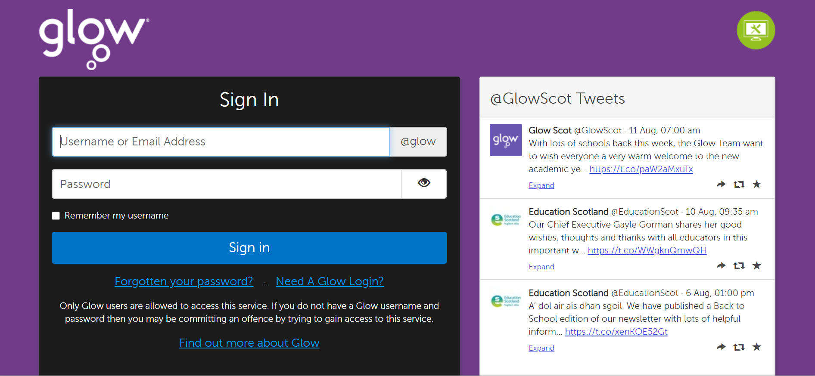

You will be asked to change your Glow password:

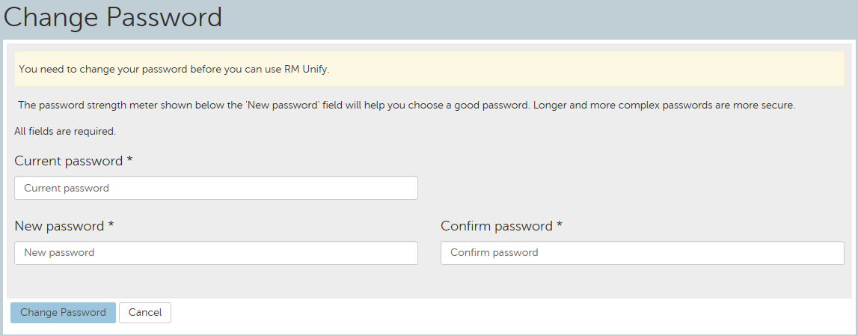

Complete the 3 fields on the ‘Change Password’ screen (Current Password, New Password and Confirm Password).

Please see the table below for password guidance. **Please do not use any of the examples provided.**

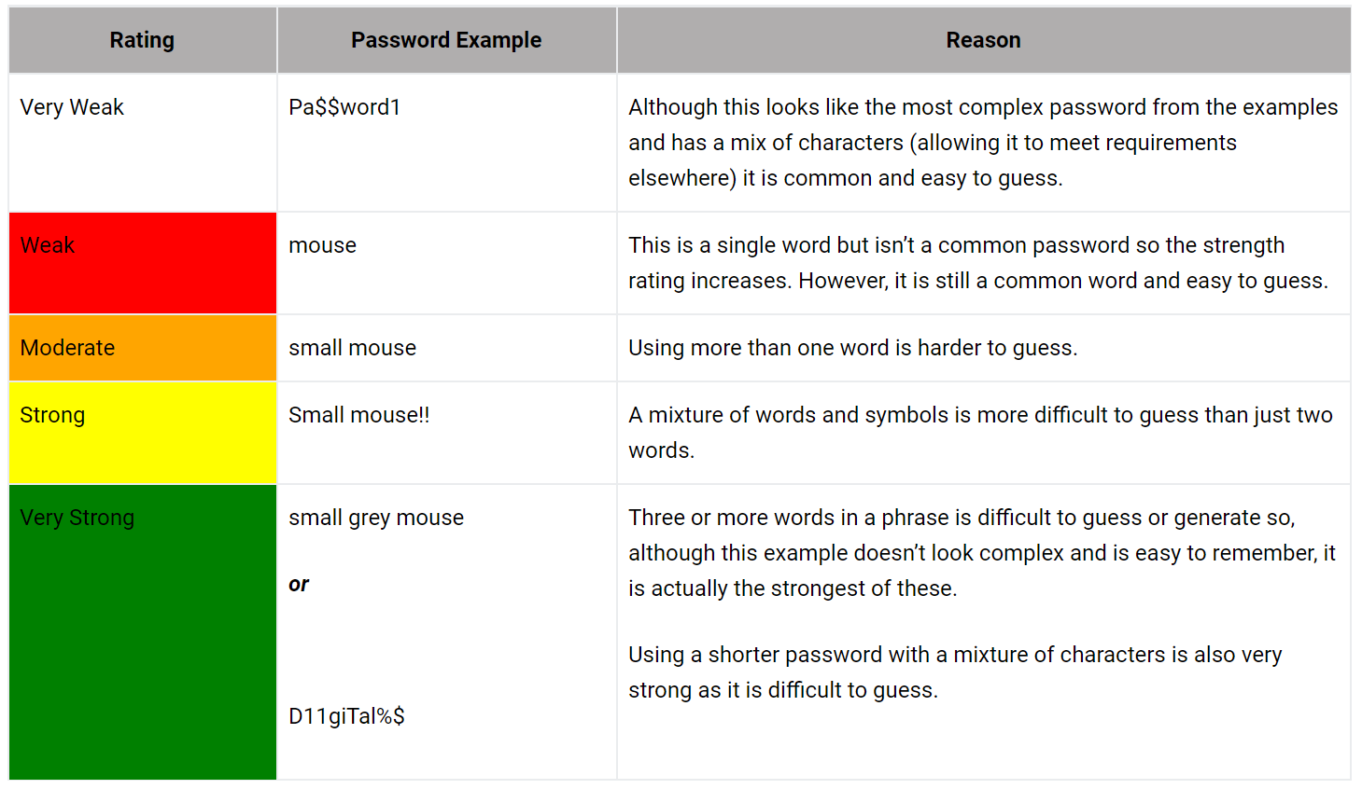

For more help on choosing a strong password please visit Glow Connect: [Password Guidance](https://glowconnect.org.uk/password-guidance/)

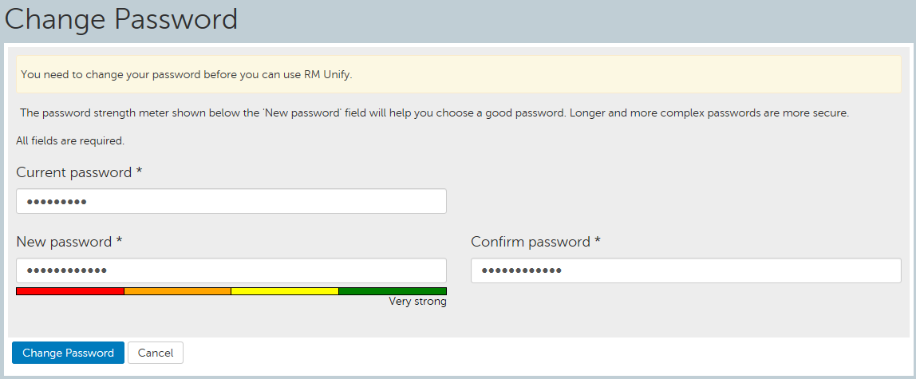

When setting a password in Glow there is a minimum requirement and you will get a password rating as you type to reflect this. The password is rated on a number of factors such as how common the password is, how long it is and how many different types of character are used. Using a group of words or a phrase, for example, would be stronger than a common password while being easy to remember. See [Password Guidance](https://glowconnect.org.uk/password-guidance/) for more information.

The Change Password button will only become available when you have met the minimum password requirement for your account type.



You have now successfully changed your password:

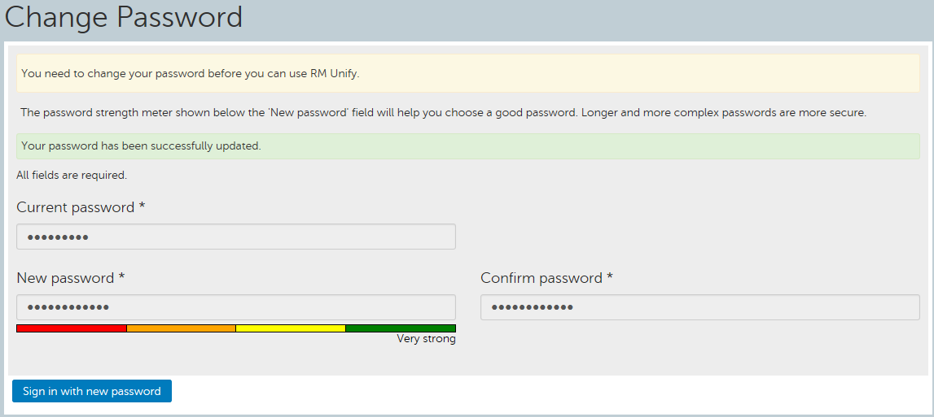

At the bottom of this screen, click the ‘Sign in with new password’ icon:



Which will take you to the following screen to sign in:



Enter your existing username and new password and then click ‘Sign in’:

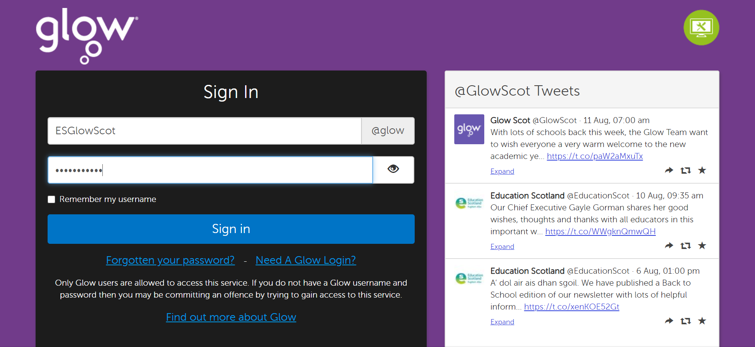

You will now be logged into Glow.