You must have a mygovscot MyAccount login and password. If you don’t have a MyAccount follow steps 1-7 to create one and if you do, go straight to step 8.
If you do not have a mygovscot/MyAccount
- You will need a device that can connect to the Internet (smart phone, tablet, PC) to create an account and to use ParentPay.
- Open any Internet browser (e.g. Internet Explorer, Google Chrome) type in: www.renfrewshire.gov.uk
- This will display the screen below. Click on ‘Sign in / Register for MyAccount’ at the top left-hand side of the page
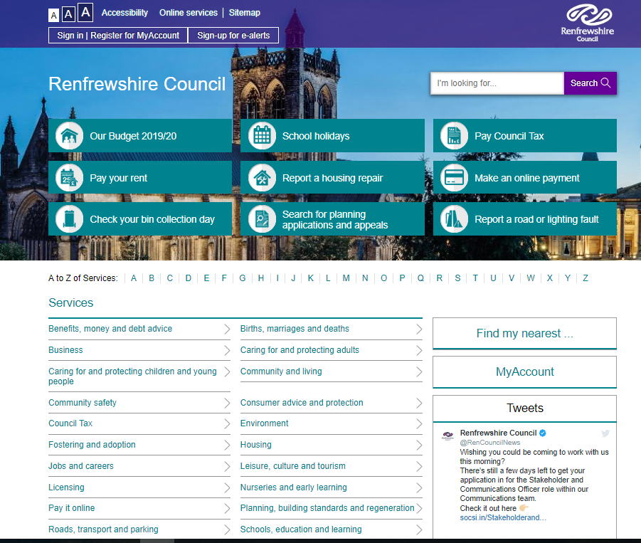

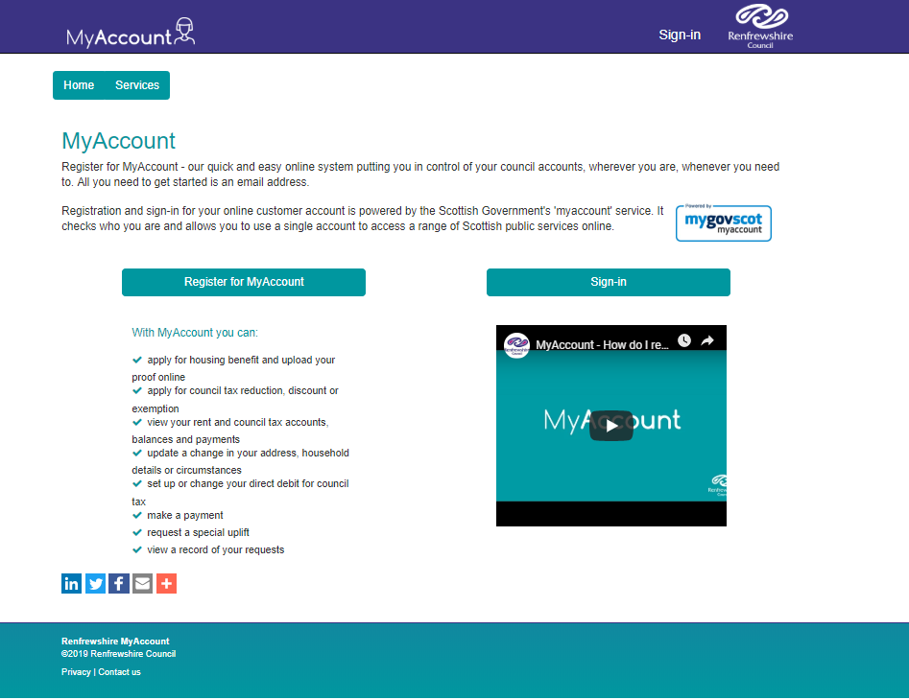
- Click on ‘Register for MyAccount: -
There is a helpful video which will guide you through the process
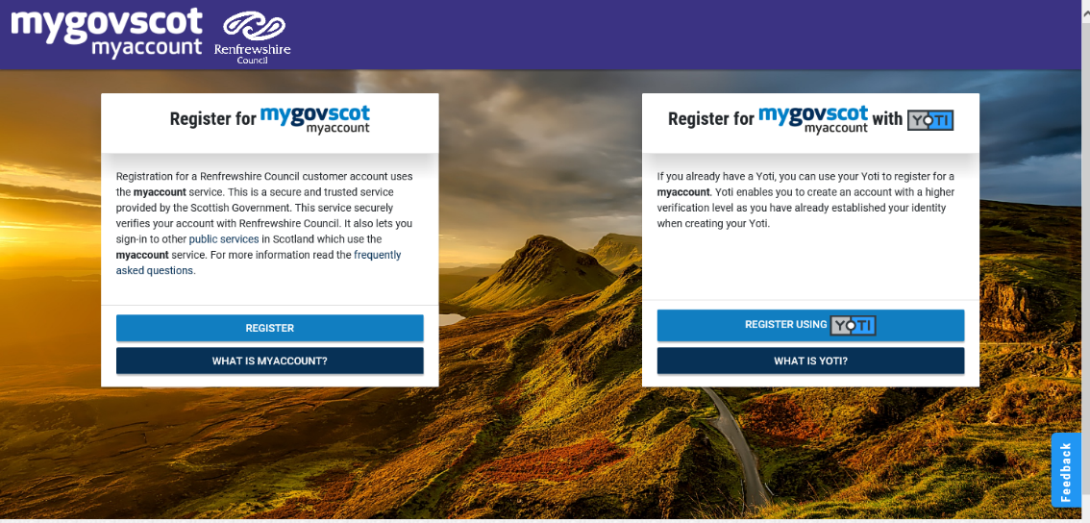
- Click here to start your registration

- The next screen looks like this and tells you a bit more about MyAccount. When you are ready, click on START
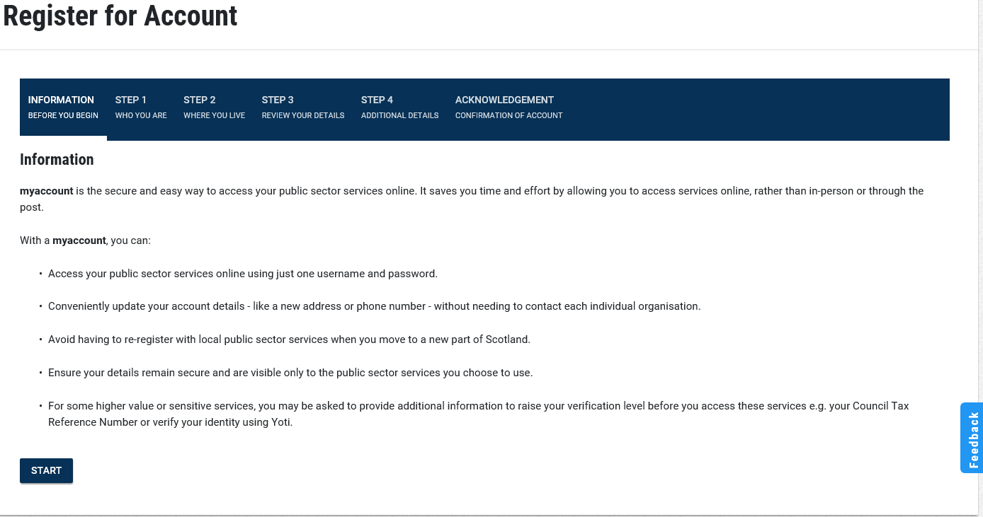

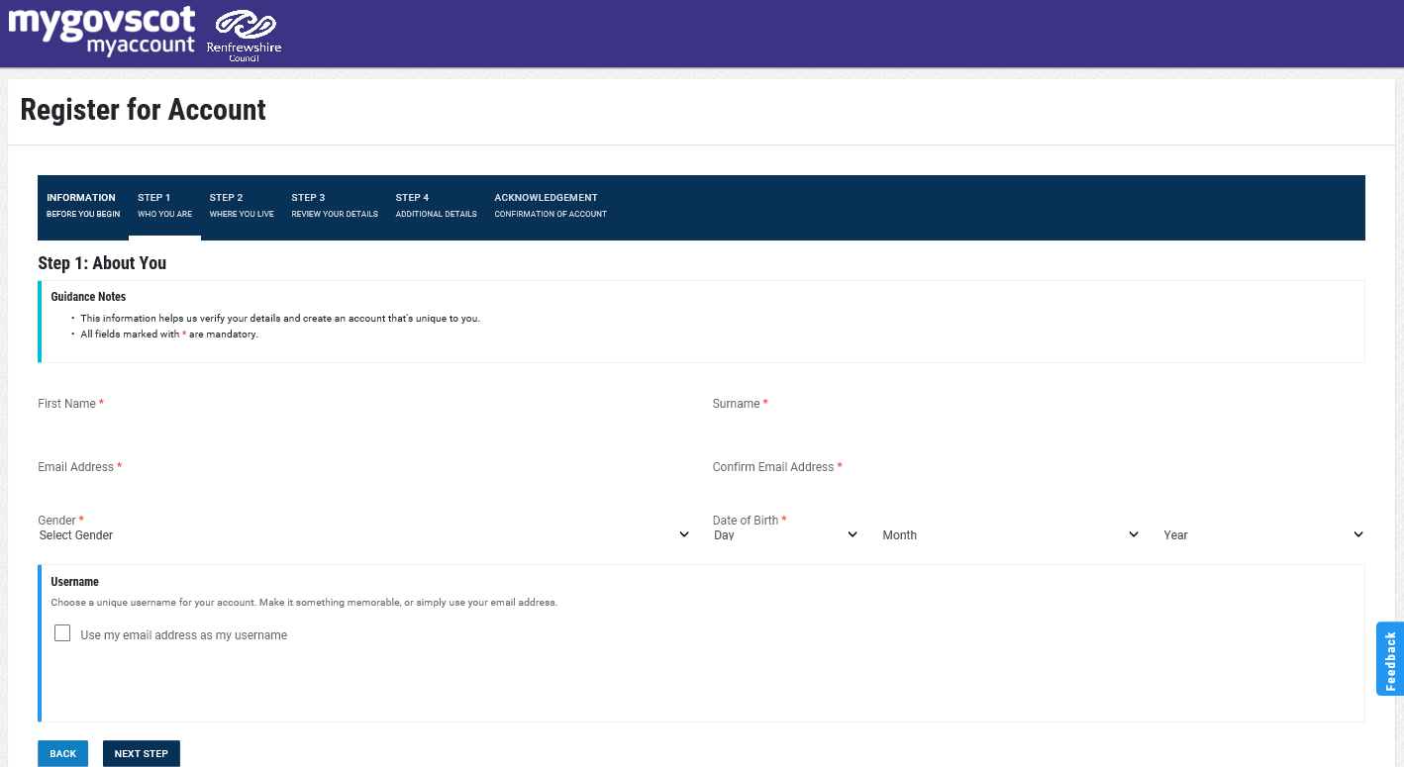
- Follow the onscreen instructions to complete the form and keep a note of your username and password.
If you have any problems creating the account, click on the help option at the bottom of the screen

