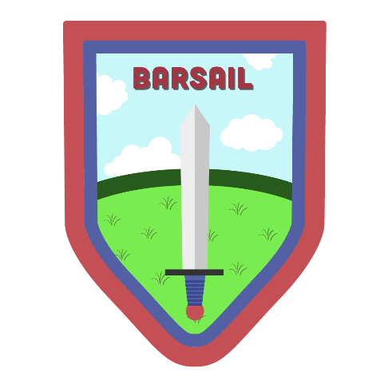

Renfrewshire Coucil

Barsail Primary School
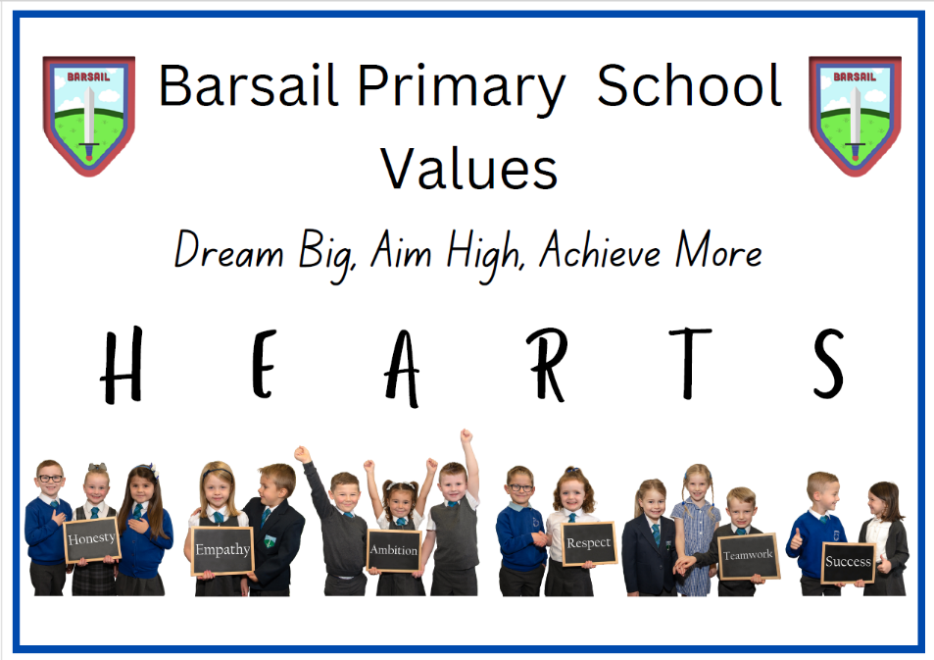
STANDARDS AND QUALITY REPORT
June 2026
This annual report will inform you of the school’s progress and achievements in 2025-2026 and it will share a summary of our plans for 2026-2027. I hope that you find it helpful and informative.

Mrs Emma Mavers

Head Teacher

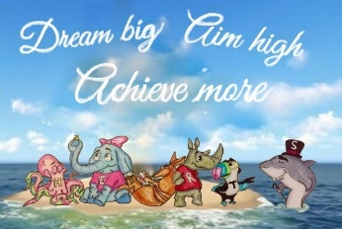
OUR SCHOOL

Barsail Primary is a non-denominational school in Erskine with 332 pupils. Approximately one third of children attend the school as a result of placing requests. 10% of pupils receive free school meal entitlement and /or clothing grants. The school has a reputation for its dynamic participation in the local community. We work closely with our local partners, including nurseries, primary schools and our associated secondary – Park Mains High School. We also work with local businesses and charities, creating meaningful links to develop skills for learning, life and work. We have an active and supportive Parent Council. The dedicated staff work together as a team to provide high quality learning experiences and opportunities for all pupils. The senior leadership team consists of a Head Teacher (HT), Depute Head Teacher (DHT) and Principal Teacher (PT). We have 13 classes. The school is highly regarded amongst parents and carers with all parents, in response to the parental survey, indicating that they are satisfied with the school.

OUR VISION, VALUES AND AIMS
Inspiring the Barsail family to:
‘Dream Big, Aim High, Achieve More!’

We want all of the Barsail family to hold these VALUES in their HEARTS:
Honesty
Empathy
Ambition
Respect
Teamwork
Success
We aim to: *All rewording done by pupils

- Create a welcoming, inclusive ethos which encourages, challenges and supports all learners to realise their potential.
Reworded by P4-7 – Work to our limits and beyond, having fun as we go.
- Provide an environment where pupils, parents and staff are respected and valued, partnerships are fostered and success is celebrated.
Reworded by P4-7 – All of the Barsail family get involved and when we do well we share and celebrate our achievements.
- Support and encourage high quality leadership at all levels ensuring forward thinking, creativity and innovation through a shared vision of excellence.
Reworded by P4-7 – We can lead and improve our school.
- Create a safe, stimulating environment which is well resourced and organised with skilled, motivated staff who have high expectations and standards for all.
Reworded by P4-7 – Everyone and everything in our classrooms and playgrounds should help us to do our best.
- Provide a broad, balanced, coherent and progressive curriculum which offers challenge and enjoyment appropriate to each learner’s needs.
Reworded by P4-7 – Learning should be fun and just right for each one of us.
- Develop confident, resilient, independent thinking learners who can work effectively on their own and in a team using effective Literacy, Numeracy and IT skills.
Reworded by P4-7 – We can work together or on our own using skills we are learning.
- Ensure high levels of attainment and achievement for all through the best quality learning and teaching experiences.
Reworded by P4-7 – All of the boys and girls should have a go and reach for the stars.

SUCCESSES AND ACHIEVEMENTS – BARSAIL IS MORE THAN AN IMPROVEMENT PLAN
Our school journey this year is captured in an iMovie shared with staff, pupils and parents through assembly and Seesaw. While progress against our three School Improvement Priorities is featured, this represents only one third of the video, reflecting the wide range of achievements and experiences beyond the School Improvement Plan. Our video celebrates the breadth of learning, achievements and opportunities across Barsail, demonstrating that the school is far more than its improvement priorities. It reflects our vision, “Dream Big, Aim High, Achieve More!” and the collective success of the Barsail family.
https://www.youtube.com/watch?v=492sPbNjAs8
(Note: video is hosted on an unlisted YouTube channel accessible via link only.)



HOW SUCCESSFUL HAVE WE BEEN IN IMPROVING OUR SCHOOL?
Our school improvement priorities for session 2025-26 were as follows: (1) Develop a cluster-based approach to skills development; (2) Improvement in attainment in literacy through high quality self-evaluation, collaboration and effective learning and teaching; and (3) Review of Relationships Policy and House System through engagement in Young Leaders of Learning.

The progress made during the session towards these priorities is outlined in the above movie and is also summarised below:

Improvement Priority 1: Cluster based approach to skills development
All staff worked collaboratively within cluster stage groups, led by a lead practitioner, to develop the following six skills identified by Park Mains High School and local employers:

- Teamwork
- Communication
- Thinking Skills
- Social Skills
- Creativity
- Problem Solving

All staff participated in peer observations within their cluster stage groups. This provided valuable opportunities to share effective practice, develop resources and engage in professional dialogue. All staff reported that collaboration within their skills groups was effective and supported professional learning.

Lead practitioners, including two Barsail teachers, worked collaboratively to establish a shared cluster approach to skills development, including a progressive skills pathway. This was successfully shared with staff and embedded within our planning processes through Microsoft Teams.

Three Barsail teachers developed progressive visual skills posters for Early, First and Second Level using Widgit symbols and child-friendly language. These are displayed in all classrooms, promoting a consistent language of skills across the school. Almost all pupils can identify and discuss the six key skills and recognise opportunities to develop them through a range of learning experiences. The resources have also been shared across the wider cluster.

Overall, almost all teaching staff increased their knowledge and confidence in skills development, resulting in more consistent and purposeful planning of skills-based learning experiences across the curriculum.

Improvement Priority 2: Improvement in attainment in literacy through high quality self-evaluation, collaboration and effective learning and teaching.

Improving our Schools (IOS)
The Senior Leadership Team engaged in Improving our Schools (IOS) this session, with writing identified as the curricular focus. A teacher audit highlighted key barriers to attainment in writing, including vocabulary, structure, spelling, punctuation and letter formation (P1). Staff, through a survey, identified differentiation, learning intentions and effective feedback as the most important features of highly effective practice to improve writing attainment.
Through participation in IOS training and professional learning, staff strengthened their understanding and application of the identified features of highly effective practice. This was reflected in increased staff confidence, which rose from an average of 3.6/5 prior to training to 4.8/5 following training.
All teachers completed a practitioner enquiry in their stages, supported by trio visits and professional dialogue. At the May Inservice, staff shared the impact of their enquiries on writing attainment and the resources developed. Enquiries focused on letter formation (P1), targeted support through effective deployment of support staff (P2), Discovery Afternoons (P3), Awesome Authors and family learning (P4–P5), and differentiated feedback (P6–P7).
Overall, increased staff confidence and more consistent use of highly effective teaching strategies have supported improved outcomes for learners in writing. School data shows that 83% of year groups improved writing attainment compared with the previous session.
Reading
This session, we strengthened approaches to reading through targeted interventions, enhanced resources and cluster moderation activities.
We expanded our range of Big Cat reading books in P1-P3 and introduced teacher tracking systems to monitor progress more effectively. New reading homework packs were developed for infant learners, providing families with reading materials and strategies to support reading at home. Almost all children engage regularly with these resources, supporting greater consistency in reading practice and strengthening links between home and school learning.

We successfully maintained our Reading Schools Gold Accreditation, reflecting our commitment to promoting a positive reading culture across the school.

All teachers participated in cluster moderation activities focused on reading comprehension. Staff shared evidence for learners who were on track, on the cusp of achieving expected levels and those requiring additional challenge. Almost all teachers agreed with professional judgements made during moderation activities, increasing confidence in the accuracy and consistency of teacher judgement.

Staff also shared effective practice and resources across the cluster, with teachers beginning to trial new approaches within their classrooms. Upper-stage staff worked alongside Park Mains High School colleagues to explore reading comprehension approaches, including RUAE strategies, supporting progression in literacy.

Overall, these improvements strengthened learning and teaching in reading. All staff reported increased confidence in assessing reading comprehension and applying agreed standards through moderation activities. School attainment data shows that 83% of year groups improved or maintained reading attainment compared with the previous session, demonstrating the positive impact of these targeted interventions on learner outcomes.

ACEL Data
Our pupils’ Achievement of Curriculum for Excellence (CfE) Levels (ACEL) data for the session ending June 2026 are as follows:
 | L&T | Reading | Writing | Numeracy
P1 | 89% | 87% | 84% | 91%
P4 | 96% | 85% | 87% | 92%
P7 | 98% | 86% | 86% | 86%

Improvement Priority 3: Review of Relationships Policy and House System through engagement in Young Leaders of Learning.

Last session, our Young Leaders of Learning (YLL) identified a range of improvements linked to their theme of relationships. This session, they successfully led the implementation of these actions through meaningful consultation with pupils, staff and parents.
The Relationships Policy was reviewed and updated to align with current national guidance and to ensure a more consistent and restorative approach. Values posters were created to clearly outline what each HEARTS value looks like in practice and are displayed in every classroom. A consistent bank of consequences linked to each value was also introduced, enabling pupils to reflect on their behaviour and select an appropriate “Pay it Back to HEARTS” consequence. Classroom plans were refreshed following feedback from pupils, staff and parents. As a result, all staff now have a clearer and more consistent framework to support positive relationships and behaviour.
To support implementation, a child-friendly version of the Relationships Policy was created in the form of a video involving all staff and featuring pupils and parents:
https://www.youtube.com/watch?v=oQH0Mx3S3fY
The video explains our values, expectations, restorative approaches and agreed consequences in an accessible way. This will be shared with pupils and families in August, strengthening understanding of expectations and promoting a shared approach to positive relationships.
A weekly value focus was introduced across the school, with assemblies and awards linked to a specific HEARTS value each week. All pupils can discuss the HEARTS values and describe how they demonstrate them in their daily interactions and learning.
House assemblies, house chants and pupil-designed house shields were introduced to strengthen house identity and belonging. Almost all pupils report a stronger sense of belonging within their house groups and increased opportunities for teamwork and collaboration.
The YLL’s also worked alongside the Rights Committee and Pupil Council to introduce a Playground Charter and ensure the Right of the Fortnight is displayed in every classroom. Almost all pupils can identify the current right and discuss how it relates to their experiences in school.

The impact of these developments is evident in the positive culture across the school. Almost all pupils demonstrate our HEARTS values consistently and relationships remain a key strength. This is reflected in our Parental Involvement and Engagement Survey, where Barsail scored above the Renfrewshire average in every measure.
Building on this success, YLL members recruited and trained a new group of leaders this session. Their focus has now shifted to learning and teaching, and they have played a significant role in identifying improvement priorities for next session's School Improvement Plan. Their leadership journey and the impact of their work are captured in the following video:
https://www.youtube.com/watch?v=X-SOdn7IND4

KEY STRENGTHS OF THE SCHOOL

- HEARTS values of honesty, empathy, ambition, respect, teamwork and success are reflected strongly in the positive culture of the school community. All children, parents, partners and staff commit wholeheartedly to demonstrating these values in all actions.

- The quality of leadership across the staff team is a key strength. Senior leaders inspire and empower all staff to take on additional leadership responsibilities. Children at all stages contribute to school improvement through various pupil leadership opportunities.

- The Barsail family is caring and inclusive. We have a nurturing and welcoming ethos. There is a strong sense of teamwork across the school including supportive colleagues and effective partnerships with parents. Everyone is part of the ‘Barsail Family.’

- A highly motivated and dedicated staff team who go above and beyond to provide engaging learning experiences and opportunities for our children.

- Attainment is a high priority for all staff members with a variety of teaching methods employed to support and meet the needs of all learners. All staff have an in-depth knowledge of children in our school. This allows staff to differentiate appropriately and meet the needs of all learners, ensuring all learners can achieve success.

- There is a big focus on celebrating success. Achievements, both in and out of school, are celebrated and tracked on a weekly basis. This develops children’s confidence and self-esteem and provides a sense of belonging as the Barsail community celebrates with each other.

- A dedicated music teacher allows for children to be taught how to read music and play musical instruments. Children are given various opportunities to showcase their talent throughout the year, providing memorable experiences for our children.

- The house system promotes a strong sense of pride, belonging and identity across the school. Pupils work collaboratively within and across house groups, fostering teamwork, positive relationships and healthy competition through a range of whole-school activities and events.

PUPIL EQUITY FUNDING (PEF)

- Quality assurance information from all stakeholders in our school community is used effectively to inform PEF spending. The views of our parents, partners and children are sought and we use a variety of methods to gain their views. Results are shared with all stakeholders and used to inform interventions, resource purchase and the focus of professional learning.

- Consultation information is used alongside monitoring and tracking evidence to help us to decide upon our priorities. This ensures a collegiate approach to school improvement and pupil equity fund spending with the views of all in the school community considered.

- Our strategy to close the poverty related attainment gap in Literacy and Numeracy is built around:
- providing targeted interventions in Literacy and Numeracy.
- improving the overall inclusion support package for children with ASN and other barriers to learning such as attendance.
- improving the overall quality of learning and teaching.

- All teaching staff consulted stated that the additional human resources (Teacher hours / Additional Support Needs Assistant hours) have a very positive impact on the inclusion, progression, achievement, and attainment of pupils affected by poverty. Almost all parents stated that their preference was to use PEF budget to maintain this support.

- All class teachers provided targeted interventions during allocated PEF time for literacy and numeracy. In addition, support was also provided by the ASNA.
- Reading: 83% of year groups equal to or improved attainment from the previous year.
- Writing: 83% of year groups improved attainment from the previous year.
- Listening and Talking: 100% of year groups equal to or improved attainment from the previous year.
- Numeracy: 67% of year groups equal to or improved attainment from the previous year.
All these learners (who represent the % increase) were part of targeted intervention groups.

- Our school is wholly inclusive and committed to removing disadvantage for whatever reason. Most of our care experienced pupils have made very good progress and the majority are on track for literacy and numeracy levels.

- A minority of our children were offered soft start every morning 8:30-9:00 to assist with wellbeing, lateness and attendance. All children who have attended have benefited with all teachers commenting on their readiness to learn when entering class.

- After consultation with our school community, our main focus next session will be to further improve attainment in literacy and numeracy by using the additional core teacher staffing of 0.3 FTE. This will enable the class teachers (for targeted year groups) to focus on targeted intervention for individual children, with a continued focus on reducing the poverty related attainment gap.

OUR NEXT STEPS – PRIORITIES FOR 2026-27

We believe that we have made very good progress during session 2025-2026 and we will use the improvement priorities listed below to build on this progress moving forward.

Improvement Priority 1 – Cluster based approach to skills development.

Improvement Priority 2 – Improvement in attainment, particularly in Literacy and Numeracy, through high quality learning and teaching.

Improvement Priority 3 – Barsail is an inclusive and supportive environment for all.

Full details of the school’s improvement priorities and actions are detailed on the school improvement plan which can be accessed on our website.

Barsail Primary School
Park Moor
Erskine
PA8 7HL
0300 300 0146
https://blogs.glowscotland.org.uk/re/barsailprimary/
Twitter: @Barsail_Primary

HAVE YOUR SAY!

Please take the opportunity to share your thoughts with us as we use feedback to help us make improvements to the school. You can do this by speaking to staff, participating in Parent Council meetings, responding to questionnaires/surveys and by completing evaluations at school events.

