
Barsail Primary School
Relationships Policy Statement

‘Dream Big, Aim High, Achieve More’

HEARTS
Honesty, Empathy, Ambition, Respect, Teamwork & Success

Purpose
The purpose of this policy is to guide teachers, pupils and parents on our restorative and relationship-focussed approach to behaviour management. This will allow the pupils at Barsail to enjoy a calm and caring environment which will support every child both emotionally and educationally to give them the best possible chance of success.
Our relationship policy is not primarily concerned with rule enforcement, but is a tool used to promote positive relationships with peers and adults with the common purpose of helping everyone learn in a nurturing, empathetic and respectful environment. Consistency, and clear, calm adult behaviour underpins this.

Aims
- To provide a clear, fair and consistent approach to behaviour based on nurturing principles and restorative practices.
- To foster, nurture and value strong and healthy relationships in recognition of the importance of this as a lifelong skill.
- To use our HEARTS Values: Honesty, Empathy, Ambition, Respect, Teamwork and Success, to underpin our nurturing and relationship-focused approach.
- To provide a safe, respectful, equitable and happy school ethos where learning opportunities are maximised.
- To give staff the tools to enable them to support and equip children with strategies to manage their behaviour and build positive relationships with others.

Barsail Values
Inspiring the Barsail family to:
‘Dream Big, Aim High, Achieve More!’
At Barsail, we have high expectations for all pupils; we expect children to be Barsail Standard by demonstrating our Barsail HEARTS Values. This is recognised through weekly Values Certificates at assembly, regular house points, positive reinforcement strategies and end of year awards.

We want all of the Barsail family to hold these VALUES in their HEARTS:

Honesty
Empathy
Ambition
Respect
Teamwork
Success

In addition, we wish to give recognition to pupils who go ‘Over & Above’.
‘Over and above’ behaviours include exceeding our school values, impacting the wider Barsail community and showing Barsail initiative.

‘If you consistently reward minimum standards then children will strive for minimum standards. If you reward children for going over and above then there is no limit to their excellent behaviour.’
Paul Dix
Positive Strategies
The following positive strategies will be used consistently by all adults in the school. They are designed to ensure ‘first attention goes to best conduct’ and to create clear, simple routines and expectations that make children feel valued members of our learning community and motivated to always try their best.
‘The foundation of every school must be excellent behaviour. We should be keeping the focus on a visible culture of impeccable conduct, and making the consistency palpable, audible and highly visible.’
Paul Dix
Teachers will create a welcoming environment by greeting pupils every morning through a formal meet and greet at the classroom door. This may be a simple, ‘Good morning’ or offering a handshake to provide a consistent check in and enthusiastic welcome to every child.
All adults will be looking out for children who show Barsail Values and go over and above.
Ways that children will be recognised for doing so:
- Hot Chocolate Fridays
Children consistently going 'over and above' will be invited to have hot chocolate with the Head Teacher on some Friday afternoons. There may be some weeks that no child in the class is chosen- it needs to be sincere high-level recognition to ensure it is not devalued.

- A Positive Note Home/Letter Home from Head Teacher
The Positive Note is also a high-level recognition for consistently going over and above. It can be given to any child by any adult in the school, staff members or visitors. There is no set amount each week- again it must be sincere to keep its value. Letters may also be sent home from the head teacher to recognise outstanding children.
‘The positive note enables you to mark the moment with the child. You are framing them with their best behaviour, their most determined effort, their greatest show of resilience.’
Paul Dix
- Recognition Board
A Recognition Board will be used to encourage social or learning behaviours. For example, ‘One voice’, ‘Kind words’ or ‘Over and above’ may be written on the board. Adults or pupils in the class can nominate names for the board and there is emphasis on children working together as a team to get everyone’s name on the board.
‘This is not intended to shower praise on the individual, it is a collaborative strategy- we are one team focussed on one learning behaviour and moving in one direction.’
Paul Dix
There is no material prize for class completion. Each class chooses a celebration when all names are on the board, e.g. teacher juggles, special celebration dance or song.

- Phone calls home
Promoted staff or teacher phones parents to share child's success.

- Barsail Values certificates
Awarded at assembly- two children are selected each week by the class teacher.

- End of year awards
Appropriate teachers choose approximately two awards to give to children for Barsail Values, Music, P.E., playground, modern languages and P7 awards.

- House points
Class Dojo is used to award children house points. At the end of each term, the winning house chooses a reward and at the end of the year, the winning house goes to Pandamonium.

- Achievement book
Children with an achievement outside of school can share it at the weekly assembly through the achievement book.

Policy Blueprint & Classroom Plan
Relationships Policy Blueprint (See Appendix 1)
This is a concise A4 document which teachers will refer to for a consistent approach to our Relationships Policy to ensure behaviour and expectations are clear and consistent.

Classroom Plan (See Appendix 2)
The Classroom Plan is a sequence of steps which are focused on small but certain consequences and a restorative, not punitive, ending. The plan will be used by every teacher to ensure consistent language and steps are being used throughout the school, and expectations and consequences for the children are clear.
Scripted Response (See Appendix 3)
As part of the Classroom Plan, a 30-Second Script will be used to reinforce expectations when behaviour shown is not reflective of our school values. This will take place at Step 3 of the Classroom Plan. The purpose of this script is to provide a quick, consistent and non-judgemental dialogue with the child to encourage positive choices to be made. The scripted response should be delivered in an emotionless tone, designed to prevent escalation. Once the script has been delivered, the child ‘owes 2 minutes’. They then must stay behind at break time or lunch to have a quick discussion with the class teacher.
Personalised Relationship Plans

These plans are in place for children with behaviour as an additional need. Relevant teachers will create these personalised plans for all adults working with the child to follow. They will be created with input from the child and shared with parents.
Restorative Approach
‘Punishment doesn’t teach better behaviour, restorative conversations do.’
Paul Dix
Every adult in our school is important and has the ability to deal with behavioural incidents. If an incident takes place in the playground, this will normally be responded to by support staff who all use the same strategies as teaching staff. This allows an intervention to take place immediately and may involve a restorative conversation. It will not usually then be revisited by the class teacher or management team unless further action is required. Teachers will deal with almost all behaviours which take place during lessons. In order to minimise loss of teaching and learning time, the management team may become involved in a variety of ways, e.g. releasing the class teacher to have a restorative meeting with a child.

Restorative Meetings/Conversations
‘The positive relationships you form with pupils depend on a restorative approach being your default mode.’
Paul Dix
At Barsail, we believe that nurturing and restorative practice, as well as high expectations, are key to building positive relationships. Restorative meetings and/or conversations aim to help the child realise how their behaviour impacts others, teach what appropriate behaviour looks like and equip the child with tools they can use to avoid a similar incident occurring in the future.
Restorative Questions (See Appendix 4)
These restorative questions will be used to support restorative meetings and/or conversations. For middle and upper school pupils, up to 5 questions will be used. For infants, the teacher may decide it would be more appropriate to start with two and build on these as the child develops in maturity.
Consequences
‘When applied consistently, equitably and as part of a school’s wider approach to relationships and behaviour, consequences can positively influence children and young people’s outcomes, including social and emotional development, learning, and long-term behaviour. They can also help maintain a safe, supportive and happier learning environment for all.’
Schools - fostering a positive, inclusive and safe environment: guidance
Scottish Government (June 2025)

At Barsail, we encourage positive behaviour which reflects our HEARTS Values. Our behaviour management approach is based upon building strong relationships between adults and children. The use of positive reinforcement strategies will always be our default approach.

However, if a child is not responding to these strategies, there needs to be clear, consistent consequences chosen by the adult dealing with a specific incident. The Scottish Government (2025) recognises that ‘consequences are an essential part of a supportive learning environment and should be integral to a relationships and behaviour policy’.

Classroom Plan Consequences
Step 1- Verbal reminder of HEARTS values
Step 2- Last chance / warning
Step 3- Two minutes owed with restorative conversation. This will be recorded on the Reinforcement Record. Support Staff will also have a Reinforcement Record to respond to playground behaviour. Mrs Mavers will review the Reinforcement Records each week and reinforce HEARTS values verbally with pupils. The restorative conversation is a reflective time where the child and class teacher privately discuss their actions and how it has impacted others. This will be at the start of playtime or lunchtime. The purpose of this is to enable the adult to remind the child of our school values and to encourage positive behaviour in future. Recording the number of incidents will help to identify patterns of behaviour and improve consistency across the school.
Step 4- If there are 3 entries of two minutes owed on the Reinforcement Record within 7 days or a serious isolated incident, a Pay it Back to HEARTS slip will be issued. This must be signed by parents and returned to class teacher the following day. This is an appropriate action linked to the incident and value which has not been shown. For example, if a child has not completed class work due to failure to respond to positive strategies, work may be sent home. Another example would be if there has been vandalism in the playground we may ask the child or children involved to help repair the damage. We ask that parents support the Barsail Relationships Policy by ensuring the Pay it Back to HEARTS form is signed and returned the following day. Parents having a discussion with their child about how to avoid ‘Paying it Back to HEARTS’ in future would be impactful.
Step 5- If there are 3 Pay it Back to Hearts slips issued within a term, a restorative meeting will be arranged with the child, their parents/carers and class teacher.
Step 6- If necessary, a further meeting will be arranged with SLT, the child, their parents/carers and class teacher.
We recognise that ‘every child or young person is unique, and they will not all respond to the same consequence in the same way. There may be situations where universal approaches are not enough and a child or young person requires more support’ (Scottish Government, 2025). Therefore:
Step 7- Personal Relationships Plan created using GIRFEC for targeted and individualised support as appropriate.
Appendix 1- Barsail Relationships Policy Blueprint
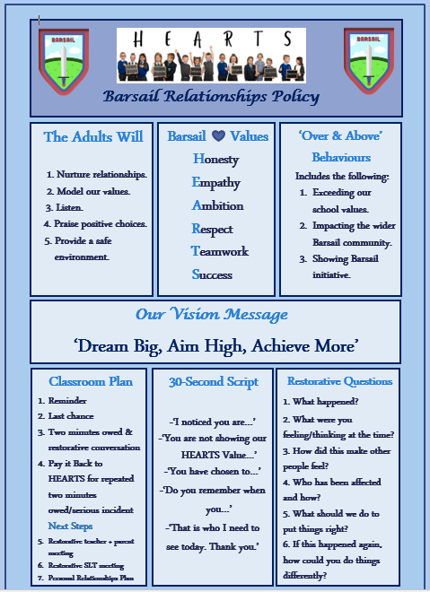
Appendix 2- Classroom Plan
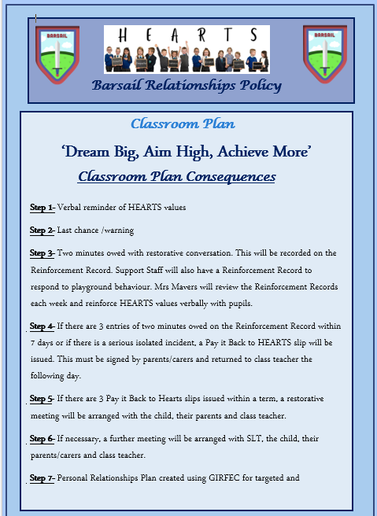
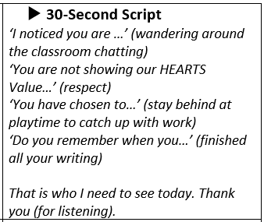
Appendix 3- 30-Second Script Appendix 4- Restorative Questions
