Bargarran Primary School

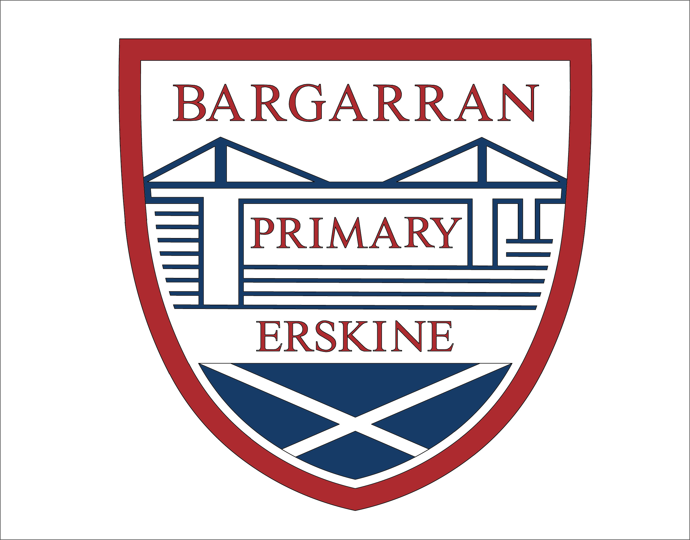



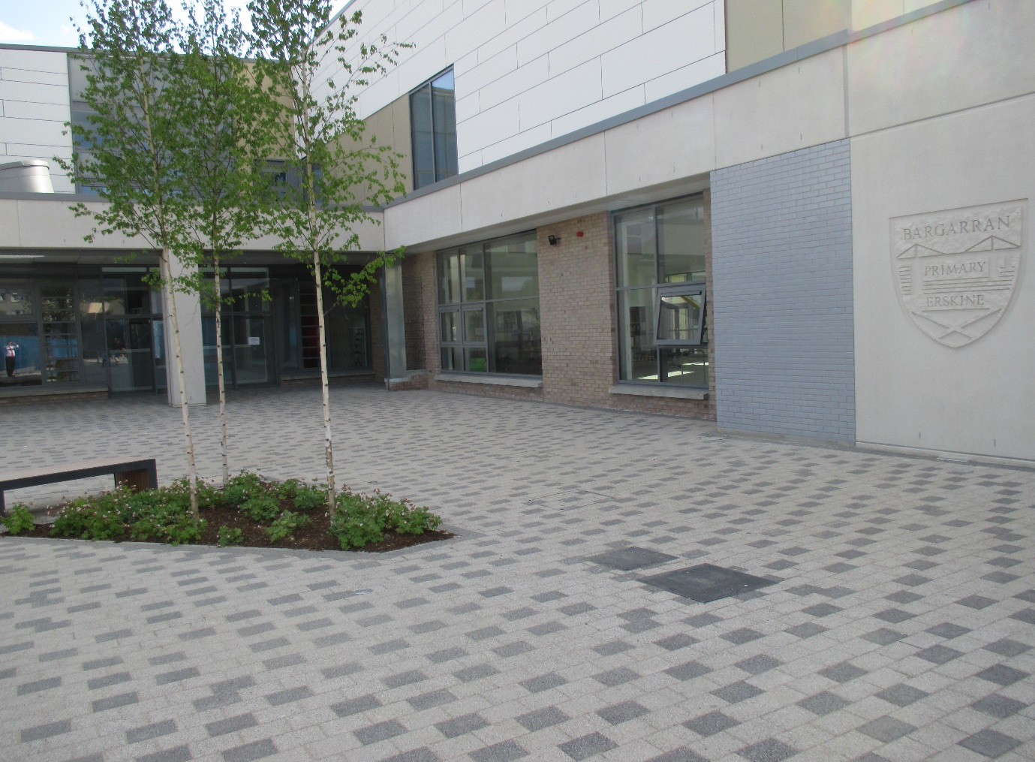

Anti-Bullying Policy

September 2022

**Policy Statement**

This policy sets out the approach to be taken in Bargarran Primary School in relation to bullying behaviour and supporting the development of respectful relationships.

This policy has been developed to take account of the national guidance on anti-bullying, ‘Respect for All – The national approach to anti-bullying for Scotland’s children and young people’ and is based on guidance from the current authority anti-bullying policy.

Children have the right to be safe. Bullying impacts on this right and can affect their right to an education. Our whole school aim is to create an environment where bullying cannot thrive.

Our policy is in accordance with the guidance set out in ‘Respect for All’ and reflects the Renfrewshire Council Policy as well as consultation that has been carried out with pupils, parents and staff.

**Principles**

It is our belief that a safe, nurturing and respectful learning environment is fundamental in supporting every child to thrive and achieve. Bargarran Primary School recognises the impact that bullying behaviour can have on wellbeing and is committed to preventing, reducing and responding to bullying behaviour.

Bargarran Primary School promotes a culture of positive behaviour and respectful relationships. This is achieved through the following: promotion of our school values; the creation our vision statement in consultation with parents; our Rights Respecting School work; our promoting positive behaviour guidance and regular whole school assemblies.

Children and young people are encouraged to report incidences of bullying behaviour or suspected bullying behaviour. Every learning establishment must offer a range of friendly, safe and confidential ways for children and young people to raise concerns about themselves or others.

Bargarran Primary recognises that bullying behaviour is not limited to the school environment and responding to it effectively needs strong partnership working – between the establishment, pupils and parents.

**Definition**

Bargarran Primary has adopted the definition of bullying used in ‘Respect for All’:

***Bullying is both behaviour and impact: the impact is on a person’s capacity to feel in control of themselves. This is what we term as their sense of ‘agency’. Bullying takes place in the context of relationships; it is behaviour that can make people feel hurt, threatened, frightened and left out. This behaviour happens face to face and online.***

In line with ‘Respect for All’, Bargarran Primary acknowledges that not all disagreements between children and young people are necessarily bullying in nature the definition set out in this policy will be used when investigating and resolving allegations of bullying behaviour.

This behaviour can harm people physically or emotionally and, although the actual behaviour may not be repeated, the threat may be sustained over time, typically by actions, looks, messages, confrontations, physical interventions, or the fear of these. This behaviour can include:

* Being called names, teased, put down or threatened face to face/online
* Being hit, tripped, pushed or kicked
* Having belongings taken or damaged
* Being ignored, left out or having rumours spread about you (face-to-face and/or online)
* Sending abusive messages, pictures or images on social media, online gaming platforms or phone
* Behaviour which makes people feel like they are not in control of themselves or their lives (face-to-face and/or online)
* Being targeted because of who you are or who you are perceived to be (face to face and/or online).

**Online incidents**

Bullying can happen face to face and online. Bargarran Primary addresses online bullying effectively when we it is addressed as part of our whole anti-bullying approach, not as a separate kind of bullying.

The vast majority of issues raised regarding on-line bullying take place when children are not in the care of the school. When these instances are reported to the school, we will immediately contact the parents and carers of children involved and expect their support in resolving the matter.

The school adopts a proactive report to educating our pupils about appropriate online behaviour. This is done though our Health and wellbeing programme, school assemblies and engaging with other agencies to promote online safety.

**Prejudice based bullying**

Bullying behaviour may be a result of prejudice that relates to perceived or actual differences. Prejudice-based bullying is when bullying behaviour is motivated by prejudice based on an individual’s actual or perceived identity; it can be based on characteristics unique to a child or young person’s identity or circumstance. These characteristics include:

* Age
* Disability
* Race
* Religion
* Gender
* Home circumstances

Prejudice-based bullying behaviour is not restricted to these categories. It may also result from perceptions about a child or young person for other reasons, such as their socio-economic background, being looked-after, being a young carer, being an asylum seeker or refugee, body image or other family circumstances.

**Our school approach**

At Bargarran Primary we aim to foster a culture and ethos of respect and responsibility, in an environment where all adults, children and young people are able to play an active part in preventing and responding to bullying behaviour.

We believe environments where bullying cannot thrive are ones where pupils, parents and carers play a part in school life. Our whole school approach to educating our pupils about Children’s rights and our successful accreditation as a Gold Rights Respecting School play a key role in this. Through this approach, there is a shared understanding of what behaviour is acceptable and what is not.

Our school vision statement and school values were created in consultation with pupils, parents and staff. These are discussed on a with children on a regular basis and are referred to when dealing with inappropriate behaviour.

**Roles and responsibilities**

The Head Teacher has overall responsibility for preventing and responding to bullying behaviour and promoting respectful relationships within the school. This is achieved through:

* developing a culture of positive behaviour and respectful relationships across the school;
* ensuring all staff within their establishment have a clear understanding of the policy on anti-bullying and their roles and responsibilities in relation to this;
* identifying a lead(s) for anti-bullying within their establishment;
* ensuring that all children and young people within their establishment know how to report any concerns about bullying behaviour;
* ensuring that staff adhere to all procedures for reporting, recording and responding to incidents of bullying behaviour;
* monitoring information on incidents of bullying behaviour and taking appropriate action where required;

All staff must be aware of, and adhere to, the school’s policy and procedures in relation to bullying. All school staff are responsible for:

* contributing to a culture of positive behaviour and respectful relationships;
* being aware of, and adhering to, the school’s and the Council’s anti-bullying policy;
* ensuring that children and young people know how to recognise and report an incident of bullying behaviour and are comfortable with the means of doing so;
* being aware of their responsibility to prevent and respond to prejudice-based bullying behaviour;
* ensuring that they are aware of, and are adhering to, the procedures for monitoring and recording alleged incidents of bullying behaviour;
* actively contribute to the development, delivery, and review of anti-bullying behaviour strategies within the learning environment;
* acting as a positive role model in establishing respectful relationships.

**Support for Children and Young People**

Support for children and young people affected by bullying behaviour is essential, both immediately following the incident, and, during an agreed period of review. This includes support for those children and young people who have exhibited bullying behaviour. Peer support, staff support and parental support all play a vital role in ensuring there is little or no long-term effect on someone who has been subjected to bullying behaviour.

When responding to bullying or suspected bullying, staff should ask themselves the following questions:

* What was the behaviour?
* What impact did it have?
* What does this child want me to do?
* What do I need to do about it?
* Is there any evidence of prejudice behaviour or attitudes?

Remembering that bullying is both behaviour and impact, Bargarran Primary will address both behaviour and impact.

The approaches that we adopt to prevent and reduce incidences of bullying behaviour and promote respectful relationships include:

* making links between discussion and policies on children’s rights and positive behaviour and bullying to help ensure a whole school approach to relationships and behaviour.
* themed assemblies and visits from other agencies;
* curricular activity;
* mentoring and/or buddy systems;
* health and wellbeing activities;
* regular discussions with pupil and parent councils;
* actively promoting positive respectful relationships through establishment values rather than focusing on bullying behaviour.

Bullying behaviour also occurs outside of the school day and often through social media, there should be greater emphasis on the need for pupils, parents, and communities to be aware of the signs of bullying behaviour. The head teacher/head of establishment should seek to raise awareness of the school’s policy through its pupil and parent councils. Bullying that takes place outside of school that has an impact on a child or young person will be taken seriously. When schools are made aware of such incidents, staff will work in partnership with parents and carers to address these issues.

Our approach to dealing with bullying behaviour is a solution-oriented approach that is designed to help people change the way they behave without being labelled. Staff and parents and carers can help children and young people change by telling them that the behaviour is bullying and that what they did is not acceptable. Labelling children and young people as ‘bullies’ or ‘victims’ is unhelpful in changing their behaviour or supporting their recovery from being bullied. Labelling an action as bullying is a more effective way of motivating a child to change their bullying behaviour. Adults dealing with bullying behaviours are expected to be able to distinguish between a person and their behaviour.

Any bullying behaviour must be challenged; however, all people (including those who are bullying) should always be treated with respect. Not labelling children does not diminish the seriousness nor impact of bullying behaviour; rather, it is an essential way of maintaining the adult’s focus and response on the problematic behaviour.

We believe it is important to tell pupils in all schools that it is okay not to be friends with everyone, but you should still show respect to people that you are not friends with. Staff dealing with bullying incidents will use this is a principle to underpin discussions on relationships.

Our pupils have told us they value supervision in the playground. We aim to continue to provide levels of supervision well above the minimum national requirements and will give staff advice how to respond to behaviour and concerns in the playground. Initiatives that involve children in the playground are valued. Some expressed that adults telling them to ‘ignore bullying’ was not helpful advice.

**Working with Parents and Carers as partners**

Parents and carers have been involved in a consultation process as part of the development of this policy and when the policy was in draft form.

Staff should use their professional judgement to determine at which stage parents/carers should be involved when there are bullying concerns. Staff should consider the wishes of a young person in relation to sharing concerns about bullying with parents. Staff should act in the spirit of GIRFEC and consider the best interest of a child. If a child or young person indicates that telling a parent could cause harm or distress, this needs to be considered. Their right to privacy is not an absolute right, and where there is a child protection concern, local procedures must be followed.

**Reporting, recording, and responding to concerns**

There are a number of ways in which alleged incidents of bullying behaviour can be reported by children and young people. These are as follows:

* reporting directly to the Class Teacher,
* reporting directly to the Head Teacher or Depute Head Teacher,
* parents or carers reporting directly to Class Teacher, Depute Head Teacher or Head Teacher
* using class ‘worry boxes’
* Keep Safe Kids App

Parents and carers should contact the school should they wish to raise concerns formally or informally. When contacting the school parents should consider the member of staff they wish to discuss the alleged incident with. This could be their child’s class teacher or the member of SMT with pastoral responsibility for their child’s stage. For Primary 1-3 children this will be the Depute Head Teacher and for Primary 4- 7 the Head Teacher.

Reports of alleged bullying made by parents/carers/others will be treated as bullying incidents and schools will aim to complete an investigation and implement any remedial action within 3 working days and communicate the outcome to affected children, young people and their parents. Investigations into alleged incidents of bullying behaviour should begin, in the establishment, on the day the incident is reported. If the incident occurs at the end of the school day or out with school hours, the investigation should commence at the start of the following school day. The member of staff who is dealing with the complaint should inform the person making the complaint how the investigation into their complaint will be carried out.

As far as possible, parents and carers should be kept informed of the progress of the investigation into a complaint. If a parent/carer is not satisfied with the way in which the establishment has handled an incident of alleged bullying, they should be referred to Renfrewshire Council’s complaints procedure.

The Keep Safe Kids App can also be used to report bullying. Using the App will not change the way reports are responded to, it will just offer another way to get support and make reports, at a time which may be more suitable. It is important to note that reports will only be picked up during school hours and will not be accessed in the evening, at weekends or during school holidays.

**Shared Campus**

Our position as a shared campus school results in children sharing the playground and lunch hall. If an allegation of bullying is made the Senior Management Teams of both schools will work together to address any concerns including the reporting and recording of incidents.

**Recording**

Recording and monitoring the number and nature of incidents of bullying behaviour ensures that appropriate responses can be made and supports the identification of trends and opportunities for early intervention.

Each incident of bullying which takes place in Bargarran Primary will be recorded in the Bullying & Equalities module within SEEMIS Click & Go, which is the main information system used to hold pupil information in Scottish schools. The Scottish Government Guidance on ‘Recording and Monitoring of Bullying Incidents in Schools’ can be accessed here -

When recording bullying incidents, the following information must be included:

* The children and young people involved as well as other adults
* The type of bullying experienced – name calling, threats or rumours etc.
* Any underlying prejudice including details of any protected characteristics
* The impact of the bullying incident, including consideration or personal or additional support needs and wellbeing concerns and
* Actions taken including resolution at an individual or organisational level.

School Staff should use their professional judgement when deciding when to record on the SEEMIS module. When parents or carers have raised an alleged incident with the school their views will be considered whether the incident should be recorded.

In line with the national guidance and this policy, not all disagreements between children and young people are necessarily bullying and staff should consider the behaviour and the impact before deciding if it is bullying and should be recorded.

All data recording, monitoring and reporting will be undertaken in line with current data protection legislation.

**Appendix 1 – Behaviour Guidance for Parents, Pupils and Staff**

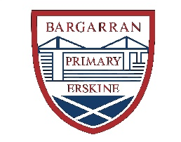



**Bargarran Primary School**

**Behaviour Guidance for Parents, Pupils and Staff**

At Bargarran Primary School we adopt a positive approach to discipline incorporating the nurture principles delivered through Renfrewshire’s Nurturing Relationships Approach. The following guidance sets out how we promote positive behaviour in our school.

**Our School Vision**

Our school vision statement was created in consultation with pupils, parents and staff with the aim of encouraging a positive learning ethos. Our vision statement is visible around the school and discussed regularly at whole school assemblies. Our vision statement is:

“At Bargarran Primary School we learn and grow together.”

**Our School Values**

Our school values were created in consultation with pupils, parents and staff. Our values apply to all members of our school community. Our values are visible around our school and discussed regularly at whole school assemblies. Values awards assemblies are held to promote our values and to recognise positive behaviour in accordance with our values. Our school values are:

* be happy
* be honest
* be kind
* be respectful
* be responsible
* be all you can be!!

**Whole School Rules**

Our whole school rules were developed in consultation with pupils, parents and staff. The whole school rules of Bargarran Primary are as follows:

* We respect ourselves
* We respect others
* We respect our school

The whole school rules should be displayed in each teaching base.

**Promoting Positive Relationships**

Staff use a number of strategies to promote positive and nurturing relationships.

* Class Dojo

Class Dojo is used for positive reinforcement whereby children receive Dojo points for their actions linked to our school values. Parents have the opportunity to access their child’s information on Class Dojo. Class teachers issue awards and certificates in connection with Class Dojo.

* House Points

House Points are awarded for good behaviour out with class. This can be for behaviour in accordance with our school values or showing kindness, concern and consideration for others. House points can be awarded for holding doors for others, displaying good manners, acting as a positive role model or lifting litter in the playground. House Points can be awarded by any member of staff. House Points are counted on a weekly basis. The house with the most points each term are awarded the House Points trophy.

* Individual Class Approaches

At class level individual teachers are encouraged to use approaches suitable to their class. These can include individual points, group points and Star of the Week.

* Renfrewshire Nurturing Relationships Approach (RNRA)

As part of Renfrewshire’s Nurturing Relationships Approach, Bargarran Primary are continuing to develop the nurture principle, ‘Language is a vital means of communication’. We use the language of belonging in our communication with children:

* You belong here
* You are welcome here
* You are safe here
* I will help you to understand
* Your feelings are okay with me
* You can work with me on this problem that is getting in the way right now

Adults in the school promote positive relationships by:

* Understanding the importance of their own language and how this can impact on children
* Share their feelings and provide opportunities for children to develop their emotional language
* Support children to understand their emotions

As part of our RNRA we have developed:

* Playground Buddies.

Our ‘Big Buddies’ consist of P6 and P7 pupils who have been trained in school to offer support and guidance to pupils at playtime and lunchtime. Buddies can be identified by their ‘Bargarran vest and Buddy Lanyard. The role of a Big Buddy is to help pupils who have fallen over, sort out minor playground disagreements fairly, organise suitable games, encourage children to join in or simply keep them company, informing staff when there are problems and setting a good example by caring for others.

* Big Deal, Little Deal

Through RNRA, we are developing pupil resilience through discussions based around ‘Big Deal/Little Deal’. This approach will help children understand the difference between a ‘big deal’ which requires adult intervention and a ‘little deal’ which is something they could resolve themselves. Through class lessons and assemblies, we will discuss how to address problems and how to change what feels like a big deal into a little deal.

* Restorative Conversations

If a child’s behaviour is causing concern, the class teacher will have a restorative conversation with the child and log this conversation. The child will be supported by the class teacher to develop strategies to develop positive behaviour. Restorative approaches are used in response to relationship and/or discipline difficulties. Questions which will allow children to reflect on their behaviour and to understand the impact of their behaviour on others, will be discussed during this conversation. Restorative questions may include:

* What happened?
* What were you thinking when it happened?
* How were you feeling when it happened?
* How are you now?
* Who else was affected?
* What do you need to feel better?
* What needs to happen to put things right?

The teacher may decide on a related, appropriate consequence for the child’s actions. For example, if significant learning time has been lost, the teacher may ask for work to be taken home to complete.

Record Keeping

The class teacher should keep a record of the dates of restorative conversations, a short description of the behaviour and any strategies which have been put in place to support the child.

Contacting Parents

If a child has been involved in three restorative conversations, then the parent or carer should be contacted by the class teacher. The class teacher has the decision whether to send a standard letter to invite the parent to school for a meeting, or to discuss any concerns with the parent over the phone.

A short pastoral note should be made by the class teacher if they meet/call a parent regarding a child’s behaviour.

If behaviour continues to cause concern, the member of the senior management team responsible for pastoral care for the child’s stage, may call or arrange a meeting with parents/carers to discuss supports which may be required for a child who finds the school environment challenging.

**De-Escalation Strategies**

Staff use de-escalation strategies to avoid low-level behaviour and get children back on track without behaviour escalating. If these strategies have not had the required response, the class teacher may deliver a short script (30 seconds):

* “ I have noticed that…” (you are not ready to learn)
* “ I need you to…” (offer a choice of two preferable actions)
* “ I know you can do this…” (refer to previous positive behaviour)
* “Thank you.” (walk away and allow child to think and act positively)

**Reflection Diary**

Children may be issued with a Reflection Diary to be completed in class at the end of each day. Here they can reflect on their day and discuss with their class teacher. This should be sent at the end of each day to the member of Senior Management Team with pastoral responsibility for the stage.

The Reflection Diary should be taken home each day for parents to view and sign and should be returned the following day.

The use of the Reflection Diary should be reviewed after two weeks. When children are taken off their Reflection Diary the parent or carer should be informed. Completed Diaries should be kept in the class Restorative Conversations Folder.

**Serious Breaches of School Discipline**

For certain serious breaches of school discipline, the member of the SMT with pastoral responsibility should be informed of any such incidents and should take the decision whether to contact the parent or carer of the child concerned. Any contact with parents or carers should be made by the member of SMT with pastoral responsibility. All serious breaches of discipline should be recorded on pastoral notes

Serious breaches may include:

* vandalising school property
* swearing
* hitting, kicking, spitting or hair pulling

***The above guidance is provided to support staff and ensure fairness and consistency across the school in accordance with our Rights Respecting Schools approach. It is recognised that the above guidance does not cover every circumstance and eventuality. Staff can exercise their professional judgement when promoting positive discipline although it is recommended that the member of the SMT with pastoral care for the child is informed of decisions taken out with this guidance.***

