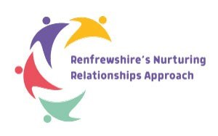
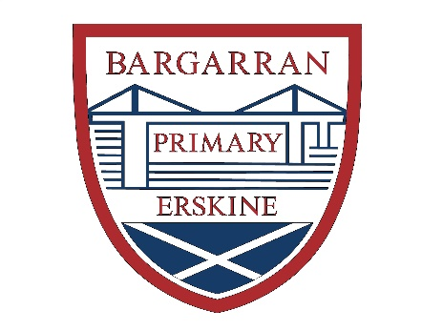

Bargarran Primary School
RNRA Update
May 2022
As part of Renfrewshire’s Nurturing Relationships Approach, Bargarran Primary are continuing to develop the nurture principle, ‘Language is a Vital Means of Communication’ to support the wellbeing and positive relationships of our school community.
As part of our Action Plan, we have developed several change ideas to promote nurture throughout the school.
- Restorative Conversations
Pupils and teachers surveyed felt that this had been a positive change to managing behaviour. With the support of their class teacher, pupils are given the opportunity to reflect on behaviour, discuss support and develop more positive relationships with their peers and teachers.
- Playground Buddies
This session we have developed the role of Playground Buddies for P6 and P7 pupils. This has been a successful change idea which has enabled the older children to support the younger children with minor issues in the playground and to support them in developing positive relationships with their peers. They are identifiable in the playground by their red Bargarran vests.
- Check-Ins
Every class has a feelings check-in which enables the class teacher to monitor wellbeing and provide support if necessary.
- Mindfulness Activities
All classes take part in mindfulness activities which help create calm minds and learning environments.
- Wellbeing Assemblies
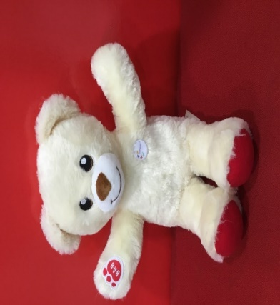
Whole school assemblies are attended by Buddy our Nurture Bear who encourages pupils to support their own wellbeing and the wellbeing of others.

