Contents
Contents 1
Welcome from the Head Teacher 3
Service Pledges 5
Standards and expectations 5
About our school 7
School staff 7
SMT Departmental Links 8
School Information 11
School roll 11
School Building/ Grounds 11
Car parking 12
School day 12
School security 12
School year 13
School in-service days 13
School dress 14
Park Mains High School Dress Code 14
Physical Education Kit Policy 16
Registration and enrolment 17
Induction procedures for pupils starting school and their parents 17
Associated primary schools 17
Plan of school 18
Special unit 21
The Bridge Base 21
Care and welfare 22
Medical and health care 22
Health Education Statement 22
The School Health Service 23
Health and Wellbeing Education 23
Attendance and absence 25
Bullying 26
Anti- bullying policy in Park Mains High School 26
Child protection 27
Mobile phones 27
School meals 28
Parent Pay 28
School transport 29
Pickup points 29
Placing requests 30
Assisted support needs 30
Pupils leaving school premises at breaks 30
Education Mmaintenance Aallowance (EMA) 31
Part time employment 31
Equalities 31
Photos 33
Behaviour and discipline 35
Pupil support 39
The Pastoral Care System 39
Chaplaincy Arrangements 41
Primary Secondary Liaison 41
Curriculum Matters 42
Curriculum for Excellence 43
Curriculum for Excellence - info re the parent toolkit - 43
Curriculum for Excellence 43
Broad General Education 43
Senior Phase 45
Examinations 45
National qualifications 45
National Qualifications 47
The Option Programme 48
S5/S6 School Link Programme with West College 2021/22 49
Assessment & Reporting 51
Getting it right for every child (GIRFEC) 52
Additional support for Learning 52
Inclusion 52
Support 52
Universal support 52
Targeted support 53
Educational Psychology Service 53
Specialist Support Service – teachers teaching in more than one school 54
Homework/ Digital Learning 54
Work experience, enterprise in education 55
The Careers Service in Park Mains High School 56
Developing the Young Workforce 57
Extra-curricular activities 58
Duke of Edinburgh Award (DofE) 59
Home school parental links 59
What type of response can parents expect? 60
The Pastoral Care Team and other points of contact 60
Parent Council 61
Home school community links 62
Parental involvement 62
Home school link service 63
School lets 64
Other useful information 64
Keeping informed 64
Listening to learn - Complaints, Comments and suggestions 64
Data protection 65
Information in emergencies 65
Websites 67
Glossary 68
Parent feedback 69
Tell us what you think 70

Welcome from the Head Teacher

Dear Parent/Guardian

It is my pleasure to welcome your child to Park Mains High School. Our aim is to provide the highest quality of education which gives learners the opportunity to achieve their full potential. We would seek your support in key areas to ensure that this happens. We will have the highest of expectations of pupils in terms of full attendance of classes, timekeeping, behaviour, completion of homework and that they work to the best of their ability at all times. It is important for us that your child feels part of our school community and identities with it by wearing our dress code and becoming involved in the many extra-curricular activities on offer at Park Mains.
We believe our positive ethos, the arrangements for pastoral care and the personal interest taken by teachers in their pupils all help to make each individual feel a valued member of the school community.
We wish to provide a broad and balanced education suitable to the needs and abilities of all pupils which will equip them with the knowledge and skills, aptitudes and attitudes to play a positive role in society.
The purpose of this handbook is to provide parents and carers with as much general information as possible. Further details together with opportunities for consultation will be provided throughout each session. In the meantime, please feel free to make contact with the school at any time on any matter connected with your child’s education and welfare at the school. I am looking forward to working with you and your child to ensure he/she has a fulfilling and enjoyable time at Park Mains High School and thank you for your anticipated co-operation in supporting the school throughout your child’s time here.

Michael Dewar
Head Teacher

Service Pledges

Standards and expectations
We will:
- offer all children and young people in our catchment area a free school place;
- provide school premises which meet health and safety standards;
- provide information on your child’s progress;
- provide religious and moral education for your child;
- give support and encouragement for parents to be involved in school life;
- provide information on school activities;
- provide 27.5 hours of class contact time for pupils in each normal school week; and
- help pupils prepare for vocational, further and higher education.

Pupils will have opportunities for:
- personal and social development;
- music, cultural activities and creativity;
- access to healthier lifestyles and sports activities; and
- community involvement.

You can also expect us to:
- provide formal written reports on your child’s progress;
- provide an annual report on school progress within the school improvement plan;
- give you an opportunity to have a formal meeting with your child’s class teacher or teachers;
- strive to meet your child ‘s needs

How can you help?
By law, you must make sure your child receives an education.
As a parent/carer, you can help your child by:
- making sure your child goes to school regularly;
- encouraging and supporting your child with any homework/home study given;
- working in partnership with your child’s school
- encouraging your child to respect the school and the whole school community

The Education (Scotland) Act 1980 uses the broadly framed definition of ‘parent’. This is as follows:

“Parent” includes guardian and any person who is liable to maintain or has parental responsibilities (within the meaning of section (13) of the Children (Scotland) Act 1995) in relation to, or has care of a child or young person;

This is a wide definition which might, by way of example, include:

- non-resident parents who are liable to maintain or have parental responsibilities in respect of a child;
- carers who can be parents;
- other with parental responsibilities, e.g. foster carers, relatives and friends who are caring for children and young people under supervision arrangements; and
- close relatives, such as siblings or grandparents caring for children who are not looked after or are under home supervision arrangements

Everyone who is a parent, as defined in terms of the 1980 Act, has rights under the Act. This includes the right to receive advice and information about their child’s education, general information about the school, to be told about meetings involving their child, and to participate in activities, such as taking part in decisions relating to a Parent Council. Education authorities and schools should treat parents equally, the exception to this general requirement being where there is a court order limiting an individual’s exercise of parental rights and responsibilities. It is for education authorities to advise schools on the application of these rights in individual cases.

About our school

School staff
Head Teacher (Mr M Dewar)
The curriculum and all matters relating to the quality of education for all learners. More specifically: Strategic overview of Curriculum for Excellence (CfE); Raising Attainment; the Delegated Management of Resources; all staff matters including appointments and welfare; school discipline; partnership in the broadest sense; Principal adviser to the Parents’ Council.
Depute Head Teacher (Mrs P Crean)
Deputising for the Head Teacher in his absence (rotation); Year group head for S1, Pupil Support, primary/secondary liaison, Senior Management Team/CfE Links for Health & Wellbeing , Physical Education ,Pupil Support (Pastoral Care , Support for Learning and Bridge Base),Inclusion & Equality and personal support. Linked with Skye House.
Depute Head Teacher (Mr S Wilson)
Deputising for the Head Teacher in his absence (rotation); Year group head for S6, timetable-options overview, Raising Attainment; Tracking & Monitoring; 16+ Co-ordinator; curriculum structure, religious observation/ assemblies, enterprise/finance, skills for lifelong learning and work, employability. Senior Management Team /CfE Links for Technology, Information and Computing Technology. Linked with Bute House
Depute Head Teacher (Mrs P Kirkwood)
Deputising for the Head Teacher in his absence (rotation); Year group head for S3, Learning & Teaching, self-evaluation, Improvement Planning; Parental engagement/Family Leaning, Senior Management Team /CfE Links English/Modern Languages, Expressive Arts. Linked with Mull House.
Depute Head Teacher (Mr B Gillen)
Deputising for the Head Teacher in his absence (rotation); Year group head for S4 & S5, SQA Co-ordinator ,Absence cover (SQA) activities week, school dances, staff matters, professional development (including CPD Coordinator/ overview of collegiate groups), Senior Management Team, /CfE links for Maths/Numeracy, Social Subjects, RMPS/Citizenship. Linked with Arran House.
Acting Depute Head (Mrs N Maynes)
Deputising for the Head Teacher in his absence (rotation); Year group head for S2; achievement (including Award Ceremonies, House System, wider achievements and Promotion, Extra-Curricular), Pupil leadership/voice, Assessment & reporting, probationers & students, Partners, Dress Code. Senior Management Team/ CfE Links for Science/STEM/Sustainability. Linked with Bute House
Education Support Manager (Mrs K Taylor)
Computerised administration; Statistical returns; SQA arrangements ( supporting SQA co-ordinatior); Room allocations; Liaison with architects and oversight of school repairs; Delegated Management of Resources; Absence cover; Management of APT & C staff; School calendar; Health & Safety, ICT Coordinator, School Transport, Finance/Budgets. Linked with Bute House

SMT Departmental Links

P Crean Pupil Support (Pastoral Care /SFL/Bridge Base), Physical Education

B Gillen Mathematics, Social Subjects, RMPS.
S Wilson Technology (Design & Technology/Home Economics), ICT (Computing/Business Education)
P Kirkwood English, Modern Languages, Expressive Arts
N Maynes Science- Biology/Physics/Chemistry

Principal Teachers of Pastoral Care
Pastoral Care staff have a responsibility for the general welfare of each pupil in their group. They maintain an overview of records and the attendance of pupils. They also make every effort to monitor the curricular progress of individual pupils and provide personal, vocational and curricular Pastoral Care. Tutor group inputs are managed by Pastoral Care staff.
Pastoral Care staff endeavour to ensure all pupils are interviewed at least once per session. They are normally the first point of parental contact with the school.

Principal Teachers /Faculty Heads, Curriculum
They take responsibility for the organisation of learning and teaching within their own department/ faculty. They have a responsibility to ensure that suitable course work is provided for all pupils and to monitor and review this in line with school, local authority and national guidelines, particularly in the light of Curriculum for Excellence. They play a key management role within the school and endeavour to keep parents informed of how they can work together with the department/faculty, for the benefit of the children.

Teaching and Support Staff
Expressive Arts |  |  | Mathematics
Miss M Fraser | AFH |  | Mrs F McLaughlin | PT
Art |  |  | Mrs L Aitken
Miss E Cassidy |  |  | Mr D Brady
Mr J McGregor | P |  | Mrs L Campbell
Mr G McGuiness |  |  | Mrs M Campbell
Mrs N McKernan |  |  | Miss S Hamilton
Miss L Sloan | P |  | Mrs L Hendry | PT (PC)
Mrs A Wright |  |  | Mrs C McLaren
Music |  |  | Mrs A Mills
Mrs L Logan |  |  | Miss T Shafi | P
Miss R Randal | P |  | Mr J Townsend
Mr A Tervet |  |  | Mr C Wake | PT (PC)
Miss M Winchester
 |  |  | Mod Languages
Bridge Base |  |  | Mrs J McKeown | PT
Mr T Church | PT |  | Miss A Eggert | P
Ms J Bremner |  |  | Mrs F Mears
 |  |  | Mr E More
Bus Ed/Comp
Miss A McGowan | FH |  | PE & Health & Wellbeing | FH
Business Ed |  |  | Mr C Chambers | P
Ms K Cochrane |  |  | Mr D Armour
Mrs C Johnson |  |  | Miss A Clark
Miss D McNeil |  |  | Mr I Combe
Mrs Smith | P |  | Ms S Heeps
Computing |  |  | Mrs F Johnston
Mr R Herbertson |  |  | Miss C Palmer | P
Mr A Milligan |  |  | Mrs H Shearer
Ms S Stewart | PT(PC) |  | Mr R Toole
 |  |  | Science/ Biology
English |  |  | Mr P Long | FH (Biology/Physics)
Mrs P Donaghy | PT |  | Mrs K Chippa
Ms K Anderson |  |  | Mrs L Gardiner
Ms S Dyer |  |  | Miss R Ishan
Mrs B Graham |  |  | Mrs M Laggan
Ms S Jones |  |  | Mr S McDougall | P
Ms K MacLennan |  |  | Miss R Provan
Miss J McGlinchey |  |  | Miss H Rendall
Mrs L Neill |  |  | - Chemistry
Miss A Sloan | P |  | Mrs M Wimpenny
Miss R Stevens | P |  | Mrs Buttar
Dr D Stewart |  |  | Mrs A Colquhoun
Mrs L Wullf |  |  | Dr L Davis
 |  |  | Miss J Gillespie
Mr M Smith |  |  | -Home Economics
Ms S Tawseen |  |  | Miss R Bunyan
- Physics |  |  | Miss G Pitt | P
Mrs L Gibson |  |  | Mrs E Thomson
Mr I Huggins |  |  | Miss L Tugman
Mrs S Mclaughlin
Social Subjects/ RMPS |  |  | Team Leader | Mrs C Wong
Mrs R Hume | FH |  | Administrative Assistant
- Geography |  |  | Clerical Assistants | Mrs C Bowden
Miss F Drennan |  |  |  | Mrs J Hards
Mrs C Grant |  |  |  | Mrs A Lipman
Ms J Leslie |  |  |  | Mrs S Shotter
Miss E Macleod
History |  |  | Classroom Assistants | Ms J Boyle
Miss L Fyfe |  |  |  | Mrs A Fulton
Mr S Huddleston |  |  |  | Mrs L Goodwin
Miss H Leitch | P |  |  | Mr S Dempster
- Mod Studies
Miss S Carr | PTPC (Acting) |  | A.S.N. Assistants | Mrs J Bolder
Ms V Hannigan |  |  |  | Mrs T Jamieson
Ms J Keane |  |  |  | Miss L Kane
Mrs K Scott |  |  |  | Mrs L Kidd
Mr M Shanks |  |  |  | Mrs A Linden
RMPS |  |  |  | Mrs B McGarvey
Miss A Dolan |  |  |  | Mrs L McMahon
Mr D Patrick |  |  |  | Ms S Sutton
Mrs J Riach |  |  |  | Mrs S Taylor
Support for Learning |  |  | Inclusion Support Assistant | Mrs P McGraw
Mrs C O’Donnell | PT
Mrs J Loney |  |  | Technicians | Mr J MacDonald
Mr M McHugh |  |  |  | Mr S McDonald
 |  |  |  | Miss W Tait
Technical
Mr K McGroraty | FH |  | Home Link Worker | Mrs A Mann
Mr A Henry |  |  |  | Miss K Fry
Miss H Madigan
Mrs G Marshall |  |  | Librarian | Mr K Naismith
Mr C McCrossan
Mr I Schofield |  |  | Janitor | Mr S Kennedy
Ms A Watt |  |  | Janitor /Cleaner | Mr A Slimming
 |  |  |  | Mr T Smith

A: Acting P: Probationary Teacher FH: Faculty Head
ASAN: Additional Support Needs Assistant PC: Pastoral Care
ESM: Education Support Manager PT: Principal Teacher

School Information
School Address: Park Mains High School, Barrhill Road, Erskine, PA8 6EY
Tel: 0300 300 1411 Fax Number: 0141 814 3387
Email: parkmainshighenquiries@renfrewshire.gov.uk

School roll
Park Mains High School is a non-denominational, coeducational, comprehensive school which caters for pupils aged from 11 to 18 in six yearly stages.
Current roll of each Year |  |  | Likely 1st year intake
Year | No of Pupils |  | Year | No of Pupils
1 | 280 |  | 2021 | 242
2 | 239 |  | 2022 | 235
3 | 234
4 | 242
5 | 259
6 | 171
Total | 1425

School Building/ Grounds
The innovative design features a teaching space across three levels. This is defined by a strong brickwork grid and joined by a two-storey management and administration building clad in Rheinzink cladding.
A multi-use assembly hall has a main stage and tiered stadium style seating which has been designed to accommodate local community activities including drama and theatre.
The use of ‘lightwells’ and glass enables a large amount of natural light to flood in giving a bright, open environment and a feeling of space throughout making it a pleasurable place in which to learn and work.

In addition to hi-tech classrooms, and wi-fi access, there are new learning opportunities through breakout areas adjoining classrooms which can be used for a variety of learning techniques.

In addition to a synthetic pitch and a 3G Astro football pitch there is a four court games hall, gymnasium, fitness suite and dance studio. Renfrewshire Leisure Ltd manages the school’s sports facilities for community and club use in the evenings and weekends.
In the school grounds, there are extensive seating areas and playground terracing areas for pupils to enjoy and socialise during breaks. The grounds have been landscaped and include wildflower areas to attract wildlife.
There is also the option for some outdoor learning using the amphitheatre.
Sustainability has been given prominence, as is shown by the BREEAM environmental certification of B+.

Car parking
The school has approximately 180 visitor parking spaces and 7 disabled parking spaces available for visitors with disabilities.

School day
The school day begins at 08.50 and will end at 15.40 on Monday, Tuesday and Thursday and 14.50 on Wednesday and Friday with a 50-minute break for lunch. The day will be divided in this way:
Mon, Tues, Thurs
1 | 2 | Interval | 3 | 4 | 5 | Lunch | 6 | 7
8.50 – 9.40 | 9.40 – 10.30 | 10.30 – 10.45 | 10.45 – 11.35 | 11.35 – 12.25 | 12.25 – 1.15 | 1.15 – 2.00 | 2.00 – 2.50 | 2.50 – 3.40

Wed, Fri
1 | 2 | Interval | 3 | 4 | Lunch | 5 | 6
8.50 – 9.40 | 9.40 - 10.30 | 10.30 - 10.45 | 10.45 – 11.35 | 11.35 - 12.25 | 12.25 – 1.10 | 1.10 – 2.00 | 2.00 – 2.50

School security
Renfrewshire Council has introduced procedures to ensure the safety and security of pupils and staff when attending or working in a school. We use a number of security measures, including a visitors’ sign in book, badges and escorts while visitors are within the school building. Normally, anyone visiting a school for any reason will be asked to report to the school office. The school staff then make the necessary arrangements for the visit.

School year
First Term | In service day | Thursday 12 August 2021
 | In service day | Friday 13 August 2021
 | Schools reopen (pupils return) | Monday 16 August 2021
 | September weekend (schools closed) | Friday 24 September 2021 and Monday 27 September 2021
 | Schools reopen | Tuesday 28 September 2021
 | October holiday (schools closed) | Monday 11 October 2021 to Friday 15 October 2021 (inclusive)
 | In service day | Monday 18 October 2021
 | Schools reopen | Tuesday 19 October 2021
 | St Andrew's Day (schools closed) | Tuesday 30 November 2021
 | Schools reopen | Wednesday 1 December 2021
 | Last day of the session | Wednesday 22 December 2021
 | Christmas and New Year break (schools closed) | Thursday 23 December 2021 to Wednesday 5 January 2021 (inclusive)
Second Term | Schools reopen | Thursday 6 January 2022
 | February mid-term break (schools closed) | Monday 14 February 2022 to Tuesday 15 February 2022 (inclusive)
 | In service day | Wednesday 16 February 2022
 | Schools reopen | Thursday 17 February 2022
 | Spring holiday (schools closed) | Monday 4 April 2022 to Monday 18 April 2022 (inclusive)
Third Term | Schools reopen | Tuesday 19 April 2022
 | May Day (schools closed) | Monday 2 May 2022
 | In service day | Thursday 5 May 2022
 | Schools reopen | Friday 6 May 2022
 | Local holiday (schools closed) | Friday 27 May 2022 and Monday 30 May 2022
 | Schools reopen | Tuesday 31 May 2022
 | Last day of session | Wednesday 29 June 2022

School in-service days
- Thursday 12 August 2021
- Friday 13 August 2021
- Monday 18 October 2021
- Wednesday 16 February 2022
- Thursday 5 May 2022

School dress
Renfrewshire Council encourages each school to adopt a dress code and for any proposed changes to be discussed with parents, pupils and the parent council. The council supports an agreed dress code because of the benefits it brings, including improvements in safety, security, discipline, ethos, community spirit and a decrease in bullying and expense for parents.
Some types of clothing will not be allowed in school for reasons of safety, decency or indiscipline. Types of clothing which will not be allowed include:
- clothes which are a health or safety risk;
- clothes which may damage the school building;
- clothes which may provoke other pupils;
- clothes which are offensive or indecent; and
- clothes which encourage the use of alcohol or tobacco.
Pupils will not be deprived of education, any benefit or access to examinations because of not wearing school uniform.
In the interests of health and safety, of both individual and others present, all jewellery, including body jewellery, must be removed before taking part in physical education lessons or physical activities.
Grants for footwear and clothing for children are available to parents receiving certain benefits. Please see the council’s website: http://www.renfrewshire.gov.uk/Freeschoolmealsandclothinggrants
Information and application forms for free school meals are available from schools, registration offices and customer service centres or download a form from the council's website: http://www.renfrewshire.gov.uk/Freeschoolmealsandclothinggrants
Please help the school and the education authority by making sure that pupils do not bring valuable or expensive items of clothing to school. The council has no insurance to cover the loss of valuable items.

Park Mains High School Dress Code
A high standard of personal appearance is expected of all students and anyone arriving at school inappropriately dressed may be sent home to get changed. Before this happens, your parents will be contacted.
This is a very large school. We need to work together as a team. The kind of people we are, and the way we treat one another is obviously very important.
One aspect of teamwork in life is the wearing of recognisable uniform, and your willingness to be part of Park Mains High School can, to some extent, be measured by your co-operation with the dress code.
You can then expect your Guidance teacher to commend you for supporting the school in this way or to prompt you to perhaps make some improvement in your standard of dress.
Our Dress Code is:
Please - always wear a white shirt/blouse and a clearly visible school tie

- always wear black (not grey) trousers/skirt (no shorts or very short “fashion” skirts allowed)

- wear smart all black footwear

Please do not - wear black shirts, black jeans or leggings

- wear denim trousers, skirts, jackets

- wear or carry anything bearing a football logo

- wear crewneck/multicoloured tops

Please also note the following important additions to this code –
- All S5 and S6 pupils are required to wear a black blazer. (The S6 Leadership Team will wear a blazer with braid)

- Any pupils in S1-4 can also choose to wear a blazer.

Physical Education Kit Policy
If pupils are not participating in the practical activity but are changed fully for PE, they will have the opportunity to take part in the Physical Education curriculum as: referees, scorekeepers, timekeepers, statisticians, recorders, equipment organisers and coaches.
All pupils will bring PE kit for every lesson even if:
-pupils have a piercing, as they will now be able to take part in their PE lesson in one or more of the roles listed above.
-pupils cannot take part fully due to health reasons, as they will now be able to take part in the lesson in one of the roles listed.
In the essence of Curriculum for Excellence all subjects are expected to contribute to educating children across the curriculum in areas such as literacy, numeracy and health and well-being. Physical Education is an excellent platform for all three areas and by always bringing PE kit all pupils can be actively involved in the lesson.
Benefits of this policy: All pupils will be able to engage positively in experiences that are fun, enjoyable, exciting and challenging in a variety of contexts.
All pupils will have the opportunity to take part in Physical Education and no one will be isolated from the work of the class.
The following sanctions will apply if pupils do not follow policy
On 3rd occasion of not bringing PE Kit - Guidance staff will be informed, and parents given group call.
On 4th and 5th occasion detention for 10 minutes at lunch time in PE classroom
After 6 times, parent will be contacted by Principal Teacher of Physical Education and pupils will be detained after school as per school detention policy
After 8 times Principal Teacher will pass on to Depute Head in charge of year group and they will make contact with parent.

Registration and enrolment

Pupils are normally transferred from primary to secondary between the ages of 11 years 6 months and 12 years 6 months, so that they have the opportunity to complete at least four years of secondary education.
Parents of pupils who have moved to the area or who want their child to transfer to the school should contact the school office for information about appropriate procedures, and to arrange a visit.
Parents who want to send their child to a school other than the catchment school should make a placing request. The procedure for making a placing request is explained in the leaflet ‘Sending your child to school.’ You can pick this leaflet up from any school, call our customer contact centre, 0300 300 0300, to have a copy sent to you, or download the form from the council website: www.renfrewshire.gov.uk

Induction procedures for pupils starting school and their parents
Parents will be advised of parent meetings and pupil induction days during the spring and summer terms.

Associated primary schools
A Lyle HT | E Mavers HT | W McNaught HT
Bargarran Primary School | Barsail Primary School | Bishopton Primary School
Barrhill Road | Park Moor | Old Greenock Road
Erskine | Erskine | Bishopton
PA8 6BX | PA8 7HL | PA7 5BE
0300 300 1447 | 0300 300 0146 | 0300 300 0161
N McGlynn HT | M Ferguson HT | R Clark HT
Inchinnan Primary School | Langbank Primary School | Rashielea Primary School
Old Greenock Road | Dennistoun Road | North Barr
Inchinnan | Langbank | Erskine
PA4 9PH | PA14 6XH | PA8 6EX
0300 300 0161 | 0300 300 0165 | 0300 300 0156

Plan of school
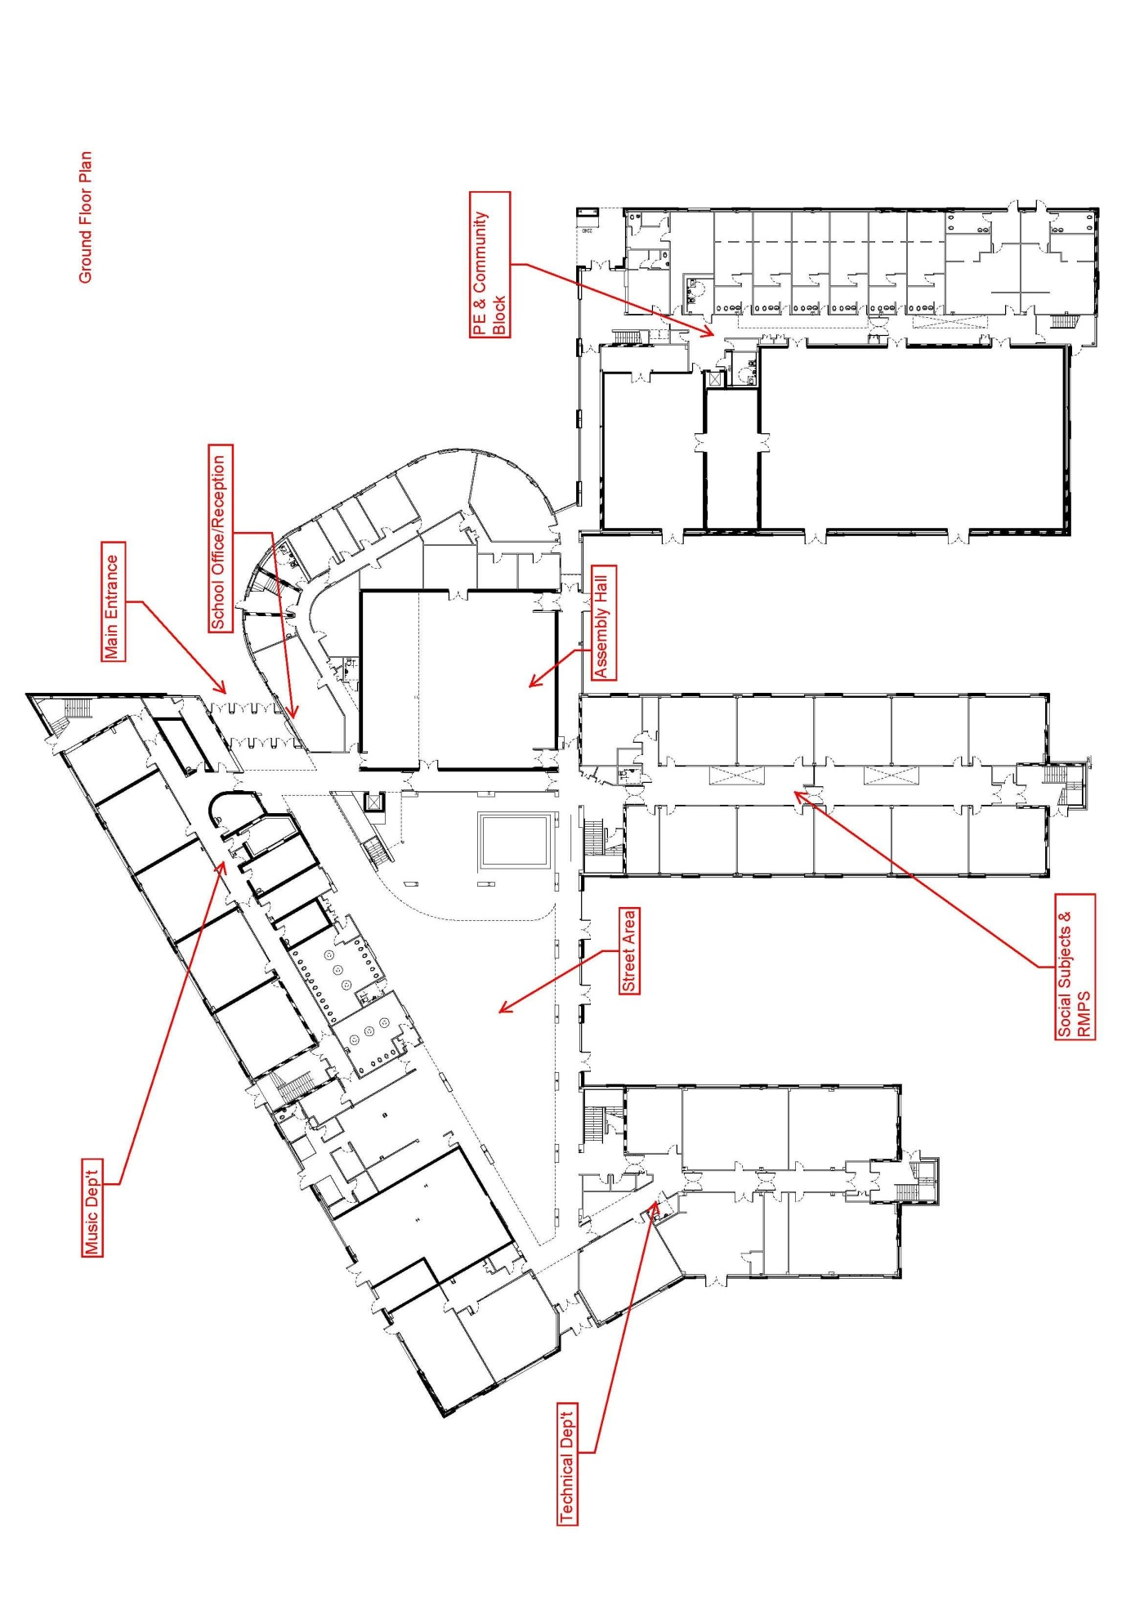
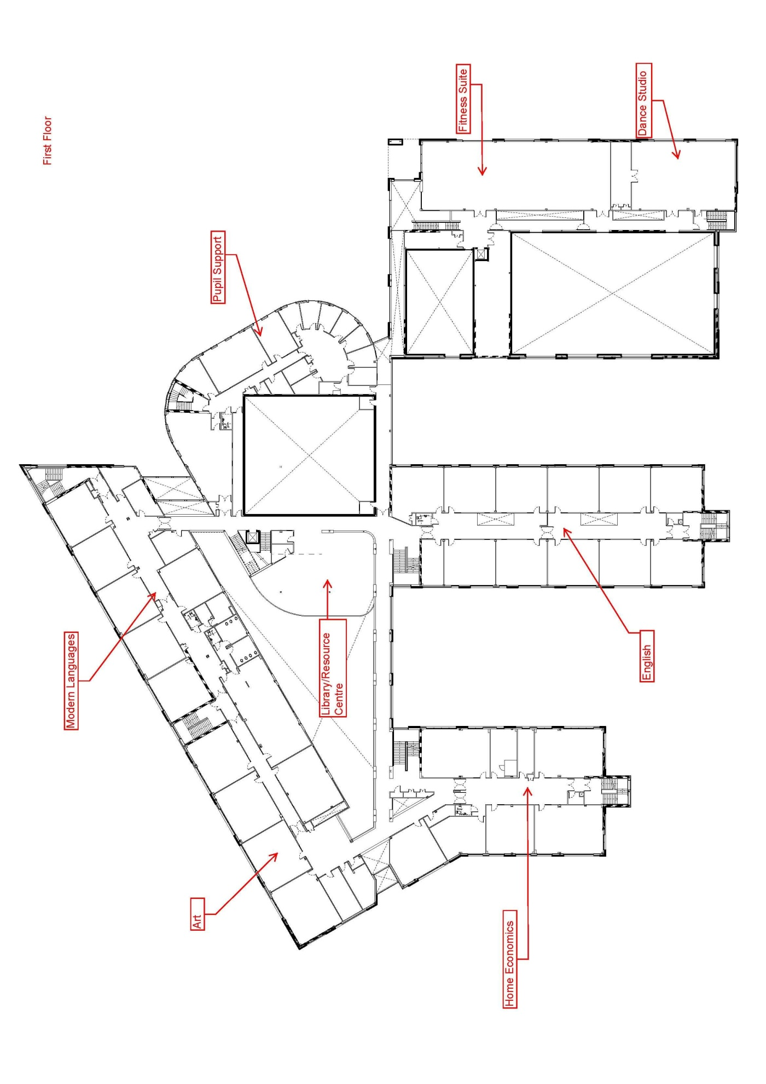
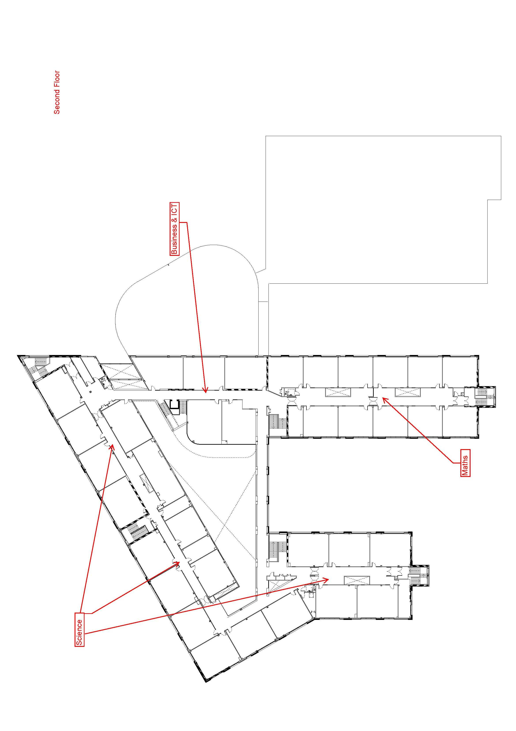

Special unit

The Bridge Base
The Bridge Base is a special support base designed to meet the needs of pupils with Autistic Spectrum Disorder and pupils with Specific Language Difficulties.
The Base has two specialist Teachers and five Additional Support Needs Assistants.
Pupils are supported in mainstream classes and they also attend the Base for tutorials to work on classwork consolidation and aspects of the following:
Communication, Social skills, Enterprise, Literacy, Numeracy, Concentration, Life Skills, Spelling, Punctuation, Grammar, Thinking and Listening Skills, Anger Management, Organisational Skills, Teamwork and Co-operation.
The Bridge Base aims are:
- To make pupils and parents feel happy and comfortable at school.

- To help the pupils identify and achieve their aims and objectives for life.

- To integrate pupils fully into the mainstream experience.

- To encourage pupils to be as successful as they can and so become successful learners, confident individuals, responsible citizens and effective contributors.

- To develop each pupil’s language and communication skills within the context of the secondary curriculum.

- To support academic attainments in the courses studied.

- To encourage good self-esteem and better social skills.

- To support teachers in classrooms and provide effective teaching strategies and information relating to Base pupils.

In addition to school staff, there is support from other professionals and external agencies, e.g. advice from speech and language therapist, educational psychologist, health, occupational therapy and social work.

Care and welfare
Your child’s welfare is central to the ethos of the school. Please contact the school to share any concerns you have about your child’s welfare or wellbeing. The staff will work with you as parents to make sure that your child is safe, happy and able to benefit from the educational opportunities we offer.

Medical and health care
Parents should notify the school of any medical requirements or allergies that their child may have. If medication is required it is better if this can be provided outside the school hours but, in cases where it is necessary during the child’s time in school, parents should contact the school to make appropriate arrangements. Staff are not obliged to give medicine to pupils.
Minor accidents are dealt with by the school’s qualified first aider. If a pupil takes ill or has an accident at school which requires that they be is sent home or for treatment, the school will provide first aid and contact parents or carers. So, it is very important that the school has contact details for all parents or carers and an additional contact person in case parents or carers can’t be reached. This information should be kept up to date. The school will not send younger pupils’ home from school unaccompanied.
In the event of a serious illness or accident, a member of staff will accompany the child to a doctor or hospital and parents or carers will be notified immediately.
Parents are asked to ensure that the school is kept informed of a current emergency contact number.

Health Education Statement
Park Mains High School is a Health Promoting School. We aim to look after the physical, social and mental well-being of our pupils by providing them with the means to make the right choices to lead a healthy lifestyle. During session 2017-18 a Health & Wellbeing Policy was developed and launched at Park Mains we try to achieve the above aims by;
- imparting knowledge and developing understanding of key issues relating to health and healthy living, through the teaching of the main curricular subjects. Tutor Group inserts and other health promoting events. allowing individual pupils to make decisions and engage in behaviour that will enhance their health. To this end the pupils are actively engaged in developing their communication skills, assessing evidence, making decisions, problem solving, making relationships and dealing with relationships.
- making our school a safe, welcoming and caring organisation, where secure and positive links are developed with parents and the community at large.
The development of the school as a community is encouraged through assemblies with pupil participation. Senior pupils are also involved in community service work, as well as helping with the younger pupils. All pupils are encouraged to participate in an active extra-curricular and activities week programme.
- enabling all staff and pupils to take part in the various health promotions, that promote a healthy lifestyle.

The School Health Service
The School Health Service is provided by: Greater Glasgow & Clyde Primary Care N.H.S. Trust.
Specific Aims of the School Health Service
- To promote the physical, mental and social well-being of children within a school setting.
- To identify and provide remedial action and support for pupils with health problems.
- To assess and provide service for pupils with Special Education Needs and their families.
The School Nurse Service
The School nurse service can be contacted at Johnstone Health Centre 01505 821326. The School Nurse carries out routine health screening at different stages in primary schools. This includes screening of vision, hearing, height & weight. If any problems are detected the School Nurse, either informs parents by phone or letter, and a plan of action is discussed.
The School Nurse is also involved in Health Education within the school. Some of the topics that may be covered include: -
- Health Education / advice as required to the school community
- Health Promotion
- Support of children and families with specific needs as required.

The following areas may be addressed –
Smoking Alcohol Puberty Relaxation
Diet / Nutrition Hygiene Immunisation Sexual Health
Hair Hygiene Drug Awareness

Health and Wellbeing Education
Learning in health and wellbeing ensures that children and young people develop the knowledge and understanding, skills, capabilities and attributes which they need for positive mental, emotional, social and physical wellbeing now and in the future. Learning through health and wellbeing enables children and young people to:
- make informed decisions in order to improve their mental, emotional, social and physical wellbeing
- experience challenge and enjoyment
- experience positive aspects of healthy living and activity for themselves
- apply their mental, emotional, social and physical skills to pursue a healthy lifestyle
- make a successful move to the next stage of education or work
- establish a pattern of health and wellbeing which will be sustained into adult life, and which will help to promote the health and wellbeing of the next generation of Scottish children and young people
- and, for some, perform at high levels in sport or prepare for careers within the health and leisure industries.
Health and Wellbeing in schools covers:
- mental, emotional, social and physical wellbeing
- planning for choices and changes
- physical education, physical activity and sport
- food and health
- substance misuse
- relationships, sexual health and parenthood.
Health and wellbeing cannot exist in a vacuum. It requires exchange of information, mutual support and collaboration with community partners, schools and parents.

Attendance and absence
It is the responsibility of parents of a child of school age to make sure that their child is educated. Attendance at school is recorded twice a day, morning and afternoon.
Please let the school know by letter or phone if your child is likely to be absent for some time and provide your child with a note on his or her return to school, confirming the reason for absence. If there is no explanation provided from a child’s parents, the absence will be regarded as unauthorised.
If your child is in S4-6 and an absence from school means that they will be missing an SQA examination, it is vitally important that you inform the school on the day of the examination. This is to ensure that the school can access the Exceptional Circumstances Consideration Service which supports pupils who have been unable to attend an examination for personal circumstances e.g. illness.
Please make every effort to avoid family holidays during term time as this disrupts your child’s education and reduces learning time. The head teacher can, however, approve absence from school for a family holiday in certain extraordinary situations. Please discuss your plans with the head teacher before the holiday. Absence approved by the head teacher on this basis is regarded as authorised. If the head teacher does not give permission before the holiday, it will be recorded as unauthorised absence
Parents from minority ethnic religious communities may request that their child be permitted to be absent from school to celebrate recognised religious events. Absence approved by the head teacher on this basis is regarded as authorised absence. Extended leave can also be granted on request for families returning to their country of origin for cultural or care reasons.
A supportive approach is taken to unexplained absence. The education authority, however, has legal powers to write to, interview or prosecute parents, or refer pupils to the Reporter to the Children’s Panel, if necessary.

Bullying
Renfrewshire Council has an anti-bullying policy which was developed in consultation with pupils, parents and staff. The policy provides guidance on the prevention, identification and management of bullying – both the bullying behaviour and the impact it has.
Our school also has its own anti-bullying policy which sets out our local approach to tackling bullying. You can request a copy of the Council’s policy and/or the school’s policy from the school office or access them online at www.renfrewshire.gov.uk www.renfrewshire.gov.uk/article/3469/Anti-bullying.
If you have a specific concern about bullying, please report this to the school so that we can investigate and take any action that might be needed.

Anti- bullying policy in Park Mains High School
Bullying is an unacceptable form of behaviour through which an individual or groups of individuals feel threatened, abused, or undermined by another individual. Bullying is behaviour which can be defined as a repeated attack of a physical, psychological, social or verbal nature by those who are able to exert influence over others.
Aims
To minimise the incidence of bullying and to ensure that any incidences of bullying are dealt with appropriately.
Role of Pupils
- Pupils should treat others as they wish to be treated themselves.
- Pupils should not be involved in name calling, picking on other pupils or joining in with other pupils who are behaving in this way. In fact, they should actively discourage such bullying activities.
- Pupils should report any incidences of bullying to a responsible adult.
Role of Staff
- Staff should ensure that they set a good example in the way they treat others. One of the Park Mains High School aims is “promoting respect by valuing ourselves, others and our community.”
- Reports of bullying should be taken very seriously and investigated at the earliest opportunity.
- Confidentiality should be respected.
- Staff should be vigilant in class, in corridors and in the vicinity of the school for any signs of bullying.
- Support staff should not hesitate to report suspected bullying.
Role of the Curriculum
Health & Well-being topics are delivered across subject departments and in tutor groups and will incorporate material which will highlight the causes, dangers and methods of prevention of bullying. Opportunities for emphasising these points in the wider curriculum should be taken whenever appropriate. The above is a brief summary of our policy. A full copy of the policy is available from the school on request. Information leaflets are issued to pupils, parents and staff.
NB: Concerns regarding bullying should be reported to the Pastoral Care Teacher or a senior member of staff.

Child protection
All children have a right to be protected from harm, abuse and neglect. The vision of the Renfrewshire Child Protection Committee is that "it's everyone's job to make sure that children in Renfrewshire are safe."
Renfrewshire Council has a child protection policy and guidelines in place of which all staff are made aware. Our staff work closely with other agencies to protect children and keep them safe. All school staff receive training every year and must report to the child protection co-ordinator, any concerns they have about the welfare of any child. In every situation, the welfare of the child overrides other considerations.

Mobile phones
The benefits of mobile phones are recognised. Many young people and their parents regard them as an essential means of communication. Mobile phones can be brought into schools however the following limitations will apply in Renfrewshire schools and education establishments:
- All phones should be turned off and kept out of sight during classes. Photographing or recording of sound or images of staff, other pupils or visitors to the school is not allowed at any time within the school campus or on school transport.
- Mobile phones may be confiscated where these rules are broken.
- Any recordings made on school premises or school transport found on confiscated phones must be deleted on their return.
- Any photographs or recordings of staff in any situation, whether taken on school premises or elsewhere, found on confiscated phones must be deleted from phones on their return.
- Children’s Services expects that schools will, through normal collegiate procedures, develop or review existing policies on the use of mobiles phones that take account of the views of all staff, parents and pupils.
- Schools should ensure that pupils, parents and staff are aware that should a pupil breach the policy, there will be consequences in line with the school’s positive behaviour/discipline policy.
- Individual school policies should clearly state for the benefit of staff, pupils, parent and visitors any variations from the restrictions on use of mobile phones set out below.
- Pupils and parents should be notified that mobile phones will be confiscated where these limitations are breached.
- Smartphones introduce additional challenges for schools and parents. Pupils and parents should be aware that this also leaves pupils open to dangers such as cyberbullying, grooming and access to inappropriate material. Parents are encouraged to read the anti-bullying policy for further guidance.
- Staff should not delete photographs or recordings from confiscated mobile phones.
- When staff confiscate mobile phones or other devices, they should ensure that these are retained in a safe place that cannot be accessed by others. This may be a lockable drawer or cupboard, a base area or a delegated area in the school office. Confiscated mobile phones should normally be passed to the school office or senior member of staff as soon as possible after confiscation.
Legal Aspects
- There are a number of aspects of the law which may apply to mobile phone misuse and the responses to that misuse. In the most serious cases there may be a crime involved – an incident that is being filmed might be an assault or breach of the peace. The misuse of a mobile phone might be an offence under the Communications Act 2003, if it involves a call or message that is grossly offensive or is of an indecent, obscene or menacing in character; and, the distribution of certain pornography might be an offence under the Civic Government (Scotland) Act 1982.
- In situations which are so serious that a school might contact the police, it is for the police, and not the school, to consider what, if any, criminal offence may apply.
These restrictions on use apply equally during any school activity that takes place off campus.
Pupils breaking the rules will be disciplined in line with the school’s positive behaviour or discipline policy.

School meals
Children of parents receiving certain benefits are entitled to a free midday meal. Information and application forms for free school meals are available from schools, registration offices, customer service centres or by downloading from the council's website: http://www.renfrewshire.gov.uk/article/2303/School-meals

Parent Pay
Parent Pay is an online cashless system introduced to schools by Renfrewshire Council. This cashless system allows parents to transfer money into their child’s school meal account, pay for trips and events and purchase items from the school shop at a time that is convenient for you.
Activation instructions can be provided from the school office if you have not yet got an account.
The account can provide parents with information on their child’s meal choices and provides a breakdown of the transactions allowing you to be informed at all times.
Additional benefits to the cashless system is the option to pay by monthly direct debit, set your own alerts (to be informed if the account reaches a certain balance) and pay money into the account over a gradual period of time before allocating to a payment item i.e. school trip.
For more information on ParentPay, please look at the following websites.
https://www.parentpay.com/schools/our-product/
https://www.parentpay.com/parents/
or for any trouble shooting/FAQ’s, there are links on the Park Mains High School website.
Children of parents receiving certain benefits are entitled to a free midday meal. Information and application forms for free school meals are available from schools, registration offices, customer service centres or by downloading from the council's website: http://www.renfrewshire.gov.uk/article/2303/School-meals
Children in receipt of free school meals still have these advantages, meal allocations are added by Renfrewshire Council by mid- morning, allowing break time purchases. Any unspent allocation is deducted by the end of the school day. Parents can top-up with additional funds.

School transport
Renfrewshire Council’s policy is to provide home to school transport to all secondary school pupils who live more than 3.219 kilometres (2 miles) from their catchment school by the recognised shortest safe walking route. Parents who think their child is eligible for home to school transport can get an application form from the school or Children’s Services in Renfrewshire House or online at http://www.renfrewshire.gov.uk/article/3486/Home-to-school-transport. These forms should be completed and returned before the end of February for those pupils beginning school in August to allow appropriate arrangements to be made. However, parents may make an application at any time.
In special circumstances the Director of Children’s Services has discretion to grant permission for pupils to travel in transport provided by the education authority, where spare places are available, at no additional cost to the authority.

Pickup points
Where we provide home to school transport, pupils may need to walk a reasonable distance from home to the transport pick-up point, but this should not exceed 3.219 kilometres (2 miles).
It is the parent's responsibility to make sure that their child arrives at the pick-up point on time and behaves in a safe and acceptable manner while boarding, travelling on and leaving the vehicle. Pupils who misbehave can lose their right to home to school transport.
Contract buses operate between Bishopton, India Drive, Langbank and the school and a late bus is provided Monday – Thursday for pupils who remain at school after 3.40pm (Mon, Tue & Thu) or 2.50pm (Wed).

Placing requests
Renfrewshire Council does not provide transport for those pupils who are granted a placing request other than in exceptional circumstances.

Assisted support needs
Renfrewshire Council may provide free home to school transport for children assessed to attend any school because of their assisted support needs. The educational psychology service will normally carry out the assessment. We also provide seat belt and wheelchair restraints needed to transport pupils.

Pupils leaving school premises at breaks
Schools have a duty to look after the welfare of their pupils This includes taking reasonable care of pupils’ safety during intervals and lunchtimes.
Renfrewshire Council recommends that pupils should not leave school grounds at interval time. Parents should encourage their children to follow these rules in the interest of safety.

Education Mmaintenance Aallowance (EMA)

An Education Maintenance Allowance (EMA) is an allowance of £30 per week paid to eligible students aged 16 to 19 years old who stay on in full-time education after the legal school leaving age.

Entitlement to an EMA is based on an assessment of household income. The income thresholds for the EMA programme academic year 2020//21 are as follows:
EMA Weekly Payments
Total Household Income for 2020/21 |  |  |  | Weekly Payment
£0 | to | £26,884 | for families with more than one dependent child in full-time education | £30
£0 | to | £24,421 | for families with a single dependent child in full-time education | £30

The weekly allowance is paid every second week in arrears directly into the student’s bank account.
For more information, please contact either the school office, Renfrewshire Council’s Customer Service Centre on 0300 300 0300 or email ema.els@renfrewshire.gov.uk
Information is also available on Renfrewshire Council’s website: www.renfrewshire.gov.uk

Part time employment
Pupils under school leaving age who want to work before or after school or at the weekend, need to hold a work permit. Pupils can get application forms from the school. Forms must be completed by employers, parents and the head teacher and returned to the school. Permitted working hours during term time are 2 hours per school day, 2 hours on a Sunday and 8 hours (over 15 years of age) or 5 Hours (under 15 years of age) for any other day (i.e. Saturday). Out with term time, the maximum total working hours in a week are 25 hours for those under 15 years of age and 35 hours for those over 15 years.
Parents are asked to co-operate with the school to make sure that the amount of time spent working doesn’t interfere with homework expectations and studying for SQA examinations.

Equalities
Renfrewshire Council is committed to ensuring that all employees, customers and partners are treated fairly and with respect at all times. We are committed to promoting equality and tackling discrimination through the way services are planned, delivered and purchased. The council promotes and encourages a culture whereby equality of opportunity exists across all the protected characteristics of age, disability, race, gender reassignment, pregnancy and maternity, religion and belief, marriage and civil partnership, sex and sexual orientation.
School education is open to all pupils and all reasonable measures will be taken to make sure that the curriculum is available to every child. The Equality Act 2010 introduced a new public sector general equality duty which requires Scottish public authorities to pay 'due regard' to the need to:
- Eliminate discrimination, victimisation, harassment or other unlawful conduct that is prohibited under the Equality Act 2010
- Advance equality of opportunity between people who share a characteristic and those who do not and;
- Foster good relations between people who share a relevant protected characteristic and those who do not

The council supports the right of each citizen to a quality of life which is free from violence, discrimination and harassment. The council will take steps to ensure that all citizens, regardless of race, ethnic or national origin, religion, social background, marital status, gender, disability, age or sexuality have full access to its services, taking all possible measures to prevent discrimination in the way its services are delivered.
Parents can help to monitor our success in promoting equality of opportunity for all by providing equalities related information when asked.

Photos
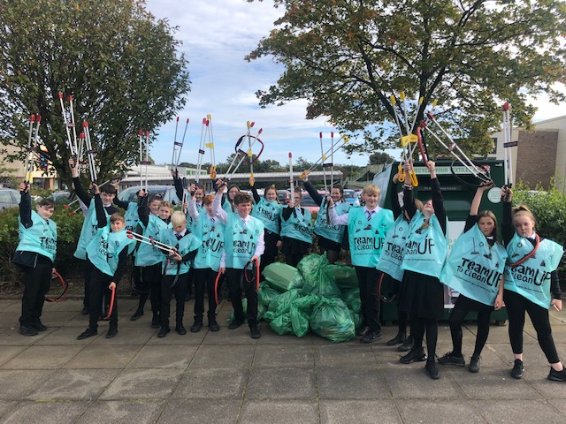
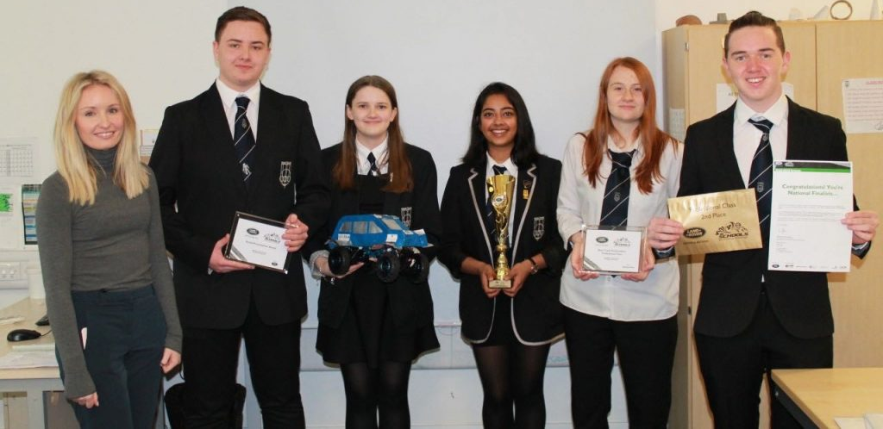
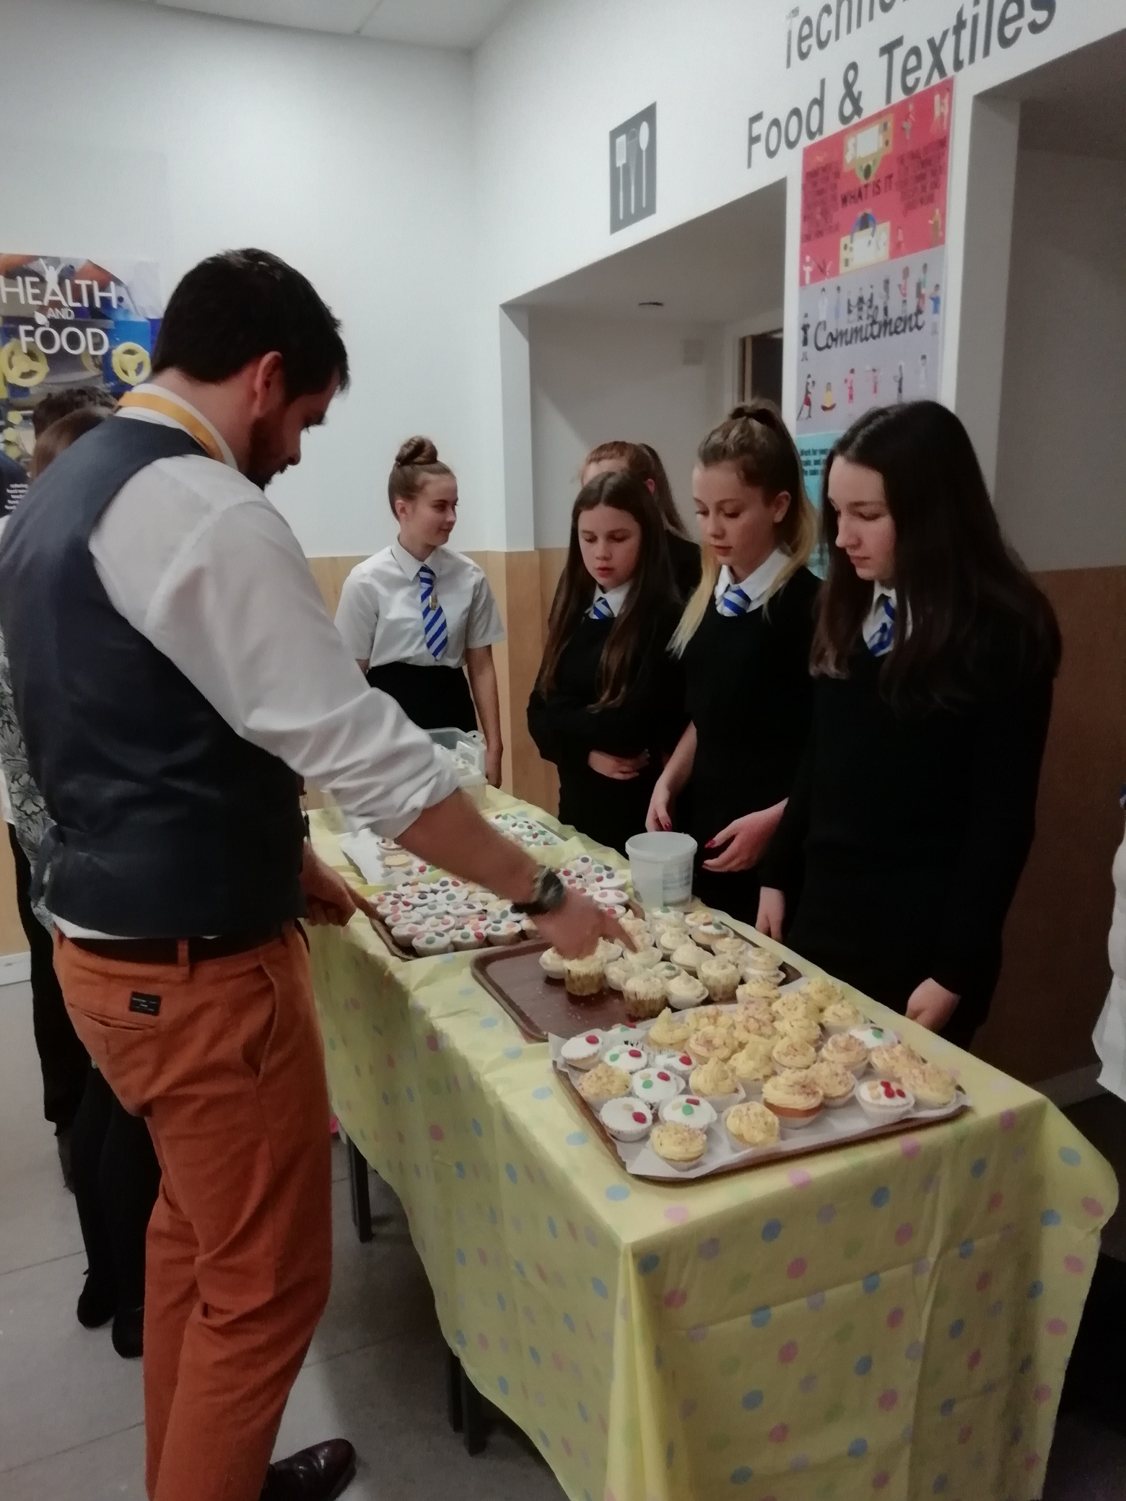
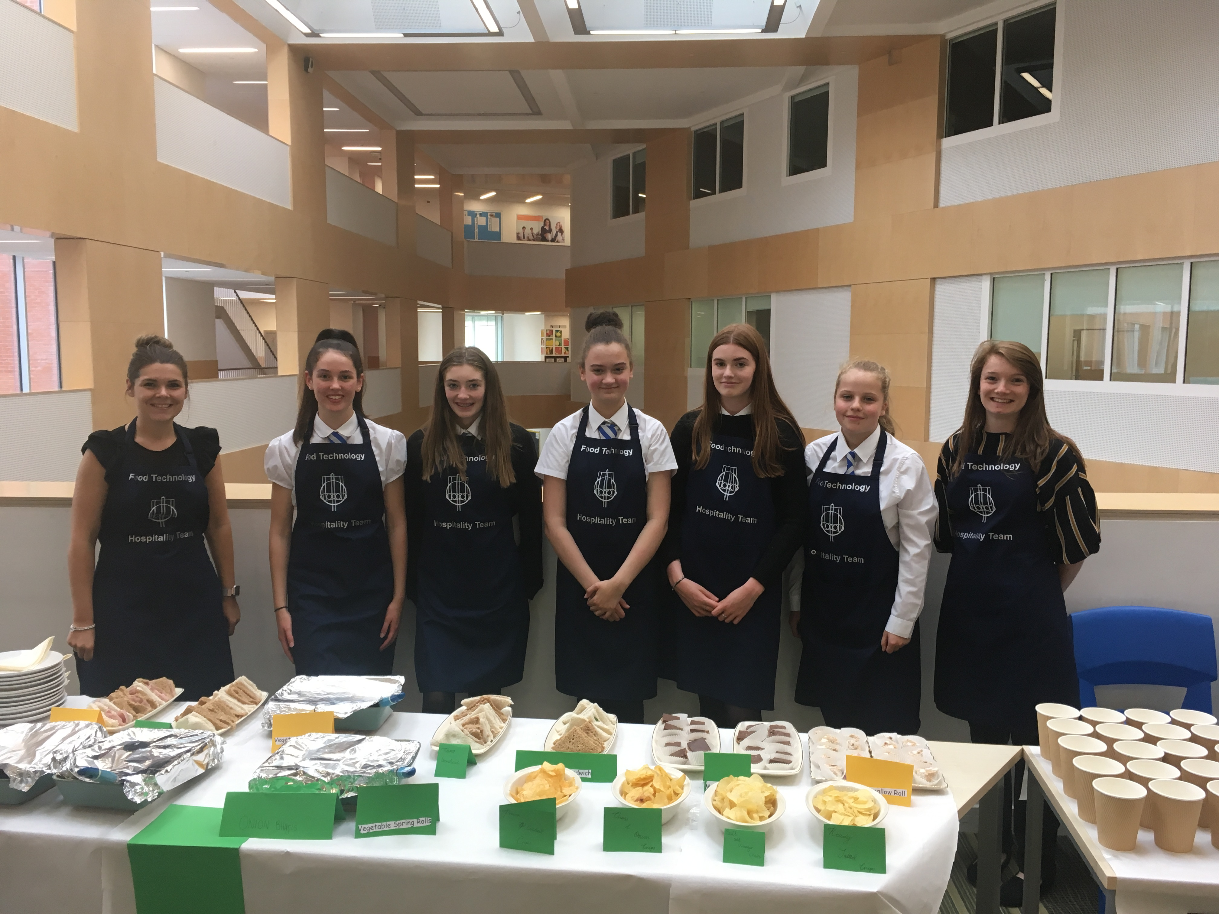
Litter Pick
Land Rover 4x4 Challenge Semtember
Children in Need
Bake Sale
Senior Awards Ceremony-Hospitality
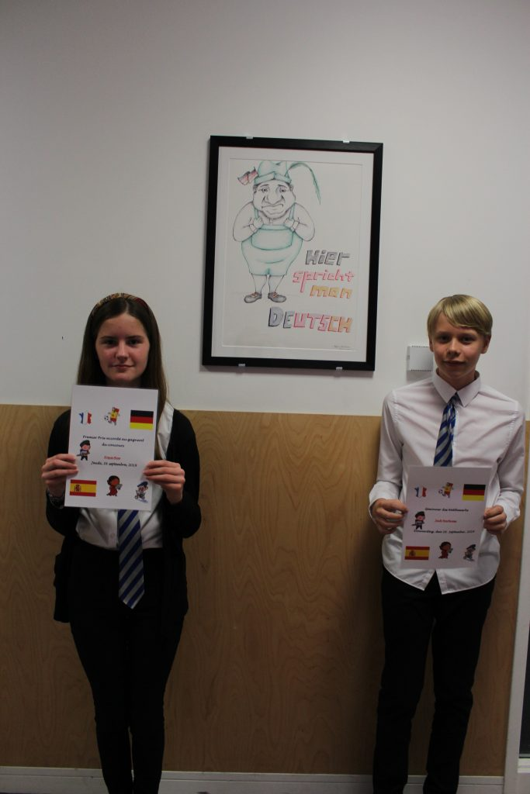
European Day of Languages
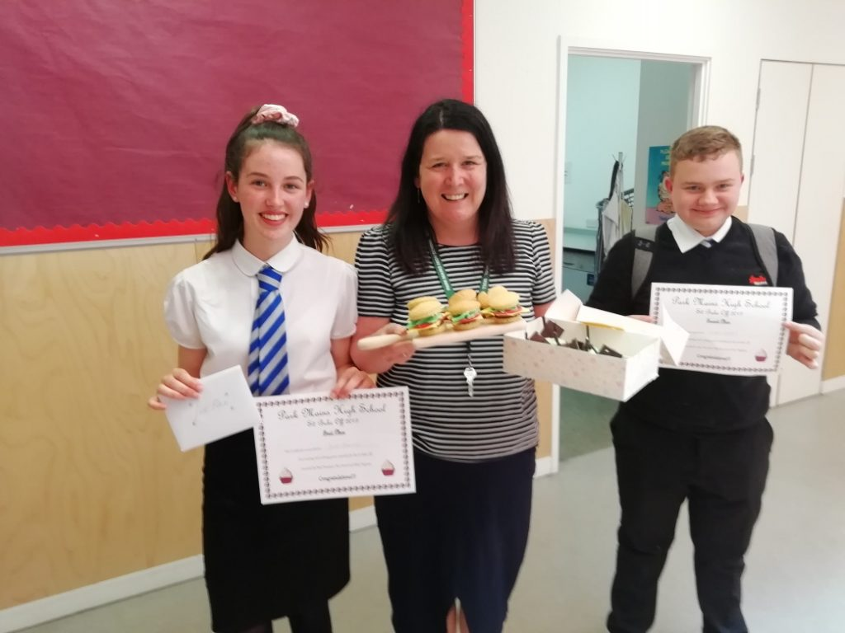
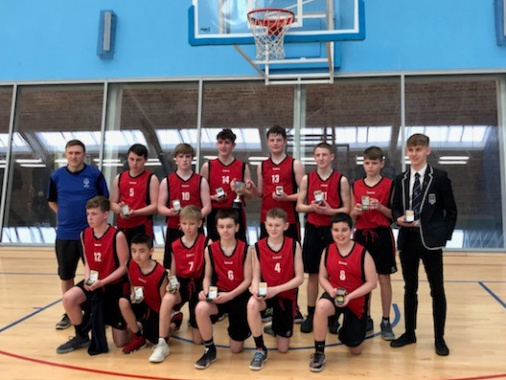
S2 Bake off
Basketball Scottish Champions

Behaviour and discipline
Introduction
This policy has clear links to the school aims and to other policies. Its purpose is to ensure suitable conditions for effective learning and teaching within the school.
Responsibilities
It is the responsibility of pupils, parents and staff to deal with each one another in a courteous and considerate manner.
It is the responsibility of all staff to help create and maintain the best climate in which effective learning and teaching can take place.
Teaching staff
The provision of relevant and varied course content and appropriate methods is important. Staff should be approachable. Encouragement and praise should be offered. Any sanctions applied should be administered fairly and consistently. Staff should work in partnership with parents and external agencies to support the pupils.
Parents
The help and support of parents is a contributory factor to good order in a school. It is the responsibility of all parents to ensure that their children attend school on time and bring with them the necessary equipment. Parents should also be encouraged to support the school dress code and take a positive interest in their child’s education. They should work in partnership with the school in the best interest of their child.
Pupils
It is the responsibility of all pupils to come to school with the necessary equipment and to be prepared to learn. Pupils should conduct themselves reasonably at all times, showing respect to those around them.
PROCEDURES
To ensure reasonable consistency, the following code of conduct for pupils has been drawn up. Pupils should be regularly reminded of the code and it should be clearly displayed in classrooms.
Code of Conduct
Pupils should:

- follow instructions given by a member of staff
- treat others with respect
- treat school property and work with respect
- arrive on time with the necessary books and equipment
- enter quietly and remain in seats unless asked to move by a teacher
- remove any outer garment (jackets), or non-uniform items of clothing
- follow school rules on mobile phones
Whilst record keeping is of vital importance, the value of communication and discussion between staff and managers should not be forgotten.
The success of all procedures outlined in this policy depends on the goodwill and cooperation of ALL members of staff. The exercise of consistency, discretion and good judgement by staff is of paramount importance in this matter.
ROLE OF CLASS TEACHER
In accordance with departmental and whole school policy, the class teacher should set and impose the standards necessary to maintain good discipline. The class teacher should strive to be informed of the pupils in her/his care, to forge good relationships with the pupils and to provide encouragement to them.
Class teachers should arrive promptly for class and should contribute to the control of movement into and out of the classroom, whilst establishing clear and consistent standards of behaviour. It is important that the staff work as a team in their supervision of pupil movement throughout the school, supporting each other.
Unacceptable behaviour may be dealt with in the following ways:
(Teachers should use their professional judgment when deciding which action is most appropriate for any given behaviour. NB These are not stages in the disciplinary process, simply suggestions of sanctions and strategies available.)
- issuing a verbal warning
- moving pupil to another seat
- moving pupil to another classroom
- issuing a reflective exercise
- referral to the Head of Department
- referral to Guidance

Reflective Exercise procedures are as follows
- the class teacher will issue a reflective exercise after a series of strategies have been employed to address behaviour
- A text will be sent to a parent notifying that a reflective exercise has been issued
- The pupil will be given two opportunities to complete the reflective exercise
- Failure to complete the reflective exercise for a classroom teacher will result in a referral to the Head of Department.
The class teacher can alert Pastoral Care staff of concerns by means of a Stepped Intervention referral.
When a serious incident occurs or a series of offences has been noted, it may be necessary to make a Seemis referral to the Head of Department.
Class teachers should discuss all referrals with their Head of Department. Heads of Department should note their action and indicate whether discussion with Pastoral Care staff or Senior Management is required.
ROLE OF HEAD OF DEPARTMENT
Heads of department have a clear responsibility for the maintenance of discipline and good order in their departments. They have a responsibility to ensure that the curriculum on offer is stimulating and appropriate to the needs and abilities of the pupils. They should ensure that departmental staff have adequate resources. They should ensure that departmental staff participate in staff development and, particularly where appropriate, in the area of behaviour management.
They must provide support for departmental staff by:
- a departmental approach to the shared responsibility for promoting positive behaviour
- arranging support for pupils experiencing problems
- setting clear lines of referral
- ensuring that pastoral care staff/ senior management are informed at an early stage when it becomes clear that a pupil is exhibiting a pattern of persistent misbehaviour
- maintaining departmental records of disciplinary incidents including details of classroom sanctions used
- forwarding all reflective exercises to Pastoral Care staff

Heads of Department may deal with pupils in the following ways:
- Department Pupil Monitoring Sheet
- Detention
- Isolation
- Removal to class of Head of Department
- Removal to another class in the department
- Letter to parents

When a class teacher issues a referral, she/he should discuss this with the Head of Department. The Head of Department should note the action taken at departmental level and pass the referral to the relevant Principal Teacher/ Year Head for information and discussion/ further action. Any referrals to Senior Management should be made as timeously as possible. The Year Head will communicate any actions to the Principal Teacher of Pastoral Care.
ROLE OF SENIOR STAFF
Senior staff should have a high profile and positive role in disciplinary matters. Where possible, SMT members should be out and about the school at the changeover of periods and breaks. They should set an example by the manner in which they deal with situations.
Senior staff will draw up a timetable for ‘on-call’. This system of ‘on-call’ is to ensure that someone is on hand to deal with disciplinary emergencies. To access this additional support staff can contact the school office.
Sanctions available to the Senior Staff:
- withdrawal of privileges
- change of class/timetable
- detentions at intervals and lunchtimes and after school (parents would be notified)
- communications with parents
- Period by Period
- referral to EST
- referral to Clyde Base
- Internal exclusion
- exclusions from school

Senior staff should, where possible, provide information timeously on referrals received for action and be open to enquiries from staff for information
ROLE OF PASTORAL CARE STAFF
Pastoral Care staff have a non-punitive role in the disciplinary procedure. They have an active role in familiarising themselves with their pupils and consulting with departments, thus enabling them to react at an early stage to approaches from staff. They should endeavour to work with all parties to address the reasons for inappropriate behaviour at the earliest stage.
On receiving a referral, pastoral care staff should note the entry and may:
- interview and counsel the pupil
- communicate with parents
- issue a period by period report
- refer pupil to appropriate year head
- refer the pupil to the EST

This policy is currently under review in accordance with Renfrewshire’s Nurturing Relationships Approach.

Pupil support

The Pastoral Care System
The Pastoral Care system in Park Mains High School is arranged vertically, which means that your daughter/son should remain in the care of the same person throughout her or his school career. Pastoral Care staff are concerned with the overall welfare of all learners; they advise and guide pupils and monitor their education progress. By means of interview and a variety of other approaches they attempt to ensure they are in a position to provide pupils with the appropriate support throughout their school career. They make contact with parents and have an important role to play with parents when pupils are making option choices. They also maintain pupil records.
Parents should contact the School Office if they require a meeting with Pastoral Care staff or wish to pass on information. Because Pastoral Care staff have teaching commitments, it is always advisable to arrange a meeting time. If parents arrive at school without an appointment it may not be possible to see the appropriate member of staff.
Pastoral Care Group responsibilities for 2021 –2022 are:
Mull– Miss S Carr Skye- Ms S Stewart
Arran – Mrs L Hendry Bute- Mr C Wake
Pupil Records
The records of pupils are maintained and kept by the Pastoral Care staff under secure conditions. Records are destroyed 5 years after the pupil has left school.
House System
Our new House System aims to:
- Give pupils a sense of belonging, which develops confidence and self –esteem which in turn supports well being
- Build on our sense of school community, pride in school, pride in house
- Provide opportunities for different age groups to interact, which can support anti-bullying strategies, role models for younger pupils
- Provide opportunities for pupils to take responsibility
- Provide opportunities for pupils to develop leadership skills
- Provide teamwork opportunities
- Provide pupils with opportunities to participate in house events, controlled competition, builds resilience
- Provide opportunities to involve more pupils in worthwhile causes, charity events
Pupils led the consultation process and decided to name Houses after Scottish Islands. Pupils also decided their House Colours. S3 pupils worked with the English department, and the pastoral care staff plus SMT to agree our House mottos.
Arran – Yellow – ‘Stand together, soar together.’
Bute – Purple – ‘Be different, be brave, be Bute.’
Skye – Skye Blue – ‘Don’t stop- exceed expectations!’
Mull – Racing Green – ‘Don’t just dream it- do it!’
Our House Logos are stencilled in the street area beside the clock and look amazing!
Every pupil and member of staff in the school is allocated to a house and all are encouraged to wear badges and lanyards to show their House allegiance.
Each Principal Teacher of Pastoral Care will be the Head of their House.
Pupil House Captains: two from each year group for each House, will be voted for by their House peers and will begin their duties every August.
House points are awarded based on positive information e.g. 100% attendance, no late coming, no referrals.
All staff are given a box of bronze tokens which have Park Main’s badge etched on them. These will be used by staff to reward excellence in the classroom, whether work, attitude, improvement and effort.
A school calendar has been created and Principal Teacher’s will award silver tokens to winners of departmental House competitions.
Tokens and points will be counted by House captains, with a prize for the winning house awarded at the end of the following time blocks
- August - October week
- October week – Christmas
- January - February weekend
- February weekend – Easter Break
- April – New timetable
The House with the most points at the end of the year will be crowned House Champions







Chaplaincy Arrangements
The school’s chaplaincy team consists of the following
Gavin Chittick Alison Loveday Jacob Morris Paul Tarrant
Our chaplains conduct year group assemblies throughout the session with extended Christmas and Easter assemblies as part of the programme. They continue to work with PMHS staff, where appropriate, to support initiatives within school and attend co-ordinating meetings.

Primary Secondary Liaison
Liaison with the associated primary schools is maintained by the Depute Head Teacher responsible for Transition. This helps to ensure continuity of education for all pupils. As a result of several visits and discussions with Primary Staff, information on the strengths and development needs of all intake pupils is obtained. Under normal circumstances pupils are then allocated to mixed ability classes (except in Maths) and information given to all class teachers about the level of support required by pupils. (Maths classes are set by taking account of information provided by the pupils’ primary school.)
Pupils are normally transferred between the ages of 11 years 6 months and 12 years 6 months, so that they will have the opportunity to complete at least 4 years of secondary education. Parents will be informed of the arrangements no later than December of the year preceding the date of transfer at the start of the new session.
Information is also obtained about medical conditions and problems which might affect the day-to-day work of a pupil in any secondary department.
Primary 7 Parent and Pupil Information Evening
In late September P7 pupils and parents are invited to an information evening in Park Mains High School. The purpose of this evening is to explain the transition process from primary to secondary and to allow pupils and parents to tour the school and to meet staff and S1 pupils in the various subject areas.
Primary 7 Visit
During term 3 the Depute Head Teacher, members of the Pastoral Care staff, Support for Learning staff and members of English and Maths departments meet with staff and/or pupils in the primary schools. In June all pupils in Primary 7 spend two induction days in the school. Prior to the induction days all P7s are invited to a team building day of STEM, PE and Maths events. This should give the pupils an opportunity to and to follow two days of what will be a good insight into life in Park Mains High School and build confidence. In addition, the induction days will allow pupils to mix with pupils from other primaries who will be enrolling at Park Mains High School.
Arrangements for this visit are made in conjunction with the individual primary schools. Parents will be notified by letter.
Finally, parents of all new entrants will be welcomed at a meeting in the school assembly hall on the evening of the first induction day.

Curriculum Matters
Curriculum for Excellence (CfE) - Scotland's approach to learning and teaching - has been a very positive development in our schools. Scotland's children and young people are now much more confident, resilient and motivated to learn.
The National Improvement Framework, updated in 2018, sets out activity the Scottish Government and partners will take to drive improvement for children and young people.
Crucially, it sets out a clear vision for Scottish Education:
- Excellence through raising attainment: ensuring that every child achieves the highest standards in literacy and numeracy, set out within Curriculum for Excellence levels, and the right range of skills, qualifications and achievements to allow them to succeed; and
- Achieving equity: ensuring every child has the same opportunity to succeed, with a focus on closing the poverty-related attainment gap.
Moving forward schools will provide a more coherent, flexible and child-focused curriculum which ensures high-quality, interesting and engaging learning, to raise attainment, close the gap, and give all our young people the best chance of success in life.

In Park Mains High School, we aim to provide a balanced curriculum for all pupils, one which, as far as possible, equips them for all aspects of their life after leaving school and assists them to achieve their full potential. The curriculum is designed to both offer progression and meet the needs of the whole person. Equal opportunities for all pupils are one of the basic aims of the school. Within such a structure, considerable attention is given to the passing of exams and the gaining of qualifications as preparation for university, further education and the world of work. Accordingly, a wide range of courses are available leading to the new National Qualifications and Higher, as well as Advanced Higher in some subjects.
At present our 33 period week structure is as follows:
SUBJECT | FIRST YEAR | SECOND YEAR
English | 4 | 4
Mathematics | 4 | 4
Social Studies | 3 | 3
Music | 2 | 2
French/German | 3 | 3
Science | 3 | 3
Physical Education | 2 | 2
Art | 2 | 2
Technical Education/STEM | 3 | 2
Home Economics | 1 | 2
Religious Education | 2 | 2
Health and Well Being | 1 | 1
I.T. | 2 | 2
Tutor Period | 1 | 1

Curriculum for Excellence

Curriculum for Excellence - info re the parent toolkit -
Park Mains High School has embraced the principles and practice of Curriculum for Excellence. The implementation of CfE is a building process which begins in the secondary school in S1 while at the same time taking account of the previous CfE experiences of pupils in our associated primaries and the developments going on in P7.
Subject departments deliver courses around the S1-S3 content, putting into practice teaching methodologies to enhance the learning taking place, [e.g. ‘Active’ learning, co-operative learning (etc)] as well as inter-disciplinary learning where appropriate.
Allocation of Pupils to Classes
Mixed ability classes are formed in such a way as to ensure the best possible balance of gender, ability, modern language choice and primary background. In addition, we listen carefully to suggestions from primary staff and requests from parents. There is normally broad banding in Mathematics from the beginning of S1.
Methodology
In a broad and balanced provision of courses, a variety of approaches will be adopted to foster and develop skills and attitudes. The school makes every effort to ensure that pupils build on their previous experience without unnecessary repetition of previous work. To this end, specific links have been established by members of staff from various departments within the school liaising with colleagues from the associated primaries.

Curriculum for Excellence
In general, the curriculum follows two phases. The broad general education (BGE) and the senior phase.

Broad General Education
One of the key entitlements of CfE is that all children should receive a rounded education, known as the broad general education (BGE), from early years to the end of S3, before moving to a senior phase in S4 to S6 which will include studying for qualifications. This BGE should provide young people with a wide range of knowledge, skills and experiences that they can draw on as their lives, careers and job opportunities continue to change.
The BGE phase of CfE is closely connected to the senior phase with the learning undertaken until the end of S3 providing a strong foundation for choosing and specialising in a range of subjects. In the senior phase, young people will have the opportunity to take qualifications and courses that suit their ability and interests.
The curricular areas which will be followed within the BGE are:
Literacy, numeracy and health and well-being – responsibility of all; and
English, mathematics, modern languages, sciences, social studies, expressive arts, technologies and religious and moral education.
The curriculum in all Scottish educational establishments follows guidelines set out in the various national documents in a relation to a Curriculum for Excellence. The curriculum in S1 and S2 will continue to be reviewed to take account of further developments within and beyond the lower school and to ensure the availability of meaningful and motivating choices to all pupils regardless of ability or gender. Towards the end of S2 pupils will be in a position to know how they are likely to progress into level 4 courses in S3 and S4.
Most subjects are taught in mixed ability groups. However, classes are normally broad banded in Mathematics from first year. To achieve this the year groups are divided into blocks and classes are organised by ability after giving careful consideration to prior attainment.
Geography, History and Modern Studies are taught in rotation in S1 and S2 to help minimise the number of teachers who pupils are taught by in any one week.
Science is taught in an integrated way in S1 but in S2 Biology, Chemistry and Physics are taught in rotation as discrete subjects.
The structure of the curriculum (that is how many subjects a pupil may choose and for the amount of time each subject will be allocated) is: -
S2→S3: Pupils will go through a course choice process where they select subjects to study under a broad general education.
S3→S4: Pupils fine tune their subjects of study by undergoing a further option process based on the subjects selected in S2. Pupils need to take English and Mathematics.
Pupils study seven subjects for four periods each per week. In S4, almost all pupils will be presented at either National 3, National 4, Level 5 or National 5 level in each subject depending on progress made.
Further information will be issued to pupils at the relevant stage in the session.

Senior Phase

Examinations
Schools in consultation with pupils and parents usually decide which exams pupils sit.

National qualifications
The Scottish Qualification Authority (SQA) is the national body which make awards. The national qualifications for young people in S4, S5, S6 as part of their Senior Phase in Curriculum for Excellence. National qualifications are offered in a wide range of subjects and at different levels designed to progress learning. Almost all learners start their journey towards formal qualifications in S4 with National 4, Level 5 and/or National 5 courses progressing from the Level 3 and 4 Experiences and Outcomes in the Broad General Education.
Assessment is how learners, parents and schools and the SQA know that pupils have demonstrated the required knowledge and skills to gain their National Qualifications. The methods of assessment used include:

Unit Assessment
Unit Assessments are no longer mandatory for N5, Higher and AH qualifications, although some subjects may still present pupils for units to assess the learning during the course of the year. Units are assessed as pass or fail by the school, following SQA quality assurance to meet national standards.

They ensure that required skills, knowledge and understanding have been achieved
One of seven methods of assessment can be used; assignment; case study; practical activity; performance; portfolio; project; and question paper/test.

Added Value Unit Assessment
Added Value Unit Assessments are required for National 4 qualifications (together with Unit Assessments) and assess the application of learning across the course.
Units are assessed as pass or fail by the school, also following SQA quality assurance to meet national standards.

Course Assessment
Course Assessments form part of National 5 qualifications and assess the application of learning across the course.
They usually consist of two components from the seven methods of assessment (detailed above). Many courses have an assignment and a question paper (exam) which are marked by the SQA. For practical reasons, other courses have components which are assessed by the school. A few subjects are entirely assessed by schools in accordance with SQA guidelines and requirements.

Level 5/6 Ungraded Courses

Scottish Credit and Qualifications Framework (SCQF) – SCQF is a way of comparing Scottish qualifications. It covers achievements such as those from school, college, university and many work-based qualifications. It does this by giving each qualification a level and a number of credit points. The level of a qualification shows how difficult the learning is. The credit points show how much learning is involved in achieving that qualification. Each credit point represents an average of 10 hours of learning.
Level 5/6 Ungraded courses have no final exam and are graded pass/fail. The skills and knowledge developed are assessed on an ongoing, unit by unit basis.

These courses are offered to provide learners with the opportunity to attain at the highest possible level. For example, in previous years a pupil who was unlikely to pass an N5 course would instead be presented at N4 level. The introduction of Level 5 Ungraded courses to S4 (and Level 6 courses in S5/6) allows pupils to secure Level 5 attainment through ongoing unit assessments, and without the pressure of a final exam. Level 5 and Level 6 courses are also specifically designed to create progression pathways through the Senior Phase to Higher qualifications.

National Progression Awards (NPAs) at SCQF Levels 2-6 are small flexible group awards that are linked to National Occupational Standards or other professional or trade standards and are designed to assess and certificate a defined set of skills in a specialist vocational area. There is no maximum credit value and therefore each NPA will vary. An example of an NPA is PC Passport (SCQF Levels 4-6). This offers a suite of vocational IT qualifications available from beginner to advanced level (focusing on industry standard software and skills). There is no external SQA exam for NPA courses. Learners must successfully complete each Unit to achieve the Course.
SFW – Skills for Work Courses are designed to develop skills and knowledge in a specific subject area as well as skills for learning, skills for life and skills for work. These can be achieved at SCQF levels 3 to 6 depending on the units offered in the course. Skills for Work courses focus on generic employability skills needed for success in the workplace. The courses offer learners opportunities to learn these skills through a variety of practical experiences that are linked to vocational areas. Skills for Work courses help young people to develop their self-confidence. They also aim to provide a very positive learning experience. A chance to work on practical skills that relate to the world of work provides real benefit to learners. There is no external SQA exam for SfW courses. Learners must successfully complete each Unit to achieve the Course.

Results
National certificates and results are sent out by post by the SQA in early August. Learners can also sign up to receive their results by text and/or email through MySQA (www.mysqa.org.uk). Certificates show both courses and units that have
been passed. Units passed by the learner will appear on certificates, even if the overall course is not passed. National 4, Level 5 and Level 6 courses will be recorded as Pass on the certificate; National 5 courses will be graded A to D. Grades A to D are a Pass; Details of courses taken but not passed are given in the covering letter that accompanies the certificate.

National Qualifications
The national qualification is delivered over a number of levels as shown below.

S4
National
Qualification
National 4
National 5/Level 5

National 6 (Higher)/Level 6
National 7 (Advanced Higher)/Level 7

S5/6

There will also be formal recognition of Numeracy and Literacy as Units within Mathematics and English courses.

The SQA website www.sqa.org.uk/cfeforparents is also full of useful information to help you understand the National Qualifications.
Some other websites you may find useful are:

www.educationscotland.gov.uk/parentzone www.scqf.org.uk

The national qualifications are delivered over a number of levels as shown below.
At present, the course structures in the senior phase are along the following lines.
S4 – National 4, National 5 and Level 5 courses
S5 – National 5, Level 6 and Higher courses along with other course qualifications to give diversification and enrich the curriculum such as Wellbeing and Personal Development Awards
S6 – Advanced Highers, Level 7 Open University YASS, Level 6 (including SQA Leadership) and Higher courses including Psychology/Politics
In addition, there will be vocational courses that pupils can do at West College Scotland. To enable more choice consortium arrangements will be put in place with the other secondary school s for pupils in S6.
- Of the option columns in the Senior School Option Sheet two columns are designed to allow travel between schools and /or college. In certain instances, it may also be possible to travel at times out with these columns.
- For most courses where pupils opt to attend college, they will require to attend two afternoons, Tuesday and Thursday – 1.45pm to 4pm or Wednesday and Friday 1.45pm to 4pm.
- At present in S5 the basic curriculum consists of 30 periods of subject tuition plus 3 periods to provide for Physical Education, tutor period and supervised study.
- In S6 most pupils choose four subjects which leaves more flexibility for personal study time and a community service element.

The Option Programme
We usually carry out the option choice programme sometime in the Spring Term, when pupils will be given the opportunity of an interview by Pastoral Care staff.
Based on the trends highlighted by this process the final selection of the subjects to be offered will be made. It will not be possible to offer subjects where the demand is low. A copy of the draft S5/S6 option choices are on the following pages, but this might be subject to change.

S5/S6 School Link Programme with West College 2021/22

Although we cannot confirm the courses on offer for the session 2021/22 the following courses were available in Session 2020/21

WEST COLLEGE SCOTLAND OPTION CHOICES  (Please write the name of the course in Choice 2 box on option form) | D  Tues/Thurs 1.45 – 4.00pm | E  Wed / Fri 1.45 – 4.00pm
SCQF LEVEL 7 - This is at Advanced Higher level in SQA qualifications | HNC ENGINEERING (must commit to 4 afternoons)  HNC HOSPITALITY (must commit to 2 full days, 9 – 4)  HNC TRAVEL & TOURISM (must commit to 2 full days, 9 – 4)  HNC BUSINESS (must commit to 4 afternoons) | COLUMN D AND E (TUE, WED, THURS, FRI)  TUESDAY & WEDNESDAY  MONDAY & TUESDAY  COLUMN D & E (TUE, WED, THURS, FRI)
SCQF LEVEL 6 - This is at Higher (N6) level in SQA qualifications | FOUNDATION APPRENTICESHIPS IN:  S5 PUPILS - A Foundation Apprenticeship will take an S5 pupil two years to complete. Pupils will spend time out of school at college and with a local employer.  *SOCIAL SERVICES CHILDREN & YOUNG PEOPLE  *CIVIL ENGINEERING  *BUSINESS SKILLS  *ENGINEERING  *CREATIVE & DIGITAL MEDIA  S6 PUPILS – shorter, 1-year duration delivery models for S6 pupils.  *ACCOUNTANCY  *SOCIAL SERVICES & HEALTHCARE  *SOCIAL SERVICES CHILDREN & YOUNG PEOPLE | HIGHER PSYCHOLOGY (S6 only) – D or E  HIGHER PHOTOGRAPHY  HIGHER DANCE  HIGHER ECONOMICS (also available Tuesday evenings 6 – 9pm)
SCQF LEVEL 5 - This is at National 5 level in SQA qualifications | NPA - CYBER SECURITY  NPA - MUSIC  SFW – EARLY EDUCATION & CHILDCARE  SOCIAL MEDIA & ANIMATION  SFW - CONSTRUCTION CRAFTS  INTRODUCTION TO SONG WRITING & MUSIC PRODUCTION  NQ HOSPITALITY ESSENTIAL SKILLS (Level 4/5) – August - December  LABORATORY SKILLS | SFW – EARLY EDUCATION & CHILDCARE  SFW - CONSTRUCTION CRAFTS
SCQF LEVEL 4 - This is at National 4 level in SQA qualifications | BEGIN HAIRDRESSING  BEGIN MAKE UP ARTISTRY (Cosmetology)  BEGIN BEAUTY (Cosmetology)  PERFORMING ENGINEERING OPERATIONS  NPA - BAKERY | BEGIN HAIRDRESSING  BEGIN MAKE UP ARTISTRY (Cosmetology)  BEGIN BEAUTY (Cosmetology)  CAR MECHANICS SQA Group Award  NPA - PROFESSIONAL COOKERY

S4/5 S5/6 Course Choice (DRAFT –may be subject to change)

Name _________________________ Class ____________
1. All pupils should choose one subject from each column.
2. Only S6 pupils should choose Community Service from one column
3. S6 pupils may also be able to access courses via the consortium arrangements with other Renfrewshire Schools
4. Chosen subject should be written in ’Choice 1’ box at bottom of table. Pupils should then make a second course choice in ‘Choice 2’ box

Column | A | B | C | D | E
Advanced Higher | BIOLOGY  PHYSICS | CHEMISTRY  ENGLISH | GRAPHIC COMMUNICATION | MUSIC | ART & DESIGN  MATHS  GEOGRAPHY  MODERN STUDIES
Higher | ENGLISH  GEOGRAPHY  HISTORY  MATHS  MODERN STUDIES  POLITICS (S6 ONLY) | HUMAN BIOLOGY  BUSINESS MANAGEMENT  CHEMISTRY  ENGLISH  GEOGRAPHY  MODERN STUDIES  PHYSICS | BUSINESS MANAGEMENT  COMPUTING  FRENCH  GERMAN  GRAPHIC COMMUNICATION  MATHS | ART & DESIGN  ENGLISH  MUSIC  PE  PHYSICS  PSYCHOLOGY (S6 ONLY)  PHOTOGRAPHY  NPA SPORTS DEVELOPMENT  DANCE | ADMINISTRATION  ART & DESIGN  HUMAN BIOLOGY  CHEMISTRY  COMPUTING  MATHS  RMPS  GRAPHIC  COMMUNICATIONS
National 5  National 4 | ENGLISH  GEOGRAPHY  MATHS  SCOTTISH STUDIES | BIOLOGY  BUSINESS MANAGEMENT  ENGLISH  MOD STUDIES  PHYSICS  TRAVEL & TOURISM | BUSINESS MANAGEMENT  GRAPHIC COMMUNICATION  MATHS | ART & DESIGN  ENGLISH  MUSIC  PE  PHYSICS  PRACTICAL METALWORK | ADMINISTRATION  ART & DESIGN  BIOLOGY  CHEMISTRY  COMPUTING  SPANISH (S6 ONLY)  PRACTICAL WOODWORK HEALTH SECTOR  GRAPHIC  COMMUNICATION
Other Courses | COMMUNITY SERVICE(S6) | COMMUNITY SERVICE(S6) | COMMUNITY SERVICE(S6) | WEST COLLEGE SCOTLAND*  COMMUNITY SERVICE(S6) | WEST COLLEGE SCOTLAND*  COMMUNITY SERVICE(S6)

Assessment & Reporting
First to Third Year
There are no formal examinations in first, second or third year. The process of assessment is continuous throughout the session. Where tests are used, in addition to class work, the timing of these is dictated by the structure of the curriculum rather than by the calendar. National and local assessment guidance is used by the school in terms of Curriculum for Excellence.
In addition to the above, areas such as Effort, Homework and Behaviour are assessed on Excellent, Good, Satisfactory or Unsatisfactory.
Fourth, Fifth and Sixth Year
For fourth year, gradings will be based on a combination of continuous assessment and formal examinations, as appropriate to each National 3,4 and 5 course.
In National 5 courses assessment is via tests at the end of each unit of work. Grades are awarded on an A-D scale with A being the highest. Normally S4 prelim examinations for National 5 are held late in November/December and formal national examinations begin in April however there will be no prelims or formal SQA diet in session 20/21 due to changes because of Covid-19 restrictions.
For fifth and sixth year SQA courses are assessed by prelim examinations in January/February and by formal national examinations beginning in April.
Advanced Higher, National 6 (Higher), National 5 - gradings A to D correspond to those gradings at SQA examinations.
In addition, end of unit assessments will be set throughout the year. Reports are issued twice per year. We also have an “Early Warning” process in October/November for pupils whose progress is causing concern and another review with recommendations conducted in February after the prelim examinations
The Scottish Attainment Challenge
Attainment Challenge and Pupil Equity Funding (PEF)
The Scottish Attainment Challenge, launched in 2015, is about achieving equity in education. This can be achieved by ensuring every child has the same opportunity to succeed. Renfrewshire is one of nine ‘Challenge Authorities’ who have received funding to improve literacy and numeracy and health and wellbeing, with a particular focus on closing the poverty-related attainment gap.
The Pupil Equity Fund (PEF) is being provided as part of the £750 million Attainment Scotland Fund which will be invested over 2016-2021. The PEF is allocated directly to schools and targeted at closing the poverty related attainment gap. Every council area is benefitting from the fund and is based on the number of pupils in P1-S3 known to be eligible for free school meals. The funding is to be spent at the discretion of the head-teacher working in partnership with parents, pupils and staff to devise plans which focus on closing the poverty-related attainment gap.

Getting it right for every child (GIRFEC)
Getting it right for every child (GIRFEC) is the national approach in Scotland to improving outcomes and supporting the wellbeing of our children and young people by offering the right help at the right time from the right people. It supports them and their parent(s)/carers to work in partnership with the services that can help them.
All education staff have a statutory responsibility to promote and support the wellbeing of children and young people in their care. There are eight wellbeing indicators and you can find out more about these here: https://www.gov.scot/Publications/2016/03/5084/1

Additional support for Learning
Education (Additional Support for Learning) (Scotland) Act 2009
The above Act commenced on November 14th, 2010 and is a revision of and replaces the 2004 Act of the same name.
Under the Act, children or young people have additional support needs where they are unable to benefit from school education without the provision of additional support.
In the Act, ‘additional support’ means provision which is additional to, or otherwise different from, the educational provision made generally for children or young people of the same age in a local authority’s schools, or as is appropriate to the circumstances, in early years establishments or any other education provision.
The Act aims to ensure that all children or young people are provided with the necessary support to reach their potential.

Inclusion
Renfrewshire's inclusive approach affords all children and young people the opportunity to be part of a community, boosting their emotional wellbeing and aiding the development of social skills. This approach is based on the core inclusive value of providing education for children within their own community as much as possible. The child’s wellbeing plan is the core planning framework for individual support for each child and young person.

Support
All children and young people need support to help them learn and develop. The needs of the child or young person should always be central to the identification, planning and provision of support. Support should be appropriate, proportionate and timely.

Universal support
Universal support starts with the ethos, climate and relationships within every learning environment. It is the responsibility of all practitioners and partners.
An environment which is caring, inclusive, fair and focused on delivering learning to meet individual needs will encourage all children and young people to strive to meet their learning potential.
Personal learning planning is at the heart of supporting learning. The conversations about learning, reviewing progress and planning next steps are central to this process. Planned opportunities for achievement which focus on the learning and progress made through activities across the full range of contexts and settings in which the curriculum is experienced also contribute to the universal aspect of support.
In addition, all children and young people should have frequent and regular opportunities to discuss their learning and development with an adult who knows them well and with whom they have a mutually trusting relationship. This key member of staff has the holistic overview of the child or young person’s learning and personal development.

Targeted support
Children and young people can benefit from additional or targeted support, tailored to their individual circumstances. This could be at any points of their learning journey or throughout the journey.
Barriers to learning may arise from specific learning difficulties, disability, social, emotional or behavioural needs, bereavement or family issues.
Targeted support also encompasses children and young people requiring more choices and more chances to achieve positive, sustained post-school destinations.
This 'targeted' support is usually, but not exclusively, delivered by staff with additional training and expertise. In a secondary school, this support may be coordinated by guidance/pastoral care/pupil support staff through a staged intervention process.

Independent sources of information and advice nationally include -
Enquire – the Scottish advice service for additional support for learning
Telephone – 0845 123 2303
E mail – info@enquire.org.uk
Scottish Independent Advocacy Alliance Ltd - a national organisation which promotes and supports advocacy
Telephone – 0131 524 1975
E mail – enquiry@siaa.org.uk

Educational Psychology Service
Educational Psychologists (EPs) support equity, inclusion and attainment and deliver evidence-based intervention to support pupils’ wellbeing in Renfrewshire’s schools, nurseries and other learning centres.
EPs work with teachers, parents and support staff to help children and young people make the most of their lives and support schools, nurseries and other learning centres to improve and develop supportive healthy learning environments through the Renfrewshire Nurturing Relationships Approach, Mental Health in Schools, Attunement Coaching and Language and Communication-Friendly Environments.
Our school has a system in place for monitoring and reviewing the progress of all children and we have a link educational psychologist who visits on a regular basis and is part of the extended support team. When concerns are raised about a child or young person, the school’s takes action to address these concerns and may involve a link EP. Parental permission will always be obtained before we request to involve the link EP.

Specialist Support Service – teachers teaching in more than one school
The specialist peripatetic service provides support to children and young people who have a range of additional support needs. The service comprises 6 teams of teachers who work in the pre-5, special, primary and secondary sectors. Staff in the peripatetic service work in partnership with staff in the establishments to plan and deliver an appropriate curriculum. The service also provides staff development and advice on resources.
The teams support the additional needs of:
- children with a significant hearing and or visual impairment;
- bilingual learners who are at early stages of learning spoken English;
- looked after and accommodated children and young people who are experiencing difficulties engaging with school;
- children at early stages of primary school who have a developmental coordination disorder along with attention difficulties;
- young people who attend the Extended New Directions provision; and
- nursery aged children who have been identified as having significant support needs.

Homework/ Digital Learning
Homework is an integral part of learning and teaching. It provides children and young people with the opportunity to develop self-reliance, self-discipline, self-confidence and be responsible for their own learning. It also strengthens the link between home and school by supporting parents and carers to share in the learning process. Homework can take many forms and will reflect the age, stage and area of learning currently being undertaken by your child. It will be issued on a regular basis and will be varied, meaningful and interesting.
Park Mains High school has a homework policy based on Renfrewshire Council's policy and guidance. You can request a copy of this policy from the school office.
Park Mains High School will no longer be using Show My Homework and Departments will instead post S1-6 Homework on class TEAMS site. Notifications to inform parents/carers of their child’s Homework will now be sent via Text message.
We will use the following criteria to alert you to Homework.

- In the Broad General Education (S1-3), a text will be sent in advance to make parents/carers aware of a forthcoming assessment or a significant piece of homework project work. A follow up text will be sent if your child has failed to submit this Homework by the deadline set.

- For Senior Phase (S4-6) we expect pupils to take increasing responsibility for the completion of Homework. Parental alerts will be issued in advance to parents/carers to notify you of a significant piece of Homework and prior to important assessments, with a follow up text if your child has failed to submit this Homework by the relevant deadline.

In addition to text alerts, we would encourage parents/carers to work together with their child to consider the resources available on each of their subject TEAMS site. These will include notes, presentations, questions, web links, video clips used in class, as well as Homework exercises
Access to TEAMS is via your child’s GLOW log on and every member of staff can reset GLOW passwords. Your child must speak to their teacher if they cannot access a class TEAM. The school is currently devising a programme of lessons and guidance to further upskill pupils, staff and parents in the use of TEAMS.
The intention is to assist the young person to develop into a self-disciplined student who sees education as a lifelong process.

Work experience, enterprise in education
Enterprise in Education [Determined to Succeed] is our strategy to develop the business and employability skills in young people.
It lies at the centre of curriculum for excellence and promotes a wide range of opportunities, for our children and young people aged 3-18 to become successful learners, confident individuals, responsible citizens and effective contributors.
The four main areas of Determined to Succeed are:
- Enterprising learning and teaching;
- Entrepreneurial learning;
- Work based vocational learning; and
- Careers education.
Six inter-related themes are built around the main areas:
- Supporting the development of skills for life and skills for work;
- Engaging employers;
- Broadening the reach of the programme;
- Embedding enterprise in the curriculum;
- Building capacity; and
- Enhancing our international profile.
Enterprising activities will be organised to reflect the age and interests of our pupils.
The range of activities can include:
- Links and partnerships with businesses, colleges, and schools abroad;
- Fundraising events organised and run by pupils;
- Fairtrade activities;
- Joint school and community initiatives; and
- Work experience placements and speakers.
Work Placement (Senior Phase S4-6)
In session 2018/19 we introduced a more flexible approach to work placements. This enables pupils to undertake relevant work experience at an appropriate time according to their intended leaving date. For some pupils this will be in S4, others will have the opportunity to carry out a work placement during their S5 or S6 year.
It is hoped that by offering a more flexible approach, pupils will be able to find a work placement that is more relevant, and employers may be able to accommodate the request for work placements more easily given a range of possible dates. It should be noted that a work placement does not need to last for the whole week and can be agreed with the employer to suit.
We encourage pupils, where possible, to find their own placement in an area that interests them. S4-6 pupils will also receive an information pack which will provide a username and password for the WorkIt website which can also help your child find a work placement.
Work Placement Information Packs will be issued to pupils at assembly and our Employability Support Team will be available to support pupils through the work placement

The Careers Service in Park Mains High School
Pupils in school have access to the Careers Service (Skills Development Scotland) through the regular visits of the Careers Adviser. In Park Mains High School, the Careers Adviser is generally in school on Mondays & Tuesdays all day, Wednesday afternoons and Thursdays and Fridays all day throughout the school’s calendar. The Careers Adviser works closely in conjunction with the school pastoral care team to ensure that pupils have access to all the help and support they need to make well informed decisions regarding careers issues.
The careers adviser will help pupils to decide:
- What careers would best suit
- How to train for a particular job
- Which college/university courses to apply for
- When to consider leaving school
- How to find work or training
Under new arrangements, pupils will normally have access to the careers adviser once they have satisfied their Pastoral Care teacher that they have sought information via ‘My World of Work’ and ‘Plan It’. Pupils can also go to Mrs McKay our Careers Advisor to request an interview.
Pupils who intend to leave school at the end of the current year are encouraged to make use of the careers adviser and are given priority.
The careers adviser aims to attend all parent consultation evenings and is available to give advice and information. The careers adviser usually gives a presentation at parents’ information evenings in transition stages.
Parents are always welcome to contact the careers adviser for advice and information regarding their child’s career plans. This can be done via the pastoral care team, the school office or directly via email - Lesley.mackay@sds.co.uk.
Skills Development Scotland also assist pupil to gain employment or training and the office is open Mon - Fri 09.00 am- 17.00pm

The Russell Institute
3C Causeyside Street
PAISLEY
PA1 1UR
Tel: 0141 849 0942

Developing the Young Workforce
Developing the Young Workforce is our strategy to develop the business and employability skills in young people. It lies at the centre of curriculum for excellence and promotes a wide range of opportunities, for our children and young people aged 3-18 to become successful learners, confident individuals, responsible citizens and effective contributors.
The four main areas are:
- Enterprising learning and teaching;
- Entrepreneurial learning;
- Work based vocational learning; and
- Careers education.
The themes are built around the main areas:
- Supporting the development of skills for life and skills for work;
- Engaging employers;
- Broadening the reach of the programme;
- Embedding enterprise in the curriculum;
- Building capacity; and
- Enhancing our international profile.
Enterprising activities will be organised to reflect the age and interests of our pupils.
The range of activities can include:
- Links and partnerships with businesses, colleges, and schools abroad;
- Fundraising events organised and run by pupils;
- Fairtrade activities;
- Joint school and community initiatives; and
- Work experience placements and speakers.

Extra-curricular activities
Below is just an example of our normal extra-curricular activities. The range of activities we have been able to offer this year has been greatly reduced due to Covid-19. PE & Music would usually have a far greater range available. Pupils can check departmental notice boards, the screens in the Street Area and the school website for up to date details.

Day | Lunchtime | Location |  | After School | Location
Monday | History Club | 0.0049 |  | Athletics | Pe Dept - outdoors
Tuesday | Henna Club | 0.046
 | Movie Club | 0.052
 | LGBT Group | 0.051
Wednesday | Eco Schools | Assembly Hall
Thursday | STEM Club | Mr Smith- Chemistry |  | Art Club | Online- Microsoft Teams
Friday | Journalism Club | 0.048
In addition, we also have:
Homework Club | Monday – Friday at Lunchtime in the Pupil Support classroom  Wednesday 2.50-3.50 in the Lomond Room
Football | Teams: U14, U16, U18, Girls U15
Basketball | Teams: Girls, Boys Junior, Boys Senior

Duke of Edinburgh Award (DofE)
The Duke of Edinburgh Award is a programme intended for young people to develop their skills, character and sense of adventure. Park Mains DofE offers young people progression from Bronze to Silver then Gold level.

The Award is available to S3 pupils and above.

For more information go to www.dofe.org

Home school parental links
As highlighted in the Head Teacher’s welcome page parents should feel free to make contact with the school at any time on any matter connected with their child’s education and welfare at the school.
Please contact the school office initially with any enquiries between 8.30 am and 4.30 pm Monday – Thursday and 8.30-4pm on a Friday and the staff will pass you on to the appropriate person. If you are enquiring about any aspect of your child’s education:
IN THE FIRST INSTANCE PLEASE CONTACT – PTs Pastoral Care
MULL - Miss S Carr
SKYE - Ms S Stewart
ARRAN - Mrs L Hendry
BUTE - Mr C Wake
SECOND STAGE – DEPUTE HEADTEACHERS (YEAR GROUP HEADS) 2020-21
S1 - Mrs P Crean
S2 - Mrs P Kirkwood
S3 - Mrs N Maynes
S4 & S5 - Mr B Gillen
S6 - Mr S Wilson

If you are not satisfied with the response at either of these 2 stages you can speak to the Head Teacher, Mr M Dewar.

Please make contact with the school prior to phoning Renfrewshire Council Offices.

SCHOOL PHONE NO: 0300 300 1411 FAX NO: 0141 814 3387
Email: parkmainshighenquiries@renfrewshire.gov.uk

What type of response can parents expect?
The response a parent should expect depends on the issue being raised but the PT Pastoral Care may need time to obtain more detailed information for the parent.
He/she would normally contact the parent by phone but email or a written response can be used if it either suits the parent or a response in writing is required.

The Pastoral Care Team and other points of contact
The Pastoral Care Team plays a prominent part in Home/School Links. Although our Pastoral Care staff are normally the first point of contact, there are many other points of contact with the school. These include:
- School Reports - Parents have the opportunity to comment on school reports. These comments are overseen by the appropriate member of the Pastoral Care Staff. Parental comments which require a response are passed to the appropriate member of the SMT, Pastoral Care Staff or Principal Teacher subject who responds directly to the parent.
- In addition to the reports above, tracking reports are provided for all year groups at another point during the year.
- Parents have the opportunity to attend an Interview Evening with their child’s teachers once per session. If a parent requires information at another time, they should normally contact the PT Pastoral Care in the first instance.
- Parents of the new first year have an Information Evening before pupils begin attendance. In addition, there are Information Evenings for parents of second, third, fourth and fifth year pupils at Course Choice times.
- The school has an active Parent Council which reports to parents once per session. It holds regular meetings with the Head Teacher and other staff, which all parents may attend.
- Principal Teachers of Subject/Faculty Heads maintain contact in a variety of ways. These include issuing end of unit reports, test results, issuing leaflets outlining courses and telephone contact with the parent if this is appropriate.
- The school currently runs two Award Ceremonies. A Junior Awards Ceremony takes place in June and a Senior Awards Ceremony is held in September.

Parent Council
By law schools have a duty to promote parents’ involvement in their children’s education and our school encourages parents to:
- be involved with their child’s education and learning;
- welcomed as active participants in the life of the school; and
- encouraged to express their views on school education generally and work in partnership with their child's schools.
Every parent who has a child attending our school is automatically a member of the Parent Forum. As a member of the Parent Forum, each parent can expect to:
- receive information about the school and its activities;
- hear about what partnership with parents means in our school;
- be invited to be involved in ways and times that suit you;
- identify issues you want the parent council to work on with the school;
- be asked your opinion by the parent council on issues relating to the school and the education it provides;
- work in partnership with staff; and
- enjoy taking part in the life of the school in whatever way you can.
The Parent Forum elects a smaller group of parents to form the Parent Council. Parent Councillors may be involved in:
- supporting the work of the school;
- gathering and representing parents’ views to the head teacher, education authority and Education Scotland;
- promoting contact between the school, parents, pupils, and the local community;
- fundraising;
- organising events;
- reporting to the parent forum;
- being involved in the appointment of senior promoted staff; and
- providing a representative to the National Parent Forum of Scotland.

Parent council chairs can attend the Parent Council Liaison Group, which gives parent councils an opportunity to speak with elected members and senior managers from the Council about issues relating to education in Renfrewshire. These meetings take place four times a year and details are sent to Parent council chairs at the start of each new academic year.
Chair of Parent Council: Mrs Catrina McGregor
c/o Park Mains High School
Barrhill Road
Erskine
PA8 6EY
parkmainshighenquiries@renfrewshire.gov.uk
For more information on parental involvement or to find out about parents as partners in their children’s learning, please contact the school or visit the Parentzone website at:
https://education.gov.scot/parentzone https://www.npfs.org.uk/

Home school community links

Parental involvement
By law schools have a duty to promote parents’ involvement in their children’s education and our school encourages parents to:
- be involved with their child’s education and learning;
- welcomed as active participants in the life of the school; and
- encouraged to express their views on school education generally and work in partnership with their child's schools.
Every parent who has a child attending our school is automatically a member of the Parent Forum. As a member of the Parent Forum, each parent can expect to:
- receive information about the school and its activities;
- hear about what partnership with parents means in our school;
- be invited to be involved in ways and times that suit you;
- identify issues you want the parent council to work on with the school;
- be asked your opinion by the parent council on issues relating to the school and the education it provides;
- work in partnership with staff; and
- enjoy taking part in the life of the school in whatever way you can.
The Parent Forum elects a smaller group of parents to form the Parent Council. Parent Councillors may be involved in:
- supporting the work of the school;
- gathering and representing parents’ views to the head teacher, education authority and Education Scotland;
- promoting contact between the school, parents, pupils, and the local community;
- fundraising;
- organising events;
- reporting to the parent forum;
- being involved in the appointment of senior promoted staff; and
- providing a representative to the National Parent Forum of Scotland.

Parent council chairs can attend the Parent Council Liaison Group, which gives parent councils an opportunity to speak with elected members and senior managers from the Council about issues relating to education in Renfrewshire. These meetings take place four times a year and details are sent to Parent council chairs at the start of each new academic year.
For more information on parental involvement or to find out about parents as partners in their children’s learning, please contact the school or visit the Parentzone website at:
https://education.gov.scot/parentzone
https://www.npfs.org.uk/

Home school link service
The Home Link Service is one of the services that supports children and families in Renfrewshire. They are a multi-disciplinary team based in different areas across Renfrewshire and linked to school clusters.
The main aim of the service is to increase the educational attainment of children and young people. This is achieved by developing links between home and school to ensure pupils identified through the school’s Extended Support Framework as facing issues at home or in school that are barriers to learning are offered additional support.
Support offered to pupils can be given individually or in a group setting. Parents are fully involved with an initial home visit to discuss the referral and updates on progress reviewed and evaluated on a regular basis.
Support is also offered to pupils who are identified as anxious during times of change, such as moving from nursery to primary, primary to secondary and secondary to further education or employment. These can be stressful times for both pupils and parents and a Home Link Worker can support parents and the school to work together to ensure a smooth transition and help children and young people learn how to cope with change.
Home Link is a non-statutory service and staff work in partnership with parents, school staff and other agencies including counselling and support services, health, social work and community learning and development, and other identified local voluntary and government agencies.

School lets
The sale and/or consumption of alcohol on school premises is prohibited. No applications for occasional licences by the school, Parent Council or other party hiring or using the school premises should be made to allow for the sale of alcohol on school premises.
To apply to use school facilities, contact the Community Facilities Section. Contact details are in the important contacts section at the end of this handbook.

Other useful information

Keeping informed
For regular updates and information on what is happening in education, you can subscribe to the Scottish Government Schools e-bulletin by visiting the website below http://register.scotland.gov.uk/

Listening to learn - Complaints, Comments and suggestions
Renfrewshire Council encourages feedback on its services from parents and pupils as part of our overall commitment to giving the best possible service and to working in partnership. We are interested in feedback of all kinds, whether it be compliments, suggestions or complaints.
If you want to register a comment of any type about the school you can do this by writing, telephoning or making an appointment to see someone. All feedback is welcome and keeps us in touch.
If, in particular, you have a complaint about the school, please let us know. It is better that these things are shared openly and resolved fairly, rather than being allowed to damage the relationship between the family and the school. There will be no negative consequences from making a complaint and we will deal with the issue confidentially. If we have made a mistake, we will apologise quickly and clearly and try to put things right.
There are some things which you should be aware of when making a complaint:
- Complaints about the school should be made first to the head teacher.
- It is helpful if you can give some details of the issue and ask for an early appointment to discuss it.
- We want to resolve complaints as quickly as possible. You will get a decision on your complaint in five working days or less, unless there are exceptional circumstances. If it is going to take longer than five working days, we will let you know.
- If you are not happy with the response to your complaint, you have the right to take it further. You can fill in a complaints form (available from the school or any council office), fill in the online form, write to us, email us at complaints@renfrewshire.gov.uk, or call us on 0300 300 0170. At this stage, we will carry out an in-depth investigation. We will acknowledge receipt of your complaint within three working days and give you a full response within twenty working days. If the investigation is going to take longer than this, we will contact you to discuss timescales.
- If you are still unhappy after the further investigation and our reply you can take the matter up with the Scottish Public Services Ombudsman. Our reply will include the contact details.
- You should also note that you have the right to raise unresolved concerns with your local councillor, MSP or MP.

Data protection
Information on pupils, parents and guardians is stored on a computer system and may be used for teaching, registration, assessment and other administrative purposes. The information is protected by the EU General Data Protection Requirement and can only be shared or disclosed in accordance with the law.
Pupils attending any type of school have a right of access to their own information. This is known as the right of subject access. When a child cannot act for themselves or the child gives permission, parents will be able to access this information on their behalf.
For more information on data protection, please contact the school.

Information in emergencies
We make every effort to maintain a full educational service, but on some occasions, circumstances arise which lead to disruption. Schools may be affected by severe weather, traffic and transport disruption, power failures or fuel shortages. In such cases, we do all we can to let you know when we are closing and reopening the school or nursery.
We use a variety of methods to keep you updated in emergency situations including e-mails, our school’s digital newsletter, text messages, the school and council websites and Renfrewshire Council's social media channels (Facebook - renfrewshirecouncil and Twitter - @RenCouncilNews).
Further information may also be provided through letters, announcements in the local press, local radio, or notices in local shops, churches and community centres.
Please ensure we have the most up-to-date emergency contact information for your family, and you are following the council's social media channels. You can sign up for the school’s digital newsletter via www.renfrewshire.gov.uk/e-alerts.
Important Contacts

Director of Children’s Services

Steven Quinn | Renfrewshire House  Cotton Street  Paisley  PA1 1LE | Email  csdirector@renfrewshire.gov.uk  Phone: 0141 618 6839
Homelink Service Senior Home Link Workers

 | c/o West Primary  Newton Street  Paisley  PA1 2RL | Email  morag.mcguire@renfrewshire.gov.uk  pamela.mckechan@renfrewshire.gov.uk  Phone: 0300 300 1415
Community Learning & Development

Community Facilities Section  Adult Learning  Services | Renfrewshire Leisure  3rd Floor  Renfrewshire House  Cotton Street  Paisley  PA1 1LE  West Johnstone Shared Campus  Beith Road  Johnstone  PA5 0BB | Email  comfac.els@renfrewshire.gov.uk  Phone: 0300 300 1430  Email  als.els@renfrewshire.gov.uk  Phone: 01505 382863
Youth Services | West Primary School  Newton Street  Paisley  PA1 2RL | Email  youth@renfrewshire.gov.uk  Phone: 0141 889 1110
Customer Service Centre

Customer Service Centre | Renfrewshire House  Cotton Street  Paisley  PA1 1AN | Email  registrar.cs@renfrewshire.gov.uk  Phone: 0300 300 0300

Websites
You may find the following websites useful.
- https://education.gov.scot/parentzone - parents can find out about everything from school term dates to exam results. This site also offers information for pre-5 and post school. It also lists relevant publications for parents and provides hyper-links to other useful organisations.
- https://education.gov.scot/education-scotland/inspection-reports/ - parents can access school and local authority inspection reports and find out more about the work of Education Scotland.
- https://education.gov.scot/parentzone/find-a-school - parents can find out about individual schools. They can choose a school and select what type of information they need such as Education Scotland reports, exam results, stay on rates and free school meal entitlement.
- http://www.renfrewshire.gov.uk/ - contains information for parents and information on Renfrewshire schools.
- http://www.childline.org.uk/Explore/Bullying/Pages/Bullyinginfo.aspx- contains information for parents and children on varying forms of bullying and provides help for parents and children who are affected by bullying.
- http://www.respectme.org.uk/ - Scotland’s anti-bullying service. Contains information for parents and children on varying forms of bullying and provides help for parents and children who are affected by bullying
- https://education.gov.scot/ - provides information and advice for parents as well as support and resources for education in Scotland
- http://www.equalityhumanrights.com/ - contains information for everyone on equality laws within the government and local authorities.

Glossary

ASL – Additional Support for Learning
ASN – Additional Support Needs
CFE - Curriculum for Excellence
CLAD – Community Learning and Development
EMA – Education Maintenance Allowance
FOI – Freedom of Information
GIRFEC – Getting it Right for Every Child
HT/PT/PST – Head Teacher/Principal Teacher/Pastoral Support Teacher
LTS – Learning and Teaching Scotland
SIP – Service Improvement Plan
SQA – Scottish Qualifications Authority
S1 – 1st year of secondary school

Although this information is correct at time of printing, there could be changes affecting any of the contents before or during the course of the school year or in future school years.

Parent feedback
Please take a few minutes to fill in and return the questionnaire on the next page. Your feedback will help us improve the handbook next year.
Tell us what you think
Your feedback will help us to improve our handbook.
Did you find Please tick?
1. the handbook useful? ◻Yes ◻No
2. the information you expected? ◻Yes ◻No
3. the handbook easy to use? ◻Yes ◻No

Please tell us how we can improve the handbook next year.

Name of school: ______________________________________
Thank you for filling in the questionnaire. Your views are appreciated. Please return this questionnaire to:
Policy & Commissioning Team
Children’s Services, Renfrewshire Council
Renfrewshire House
Cotton Street
Paisley
PA1 1LE
Email address: csdatapolicy@renfrewshire.gov.uk

