adge/photo

Auchenlodment Primary School and Early Learning & Childcare Class (ELCC)

STANDARDS AND QUALITY REPORT
June 2024

This report will inform you of the school’s progress and achievements in the last session and let you know about our plans for 2023-2024. I hope that you find it helpful and informative.

Denise Newlove

Head Teacher

OUR SCHOOL

Auchenlodment Primary School and ELCC is located within the community of Johnstone Castle.
Auchenlodment Primary is a non-denominational school with a role of 195 pupils which currently comprises of 8 classes. Our ELCC role is currently at 54 pupils with 8 children in the 2-year-old room and 46 in the 3-5 year-old room. The majority of these nursery children move into Auchenlodment Primary making transition a smooth and effective process for children and families. The majority of P7 leavers move onto Johnstone High School which provides a strong transition programme.
Our committed staff team provide a quality education ensuring they meet the needs of our learners. Our Senior Leadership Team comprises a Head Teacher, Depute Head Teacher, and Principal Teacher. We have 10 teaching staff and 5 Support Staff. In the ELCC we have one Senior (SELCO), an Early Years graduate, 11 ELCOs and 3 Support Staff.
Business Support and Soft Facilities Management staff provide support for both the school and ELCC.
Auchenlodment has strong links with the community, and we will continue to build on this in session 2023-24. The school and ELCC are very proud of their achievements and their excellent reputation they hold. The whole school community strive to be Successful, Positive, Active, Respectful and Kind – our school values. Children ‘caught’ displaying our School Values are celebrated at our termly Red-Carpet Values Assemblies.

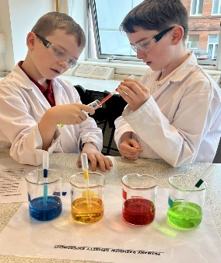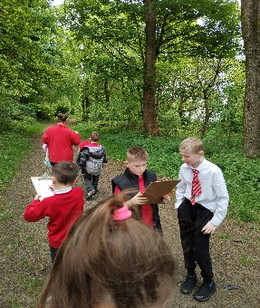

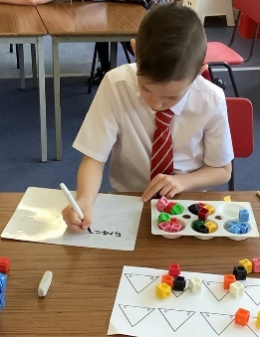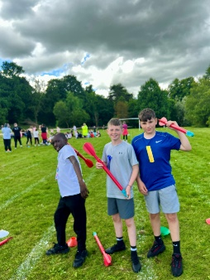

OUR VISION, VALUES AND AIMS


SUCCESSES AND ACHIEVEMENTS

- This session we have focused on literacy and numeracy with a focus on raising attainment. We deliver literacy and numeracy using consistent evidence-based approaches across the school positively impacting attainment.

- The Talk For Writing approach is embedded across the school and was successfully implemented into the ELCC this year. Using the Talk For Writing approach has led to increased engagement and improved use of more complex language and features of writing.

- Health and Wellbeing is the foundation of everything we do here at Auchenlodment. Renfrewshire’s Nurturing Relationships Approach is embedded across the school and ELCC. In June 2024 we were awarded the Ruby Award recognising we have a nurturing ethos and there has been an increase in engagement with the nurturing approach with the majority of CYP and families and across the wider community.

- We successfully developed the Science Technology Engineering and Maths skills of children and staff through commitment to the SSERC Primary Cluster programme in STEM. This programme supported staff in enhancing their confidence and expertise in delivering excellence in practical STEM learning activities to all learners across the school. Parental understanding of the positive impact of STEM was shared with parents at our Open Afternoon in February 2024.

- Active Schools Clubs continued to show a high level of engagement with increased participation across the school.

- Our newly formed Parent Council organised and ran our first ever Summer Fayre after school, an event which was a positive benefit for both the school community and wider community.

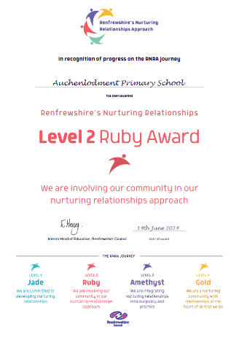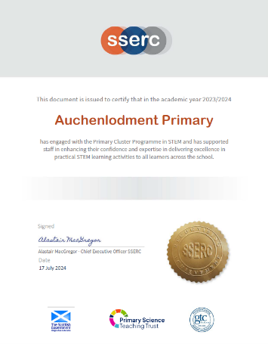

HOW SUCCESSFUL HAVE WE BEEN IN IMPROVING OUR SCHOOL?

School Leadership

- Our whole school and ELCC community demonstrate leadership to drive forward improvement and create a positive learning community centred around our school values of Successful, Positive, Active, Respect and Kindness.

- All pupils are members of Pupil Leadership Groups (Citizenship Groups) leading improvements in the school and ensuring pupil voice is integral to school improvement.

- Primary 7 pupils take on leadership roles within the school supporting other pupils through the House structure. Primary 7 pupils lead weekly assemblies and plan and lead termly house events to fundraise for charities or school funds.

- Weekly assemblies celebrate children’s wider achievements and Red Carpet Assemblies celebrate children displaying our school values.

- All teaching staff contributed to the leadership of curriculum development through working parties. This year each working party reviewed and developed curriculum pathways to support learning and teaching.

- Distributed leadership is a strength in Auchenlodment Primary and ELCC. Almost all staff have taken on leadership roles within the school and ELCC linked to their skills, interests, and priorities within our School Improvement Plan. Our Talk For Writing Project Lead attended sessions to support staff to drive forward the Talk For Writing approach.

- Our RNRA lead worked in partnership with the Head Teacher and Educational Psychologist to further embed the nurturing approach across the school and ELCC. They led regular Core Group meetings, provided updates and reviews at staff meetings and worked with pupil focus groups to drive forward improvement. In June 2024 our improvement was recognised with our Ruby Award accreditation.

- Our STEM lead collaborated with Cluster STEM mentors to ensure the development of STEM skills across the staff and pupils. Our STEM lead attended SSERC conferences and meets, using this knowledge to support staff culminating in leading STEM professional development workshops to support staff across the Johnstone Cluster.

- Our Senior Leadership team have continued to develop their leadership skills to better support pupils, families and drive forward improvement. The SLT have secured their substantive posts and have continued to develop professionally ensuring they lead the school and ELCC with knowledge, skill, and enthusiasm.

Staff Professionalism

- All staff engage in professional learning and dialogue to ensure they can support the needs of all children and families. All staff receive annual PRDs identifying individual professional learning requirements and self-evaluation identifies training needs of the staff team.

- All staff undertook Renfrewshire’s Nurturing Relationships Approach training with our Educational Psychologist on our new nurture principle ‘All learning is understood developmentally’. From there we identified CIRCLE training to support the inclusion of all learners within the school and ELCC environment.

- All teaching staff participated in Talk For Writing moderation with a partner school. Collaboration, peer visits and subsequent professional dialogue resulted in improved staff confidence in the delivery of the Talk For Writing approach.

- Project leads in numeracy, literacy and RNRA have attended professional development workshops in Talk For Writing, Maths Recovery and RNRA, ensuring they have the skillset to lead in their areas.

- One ELCO received a qualification in Froebel in Childhood Practice through Edinburgh University. This has positively impacted the play experience in our ELCC.

- Our PT, Mrs Niven, attended the Aspiring DHT course; our DHT, Mrs Scott participated in DHT learning sets and led coaching sessions for Aspiring Deputes; and Ms Newlove, HT, continued her Into Headship qualification through Strathclyde University. These professional learning opportunities have equipped our Senior Leadership Team with the skills to support our school and ELCC community and drive forward improvement.

Parental Engagement

- Use of an online parental survey self-evaluation ensures all parents have the opportunity to feedback on their child’s learning experience and provide feedback on how the school and ELCC can improve. Parents also had the chance to provide paper feedback at our Open Afternoon. Responses were collated and used to inform planning for 24-25.

- Learning progress was provided at two How Good Is My Learning target sessions and at our Parents Evening. Children, teachers and parents discussed learning targets and how to achieve the targets. Written reports on each child’s learning identified progress and how to support the next steps in their learning.

- A Meet the Teacher session in September provided parents and teachers with the early opportunity to establish positive relationships to best support each child.

- Digital communication is used regularly in the school and ELCC; SEESAW, Sway newsletters, Twitter and text to engage all families. Our regular Sway newsletters are sent out to the school and ELCC and views range between 223 and 580 views. Group Call was implemented and has received a positive response from parents.

- Regular ELCC Bookbug sessions lead by ELCOs involving the children and the parents. Feedback was extremely positive and there has been an increased engagement in reading with families identifying the importance of reading to and with their child.

- Our P1 Transition programme which included an early visit in January, and afternoon in May and two afternoons in June as well as a SEESAW group and text letters ensured parents and children felt comfortable about moving on to school.

- Parents and Family members were welcomed to school events throughout the year including the Nativity, Christmas Fayre, P7 Burns Supper, our Open Afternoon, Sports Day, ELCC Fun Day and our newly introduced Summer Fayre. This builds a positive, open ethos in the school and gives an opportunity for staff, pupils, and family members to mix and build positive relationships in a more informal setting.

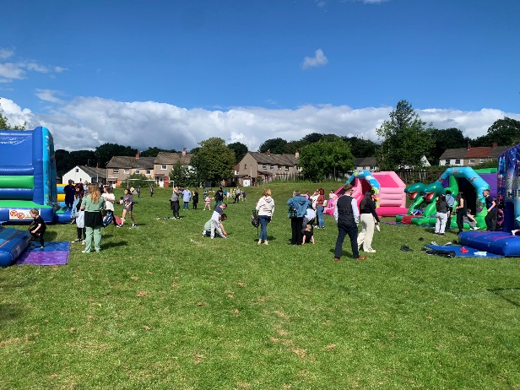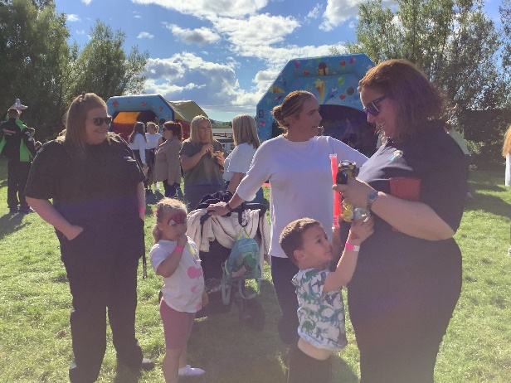

Performance Information and Assessment of Children’s Progress

Pupil attainment is a key focus at Auchenlodment. Self-evaluation currently has our attainment as good with identified areas for improvement.

Data displaying children on track (June 2024)

 | P1 | P2 | P3 | P4 | P5 | P6 | P7
L&T | 88% | 91% | 100% | 85% | 72% | 96% | 88%
Reading | 71% | 71% | 82% | 82% | 89% | 85% | 94%
Writing | 71% | 65% | 82% | 71% | 78% | 70% | 72%
Numeracy | 88% | 74% | 86% | 74% | 78% | 81% | 81%

- Our Achievement of Curriculum Excellence Level data which focuses on P1, P4 and P7 shows the following positive trends:
Listening and Talking attainment has improved by 6% in P1 and remained the same in P7.
Reading attainment has increased by 4% in P4 and remained the same in P7.
Writing attainment remained the same in P4 and P7.
Numeracy attainment has increased in P7 by 3% and remained the same in P1.

- Attainment meetings are held termly with teaching staff to discuss the attainment progress of all pupils in literacy and numeracy. We identify children who require support and track interventions. Staff analyse data and identify trends in attainment to identify improvement areas.

- GIRFEC meetings are held with staff to identify specific learner needs and identify support and interventions. Support staff feedback on interventions to inform Pupil Support planning.

- An agreed Assessment Calendar provides a consistent approach across the school and ELCC. Scottish National Standardised Assessments (SNSA) are used diagnostically in P1, P4 and P7 to identify areas requiring support and challenge for both individual children and as a school. We use the New Group Reading Test (NGRT) yearly to identify children who require support and challenge. These assessments help staff plan to meet the needs of the learners as well support their professional judgement.

- The Health and Wellbeing of all children is tracked using the Glasgow Wellbeing Profile survey, completed twice a year. All teachers speak with pupils regarding their profiles and help to set targets and interventions.

- The Early Years Progression Toolkit is used by ELCC staff to track the progress of children and identify where support is required.

- Attendance has increased from 91% in 22-23 to 92.2% in 23-24.

School Improvement

- School and ELCC improvement information is collected using the How Good Is Our School 4 and How Good Is Our Early Learning and Childcare Framework. All stakeholders are involved in the improvement cycle through questionnaires, surveys, focus groups, feedback, and self-evaluation activities.

- Analysis of all feedback informs our School Improvement Planning. Our School Improvement Plan is shared with all stakeholders through our newsletter and on our school website.

- In session 23-24 we prioritised raising attainment in writing and embedded the Talk For Writing approach. The Talk For Writing approach was introduced into the ELCC and we will continue to develop the Talk For Writing approach across the school and embed the approach into our ELCC to ensure a consistent and robust approach.

- Running alongside the whole school approach were targeted interventions in writing. Interventions and targeted support focusing on spelling, punctuation and grammar were provided.

- As a school and ELCC we prioritised raising attainment in numeracy. The new Renfrewshire numeracy plans have been embedded across the school and confidently and consistently use them when planning. Staff use SEAL, Number Talks and CPA approaches to learning and teaching.

- Staff regularly review each priority and impact it’s having on learner engagement, attainment and subsequently improvement.

PUPIL EQUITY FUNDING

- This year we received £56,350 Pupil Equity Funding to raise attainment and close the poverty related attainment gap for targeted pupils. Our strategy for closing the poverty related attainment gap in literacy and numeracy focused on:
- Providing extra staffing provision in Primary 1 to provide support to pupils to develop their foundation skills in literacy and numeracy.
- Improving the quality of learning and teaching in writing through teacher professional development and moderation.
- Providing targeted interventions in literacy and numeracy.

- Stakeholder consultation on PEF highlighted the need to focus on providing attainment support through staff provision. In 23-24 we employed 1 full time ELCO to provide attainment support in Primary 1. To target writing attainment, we employed a 0.4 teacher focusing on improving tools for writing. We employed one ASNA to provide targeted interventions in literacy and numeracy.

- We employed a Breakfast Supervisory Assistant to run a daily Breakfast Club ensuring all children can be supported nutritionally and be socially and emotionally ready for school. Moreover, the aims of the Breakfast Club were to support attendance and provide a supportive transition from home to school.

- Through robust and regular tracking meetings we were able to identify children requiring targeted support and adapt this support throughout the year. PEF staff met with SMT to regularly track the progress of the targeted children. Professional dialogue and assessments provided feedback and informed planning for next steps for targeted children.

Impact of PEF

- Primary 1 data shows there has been a positive impact on attainment. We have successfully closed the gap in reading and writing. Self-evaluation shows that children were supported in their readiness to learn, and a positive and inclusive learning environment was successfully developed in Primary 1.

- Attainment data shows that we have closed the attainment gap across the school. In analysing the P1, P4 and P7 data the biggest gain has been in Primary 4 where we have significantly closed the poverty related attainment gap in writing. There is no longer a gap between the most disadvantaged and least disadvantaged.

- Self-evaluation from staff and pupils identifies the Talk For Writing approach as increasing children’s vocabulary, use of language and ability to write in different genres. Increased teacher professionalism and targeted writing interventions have positively impacted on writing attainment across all stages in the school.

- Targeted interventions in literacy and numeracy were provided by an ASNA and 0.4 teacher in P2, P3 and P4. In P4 this resulted in a closing of the poverty related attainment gap in both writing and numeracy. In numeracy the gap was closed by 6% and in writing the gap was closed.

- Breakfast Club has positively impacted the start of the day for the children attending. Feedback stated they liked talking to their friends over breakfast and liked talking to their friends. Attendance has increased from 91% in 22-23 to 92.2% in 23-24.

KEY STRENGTHS OF THE SCHOOL

- Positive, happy, and engaged children who demonstrate the chosen values of Auchenlodment Primary. They can confidently talk about their learning, are motivated by regular pupil voice and leadership opportunities and are very proud of their school and Early Learning and Childcare class.
- A nurturing, enthusiastic staff team with a strong focus nurture, inclusion and promoting wellbeing for all children. Staff provide children with opportunities to improve their wellbeing, celebrate their successes, increase participation and contribute to improving the work of the school and Early Learning and Childcare class.
- Staff have a very good knowledge of the children, their families and unique circumstances through robust tracking and monitoring meetings. This ensures the needs of our children are being met.
- Across the establishment, all staff work very well together as a team. They engage enthusiastically in professional learning and reflect effectively on their practice. This is driving forward improvement and securing positive outcomes for children.
- Strong partnerships between with parents/carers and partners to support the needs of the children in our school and ELCC.
- An effective transition programme resulting in smooth transitions from our ELCC and other ELCCs across Renfrewshire into our Primary 1 class.
- High quality events such as the P7 Burns Supper, ELCC Fun Day and Summer Fayre resulting a meaningful, memorable experiences which the children and families value.

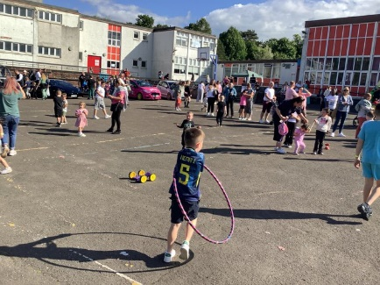

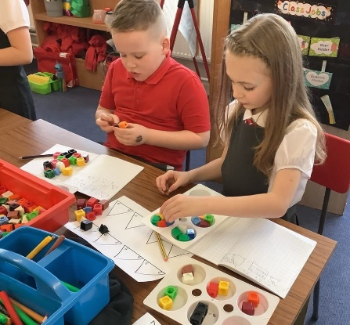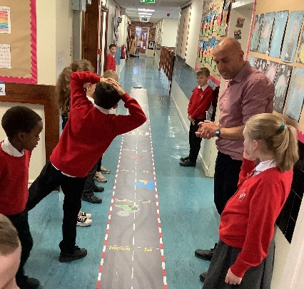

OUR NEXT STEPS – PRIORITIES FOR 2024-25

Through self-evaluation from pupils, parents and staff, and through triangulation of data, we have identified the following next steps:

- Continue to develop and moderate our Talk For Writing approach across the school and ELCC to raise attainment in writing.

- Continue to develop and build upon our use of Number Talks and SEAL in numeracy to raise attainment in numeracy. A focus on teacher professional development and coaching and modelling of quality learning and teaching will support this.

- Continue our Renfrewshire’s Nurturing Relationships Approach journey, with a focus on the nurture principle, children’s learning is understood developmentally.

- Begin implementing the CIRCLE and UP, UP and AWAY approaches in our school and ELCC to improve the physical and social and emotional environment to best support our learners.

We have made good progress during session 2023-24 and we will use the improvement priorities listed below to build on this progress moving forward.

Priority 1: To raise attainment in literacy with a priority focus on writing.
- To further develop Talk For Writing approaches across the school through professional development and moderation and begin to embed this approach in the ELCC.
- To provide targeted support for children who are not on track.
- To provide enhanced support in Primary 1.

Priority 2: To raise attainment in numeracy.
- To use our SEAL, Number Talks, CPA and Maths Recovery approaches across the school and ELCC to raise attainment for all.
- To provide targeted support for children who are not on track.

Priority 3: Improvement in children’s health and wellbeing
- To continue our RNRA approach in the ELCC and school
- To implement the CIRCLE approach to develop the physical and social environment.

Full details of the school’s improvement priorities and actions are detailed on the school improvement plan which can be accessed on our website or by contacting the school office.

Auchenlodment Primary and ELCC  Aspen Place  Johnstone  PA5 9QQ  0300 300 0145  auchenlodmentenquiries@renfrewshire.gov.uk  https://blogs.glowscotland.org.uk/re/auchenlodment  Twitter @AuchenlodmentPS | HAVE YOUR SAY!  Please take the opportunity to share your thoughts with us as we use feedback to help us make improvements to the school. You can do this by speaking to staff, participating in Parent Council meetings, responding to questionnaires/surveys and by completing evaluations at school events.

