adge/photo

Auchenlodment Primary School and Early Learning & Childcare Class (ELCC)

STANDARDS AND QUALITY REPORT
June 2023

This report will inform you of the school’s progress and achievements in the last session and let you know about our plans for 2023-2024. I hope that you find it helpful and informative.

Denise Newlove

Head Teacher

OUR SCHOOL

Auchenlodment Primary School and ELCC is located within the community of Johnstone Castle. The community has undergone a period of regeneration, with the building of 100 new family homes completed, and new families moving in at the end of 21-22.
Auchenlodment Primary is a non-denominational school with a role of 195 pupils which currently comprises of 8 classes. Our ELCC role is currently at 54 pupils with 8 children in the 2-year-old room and 46 in the 3-5 year-old room. The majority of these nursery children move into Auchenlodment Primary making transition a smooth and effective process for children and families. The majority of P7 leavers move onto Johnstone High School which provides a strong transition programme.
Our committed staff team provide a quality education ensuring they meet the needs of our learners. Our Senior Leadership Team comprises a Head Teacher, Depute Head Teacher, and Principal Teacher. We have 10 teaching staff and 5 Support Staff. In the ELCC we have one Senior (SELCO), an Early Years graduate, 11 ELCOs and 3 Support Staff.
Business Support and Soft Facilities Management staff provide support for both the school and ELCC.
Auchenlodment has strong links with the community, and we will continue to build on this in session 2023-24. The school and ELCC are very proud of their achievements and their excellent reputation they hold. The whole school community strive to be Successful, Positive, Active, Respectful and Kind – our school values. Children ‘caught’ displaying our School Values are celebrated at our termly Red Carpet Values Assemblies.

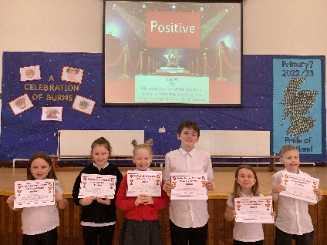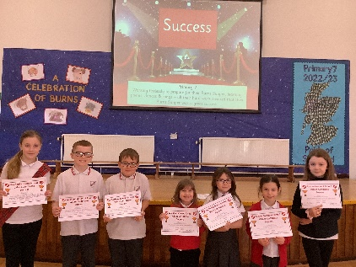

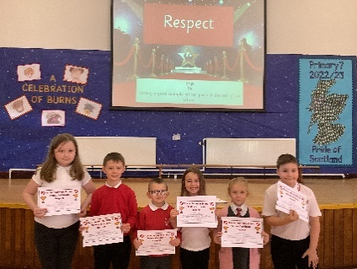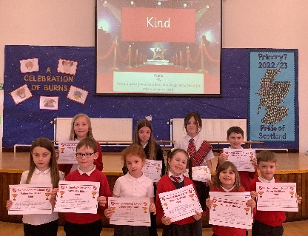

OUR VISION, VALUES AND AIMS

SUCCESSES AND ACHIEVEMENTS

This session we were supported in our development and growth through a very positive Education Scotland Inspection report which clearly highlighted our key strengths and next steps. Successes and Achievements were identified throughout the report.

The Inspection team focused on four quality indicators and provided the following evaluations:

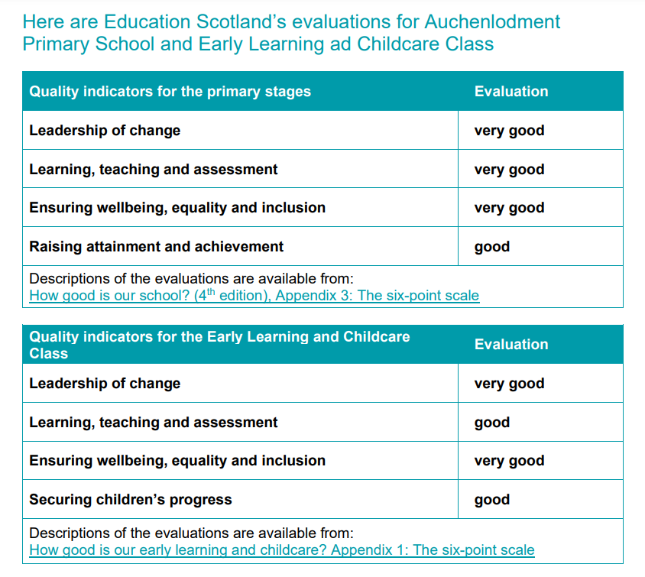

Further successes and highlights this session have been:

- We were awarded the Cycle Friendly Award for providing a comprehensive Bikeability programme and active travel programme.

- Our Outdoor Citizenship Group was awarded a Natural Health Award for their partnership work with the Forestry Commission.

- Active Schools participation was again, very good. Our Primary 7 netball team competed in the Renfrewshire Netball Finals Day. We entered teams into the football, basketball, netball and dodgeball leagues and road race and cross-country competitions.

- Our Reading Schools group created a successful partnership with Renfrewshire Libraries Skoobmobile which supported families every Monday after school to engage and support our learners and their family in reading.

- Primary 1 ran successful and engaging Family Learning sessions including Campfire and Bedtime reading sessions. Feedback from parents and children was excellent.

- Our ELCC continued its excellent partnership with Dolly Parton’s Imagination Library with children receiving a free book each month to build up their own personal library. This enthusiasm for reading and books was further developed by ELCC staff and parents at the Bookbug sessions.

- Primary 6 won the Cluster STEM competition

- Primary 6 finished 4th in Renfrewshire’s Euro Quiz

- Primary 4/3 finished in the top 10 of the Renfrewshire Sumdog competition

- Our Health Week created a huge parental and partnership engagement, and we will look to build on this in session 23-24.

- Our ELCC Fun Day had very good parental engagement and provided a positive community event which received excellent feedback

- An active Parent Council which not only raised money for the school and ELCC but also provided robust support throughout the year, regularly communicating with the parent body.

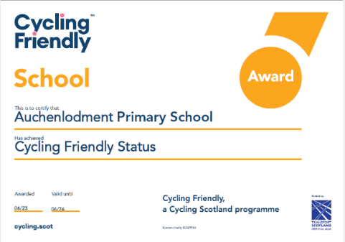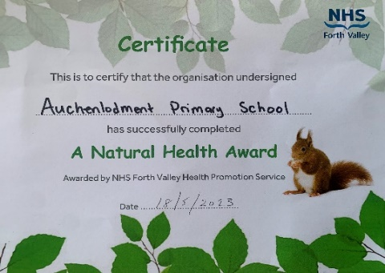

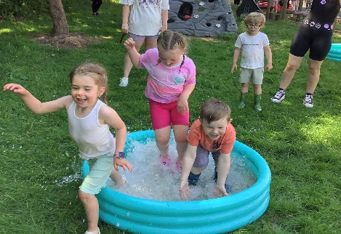

HOW SUCCESSFUL HAVE WE BEEN IN IMPROVING OUR SCHOOL?

School Improvement

School Improvement Plan 22-23 Priority 1: Promote the positive mental health and wellbeing of children and young people

This priority was evaluated in our inspection. Education Scotland evaluated Quality Indicator 3.1 Ensuring wellbeing, equality and inclusion as very good in both the school and ELCC. The evidence gathered in their evaluation stated that;

- The whole school community has a well-developed approach to nurture and improving children’s wellbeing. Senior leaders, supported by staff and partners, have prioritised physical and mental wellbeing of all children in the school. As a result, almost all children feel well supported, safe and included in school.
- Wellbeing sits at the heart of school and class activity. Across the school, all staff are aware of their roles and responsibilities in relation to Getting it right for every child (GIRFEC).
- School staff work well with external partners to enhance wellbeing and the health and wellbeing curriculum.

Evidence gathered from Education Scotland and self-evaluation shows that we have successfully improved and promoted the positive mental health and wellbeing of children and young people. Our Renfrewshire’s Nurturing Relationships Approach is embedded across the school and is identified as a strength. Our partnerships with supporting agencies have successfully supported the positive mental health and wellbeing of children. We will continue to ensure this continues into the following session.
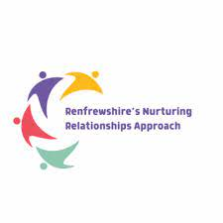
School Improvement Plan 22-23 Priority 2: Develop high quality learning and teaching to raise attainment in numeracy

- In 22-23 we were successful in developing high quality learning and teaching in numeracy.
This is evidenced in our inspection report which stated our ELCC ‘Practitioners attune well to children and are able to sensitively step in with well-judged and skilful interactions. They use mathematical language and interesting vocabulary when talking to children which helps to support learning and extend children’s thinking.’ In our school it was evidenced that ‘Overall, high quality teaching is provided across the school. Teachers plan learning activities well to ensure that children engage confidently with learning. Most children benefit from appropriate and challenging learning experiences, designed to motivate them.’
- In analysing our attainment from 22-23 we met our targets in P1 and P2 and these two groups were specifically targeted in our School Improvement Plan. The use of Maths Recovery, an ASNA to provide SEAL support and Family Learning all helped to raise attainment.
- Our target was also met in Primary 6 with 84% of children on track. This group was specifically supported by our Raising Attainment teacher who used Maths Recovery and SEAL approaches to raise attainment.
- In Primary 5 we met our minimum target but not our maximum target with 69% of children on track. This group were supported by our PEF funded teacher to raise attainment.
- In 23-24 we will continue to push to raise attainment in numeracy. Using the data, we have identified that we will specifically target P1, P4, P5 and P6. In P1 our ELCO (PEF) and ASNA (PEF) will deliver approaches and support children to raise attainment.

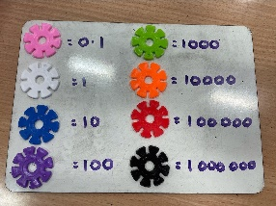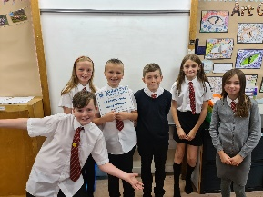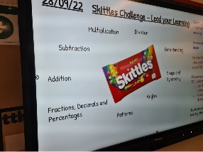

School Improvement Plan 22-23 Priority 3: Raise attainment in literacy with a priority focus on writing

In 22-23 our inspection report clearly evidenced that writing was a focus by stating ‘Writing is a whole school priority area for improvement. Staff are applying professional learning to improve the teaching of writing. Whilst early in implementation, across all stages children’s progress is showing positive signs of improvement. Most children are widening their range of vocabulary, extending the amount they write and retelling stories with increasing confidence.’ In the ELCC ‘Practitioners have a good understanding of how children learn and develop. They plan responsively and follow-up on and extend children’s interests.’

- In analysing our data from 22-23 we met our writing targets in P1 and P2. Staff were extremely committed to the professional learning and have embedded the Talk For Writing approach which is increasing the vocabulary and extending the amount our learners write. The use of an ASNA (PEF) to provide support and Family Learning all contributed to raising attainment.
- In our School Improvement Plan we had also targeted our P5 and P6 writing attainment. In Primary 5 we achieved our target with 69% of children on track. A PEF teacher provided targeted support in writing specifically focusing on the tools for writing while the class teacher implemented the Talk For Writing approach.
- In Primary 6 we did not quite achieve our target with 59% of children on track. This was partly due to the change in composition of the class and due to the need to increase the tools for writing skills of our P6 learners. Spelling, punctuation and grammar will be a key focus for this group in 23-24.
- In session 23-24 we will continue to prioritise raising attainment in writing. We will continue to embed the Talk For Writing approach across the school and introduce it to the ELCC to ensure a consistent and robust approach. Running alongside the whole school approach will be a focus on supporting targeted children with their tools for writing. Interventions and targeted support around spelling, punctuation and grammar will be provided.

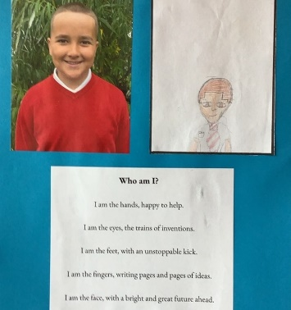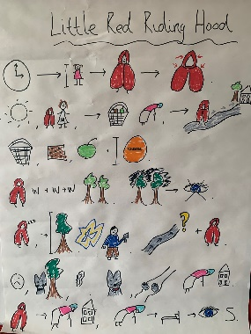

Performance Information and Assessment of Children’s Progress

Pupil attainment is a key focus at Auchenlodment. Education Scotland evaluated our attainment as good in October 2022.
Attainment in reading is very good across the school. Attainment in writing and numeracy is good. Our data below shows that attainment in numeracy and writing will be a key priority for us in 23-24.

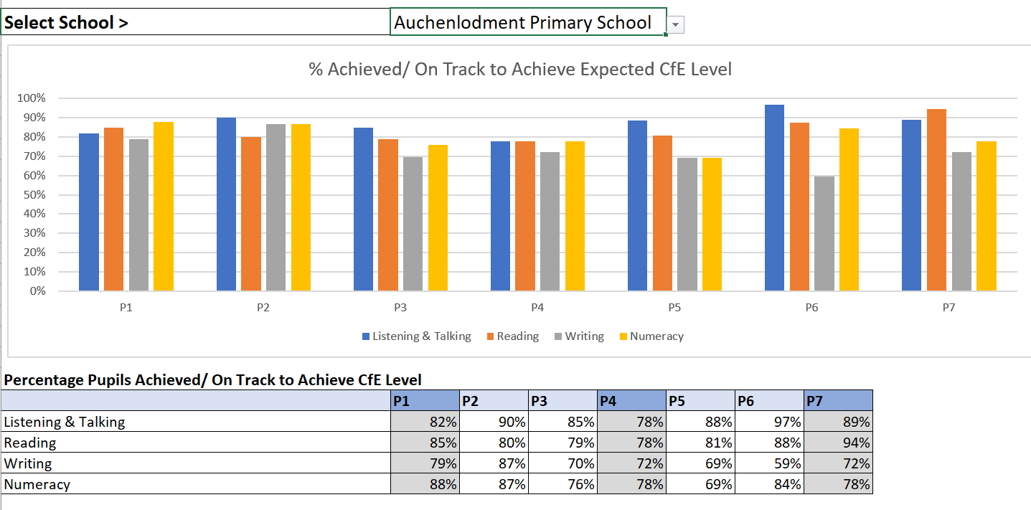

This year we set targets in or stretch aims in October 2022. All stages met their targets in listening and talking and in reading. In writing P1, P2, P5 and P7 met their targets. In numeracy P1, P2, P5, P6 and P7 met their targets.

Our ACEL data in P1, P4 and P7 showed improvement with over a 10% increase in Primary 1 attainment in reading, writing and numeracy.

At Auchenlodment we have an assessment procedure to ensure we are able to identify children’s progress and the children who require further support.

- Each term SMT meet with teaching staff to discuss the progress of every individual pupil in their class. We identify children who need support and children who need challenge. We use this information to timetable in support and challenge using resources and staff.

- We have a strong focus on Health and Wellbeing and therefore hold termly GIRFEC meetings with all class teachers to identify specific learner needs, attainment gaps and evaluate interventions. We use the information from these termly meetings to plan for all our learners. This information informs Support Staff timetables with specific interventions and impacts the Support Plans for identified children.

- At Auchenlodment we use a range of assessments to help build a picture of each child’s progress. We have an agreed Assessment Calendar so there is a consistent approach across the school and ELCC.

- We use standardised assessments including the Scottish National Standardised Assessments (SNSA) in P1, P4 and P7. We use these assessments diagnostically to identify areas requiring support and challenge for both individual children and as a school. We use the New Group Reading Test (NGRT) yearly to identify children who require support and challenge. These assessments help staff plan to meet the needs of the learners as well support their professional judgement.

- As a staff team we planned sessions throughout the year to analyse the data around attainment and progress. Staff have also attended courses on analysing data to improve their knowledge. At our staff sessions we identified trends in our Achievement of Curriculum for Excellence Level to inform strategic planning in order to best meet the needs of our learners.

School Leadership

Our HMIE inspection report highlighted the following strength in school leadership. ‘Leadership at all levels is a very strong feature of the school’s work. All staff contribute and feel empowered to lead school improvements, for example by developing themes such as science, technology, engineering and mathematics (STEM), curricular areas, or play pedagogy.’

- Distributed leadership is a strength in Auchenlodment Primary and ELCC. All staff have taken on leadership roles within the school and ELCC linked to their skills, interests and priorities within our School Improvement Plan.

- Our Talk For Writing Project Leads attended training sessions to ensure the Talk For Writing approach is embedded. They have created the reading spine boxes and are facilitating the development of resources.

- Our Literacy Champion and Numeracy Champion attended meetings to support the development of learning and teaching in literacy and numeracy to positively impact attainment.

- Our Digital Champions in the school and nursery have attended meetings to ensure we are up to date with the latest developments. They take the lead in supporting staff and pupils in building digital literacy.

- Our Reading Schools pupil group established a successful partnership with Renfrewshire Libraries Skoobmobile with weekly access to the library in our playground ensuring families were supported with reading.

- Pupils lead relevant Citizenship Groups where they actively contribute to the life of the school and community. They make decisions and affect change which positively impacts their school experience.

- Depute Head, Tracy Scott, completed her Coaching For Success modules which have given her specific skills to support staff and coach them through any issues arising.

- Head Teacher, Denise Newlove, is in the process of completing her Into Headship qualification through Strathclyde University. This will enable her to develop and reflect upon her strategic leadership and management skills.

Teacher Professionalism

- All teaching staff have undertaken Talk For Writing training ensuring a consistent and progressive approach to writing to ensure we raise attainment. Education Scotland stated ‘Staff are applying professional learning to improve the teaching of writing. Whilst early in implementation, across all stages children’s progress is showing positive signs of improvement.’

- All staff undertook Renfrewshire’s Nurturing Relationships Approach training with our Educational Psychologist. All staff identified strategies and resources to support the mental wellbeing of children and families.

- Teaching staff have attended STEM training resulting in rich learning experiences for our learners.

- Three teaching staff attended PE training to increase their skill and confidence in delivering PE.

- Three teaching staff attended the Nicola Benedetti Foundation music CLPL to develop their skill and confidence in delivering music.

- One ELCO received a qualification in Froebel in Childhood Practice through Edinburgh University. This has positively impacted the play experience in our ELCC.

Parental Engagement

- Enhanced use of digital communication in the school and ELCC using SEESAW, Sway newsletters, Twitter and text to engage all families.

- Renfrewshire Libraries Skoobmobile in the school playground every Monday after school ensuring regular and easy access to reading books for school and ELCC families. Reading had a high profile and families were supported with reading.

- Primary 1 Bedtime Reading and Campfire involved Primary 1 family members in their learning.

- Regular ELCC Bookbug sessions lead by ELCOs involving the children and the parents. Feedback was extremely positive and there has been an increased engagement in reading with families identifying the importance of reading to and with their child.

- Meet the Teacher evenings gave all parents the opportunity to chat to their child’s teacher. How Good Is My Learning parent, teacher and child meetings give learners the opportunity to discuss their targets and the strategies that can be used to meet them. Written reports on each child’s learning identified progress and how parents could support the next steps in their learning.

- P1 Transition programme which included an early visit in January, and afternoon in May and two afternoons in June as well as a SEESAW group and text letters ensured parents and children felt comfortable about moving on.

- Parents and Family members were welcomed to school events throughout the year including the Nativity, Christmas Fayre, P7 Burns Supper, Sports Day, ELCC Fun Day and our Open Afternoon. This builds a positive, open ethos in the school and gives an opportunity for staff, pupils and family members to mix and build positive relationships in a fun setting.

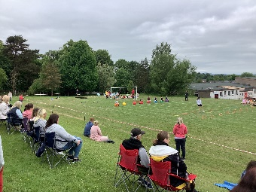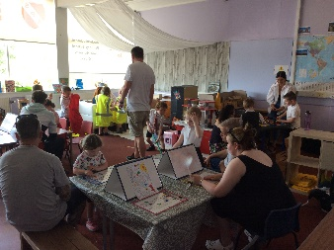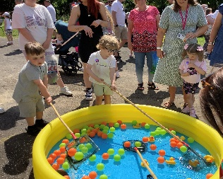

PUPIL EQUITY FUNDING

- This year we received £56,350 Pupil Equity Funding to raise attainment and close the poverty related attainment gap for targeted pupils. The majority of our children are in SIMD 1-3 and therefore we target pupils who are not on track. Our stakeholders feel strongly that we should use PEF to employ additional staffing to be able to deliver additional support to targeted pupils.

- In 22-23 we employed an additional 0.2 teacher to give targeted support in literacy and numeracy in P5 and P6. We employed two PEF ASNAs who provided targeted support in Primary 1. We also employed one PEF Classroom Assistant who provided literacy and numeracy support in P3 and P4/3.

- Data below shows that we met all of the minimum targets set in Primary 1 and Primary 2 and almost all of the maximum targets set. There has been over a 10% increase in attainment in reading, writing and numeracy in Primary 1. In Primary 3 and Primary 4 targets were met in reading. Continued support in numeracy and writing is required. In Primary 5 we met all of our minimum targets and in Primary 6 we met all of our minimum targets apart from writing. Feedback stated more intensive focus on the tools for writing is required.

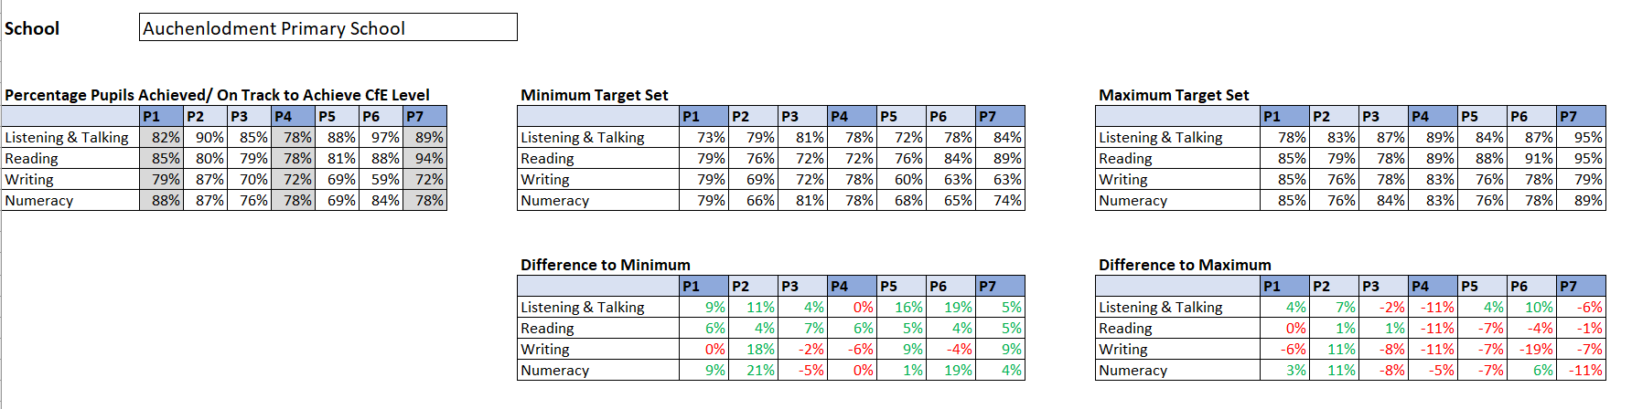

- Education Scotland and our own self-evaluation has helped us create our plan for spending our future allocation of PEF.
- Our Education Scotland inspection report stated that our attainment was good. Our aim is to move this to very good by getting most children on track. The report identified a key priority which was to ‘Continue to embed approaches which support raising attainment in writing and numeracy.’
- Our self-evaluation activities including pupils focus groups, parental surveys and staff evaluations- all highlight the need to focus on raising attainment in numeracy and writing.
- Parents, staff and pupils were all consulted in decision making around PEF. The feedback was analysed and discussed further with staff, the Parent Council and pupil focus groups. Feedback highlighted how much value all stakeholders place on extra staffing able to provide targeted support to our learners.
- PEF funding allowed us to employ additional staffing to provide targeted support identified in our School Improvement Plan. Targeted SEAL and Maths Recovery targeted support was delivered by an ASNA (PEF), Classroom Assistant (PEF) and Teacher (PEF). Writing support was provided by ASNA (PEF), Classroom Assistant (PEF) and Teacher (PEF). The writing interventions were focused on the tools for writing.
- PEF staff met with SMT to regularly track the progress of the targeted children. Professional dialogue and assessments provided feedback and informed planning for next steps for the targeted children. Data for interventions was tracked throughout the year and demonstrated that all interventions have had an impact on most pupils.
- Data analysis has been embedded across the school and this has empowered staff to be able to identify targeted pupils and trends in attainment so we can identify where to close the poverty attainment gap. Targeted interventions and subsequent training are shared with staff ensuring all staff can deliver these interventions creating a more sustainable culture moving forward.
- Evidence based success gives staff the confidence and drive to continue to deliver these interventions knowing what they are doing is closing the poverty related attainment gap.
- Throughout the year we have tracked the attainment of care experienced children to ensure they have access to activities that might be required to close the educational attainment gap. We will continue to track their attainment progress and provide resources to ensure their success.

KEY STRENGTHS OF THE SCHOOL

The Education Scotland HMIE inspection report identified the following key strengths of our school and ELCC.

- Enthusiastic, confident and engaged children who demonstrate daily the chosen values of Auchenlodment Primary. They are highly motivated by meaningful leadership opportunities and are very proud of their school and Early Learning and Childcare class.
- The strong, effective leadership of the headteacher and depute headteacher. They are deeply committed to supporting children and staff to lead change which is continuing to improve outcomes for all learners.
- A committed staff team with a strong focus on nurture, inclusion and promoting wellbeing for all children. Staff provide children with opportunities to improve their wellbeing, celebrate their successes, increase participation and contribute to improving the work of the school and Early Learning and Childcare class.
- Across the establishment, all staff work very well together as a team. They engage enthusiastically in professional learning and reflect effectively on their practice. This is driving forward improvement and securing positive outcomes for children.

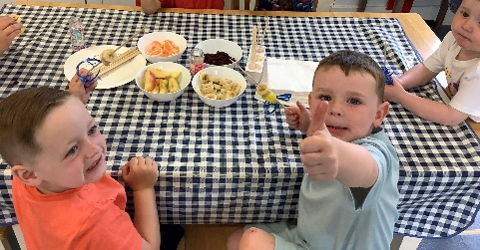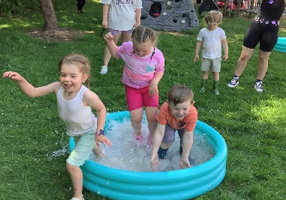

The Summarised Inspection Findings of the School detailed further strengths.

- Leadership at all levels is a very strong feature of the school’s work. All staff contribute and feel empowered to lead school improvements, for example by developing themes such as science, technology, engineering and mathematics (STEM), curricular areas, or play pedagogy.
- Overall, high quality teaching is provided across the school. Almost all staff use skills developed from professional learning to improve continually children’s learning experiences. Staff regularly share ideas and effective practice that ensures a consistent approach to teaching and learning across all stages.
- Classroom assistants and additional support needs assistants use their skills and training very well to support targeted children effectively.
- All teachers regularly involve children well in planning processes where they identify what and how they would like to learn. All children are setting targets for their learning across a range of curricular areas. They benefit from conversations with teachers to set and evaluate their individual targets in literacy and numeracy. This is empowering children to understand their progress and to lead their own learning.
- The whole school community has a well-developed approach to nurture and improving children’s wellbeing.
- Children speak positively about staff and how they provide helpful guidance and support. Staff promote very well children’s rights and explore responsibilities. This is exemplified in the wide range of meaningful pupil leadership groups in which children are involved. Children are proud of their contribution to these groups.
- School staff work well with external partners to enhance wellbeing and the health and wellbeing curriculum.
- Participation in sport is an important focus for children and staff at Auchenlodment Primary School. Children are encouraged and supported to participate in a range of sporting opportunities.

The Education Scotland inspection team identified further strengths of the ELCC in their report. These included the following:

- Practitioners in the ELCC class have worked very well together to create a meaningful vision, values and aims. Staff involve children and parents fully in this process. As a result, everyone understands well the vision, values and aims and these underpin all areas of the nursery’s work.
- All practitioners are involved in planning for improvement. They have high expectations and take part in regular professional development. This is impacting very positively on the setting and practitioners are keen to share their learning.
- There is a very inclusive ethos in the setting and practitioners work well together to support the individual needs of all children.
- The room for two-year-olds is well organised and children have access to a wide variety of resources that enable them to develop their interests and skills.
- In the three to five room, children are able to choose from a variety of areas and resources, including a home corner, block play and sensory area. Practitioners have set up the pattern of the day to enable children to make choices, including when to play outside and when to have snack.
- Practitioners have a good understanding of how children learn and develop. They plan responsively and follow-up on and extend children’s interests
- Practitioners develop very strong, caring relationships with all children and families. They are very nurturing and show a high level of care for individual children. This is a strength in the setting.

OUR NEXT STEPS – PRIORITIES FOR 2023-24

In October 2022 we received feedback from Education Scotland on our next steps and this was published in December 2022. Through the inspection process Education Scotland identified the following areas of improvement:

- Continue to embed approaches which support raising attainment in writing and numeracy.

- Continue to develop learning pathways to support children to build their skills across the curriculum.

- Practitioners should explore how they can develop the playroom further to provide children with access to spaces and resources to help them lead their own learning.

In session 23-24 we are going to focus on the first area of improvement identified which is to embed approaches which support raising attainment in writing and numeracy. The second and third areas for improvement will also be actioned as these will positively impact attainment.

We have made good progress during session 2022-23 and we will use the improvement priorities listed below to build on this progress moving forward.

Priority 1: To raise attainment in literacy with a priority focus on writing.

- To further embed Talk For Writing approaches across the school and begin to embed this approach in the ELCC.
- To provide targeted support for children who are not on track.
- To increase parental engagement through Family Learning sessions with the focus on supporting their child in literacy.

Priority 2: To raise attainment in numeracy.

- To further embed SEAL, CPA and Maths Recovery approaches across the school and ELCC.
- To provide targeted support for children who are not on track.
- To increase parental engagement through Family Learning sessions with the focus on supporting their child in numeracy.

Full details of the school’s improvement priorities and actions are detailed on the school improvement plan which can be accessed on our website or by contacting the school office.

Auchenlodment Primary and ELCC  Aspen Place  Johnstone  PA5 9QQ  0300 300 0145  auchenlodmentenquiries@renfrewshire.gov.uk  https://blogs.glowscotland.org.uk/re/auchenlodment  Twitter @AuchenlodmentPS | HAVE YOUR SAY!  Please take the opportunity to share your thoughts with us as we use feedback to help us make improvements to the school. You can do this by speaking to staff, participating in Parent Council meetings, responding to questionnaires/surveys and by completing evaluations at school events.

