school Logo

Renfrewshire Coucil

**AUCHENLODMENT PRIMARY AND ELCC**

 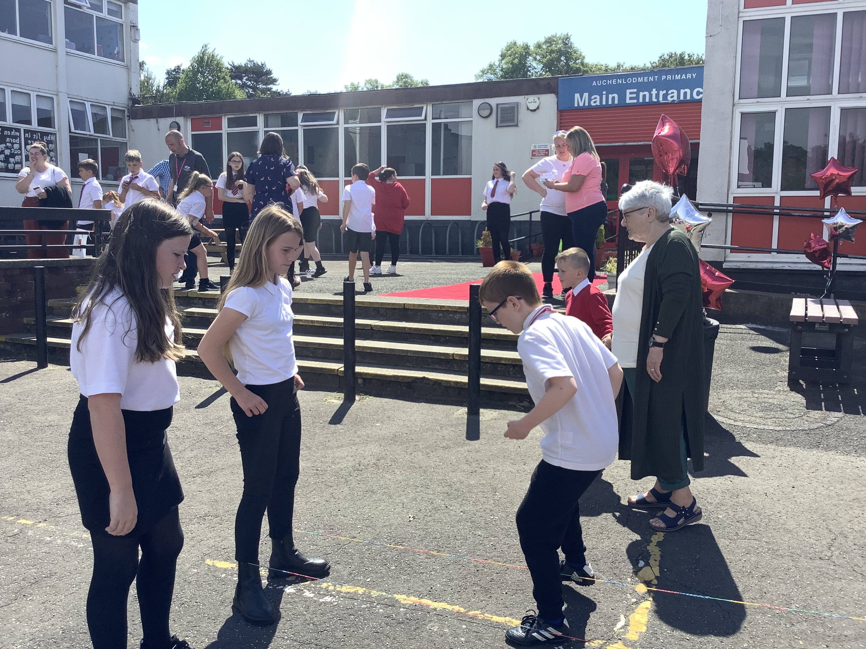 

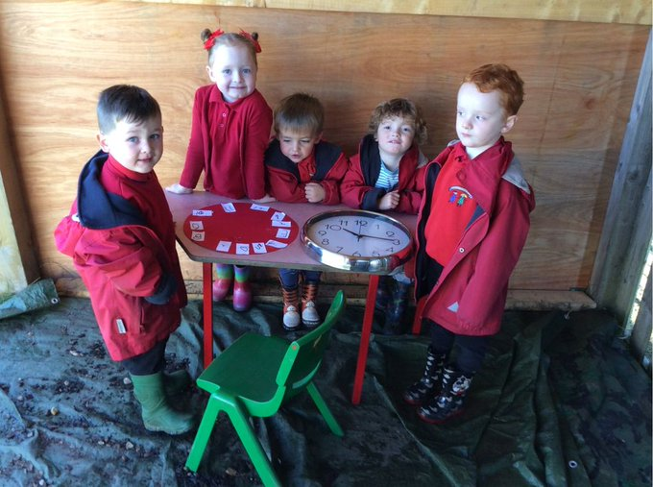

STANDARDS AND QUALITY REPORT

June 2022

This report will inform you of the school’s progress and achievements in the last session and let you know about our plans for 2022-2023. I hope that you find it helpful and informative.

Denise Newlove

Head Teacher

SUCCESSES AND ACHIEVEMENTS

This session has focused on Building Back Better and recovery post pandemic. Our focus has been on attainment, the mental health and wellbeing of our learners, families, staff, and school community and the reintroduction of whole school events with our 60th Anniversary celebrations being a key focus.

* **Literacy and Numeracy** – The Renfrewshire Primary Literacy and Numeracy programmes continue to run successfully and positively impact attainment. Our attainment in literacy and numeracy is a strength; tracking shows it is above average in terms of Quartile 2 schools in Renfrewshire.
* **Numeracy** – Four teaching staff participated in the Education Scotland Maths Recovery and implemented the programme with targeted children. This led to increased staff expertise in assessing, identifying needs and implementing support to raise attainment in numeracy.
* **Mental Health and Well-Being** – This session we focused on building mental strategies and resilience to support mental health and well-being of our learners by implementing the Headstrong pilot. Data shows the impact of the pilot shows children have identified more strategies to support their mental health and well-being.
* **ELCC use of Early Years Progression Toolkit** – Auchenlodment ELCC has implemented the use of the Early Years Progression Toolkit which has greatly helped practitioners in identifying learning needs within the ELCC.
* **Dolly’s Imagination Library in Renfrewshire–** Our ELCC worked in partnership with Renfrewshire Council to enrol our children and families into the scheme which provides a free reading book for each child every month to promote reading by ensuring each child has their own personal library before starting school.
* **Active Schools** – This session Active Schools Clubs, tournaments, and competitions were reintroduced, prioritised, and promoted so pupils could make the most of the sporting opportunities this session. Pupils attended football, netball and basketball tournaments qualifying for the Junior NBA Basketball Finals against East Renfrewshire Schools.
* **Transition Programme** – Extensive P7 Transition linking with JHS. Both digital and in person transition opportunities offered. Positive feedback from our P1 Transition programme with excellent links established.
* **STEM** – Staff CLPL and partnerships with the Glasgow Science Centre provided rich learning experiences for all classes. Class Trips to the Science Centre provided links to learning.
* **Whole School Events** – The reintroduction of whole school events with the highlight being the celebration of our 60th Anniversary. The official Open Day with welcome ceremony, pupil led tours, 60s playground games, art gallery, photo gallery and class activities positively impacted the community and helped to re-establish a sense of belonging post COVID.

OUR VISION, VALUES AND AIMS



OUR SCHOOL

Auchenlodment Primary School and ELCC is located within the community of Johnstone Castle. The community has undergone a period of regeneration, with the building of 100 new family homes completed, and new families moving in last session. The majority of our nursery children move into Auchenlodment Primary making transition a smooth and effective process for children and families. The majority of P7 leavers move onto Johnstone High School. Auchenlodment has strong links with the High School and will continue to build on this in session 2022-23. The school and ELCC are very proud of their achievements and their excellent reputation they hold in the community. The whole school community strive to be Successful, Positive, Active, Respectful and Kind – our school values.

**HOW SUCCESSFUL HAVE WE BEEN IN IMPROVING OUR SCHOOL?**

**School Leadership**

* Distributed Leadership is a strength of Auchenlodment Primary. All staff have taken on leadership roles within the school and ELCC linked to their skills, interests, and priorities within in our School Improvement Plan.
* Reading Schools lead has established a successful Reading Schools Pupil Leadership Group which is leading on the Reading Schools Award application and is working in partnership with our Literacy Champion to implement Talk For Writing across the school to raise attainment in writing.
* Numeracy Champion lead a Numeracy Working Party to implement new numeracy planners and identify resources to support the learning and teaching.
* Digital Champion supports staff and pupils in building digital literacy.
* P6 and P7 teaching staff lead the re-introduction of the Bikeability programme to enable P5-P7 pupils the opportunities to develop their cycling and road safety skills and knowledge.
* Newly appointed Head Teacher, Denise Newlove was successful in her application for the Into Headship course with Strathclyde University. This will enable her to develop and reflect upon her strategic leadership and management skills.
* Acting Deputy Head, Tracy Scott has successfully completed the Middle Leadership qualification and participated in the Deputy Head Teacher learning set and has completed her Managing Difficult Conversations training. These skills can be used to successfully coach staff.
* All pupils in Primary 7 have leadership roles with House Captains organising whole school events and Infant Monitors leading in the Infant School playground to support positive play.
* Pupils were elected to the Pupil Council who subsequently planned our 60th Anniversary celebrations.

**Teacher Professionalism**

* Four teaching staff completed the Maths Recovery training with Education Scotland resulting in increased skill in assessment, identifying needs and using strategies to support these needs to raise attainment.
* Acting Deputy Head Teacher Tracy Scott and Acting Principal Teacher Caroline Ekincioglu completed the Non-Violent Resistance training and are now mentors. They work with children and families to ensure a consistent approach to behaviour in home and school.
* All staff undertook Renfrewshire’s Nurturing Relationships Approach training with our Educational Psychologist. All staff identified strategies staff and pupils could use to support their mental health.
* Teaching staff completed the STEM training led by the Glasgow Science Centre resulting in rich experiences for our learners.
* Two staff members provided consistent support as NQT Mentors resulting in all NQT requirements being met and successful learning and teaching in their classes.
* ELCO qualification in Froebel in Childhood Practice through Edinburgh University. Staff have a deeper understanding of learning and development through play in a relaxed environment and can apply this knowledge to the playrooms.

**Parental Engagement**

* Enhanced use of digital communication in the school and ELCC using SEESAW, Sway newsletters, Twitter, and text to regularly engage parents during COVID protocols.
* Meet the Teacher and How Good Is My Learning phone calls to update parents on their child’s learning.
* Written reports on each child’s learning to identify progress and how parents could support the next steps in their child’s learning.
* P1 Transition programme including ELCC creation of digital books to support transition into school.
* Videos created of special events including our Nativity and P7 Burns Supper. Links sent home so families could watch the events together.
* Parents were welcomed back into the school building in the final term to take part in a whole school Open Afternoon to celebrate our 60th Anniversary.

**HOW SUCCESSFUL HAVE WE BEEN IN IMPROVING OUR SCHOOL**

**Assessment of Children’s Progress**

* Robust termly tracking meetings using the benchmark trackers to inform teacher judgement.
* Termly GIRFEC meetings to identify learner needs, attainment gaps and evaluate interventions.
* Increased staff confidence in the use of data to inform planning.
* Early Years Progression Toolkit introduced to identify needs and implement strategies to close the poverty related attainment gap
* Use of Renfrewshire ACEL data to inform strategic planning.

Primary 1 Primary 4 Primary 7

**School Improvement**

* Focus on attainment in literacy and numeracy as part of Building Back Better has continued to be a success with our attainment data above average of comparable Quartile 2 schools.
* Effective use of Scottish Attainment Challenge teacher has raised attainment for targeted Pupil Equity Fund pupils in literacy and numeracy.
* Evaluation of the P1 transition programme was extremely positive. Parents felt supported in the transition to primary school and reported the communication was clear with many opportunities to ask questions.
* Feedback data from the Headstrong pilot focusing on mental health shows an increase in the identification of strategies pupils can use to manage anxiety and their emotions.

**Performance Information**

* Pupil attainment is a key focus at Auchenlodment. Our data shows that in Primary 4 and Primary 7 we are above average in literacy and numeracy for Quartile 2 schools within Renfrewshire. In Primary 1 we are comparable to Quartile 2 schools and have identified attainment in the Early Years and Primary 1-3 as a focus session 2022-23.

Primary 4 Primary 7

* Attainment in reading is above the Renfrewshire average.
* Active Schools participation is higher than it was in 2018-19 which means we have more pupils participating in Active Schools Clubs than we had pre-COVID.
* Early Years Progression toolkit identifies specific areas for staff to target and support in in literacy and numeracy. Primary 1 staff will use this data to inform planning in 2022-23.

KEY STRENGTHS OF THE SCHOOL

* Positive, nurturing relationships continue to underpin the positive ethos of our school. Skilled staff build relationships using trauma informed practice and de-escalation strategies to support and include all families.
* Very good attainment in literacy and numeracy. Tracking shows that we continue to perform above our Quartile’s average across P1-P7. In Primary 7 our attainment data shows we are above Renfrewshire’s average.
* High quality learning and teaching with the Primary Literacy Programme and Primary Numeracy programme embedded across the school and ELCC.

PUPIL EQUITY FUNDING

* Parent surveys, Parent Council feedback meetings, Pupil Council meetings, pupil focus groups, staff meetings and staff surveys ensured all voices were involved in the decision making around the spend of our PEF allocation.
* The surveys and feedback demonstrated all stakeholders wanted to use the PEF allocation on staffing to raise attainment.
* Our PEF staffing allocation for 21-22 was a Scottish Attainment Challenge Teacher (0.6 which is equivalent to 3 days), a teacher (0.2 which is equivalent to 1 day) to support writing attainment in P1-P3 and two full time Support Staff members, an ASNA and a Classroom Assistant.
* As part of the Pupil Equity Fund Quartile 2 schools’ allocation within Renfrewshire, we were allocated a Scottish Attainment Challenge teacher. We used this allocation to target attainment in literacy and numeracy in Primary 4 and Primary 5.
* Our Scottish Attainment Challenge Teacher delivered intensive literacy support and numeracy including reading coaching, a structured International Phonics programme, writing support and numeracy support using the Stages of Early Arithmetical Learning numeracy programme.
* Our Primary 4 class went from having 66% of pupils on track for reading in Primary 3 to 81% of pupils on track at the end of Primary 4. All pupils in P4 and P5 made very good progress through the book bands. The majority of P4 and P5 pupils developed their foundational numeracy skills.
* In Primary 2 our PEF teacher supported targeted pupils to raise attainment in writing through intensive, small group support. At the beginning of P2 58% of learners were on track which increased to 70% by the end of Primary 2.
* We employed two Support Staff members through the Pupil Equity Fund: an ASNA and a Classroom Assistant. Both staff members supported attainment in our Primary 1-3 classes. This included delivering targeted small group numeracy support using the SEAL approach, phonics support using the Jolly Phonics approach and reading coaching. All targeted pupils made progress.
* Our PEF Classroom Assistant supported the re-introduction of free flow Play Pedagogy once COVID restrictions had been altered.
* Our PEF Support Staff members ran the Breakfast Club which positively impacted on the health and wellbeing of targeted pupils.
* All care experienced children made very good progress.
* All Class Teachers provide targeted support and interventions. Most pupils involved in targeted interventions made more than expected progress. The majority of staff believe we are very good in raising attainment in literacy and numeracy.

KEY STRENGTHS OF THE SCHOOL

* Quality staff who are committed to their own professional development and implement evidence-based initiatives. Staff are focused on building back better in terms of attainment and in terms of supporting pupils with their mental health and wellbeing.
* Skilled Support Staff, Office Staff and Environmental Staff who are committed to positively impacting the wellbeing and school experience of our learners.
* Targeted Pupil Equity Support has successfully raised attainment.
* Our ELCC build excellent relationships with families and provide support through challenging times such as the recovery from COVID-19.
* Transitions from our ELCC to P1 and from P7 to Johnstone High School are well structured and provide comprehensive support to pupils and families.
* The effective use of the Early Years Progression toolkit enables the early identification of needs and implementation of support.

OUR NEXT STEPS – PRIORITIES FOR 2022-23

We believe that we have made very good progress during session 2021-22 and we will use the improvement priorities listed below to build on this progress moving forward.

* **Raise attainment in literacy**
* Use the Reading Schools Action Plan to ensure we continue to develop a quality reading culture within our school and ELCC and to ensure reading maintains a high profile among all stakeholders.
* Implement the Talk For Writing approach across the school and ELCC to raise attainment in writing.
* Talk For Writing Project Leads to support staff in the implementation of Talk for Writing
* Focused professional learning on Talk For Writing for teaching and support staff.
* Effective use of our Pupil Equity Fund to raise attainment in writing for targeted pupils.
* Family Learning sessions targeted to raise attainment in writing.
* **Raise attainment in numeracy**
* Continue to use evidence-based approaches from the Primary Numeracy Programme to raise attainment in numeracy and implement the use of Renfrewshire’s new numeracy planners to support these approaches.
* Purchase of new numeracy resources to support the concrete-pictorial-abstract approach in numeracy.
* Use Maths Recovery assessment strategies to identify next steps for pupils.
* Effective use of Pupil Equity Fund to target interventions to raise attainment in numeracy.
* Family Learning sessions focused on Maths Recovery strategies and a positive growth mind-set.

* **Health and Wellbeing**
* Use Renfrewshire’s Nurturing Relationships Approach Action Plan to focus on developing and embedding strategies to support our nurture principle ‘Nurture is important for wellbeing’.
* Strategies identified and developed during the Headstrong pilot to be implemented in all classes. Feedback to be shared with all stakeholders.
* Use of partnerships such as Home-link and Families First to effectively support the mental health and wellbeing of pupils and parents.
* Active Schools to support health and wellbeing through increased participation in clubs and Active Schools events.

Family Learning

OUR NEXT STEPS – PRIORITIES FOR 2022-23

* **Other Priorities**
* Identify our digital technologies next steps through the Digital Schools Award process
* Implementation of Play Pedagogy into Primary 3 focusing on inquiry-based learning.

Full details of the school’s improvement priorities and actions are detailed on the school improvement plan which can be accessed on our website or by contacting the school office.

HAVE YOUR SAY!

Please take the opportunity to share your thoughts with us as we use feedback to help us make improvements to the school. You can do this by speaking to staff, participating in Parent Council meetings, responding to questionnaires/surveys and by completing evaluations at school events.

**Auchenlodment Primary and ELCC**

**Aspen Place, Johnstone**

**PA5 9QQ**

**0300 300 0145**

**blogs.glowscotland.org.uk/re/auchenlodment/**

**Twitter @AuchenlodmentPS**