**Auchenlodment Primary School – Remote Learning Survey Results**

**February 2021**

Thank you for taking the time to complete the online surveys (school and local authority) about remote learning. We received approximately 80 responses and are now able to share with you the results from the survey. The purpose of the survey was to gauge how families were finding remote learning and to allow the school to put in supports where required. The staff have been very pleased with the engagement online (approximately 85% of children are engaging every day) and we empathise with families as we know how challenging the experience has been. We are hopeful that on Tuesday 16th February, the First Minister will confirm the return to school and ELC for Nursery – P3 pupils, week commencing 22nd February. There has been no update for P4-7 pupils as yet. We are in regular contact with families, either through phone call, email or Seesaw. Please get in touch if you require any further support with remote learning or if you would benefit from receiving a device, IT support or a food parcel. Thank you once again for your patience and support during this time.

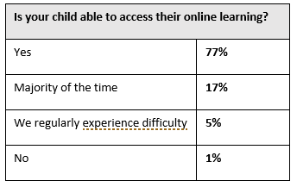

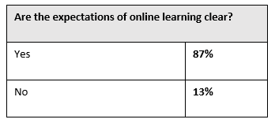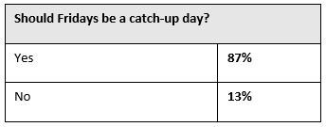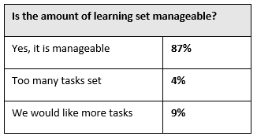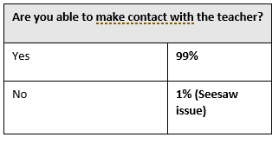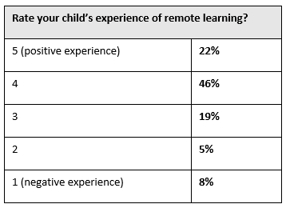

Based on these results, it has been confirmed that Fridays will be a catch-up day. This will allow children to catch up on any tasks they didn’t complete throughout the week. It also provides more time for teachers to correct work and provide feedback on tasks from the previous days. Tasks will be posted on a Friday, however, they will be online based with no written aspect to them.

Thank you for taking the time to complete the survey and for providing comments, both positive and constructive. These are very helpful in ensuring we are able to provide the best experience possible.

Please get in touch if you require any support or you would just like a chat regarding your child’s education.

Phone: 0300 300 0145

Email: [auchenlodmentenquiries@renfrewshire.gov.uk](mailto:auchenlodmentenquiries@renfrewshire.gov.uk)