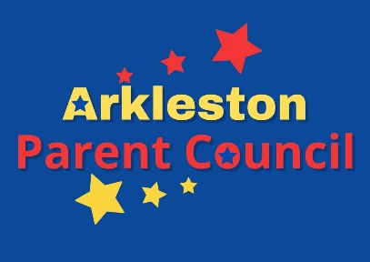
Email:arkleston@renfrewshire.npfs.org.uk
Facebook: @arklestonparentcouncil
Twitter: @ArkyPC

Minutes of Parent Council Meeting
Wed 31st August 2022 7pm Online via google meet
PRESENT:
Saima Saeed |  | Chair
Laura McColl |  | Secretary
Debbie Elms |  | Vice Chair
Gemma Fleming |  | Treasurer

Rama Bochi | Carolyn Crawford (HT)
David Bonnar (DHT) | Jennifer Dumbreck
Amy Valentine | Hannah Halsall

1 Welcome and attendees

As noted

2 Apologies

Received from Kirsty McNish, Barbara McMeekin

3 HT Report

Attached

4 Treasurer Report

Attached

5 Matter Arising

School working on creating designated football areas within playground (soft balls ordered).

Awaiting info on what the road closure from 5th Sept will look like.

School energy bills are paid by HQ (heating controlled remotely from HQ) therefore budget unchanged re energy price cap. School has been assessed by Energy Management Officer to assess usage and see where savings could be made. This may affect booked lets in future due to cost saving.

Suggestions to improve engagement with PC include publicising achievements on social media. Also, sharing more of the role of a parent council using Connect resources. Seek a representative from each WhatsApp class group to feed back to PC. Look into anonymous parental surveys for engagement.
Arrange letter to go into P1 book bags (which have been delayed by supplier).
Share meeting links on class WhatsApp groups and Seesaw.

School/council have no responsibility for bridge car park. School continues to encourage considerate parking for parents and visitors.

6 Calendar Of Events

Anniversary Fayre: Thursday 15th September 6-8pm
Halloween Disco: Thursday 27th October
Christmas Fayre: Saturday 3rd December
Valentines Disco: TBC
Summer Fun Day: TBC
Shorts n Shades: TBC

7 Anniversary Fayre

19 volunteers so far
Saima working on spreadsheet for roles
Debbie working on raffle prizes (raffle to be sold on the night). Look at level of prizes then assess if worth selling tickets in advance.
Flyer out on social media channels.
Ask other PC’s to advertise.
Find a small car owner willing to have their car filled with gold balloons!
Saima sourcing halal food options for inclusion.
School to support by asking for tombola/home baking donations
Further plans via WhatsApp chat.

