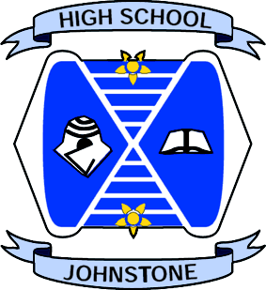
JOHNSTONE HIGH SCHOOL
PUPIL BULLETIN
20 May 2016
- Note from Mrs Hollywood
We’ve just had another busy week in school with assemblies for pupils on Wednesday and then the new timetable on Thursday. Well done to everyone for getting into the swing of their new timetables so quickly. Of course, it’s not just classes that have changed as each year group has ‘bumped up’ and some now have a new head of year:
New S2 Mr Miller
New S3 Mr Miller
New S4 Mr Gilbert
New S5/6 Mr Munro
Mrs Sturgeon is currently working with the primary schools around the p7 transition and she will be head of year for the new S1 in August.
Some of the new S4 have already purchased senior ties and these are available from the office at a cost of £7. We will also have a uniform outfitter coming into school when the seniors return (in June) to measure pupils for blazers and to put braiding on seniors’ blazers. More information will come to you via a flyer nearer the time.
Next week is also looking very busy with SQA exams on, the primary 7 parents’ evening on Wednesday and of course, the in-service day on Thursday before the long weekend.
I hope you all have a relaxing break before the last month of the school session. Please take advantage of the opportunities available to you in June, including work experience, the school show, mission discovery and activities week – get involved!

- Office

A mobile phone has been handed in to the office which was lost on Wednesday this week. Please come to the office if it belongs to you.

- Art Department
Congratulations to Lauren Anderson of S3 and Samantha Miller of S4 for winning their respective age categories in the Paisley Arts Institute Schools Competition. Their work, along with work by Rachel Aird, Joseph Cameron, Kira Graham, Jack Vaughan, Kirsty Hiddleston and Hannah Leitch is currently on display at Paisley Museum.

- Annie
Adult: £8.00
Child/Concession: £5.00
Family(2x2): £20.00

14th, 15th & 16th of June.
Don't Miss Out!!
TICKETS ARE ON SALE EVERY INTERVAL/LUNCHTIME IN MISS MITCHELL’S CLASSROOM!

