DATES FOR YOUR DIARY
December
Friday 7th Christmas Fayre (1.15pm – details to follow)
Monday 10th Christmas Panto for pupils (PM) in the gym hall
Wednesday 12th Nativity 10.00am & 1.30pm performances
Thursday 13th Christmas Lunch
Christmas Disco
Wednesday 19th P7s singing Carols at Braemount Care Home (am)
Thursday 20th Christmas Service (pupils only)
P1 and P2 Christmas Party (pm)
Friday 21st Non uniform day
SCHOOL CLOSES AT 2.30PM
January
Monday 7th School reopens today.
Wednesday 9th P7s to Scotland Street Museum and Glasgow Science Centre
Thursday 10th Home-link jotters sent home today for signing
Monday 14th Parent Council Meeting (6.15pm)
Wednesday 16th P1 Registration Day (pm)
Thursday 17th P1 Registration Day (pm)
Friday 18th P7, to Gleniffer High School
Tuesday 22nd P7s to Robert Burns Museum

Citizenship Winners   | Congratulations to the following pupils for displaying ‘Being Kind to Others’ during the month of October:  P1A Tyler Crawford P1B Carly Murphy  P2 Evan Armstrong P2/3 Leah Peakman  P3 Marlee McVitie P4 Jemma Butler  P4/5 Tia Campbell P5 Ben Millar  P6A David McCotter P6B Cerys Murphy  P7A Sophie Murphy P7B Georgia Hume
Parent Council News
Our chairperson, Mrs Gold, would like to thank all the parents who helped out at the recent Hallowe’en Disco and she will again be looking for your support at our Christmas Disco which will take place on Thursday 13th December (P1-P3 6pm-7.15pm and P4-P7 7.30pm – 8.45pm). An information letter will be sent out shortly. Please note that even on cold/wet nights, we will not be able to open the front door to let parents in to collect their children until we are satisfied that pupils are seated in the gym hall with their coats on. I trust that you will understand that this is to help make the leaving process at the end of the evening as safe and secure as possible. Thank you.
Non Uniform Day
As a thank you to all of our pupils, there will be a non-uniform day on our last day of term, Friday 21st December. There is no charge for this.
Car Park
Following some near incidents, I would ask that you do not bring your car into the car park as the safety of our pupils, your children, is paramount. Please always way up the inconvenience of a two minute walk with that of a child being seriously injured. Thank you for your support.

Langcraigs Primary
Newsletter December 2018


L
P
S
Dear Parent/Guardian Newsletter 2018
Harvest Assembly | Many congratulations to P4, P4/5 and P5 who led a wonderful assembly at the end of October in front of the whole school, parents and also residents from the local care home. After the assembly,  sixty eight bags were filled with your donations and our Head  Pupils, and I delivered the bags to Braemount Care Home and Hillside View  Care Home, who were so appreciative of your kindness. Well done to everyone in Langcraigs – we really have made a difference to people’s lives.
Remembrance Service  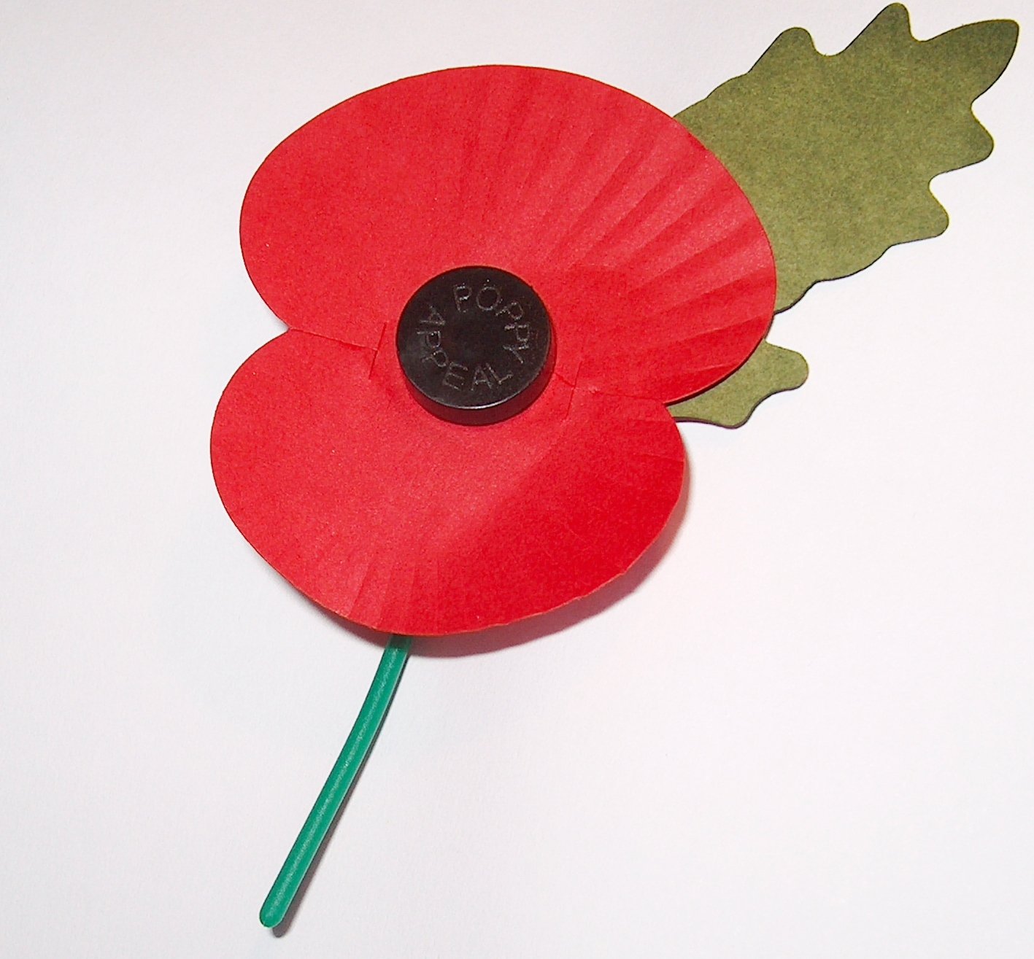 | On Friday 9th November, P7 pupils performed a most informative and thought provoking tribute to all of the men and woman who have lost their lives or been injured in various wars over the years. Everyone who was there was impressed with the performances of all of our P7 pupils and it was also great to see so many parents taking the opportunity to go back with their child to see the classroom to have a chat about their topic work. Well done everyone
Pupils Council Spooktacular
Pupils and staff enjoyed a day of spooky fundraising on Thursday 1st November at the Halloween Spooktacular fundraiser, organised by the Langcraigs Pupil Council. School uniform was abandoned for the day with children (and staff!) coming to school in spooky costumes or with scary hair. A carved pumpkin competition transformed the foyer, along with a bake sale of delicious cakes and goodies.
Thank you to everyone who supported this event by dressing up, baking, decorating and carving pumpkins. A spooktacular total of £357.56 was raised in school, this amount will be doubled by Renfrewshire Council. The Pupil Council have selected CHAS as the charity they would like to support this session. Mary McIntyre from CHAS came along to assembly on Monday 26th November to tell the children about CHAS and receive the cheque from the Pupil Council.
The competition winners were:
Spooky Cake 1. Max & Beth Stevenson 2. Ava Wilson, 3. Logan Brown
Pumpkin Carving 1. Cooper Blair, 2. Anaya Malcolm, 3 Summer Norris
Head Girl Report  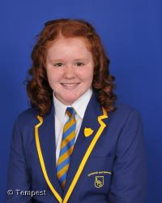 |  | Hello, everyone my name is Emma Hemming and I am your new Head Girl at Langcraigs Primary School. Even though it has been a short time since I started, I have been really busy with all the jobs that I am responsible for. I was able to welcome lots of parents at our first parents’ night this term and I also helped with the delivery of the Harvest Festival food to the local Elderly Care Home. I have taken pride in my role and I love wearing my Head Girl tie and I am enjoyed wearing the very smart school blazer at special events. I have really enjoyed this job so far and feel honoured that I was chosen to represent Langcraigs Primary School. I hope to try and make a difference this year and look forward to the busy months ahead!

