

**Serving**

What types of serves do you know?

1.

2.

3.

What are the rules of serving?

1.

2.

3.

Try watching the video below: 5 ways to improve your serve 

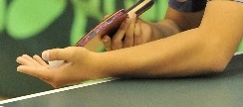

**Please complete the word search below using key words linked to table tennis**

Table Tennis

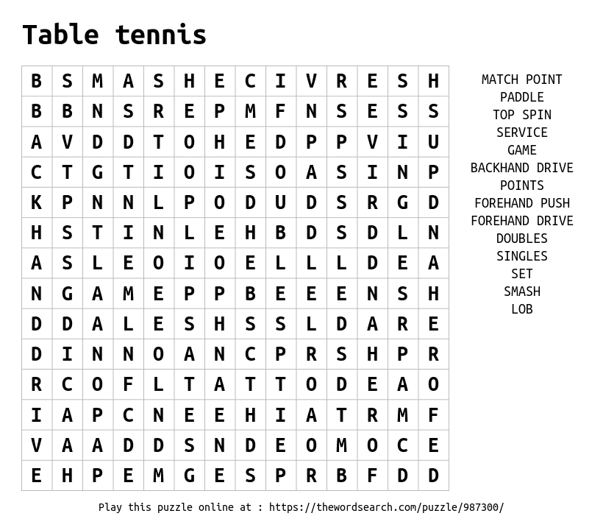

Explain using the table below the rules of table tennis

**Different types of shots**

List as many different shots as you know.



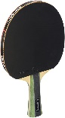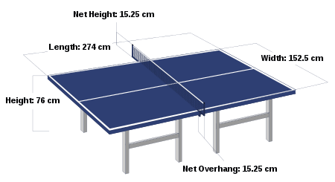

Task- Explain how the rules differ between singles and doubles in table tennis. Use diagrams if needed.

**World champions…**

Who is currently female world champion?

**World champions…**

Who is currently male world champion?



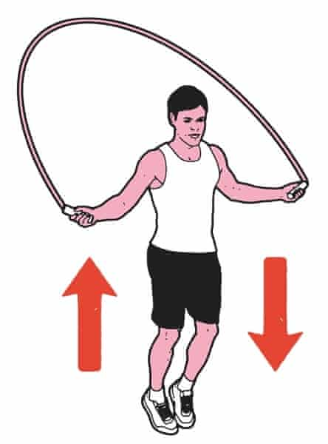

Challenge 1

Co-ordination

BOUNCE CLAP CATCH

Using any ball, bounce it against the wall, floor or table then catch it again.

Make it harder…

Add in claps between throwing and catching the ball and increase the temp

Challenge 2

Footwork

5 minute challenge

Try skipping for 5 minutes. This is important in table tennis as footwork is vital to get around the table and into the correct positions to play shots.



**Challenge 4**

Agility

Place two jumpers 5m apart. Using side steps travel between the two objects using side step. See how many you can do in 30 second.

This will improve your agility which is important in table tennis when changing direction when moving to and from each side of the table.

Challenge 3

Accuracy

Place a cup at the end of a table. Aim to bounce the ball once and land it into the cup.

This will increase accuracy and precision which is very important when playing every shot in table tennis.

