**______________‘s WEEKLY WELLBEING DIARY**

|  |  |  |  |  |  |  |  |  |
| --- | --- | --- | --- | --- | --- | --- | --- | --- |
| Date | **Activity 1**  (minutes) | **Activity 2**  (minutes) | **Activity 3**  (minutes) | **Activity 4**  (minutes) | Total  Active Minutes | Wellbeing Workout | Hours Sleep | Screen time |
| **Monday** |  |  |  |  |  |  |  |  |
| **Tuesday** |  |  |  |  |  |  |  |  |
| **Wednesday** |  |  |  |  |  |  |  |  |
| **Thursday** |  |  |  |  |  |  |  |  |
| **Friday** |  |  |  |  |  |  |  |  |
| **Saturday** |  |  |  |  |  |  |  |  |
| **Sunday** |  |  |  |  |  |  |  |  |

Bronze target – 25 minutes a day Silver target – 40 minutes a day Gold target – 60 minutes a day

**Physical activity inspiration**  **Wellbeing Workout inspiration**

Walking/cycling/running – with 2 other people max. Read a book

Daily step goal (recommended target is 10,000) Help prepare and cook a healthy meal/snack

Take your dog (or mum or dad or siblings) for a walk Do some colouring/painting/drawing

Home workouts – follow @jhighHWB on twitter for ideas Try some mindfulness/yoga/listen to music

Design your own home workout & challenge your friends/family Help out around the house

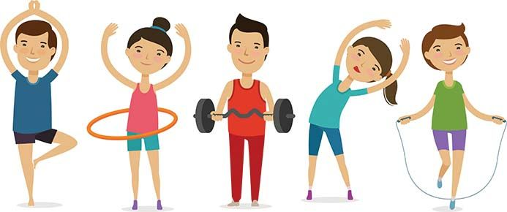to complete it Play a boardgame