S2 Design- Carnival costume

Lucille is 20 years old and has loved the Rio Carnival since she was a little girl. She is studying to be a designer and is learning how to make the costumes herself. This clip illustrates the intricacy of the work involved, from the pattern cutting to the gluing on of sequins. We see how the designers take a theme and the outfits are designed to illustrate it. It takes a year for the costumes to be completed and we see the splendour of the results at the Rio Carnival.

Watch the video at

<https://www.bbc.co.uk/bitesize/clips/z8hngk7>

TASK

Using the theme of TECHNOLOGY use the male or female model to add your own design for the Rio Carnival like Lucille’s design. Pause and look closer at the designs if you can when watching the video. Make a few sketches from the video and add in your own ideas in the final drawing.

You can print out and draw on the models or copy them from the screen.

Add colour and point out what the materials could be made from

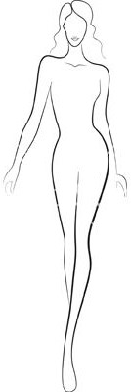Ideas- Cds, electronic boards, cables .

