**Nature inspired buildings**

Below are a few examples of well known buildings that were inspired by nature in their design.

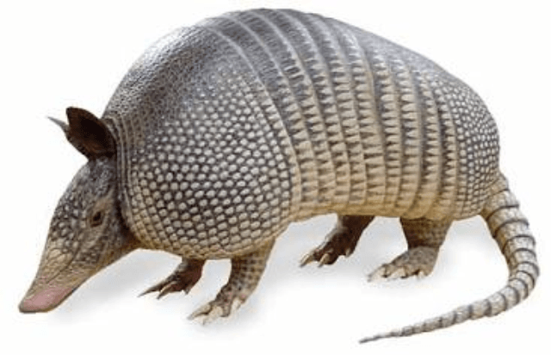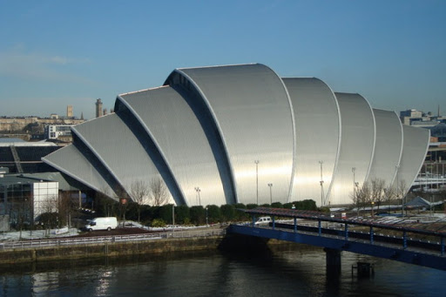

The Clyde Auditorium ‘ Armadillo’- Inspired by the armoured plates of the animal.

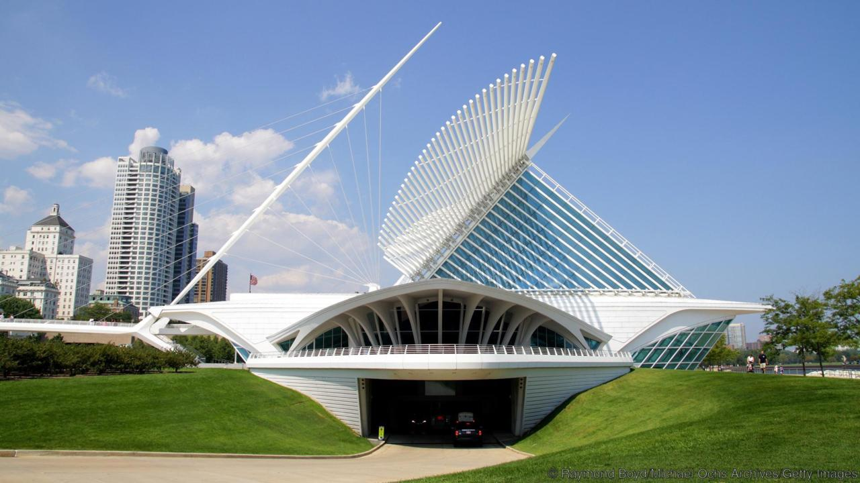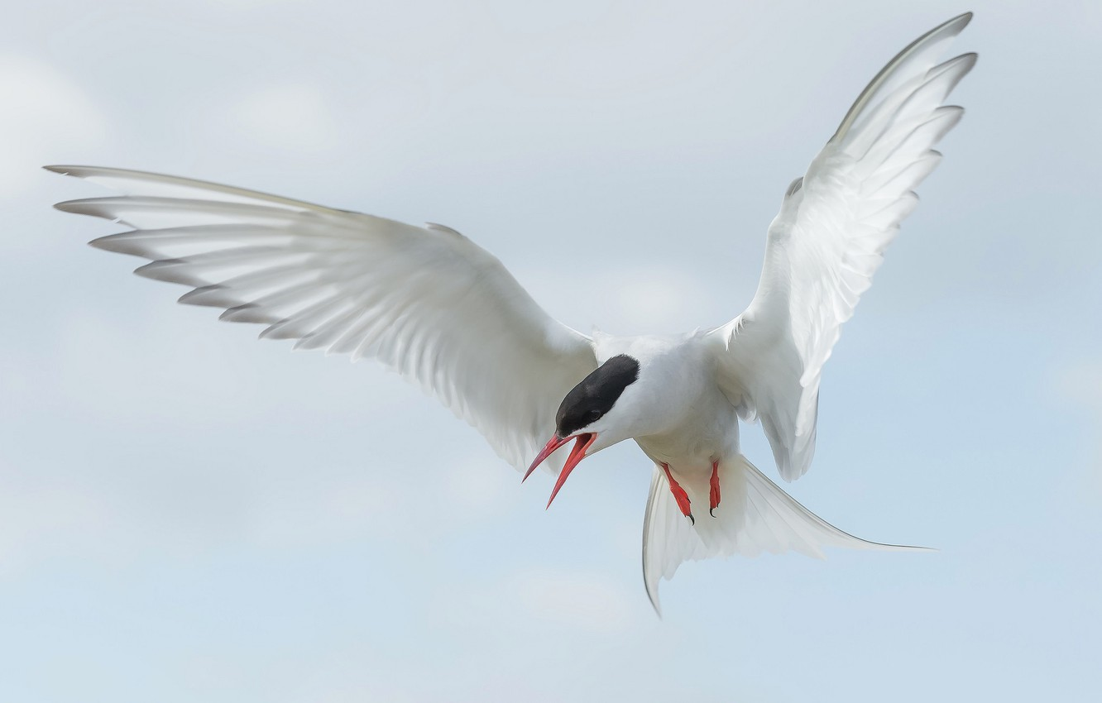

The elegant Milwaukee Art Museum’s most eye-catching feature is its huge sunscreen roof – the Burke Brise Soleil – which is reminiscent of great white wings thanks to an open and closing mechanism controlling the 90 tonne screen.

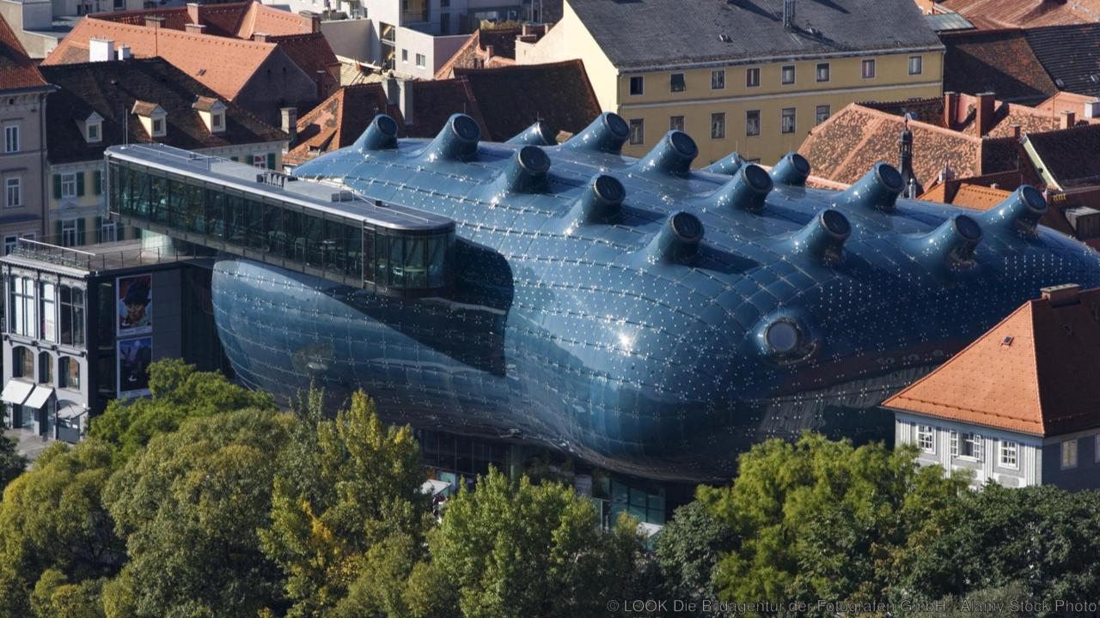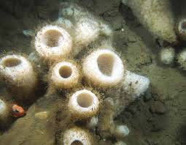

Like some colossal, stranded deep-sea blob, the biomorphic Kunsthaus Graz rises up amid angular, red-roofed buildings.

**TASK**

**Design a fantasy house that is inspired by some aspect of nature.**

**It can just be the outside or add in rooms and features of your choosing no matter how weird!** *Tip- animals, weather, rocks, water, fire, lightning*