**GRAPHIC DESIGN- FONTS**

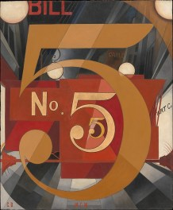Charles Demuth was an American artist and designer. He studied and lived in Paris where he became a part of the Avant Garde art scene. He died at the age 51

He was part of the **Precisionism** movement concerned with industrialisation and the modernisation of the American landscape. The structures of which were created in precise, sharply defined geometrical forms. Many of his ideas formed the basis for modern magazine/poster and digital graphic designs.

“*I Saw the Figure 5 in Gold*“ by Charles Demuth

**TASK**

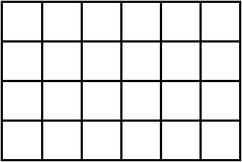

1. **Create a 4 x 6 grid. You choose how big for each box**
2. **Draw approx 5 characters from 3 different fonts. Choose from letters, numbers, characters upper or lower case. Vary the sizes of all 3. They can overlap.**
3. **Colour and render with tone**
4. **Add pattern into the spaces that are left**

**SEE THE PHOTOS BELOW FOR IDEAS**

**3 FONTS- Or choose your own**

