Celtic Knot Design

Note- Celtic (pronounced ‘keltic’ refers to a long ago race of people, not the football team)

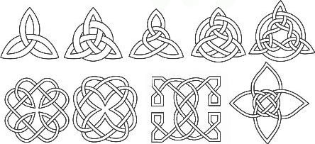**Despite the fact that the Celtic civilisation has long since ceased to exist, remnants of it can be seen everywhere. However, few aspects of Celtic culture are more apparent in modern society than Celtic knots.**

These knots are complete loops that have no start or finish and could be said to represent eternity whether this means loyalty, faith, friendship or love. Only one thread is used in each design which symbolizes how life and eternity are interconnected. These complex designs are used as decorative accompaniments to a variety of items including jewelery sets, plates, mugs, clothing and even cutlery. They are also very popular as tattoos

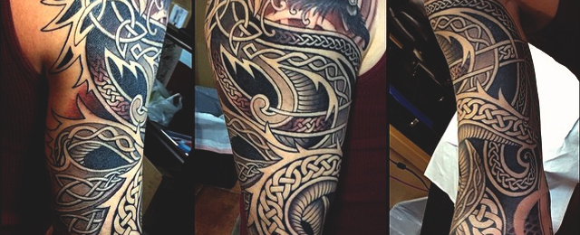

**TASK- Create your own very simple knot or interlinked chain using the video link. Outline in pen and add shade with pencil**

<https://www.youtube.com/watch?v=m_D096JqnbY>

If you want to challenge yourself try the next link! ( you’ll need to grid your paper in squares first)

<https://www.youtube.com/watch?v=2IyklPiZUKg&vl=en-GB>