**Art inspired Design- These are examples of how famous Art has inspired design.**

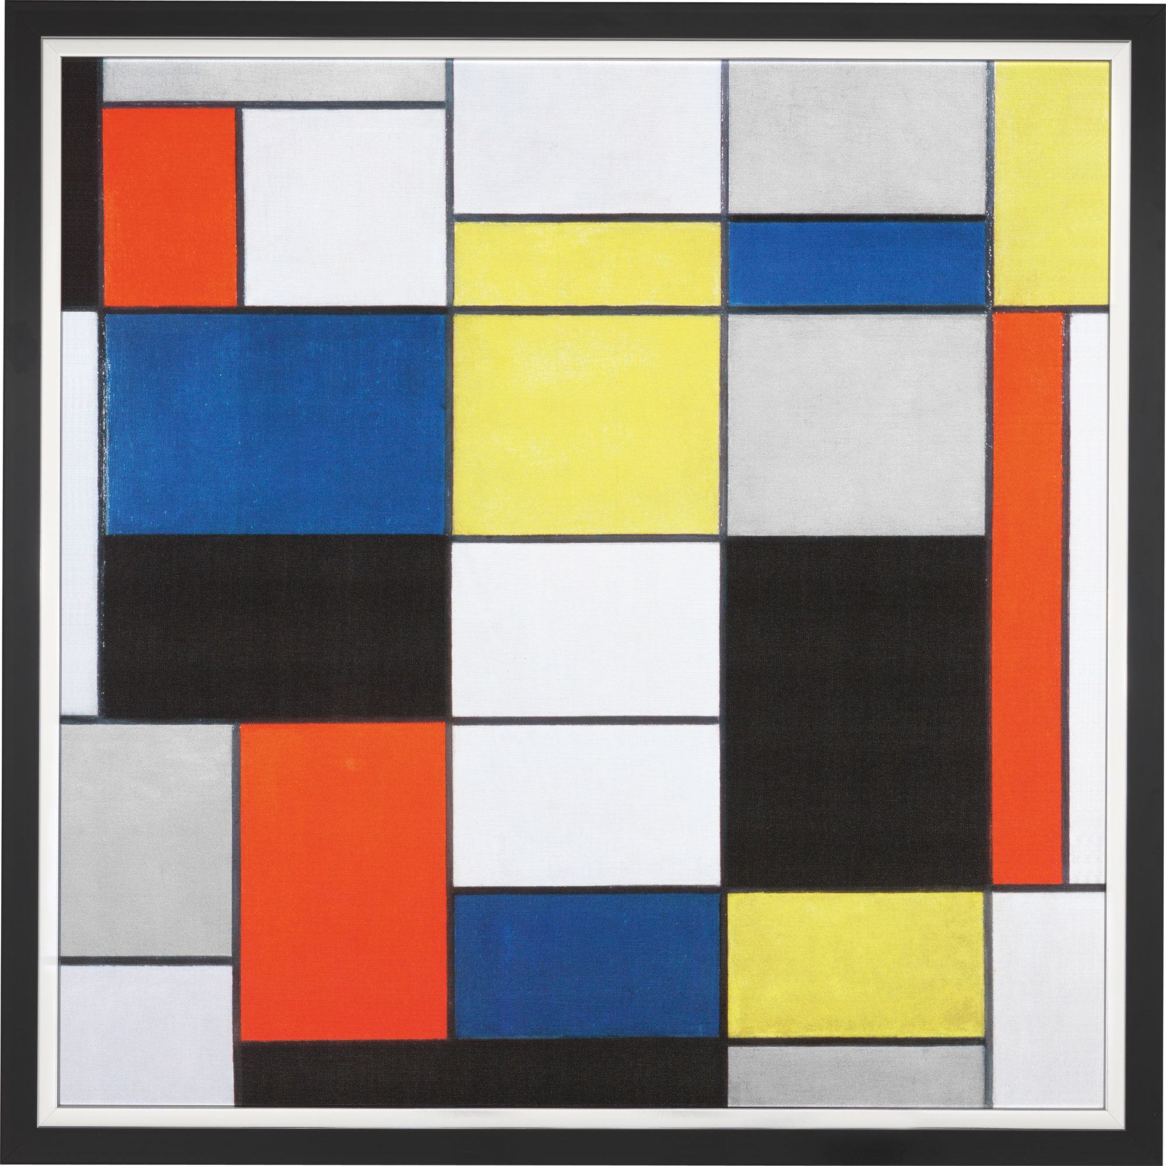

Piet Mondrian s composition A inspired Loreals hair products in the 1980’s

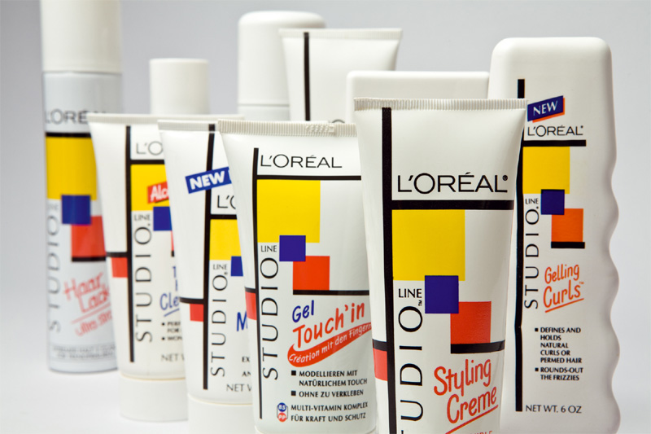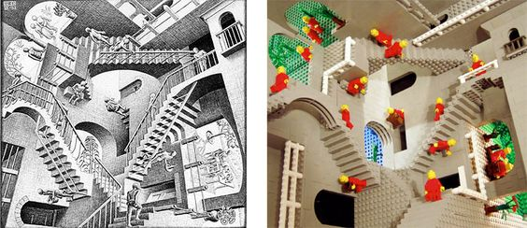

MC Eschers famous optical art inspired this lego design.

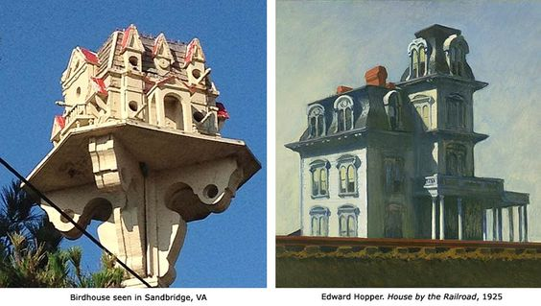

Famous landscape painter Edward Hoppers art has inspired this bird house.

**What could these two famous painting s inspire and be made as products? Sketch your 2 ideas below**

**ideas- food, clothes , shops**

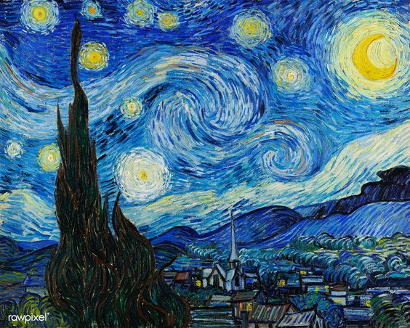

Van Gogh –Starry Night

Magritte- The Son of Man

