Luncarty Primary School
Nursery Handbook


2026
Luncarty Primary School
Marshall Road
Luncarty
PH1 3EX
Telephone: 01738 474185
E-Mail luncarty@pkc.gov.uk

Welcome to Luncarty Primary School Nursery. We are delighted that you and your child are joining our learning community, we very much look forward to working together.

We are committed to working in partnership with parents and recognise the vital importance of sharing information between home and nursery. We believe that only by working together, can we help our children reach their full potential. To do so, we will endeavour to build relationships based on mutual respect, honesty and openness. I’m sure you will find all staff to be friendly and approachable, so please do not hesitate to contact us if you have any queries, concerns or suggestions.

Staff Team
Head Teacher Mrs Emma Bendoris

Principal Teacher Mrs Emma Hepburn
Early Years Support Teacher |  | Ms Nicola Brown
Early Childhood Practitioners |  | Miss Angie Watt
 |  | Mrs Marie Godden
 |  | Ms Sharon Fertacz
Nursery Play Assistant Mrs Mel Scott

School Secretary / First Aider Mrs Lynn Smith

Childcare Supervisor Mrs Alison Peters-Waistell Deputy Childcare Supervisor Miss Paige Hunter
Play Worker Mrs Yvonne Campbell

INCLUDED & NURTURED

An introduction to our Nursery Environment

Our nursery children’s entrance is to the left-hand side of the school building, where each morning you will be met by a member of staff. This is also where you will collect your child at the end of the day. If you need access out with these times, please contact the school office via the main entrance. We believe this informal contact time is a great opportunity to share information and start and end the day with a smile. We encourage active travel to and from school and nursery. If you do need to drive to nursery, please park and stride from the park along the path which runs along the right hand perimeter of our school grounds. The street our school is situated on is within an Exclusion Zone. Cars are prohibited from using Marshall Road between 8.15am – 9.00am and 2.45pm – 3.30pm unless a permit has been issued.

A short walk through the fenced nursery garden leads into a small cloakroom area and then into our indoor learning provision. Please ensure you close the gate securely each time you arrive and leave. Our Nursery space offers a range of activities and experiences designed to provoke curiosity and support your child’s development. We ask that all mobile phones are out of sight and switched to silent during drop off and pick up times.

We have 24 nursery places and children are organised into three groups. Children can freely access indoors and outdoors as they choose, allowing for a variety of rich learning experiences all year round. We also make use of our local park and woodland as we explore our local community.

Nursery staff plan a wide range of learning activities to support and challenge children’s development, through a balance of free-play and focussed group work. We are responsive to children’s questions and interests and work to extend their curiosity, knowledge and skills. As such, we don’t always cover traditional seasonal topics.

ACHIEVING & ACTIVE

Nursery Curriculum

Our nursery supports 3–5-year-olds and follows the Curriculum for Excellence. This spans across nursery and primary school ensuring continuity and learning progression.

We have an inclusive, safe, and welcoming learning environment that respects the individuality and uniqueness of each child and their family. We provide high quality education and childcare through an active child centered play pedagogy that nurtures and supports children to develop social and emotional confidence and fosters a love for learning.

Assessment of Children’s Progress

Through regular observations, nursery staff will gather and analyze information related to your child’s learning. We share pictures, videos, and general information through Learning Journals. Parents will be given an activation code for their child, please do not share this with anyone else. You will then be required to download the Learning Journals family app and sign up to your child’s profile. The Learning Journals platform provides a secure 2-way communication between school and home, which is extremely popular. We would encourage families to comment on their child’s profile, and to fully participate in their child’s learning journey. Please get in touch with our nursery team or Lynn Smith, our school secretary if you require any assistance.

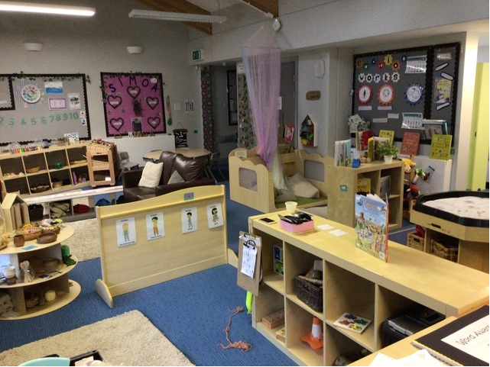
Starting Nursery and what to bring

A positive start to nursery is essential, so please be prepared to stay until your child is well settled. Some children take longer than others to part from their parents, staff understand this and are available to help. From experience, we have also found that a period of phasing in (staggering start dates and gradually increasing session lengths) can be beneficial. Please speak to a member of staff who will co-create a plan to meet your child’s individual needs. Your child will be allocated a key worker who will be responsible for planning, assessing and tracking your child’s progress. They will be your main point of contact in nursery.

We love learning outdoors every day, whatever the weather! Active learning opportunities in nursery call for comfortable, practical clothing that your child can manage for themselves. Best clothes might get messy and spoiled so are better kept for home. On sunny days please apply sunscreen to your child before they come to nursery in the morning. We will encourage the children to re-apply sunscreen themselves throughout the day. Staff will wear gloves if children need help to apply sunscreen.

Each child has their own labelled coat peg and shoe box to store the following items, which we would be grateful if you could provide:
- One full change of clothes, including underwear
- Indoor shoes that are easy to fasten to encourage independence
- Wellies & waterproof outdoor wear
- Sunscreen (Name and date opened) on bottle, (A minimum of SPF 30, which provides 4-star protection against UVA and UVB) this will be kept in nursery
- Sun hat/cap (during warm weather)

Please remember to clearly label all items of clothing and footwear. If your child needs a change of clothes during their session, and requires to borrow nursery spare clothes, please wash and return them as soon as possible.

Encourage your children to leave toys at home, we have plenty in nursery! Toys can easily be broken or lost. The resources we have available in nursery each day, have been carefully chosen to scaffold particular learning at that time.

Partnership with Parents and Carers

We believe that only through full partnership with parents and carers, can we get it right for our children. Our links with you are vital in providing a relevant and personalised experience for your child.

There are many opportunities for good communication: beginning/end of each session, parent contact evenings, shared learning events, termly Sway newsletter, Luncarty Parent Council, annual progress report and regularly on Learning Journals.

Another important way to keep us informed is by completing the ‘All About Me’ document. This form really helps us to get to know your child quickly. We use this information to help us plan how to best support your child’s developmental, health, safety, and well-being needs. In partnership with parents this document is reviewed every six months.

We would appreciate it if you could keep us informed of events at home which may affect your child’s well-being at nursery, and we shall do the same. If your child becomes unwell in nursery, parents will be contacted in the first instance, if this has not been possible then the emergency contact will be called.

We are keen to involve parents in the improvement of our service. As such we welcome any feedback, suggestions or comments you wish to make. Please speak to a staff member or send an email.

HEALTHY

Snack and Lunch

We encourage our children to make healthy choices. Our free snack always includes milk, fruit and vegetables and water is available to drink at all times. Snack menus are displayed in the Nursery cloakroom.

If your child is staying with us for lunch, they can either have a free school lunch or bring a healthy packed lunch. The school lunch menu can be accessed online here: https://www.tayside-contracts.co.uk/catering/school-catering
Please discuss the options with your child to help them choose something they like and share this information with nursery staff. Staff are not permitted to heat food stuffs. As packed lunches are not stored in a fridge, please include an ice pack within the lunch box each day.

Please note we operate a no smoking/ vaping policy within our school premises.

Allergies and intolerances

It is important that staff are informed on your child’s first visit of any food allergies or dietary requirements. If you have any concerns about the snack menu, please speak to a member of staff who can share with you a complete list of ingredients and discuss options.

Toothbrushing

We encourage all children to brush their teeth during the nursery session. A member of the ‘Child Smile’ team visits the nursery to demonstrate good toothbrushing habits and techniques. All our staff are ‘Child Smile’ trained. If you do not wish your child to participate in the ‘Child Smile’ programme, please inform a member of the nursery staff to opt out.

SAFE

Attendance Policy

We operate in term-time with session times from 9.00am until 3.00pm.

Please ensure that your child is brought to and collected from nursery by an adult. (At least 16 years old) If someone different is collecting, please make sure that both staff and your child are aware of this.

If you wish to change an attendance pattern, it can only be done termly and must be made in writing to the authority. Where possible these requests will be accommodated by the setting and changes will take effect from the start of a new term.

Should a child be absent from nursery without explanation, the following procedure will be followed:

- On the first day of absence the school will try to contact parents, carers, or emergency contact(s) to establish a reason for absence.
- If no contact can be made, school management will take appropriate action to ensure the child is safe. This may include contacting the child’s Named Person. For nursery children this is the Health Visitor.
If your child is not well, you must not bring them to nursery until they are fit and well enough to return. This is particularly important for instances of sickness or diarrhoea; the medical advice is that you must keep your child at home for 48 hours after the last bout, this keeps us all safe and well.

Please call the school in cases of absence – 01738 474185

Tissues

As you can imagine, we go through lots of tissues in nursery! We have boxes throughout the playroom, and we encourage children to wipe their own noses and mouths, before disposing of used tissues in the bin. Donations of boxes of tissues are always gratefully received and very much appreciated.

Child Protection

It is everybody’s job to keep children safe, please pass on any concerns you have. The Child Protection Officers for Nursery are Mrs Bendoris and Mrs Hepburn. Confidentiality is very important to us, however if we are concerned or become aware that any child is at risk of harm, we have a responsibility to share this information with the appropriate agency.

First Aid

If your child has a minor bump or scrape at nursery the details of the incident and treatment given will be recorded on an accident form which will be shared at pick up time. If your child has a more serious bump or accident, you will be contacted directly and made aware of the incident.

Medicines

If medication is to be administered during the Nursery session, you will be asked to complete the required consent form, giving your permission and full details of the medicine and dosage. The first dose of medication must be administered by parents at home. Please also let us know when the first dose was administered. All medication will be signed in at the start of each term and signed out at the end of term. This allows you to check expiry dates and review whether any medications are no longer required.

RESPECTED AND RESPONSIBLE

Nursery Ethos

Children learn from each other and from all the adults around them. We aim to demonstrate our values of kindness, respect, trust, responsibility and teamwork in all that we do. The children will have opportunities to be recognised for demonstrating these values through earning stickers and certificates. We endeavour to resolve difficulties or disagreements through restorative discussions.

Toileting

Please let a member of nursery staff know if your child is not yet fully toilet trained. All children using nappies/pull-ups should come to nursery with extra nappies/pull-ups, nappy sacks and wipes.

Nursery to Primary Transition

Nursery children have informal contact with the school and get to know the layout of the building and various members of staff by accompanying staff to the office, using the hall for games and eating lunch with the rest of the school.

At specific times Nursery join with the rest of the school for school shows and assemblies.

Transition activities will be arranged in the final term for the pre-school children to take part in visits to the P1 classroom and to meet their teacher. A P1 information session for parents is held in the summer term.

A detailed handover from Nursery to the P1 teacher, allows for smooth transition into primary school.

If your child was born between the first day of the first term and the last day of February, they are eligible for an additional year of nursery education. If you require support making the decision between them moving up to Primary 1 or taking up the additional year, please arrange a time to meet with your child’s keyworker and Mrs Bendoris.

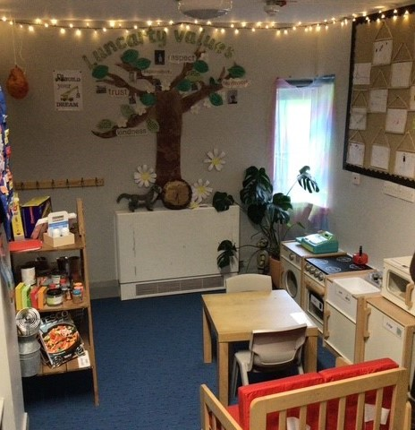

We hope you and your child have a positive experience at Luncarty. However, if you have a concern or complaint regarding any aspect of our service, please speak to a staff member.

Parents can contact Mrs Bendoris directly by email -Luncarty@pkc.gov.uk or by telephone on 01738 474185.

If you require further assistance, the Care Inspectorate can be contacted on 0345 600 9527.

We hope you have found this handbook helpful.

