**Attendance, Attainment and Achievement**

Most pupils are achieving at the expected levels in literacy and numeracy. Almost all pupils in Nursery are meeting their developmental milestones.

Our strategies to meet the needs of our learners continue to evolve. Pupils who are not on track to attain in literacy or numeracy are receiving tailored and targeted support.

This year, we have continued to utilise our Pupil Equity Funding to enhance the development of literacy and numeracy, particularly focussing on phonics and spelling. Again, we have also continued to ease the financial pressure on families during this school year. We've ensured no families have been asked to contribute financially towards excursions or school activities.

As a school, we celebrate the achievements of all learners through our school value awards and through the use of the house system. We continue to pride ourselves on making sure

Our average attendance rate for 2023/2024 was £££££%.

**Improvement Priorities for Session 2023/2024**  
  
Our capacity for school improvement is good and our Improvement priorities for 202-2023 are:

* The continued development of Teaching and Learning approaches including the development of digital learning in our ELC setting, outdoor learning across all stages and learner participation.
* Raising attainment within writing through the development of whole school approaches and interventions, and the implementation of a new literacy programme in P3-7.
* Continuing to build a safe and nurturing learning environment with a focus on Nurturing Approaches, Rights Respecting Schools Award, and development of an anti-bullying approach.

**  
Logierait Nursery and Primary School  
Standards and Quality Report 2023/24**

Our Vision

At Logierait we strive to provide a nurturing and inclusive environment where children are supported to achieve their full potential.

We encourage our pupils to be ambitious in learning and develop key skills for the future.

We work together with our community to ensure our school is a happy and safe place full of kindness and respect.

Our Values

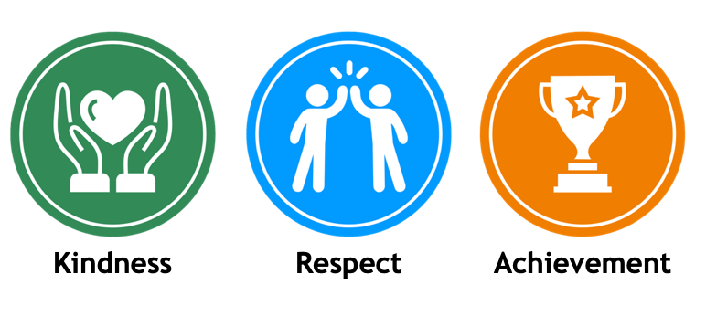

|  |  |
| --- | --- |
| School Self- Evaluation | |
| 1.3 Leadership of Change | Very Good |
| 2.3 Learning, teaching, and assessment | Very Good |
| 3.1 Ensuring wellbeing, equity, and inclusion | Good |
| 3.2 Raising attainment and achievement | Good |

**Learning and Teaching**

Throughout this school year, our piloting of new digital approaches has continued, equipping each Primary 1 to Primary 7 pupil with personal digital learning device. Furthermore, we have advanced our coding pedagogy and developed our use of iPads to monitor academic progression. This session we received the Digital Schools Award, the outstanding feedback we received highlighted the transformative impact these resources had on pupils' engagement, the evolution of our coding strategies, and the advantages of these devices for those pupils requiring additional support.

Within literacy, we've introduced a new phonics, reading, and writing programme for Primary 1 and 2. For the pupils in Primary 3-7, we've carried out a full update of our reading scheme to ensure it remains relevant and engaging. Within our Nursery, we've incorporated the 'Word Aware' programme, an initiative aimed at boosting early language development. Our teaching methods for writing have undergone comprehensive self-evaluation, and significant staff training has been carried out, laying the groundwork for further enhancements in the next school year.

Within numeracy, we've introduced a new teaching approach that has been implemented from Nursery to Year 7. This has been complemented by the introduction of new learning resources and a broader development of the curriculum. In partnership with PKC, our staff has undertaken an extensive development programme in numeracy teaching, leading to the creation of new progressive pathways aligned with these new methods. Targeted interventions have also been implemented to support those pupils who require support.

As part of our ongoing commitment to teaching and learning, our teaching staff have completed a year-long professional development programme focused on pupil assessment. This has led to the introduction of new methods for assessing pupil progress and planning for their future learning journeys.

**Leadership**

As a school community, we have continued to embed our vision and values deeply within the ethos of the school, making them the backbone of our positive relationship building and restorative practices. Our values awards now play a central role in our weekly celebrations, reinforcing these principles within our pupils' everyday school life. The school has reclaimed its standing as a key partner within the local community, with our pupils, staff, families, and visitors all noting our renewed sense of pride and ambition.

Our emphasis on self-evaluation remains a cornerstone in shaping our improvement plans, focusing on suitable development priorities. We're refining a variety of self-evaluation techniques aimed at evaluating the school's work, especially with a view to enhancing attainment in literacy and numeracy. This year, our staff have joined forces to evaluate our progress in areas such as teaching and learning, planning and evaluation, and digital methodologies.

In collaboration with our entire school community, we've developed and put into action our new Curriculum Rationale. This is based on our five Northern Stars – Numeracy, Reading, Writing, Health & Wellbeing, and Citizenship. These guiding principles light our path towards an inclusive, balanced educational approach, deeply rooted in our shared values of being Kindness, Respect, and Achievement. This new rationale embodies our commitment to equipping learners with the knowledge, skills, and values they need to thrive in an ever-changing world, with a significant emphasis on outdoor learning, digital literacy, and individual achievements.