NHS 24's 111 service:
new non-English Interactive Voice Response (IVR)
Our 111 service provides support for the health and care needs 24/7. This includes:
- out of hours care when your GP practice or dental surgery is closed
- urgent care if you think you need A&E but it’s not life threatening
- mental health support.
Callers to the 111 service first hear an automated message with options to help them get the right support for them.
This was identified as a possible barrier for callers whose first language is not English, and ways of improving access have been considered.
As a result, callers now have the option to listen to our IVR messages in seven languages: Arabic, Mandarin, Polish, Spanish, Romanian, Sorani, and Ukrainian. When answering these calls, NHS 24 staff will know the caller has requested language support. They will arrange for an interpreter to join the call.
For more about when to phone 111 visit www.nhs24.scot
We need your help to spread the word!
Please help raise awareness of the non-English IVR with:
- people you support,
- your community,
- and your networks.
Let’s make sure people whose first or preferred language is Arabic, Mandarin, Polish, Spanish, Romanian, Sorani, and Ukrainian know how to access the 111 service.
In this toolkit, we have included promotional resources you may want to use: text for any articles; translated WhatsApp messages with images; links to a short multi-lingual animation; and links to translated leaflets to help people access the 111 service.

Promotional resources
Suggested article
Below is some wording that you might want to use for any e-bulletin, intranet article or email communication, as appropriate:
Improved access to NHS 24’s 111 service
People whose first or preferred language is Arabic, Mandarin, Polish, Spanish, Romanian, Sorani, and Ukrainian can now choose to listen to Interactive Voice Response (IVR) messages in these languages.
Having dialled 111, and pressed 9 on their phones, callers will have the option to press 1 if they want to listen to the IVR messages in other languages:
- for Polish, they should press 1
- for Arabic, they should press 2
- for Mandarin, they should press 3
- for Spanish, they should press 4
- for Romanian, they should press 5
- for Sorani, they should press 6
- for Ukrainian, they should press 7
- for other languages, they should press 8
The NHS 24 colleague who answers will know the caller has requested language support, and will arrange for an interpreter to join the call.

WhatsApp messages
We have developed and translated WhatsApp messages that you may choose to disseminate to your contacts (or use on your social media channels):
English | Polish
If you feel ill and your doctor is closed dial 111  Press 9  Press 1  For Polish press 1 | Jeśli czujesz się źle, a twój lekarz nie przyjmuje wybierz 111.  Wciśnij 9  Wciśnij 1  Polski – wciśnij 1.

English | Arabic
If you feel ill and your doctor is closed dial 111  Press 9  Press 1  For Arabic press 2 | إذا كنت تشعر بالمرض وكانت عيادة طبيبك مغلقة، فيمكنك الاتصالاتصل بـ 111.  اضغط الرقم 9  اضغط الرقم 1  للغة العربية اضغط الرقم 2

English | Chinese Simplified - Mandarin
If you feel ill and your doctor is closed dial 111  Press 9  Press 1  For Mandarin press 3 | 如果您觉得身体不适，而且您的医生关门了，请拨打 111。  请按 9  请按 1  普通话请按 3
English | Spanish
If you feel ill and your doctor is closed dial 111  Press 9  Press 1  For Spanish press 4 | Si se siente mal y el médico está cerrado marque 111.  Pulse 9  Pulse 1  Para español, pulse 4

English | Romanian
If you feel ill and your doctor is closed dial 111  Press 9  Press 1  For Romanian press 5 | Dacă vă simțiți rău și medicul nu este disponibil, formați 111.  Apăsați 9  Apăsați 1  Pentru română apăsați 5

English | Kurdish - Sorani
If you feel ill and your doctor is closed dial 111  Press 9  Press 1  For Sorani press 6 | ئەگەر نەخۆشیت و پزیشکەکەت بەردەست نییه، دەتوانیت تەلەفۆن بۆ 111 لێبدە.  پەنجە بە ژمارە 9 دا بنێ ئەگە  پەنجە بە ژمارە 1 دا بنێ ئەگە  بۆ زمانی کوردی بە ژمارە 6

English | Ukrainian
If you feel ill and your doctor is closed dial 111  Press 9  Press 1  For Ukrainian press 7 | Якщо ви погано почуваєтесь, а ваш лікар не працює, tелефонуйте за номером 111  Натисніть 9  Натисніть 1  Для того, щоб прослухати повідомлення українською мовою натисніть 7
WhatsApp images
We would suggest using the images below for any WhatsApp messages, but feel free to use them in any other communication, as appropriate.
IVR image phone
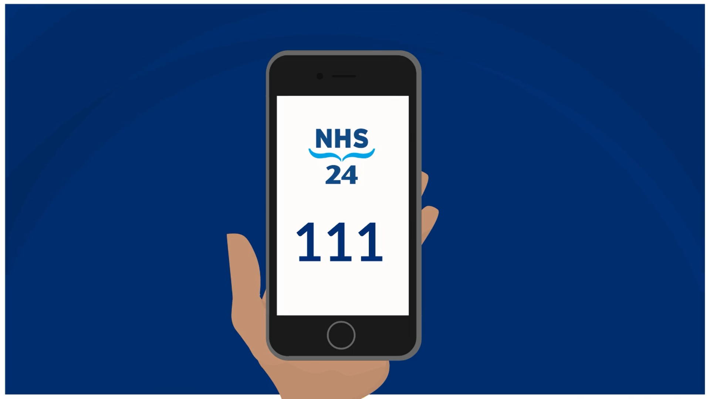

IVR image speech bubbles
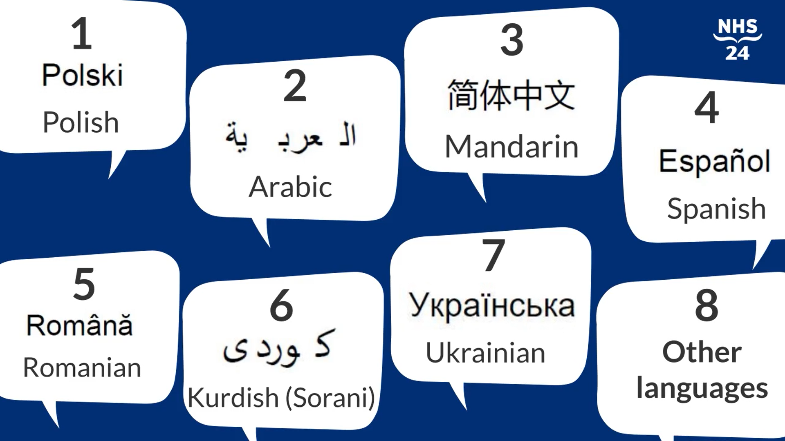
WhatsApp animated image (GIF) - right click on image and then use Save As.
Multi-lingual animation
We have developed a short multi-lingual animation showing what callers should do to access the 111 service in other languages. Each animation includes a translated voiceover and translated captions. It is available in English, Arabic, Mandarin, Polish, Romanian, Sorani, Spanish, and Ukrainian. The download links are below:
- Calling 111 animation: Arabic
- Calling 111 animation: Mandarin
- Calling 111 animation: Polish
- Calling 111 animation: Romanian
- Calling 111 animation: Sorani
- Calling 111 animation: Spanish
- Calling 111 animation: Ukrainian
- Calling 111 animation: English (for all other languages)
Leaflets
The Calling 111 leaflet explains how to get language support when accessing the service. It is available in a number of languages, and the download links are below:
- Calling 111 leaflet in Arabic
- Calling 111 leaflet in Chinese (Simplified) Mandarin
- Calling 111 leaflet in Polish
- Calling 111 leaflet in Romanian
- Calling 111 leaflet in Kurdish - Sorani
- Calling 111 leaflet in Spanish
- Calling 111 leaflet in Ukrainian
The My important information for NHS 24 leaflet can be used to write down key information about their health, things they may be asked if they call NHS 24. It is available in a number of languages, and the download links are below:
- My important information for NHS 24 leaflet in Arabic
- My important information for NHS 24 leaflet in Chinese (Simplified) Mandarin
- My important information for NHS 24 leaflet in Polish
- My important information for NHS 24 leaflet in Romanian
- My important information for NHS 24 leaflet in Sorani
- My important information for NHS 24 leaflet in Spanish
- My important information for NHS 24 leaflet in Ukrainian
For other languages and formats visit NHS inform

Need more information?
Promotional resources listed in this toolkit can be downloaded from the NHS 24 website: www.nhs24.scot/non-english-interactive-voice-response
Do get in touch if you have any questions about the multi-lingual IVR!
Email our team at NHS24.EngagementTeam@nhs24.scot.nhs.uk and one of us will be delighted to get back to you.
Thank you

