Summer Workshops and Events at Perth Museum and Art Gallery

All Aboard the Miniature Train!

26th June 2021: Mill Street Plaza
Come and celebrate the launch of our All Aboard! exhibition at Perth Museum and Art Gallery with a trip on a miniature train. The Ride-Along Miniature Train will be at Mill Street Plaza in front of Perth Museum and Art Gallery between 11.00am – 3.30pm.The train is free to board and will be running on a drop-in basis.
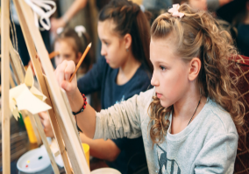

Crafty July for Creative Kids:
- Mini Clay Houses :15th July 2021 : 10 15am-12 15pm.
In this workshop, children will be designing their own quirky clay house or even a replica of their own home!
- Decorating Wooden Bunting: 15th July 2021 : 2pm-4pm
Children joining this workshop will be decorating wooden bunting using our super-colourful pens.
- Mini Acrylic Canvas Painting: 22nd July 2021 :10 15am-12 15pm
Children will be encouraged to paint their own summer-themed canvas.

- Pom-Pom Bugs and Sun Catchers: 22nd July 2021: 2pm-4pm
Children will be encouraged to let their imagination go wild to create their very own sensational summer bug and suncatcher!
Booking via eventbrite for Crafty Kids. Suitable for children 8+ years. Each workshop costs £10-all materials included.
https://www.culturepk.org.uk/whatson-search-results/?event=children-and-families

