What are our aims?

- To provide English language support across the curriculum for bilingual children.

- To support teachers of bilingual pupils and liaise with other agencies who may also be involved.

- To promote the welfare of these children in school and in the community

- To ensure equality of opportunity and access to the mainstream curriculum.

- To work in partnership with schools to promote effective home/school
communication.

- To raise awareness of the linguistic, cultural and religious background of EAL pupils.



What do we offer?

Consultation on all matters concerning bilingual children (in nursery, primary, or secondary)

- INSET/Twilight Sessions –Staff Awareness

- Direct Tuition

- Co-operative teaching

- Consultation & Curricular planning

- Advice on:

Enrolment Procedures

Assessment

Resources

Teaching strategies

Linguistic and cultural issues

Access to bilingual staff

SQA ESOL Qualifications

Who is the service for?

Children –
Whose first or home language is not English e.g.
- Beginners/New Arrivals

- those with limited English

- those who speak fluently but are not achieving their full potential

Teachers
- Class, subject, guidance and support

- Promoted staff & SMT

Who else do we work with?

- Psychology Service

- Speech & Language Therapists

- Sensory Support Services

- Medical Services

- And others who work with bilingual pupils

The EAL Service Staff:
EAL teachers:
- Tricia Davenport – Principal Teacher
- Fiona Anderson
Polish Community Link Workers:
- Violetta Malon
- Dorota Marciniec
Community Learning Assistant:
- Ullas Mann (Urdu, Hindi, Punjabi)
Pupil Support Assistant:
- Linda Dumitras (Romanian)-Supply

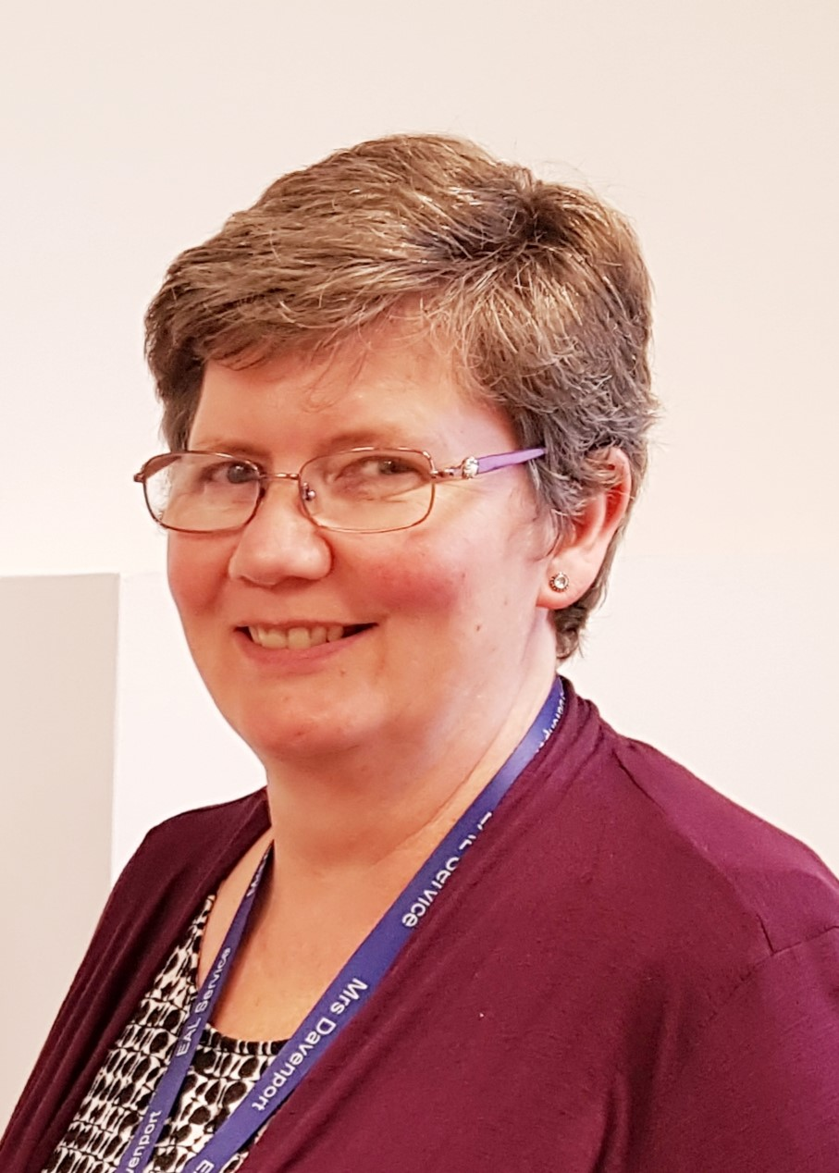

T Davenport PT F Anderson
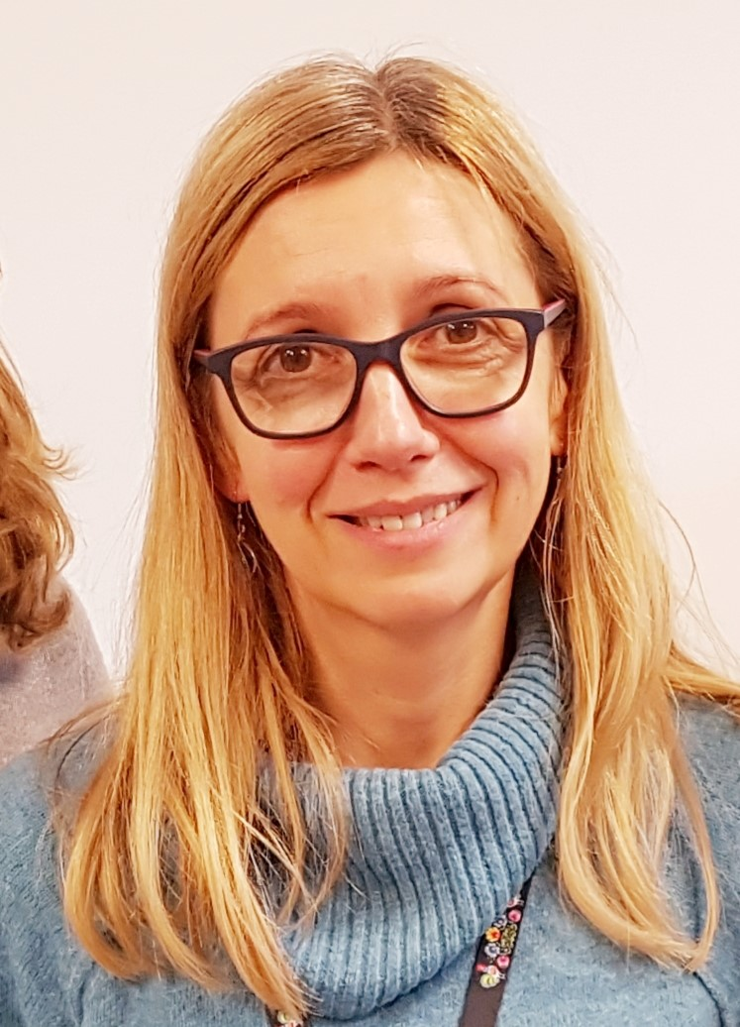
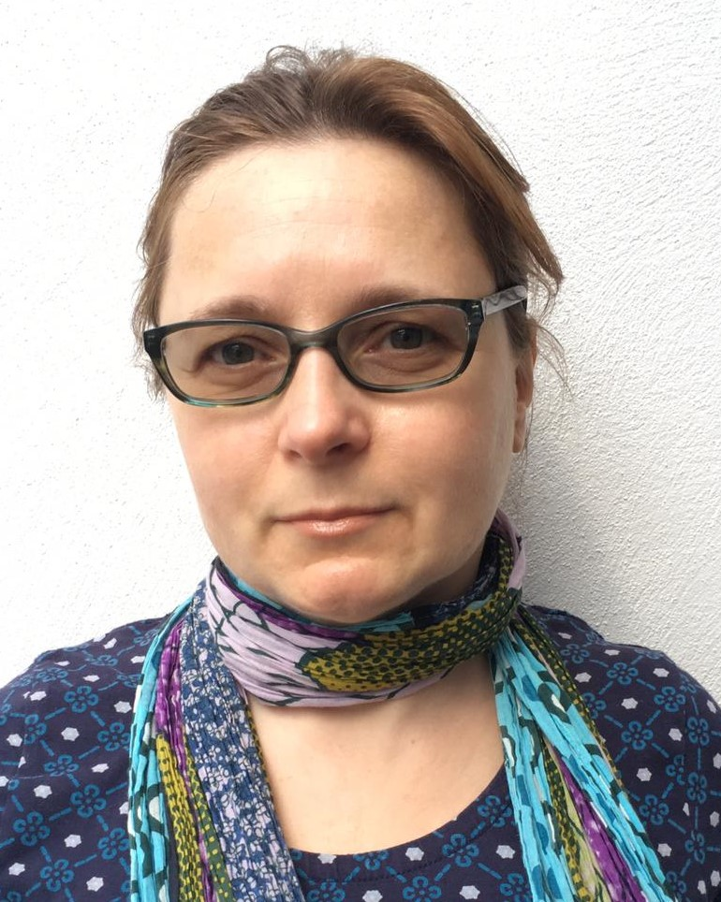

V Malon D Marciniec
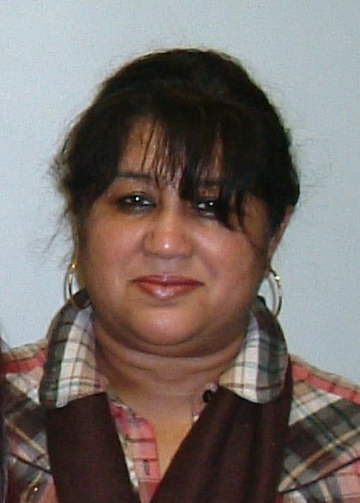

U Mann

How can you get in touch?

Contact –
Tricia Davenport
EAL Service
North Inch Community Campus
Gowans Terrace
Perth
PH1 5BF
Tel- 01738 454480
E-Mail –
tdavenport@pkc.gov.uk



https://blogs.glowscotland.org.uk/pk/ealblogs/

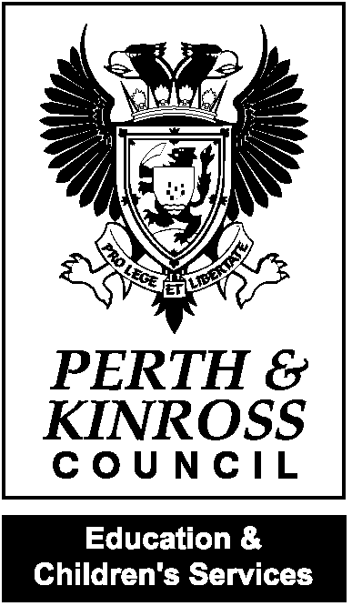

English

as an

Additional

Language
Service

Supporting Bilingual
Pupils in
Perth & Kinross

