Dunbarney Primary School
The 4 Part Lesson Model

Teacher Pack

THIS PACK INCLUDES:
- An explanation of the 4 part model and how to use it
- Photographs to support implementation
- A list of strategies we may use for each of the 4 parts

Education must develop every child’s personality, talents and abilities to the fullest. It must encourage the child’s respect for human rights, as well as respect for their parents, their own and other cultures and the environment.
[UNCRC Article 29 The Goals of Education.]

Honesty Ambition Respect Kindness

What is the 4 part lesson model?
At Dunbarney all teachers use the 4 part lesson model framework which is built from the idea of the “Accelerated Learning Cycle”. Accelerated learning is the term that the TEEP model uses to describe the techniques and strategies that we use to actively engage learners in learning. It is based on research of brain function, student motivation and multiple intelligences and provides a platform for life-long learning by promoting the importance of understanding how we learn as much as what we learn. The key ideas of accelerated learning can be briefly summarised as:

- Making connections with prior knowledge and experiences
- Experiencing the content of the curriculum through the senses
- Supporting students to take risks in their learning
- Allowing opportunity for exploratory talk
- Providing students with relevant and useful feedback
- Offering learning experiences that are both pleasurable and memorable
- Regular review of learning”
(Taken from http://www.teep.org.uk on 18/10/2011)

The ‘Accelerated Learning Cycle’ was originally devised by Alastair Smith and works under 4 main headings as listed below.
Connect: Make learning personal. Start by connecting to what has been learned before. Involve the whole group, create a learning climate, agree the outcomes and share the Big Picture.
Activate: Help students familiarise themselves with key information. Make this multisensory, pose questions and engage curiosity. Engage students directly with the problem presented.
Demonstrate: Give students opportunities to show understanding. Use feedback to fine tune learners’ thinking. Make this a highly interactive student-centred phase and provide educative feedback.
Consolidate: Reflect on what has been learned and how. “What do we now know and understand that we didn’t know before? How have we learned? How can we apply our learning elsewhere?”

How do I use the 4 Part Lesson Model?

The four part lesson model isn’t as prescriptive as it may sound.
Each of the four parts are what most of us already consider when planning our lessons – the addition consideration is making it visible to the learners. It’s about ensuring that they understand what the 4 parts of the lesson are, and how each part is valuable to their learning. This ties in very well with John Hattie’s work on making learning visible.

We can decide how to display and use the resources in a way that suits our children best. They can be displayed on a large whiteboard, on an IWB (this can pose problems when screen changes) or on separate display boards. At Dunbarney we use the wedge in class to consistently display the 4 Part Model throughout lessons so that they can be seen and used throughout the learning experience. NCCT teachers have a ‘travel board’ which they can take with them wherever they go, ensuring that they always have what they need to hand, while maintaining consistency throughout the school. This is a collapsible wedge which contains polly-pockets for every lesson.

The diagram below incorporates ideas from both the accelerated learning cycle and the 4 part lesson model. It also uses our agreed colours in their correct places.

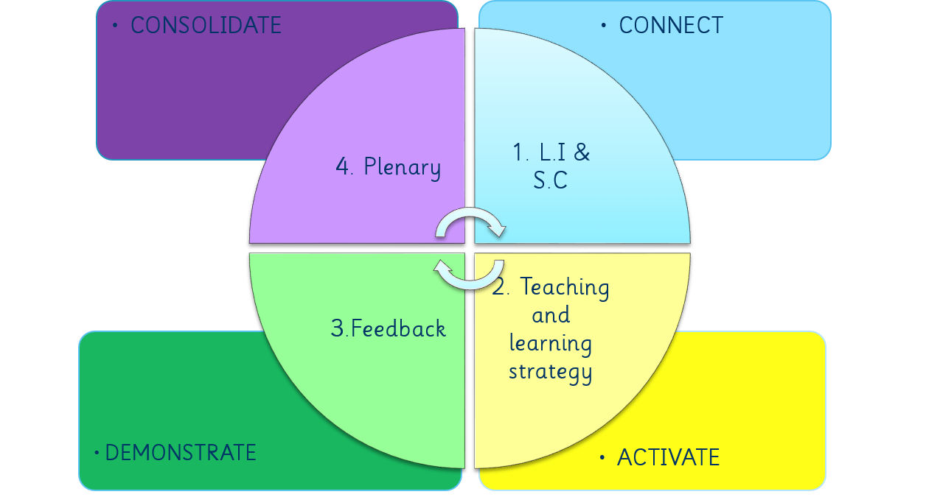

Part 1 : Learning Intentions and Success Criteria - CONNECT
- Planned learning to clearly identify and address pupil’s needs
- REFLECT on previous learning – what do we already know?
- Children involved in planning process and agreeing targets – what and how are we going to learn?
- Awareness of skills involved – how will this learning benefit us in the future?
- Positive attitudes to learning.
- This part shouldn’t take too long, 5-10 minutes at the beginning of the lesson.

Part 2: Teaching and Learning Strategy - ACTIVATE
- Present the children with the information they need and an activity to complete or a problem to solve
- Pick one or two learning strategies which lend themselves to the curricular area
- Vary strategies to cater for different needs.
- Together with the children, learn the definitions of each strategy and SLOWLY introduce to classes using the progression provided in this pack.

Part 3: Feedback - DEMONSTRATE
- Children to use different AifL strategies to feedback on their learning – what have I learned? what do I know that I didn’t know before? (This is not for children to feedback on the delivery of the lesson or their teacher’s performance!)
- Ensure the children understand the importance of instant feedback in various forms
- Have an active ‘Assessment Station’ in your classroom where the children can self-assess their own learning. *see picture included in the pack
- Get the children in to the habit of using their learning pit/ bridge to success as part of the feedback.

Part 4: Plenary - CONSOLIDATE
- The plenary is often rushed (or forgotten) yet it is crucial to developing the children’s learning. This should be given ample time as part of the lesson.
- Choose one of the plenary cards which fits the activity best.
- These should be changed around like the teaching and learning strategies.
- Review the methods of learning and the learning itself and discuss progress that has been made, and what the next steps are.
Photographs

1.

- A P5 assessment station. This was stocked with highlighters, pens, post-its, stamps and stickers to allow the children to self-assess their work.

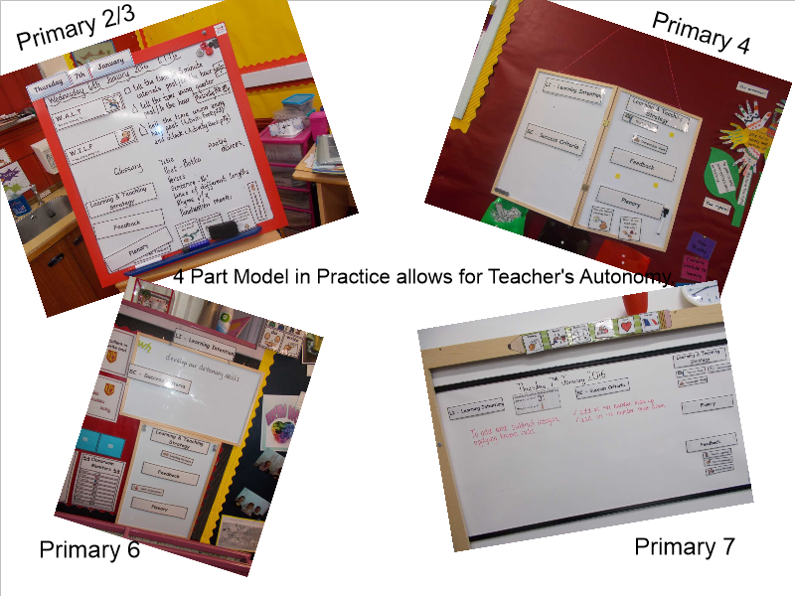
2.

This picture demonstrates the element of choice and creativity. Each teacher chooses their own way of displaying – this can incorporate the use of puppets, characters and sound effects. The top right picture is similar to the NCCT board referred to earlier. It is smaller, lighter and easily transported from class to class.
3.
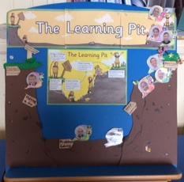

Using our learning pits during the feedback part of the lesson will help us use them in a more regular, meaningful and linked way.
Not only will it give the teacher an instant picture of how the children in the class are feeling about their learning, it will prove a useful tool for facilitating rich discussion regarding the three feedback questions John Hattie says it is vital the children are able to answer:

- WHERE am I going? (What are my goals?)

- HOW am I going? (What progress is being made towards the goal?)

- WHERE am I going NEXT? (What activities need to be undertaken next to make better progress?)

*Each classroom should have a learning pit with the children as avatars - the design of the learning pit can take various forms, the important thing to remember is that it is accessible to the children. This session we will incoroparte the Bridge to Success – bridging the gap in our learning.
NOTE:
Feedback vs. Praise

Do not confuse feedback with praise. Feedback is not about approval – it’s about finding out about where to go next.

In learning it is better to increase informational feedback and go lean on praise.

John Hattie (2012)

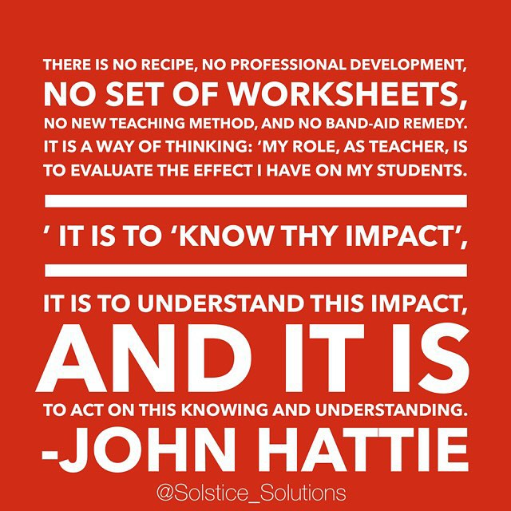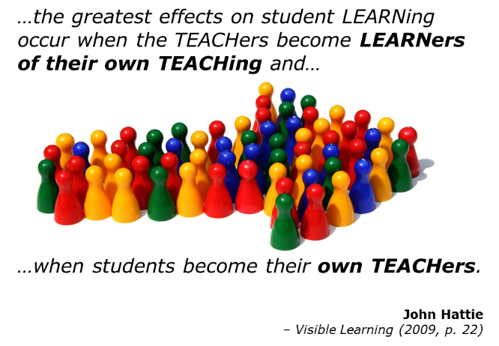

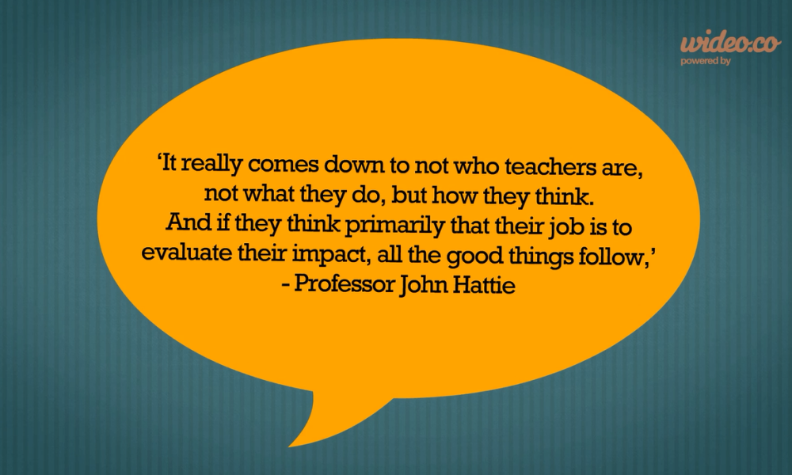
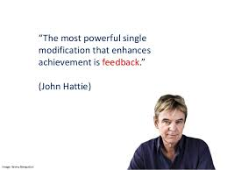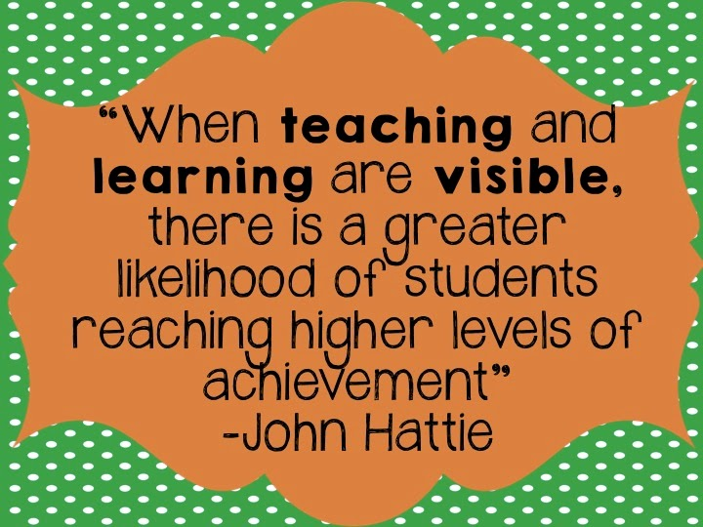

Strategies we may use for each part of the lesson

Strategy Used during :
2 Stars and a Wish Feedback Plenary
4 Finger Check L&T Strategy Feedback Plenary
Appointment Cards Feedback Plenary
Brain Breaks Feedback
Carousel L&T Strategy
Chilli Challenge L&T Strategy Feedback
Cooperative Learning L&T Strategy Feedback Plenary
Discussion L&T Strategy
Exit Pass Plenary
Fat or Thin Questions L&T Strategy
Fist of Five Feedback Plenary
Gallery Walk L&T Strategy Feedback Plenary
Group Work L&T Strategy
Highlighting Feedback Plenary
Hot Seating L&T Strategy Feedback
Independent Work L&T Strategy
Investigating L&T Strategy
Kind Calling Out Feedback
Learning Partners L&T Strategy
Learning Pit L&T Strategy Feedback Plenary
Lollypop Sticks L&T Strategy Feedback Plenary
Marking Guide Feedback Plenary
Marking + = - Feedback Plenary
No Hands Up L&T Strategy Feedback Plenary
Numbered Heads L&T Strategy Feedback Plenary
Peer Marking Feedback Plenary
Post-box Comments Plenary
Practice L&T Strategy
Problem Solving L&T Strategy
Question Openers L&T Strategy Feedback
Reflection Time Feedback Plenary
Review of Learning Feedback Plenary
Sharing Good Work L&T Strategy Feedback Plenary
SMART Targets Feedback Plenary
Snowballing L&T Strategy Feedback
Take a question round L&T Strategy Feedback
Talking Partners L&T Strategy Feedback
Talking Tokens Plenary
Target Setting Feedback Plenary
Teacher Directed L&T Strategy
Think-Pair-Share L&T Strategy
Thinking Time L&T Strategy
Thumbs Feedback Plenary
Tic Tac Toe Plenary
Traffic Lighting Feedback Plenary
Travelling Discussion L&T Strategy
Two Stars and a Wish Plenary
Two Things L&T Strategy Feedback Plenary
Two Truths and a Lie Plenary
Verbal Feedback L&T Strategy Feedback
Visible Planning L&T Strategy Feedback Plenary
Wait Time L&T Strategy
Walkabout Talk about L&T Strategy Feedback
What went well… Feedback Plenary
Even better if…
Writer’s Chair L&T Strategy Feedback Plenary
Write- Pair – Share L&T Strategy

