Headteacher’s report – Parent Council
Monday 28th September 2020

Term 1 Pupil attendance (weekly)
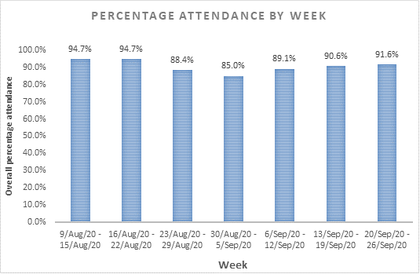
Term 1 Pupil attendance (daily)

Term 1 Staff attendance

557 periods of cover (Term 1 2018/19)
418 periods of cover (Term 1 2019/20) 91 periods of cover (Paris 2019)
369 periods of cover (Term 1 2020/21)
188 periods less cover (34% reduction from 2018/29 to 2020/21)
147 hours more contact with timetabled teacher compared to 2018/19

Staffing update
PT Home Economics: Gwen Barrowman has decided to step down from her Principal Teacher of Home Economics post. In the interim, Graeme Aitken will be PT Health and Wellbeing across HE and PE.
PT Science: Jude Finlayson started her maternity leave this week. Lynsey Potter has joined us on secondment from Blairgowrie High School.
Mathematics: Sharon Lang will be retiring from her Teacher of Mathematics post at the end of October 2020.
In addition, we have made the following staffing appointments:
- Catriona Smith (Campus Management Assistant)
- Nicola Shaw (Pupil Support assistant)
- Victoria Cameron (Pupil Support Assistant)

COVID arrangements – Staff views on in-school arrangements

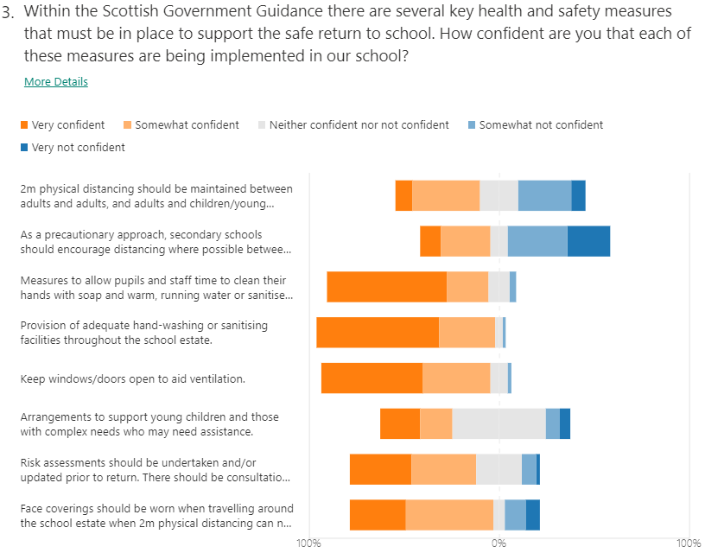

2m physical distancing should be maintained by adults and adults & adults and young people
41.2% of Crieff HS staff responded ‘Very confident’ or ‘Somewhat confident’ (Sep ’20) compared to 11% nationally (EIS Reopening schools in Scotland survey – 60% turnout – Aug ’20)
As a precautionary approach, secondary schools should encourage distancing where possible between S5/S6 pupils
35.3% of Crieff HS staff responded ‘Very confident’ or ‘Somewhat confident’ (Sep ’20) compared to 8.3% nationally (EIS Reopening schools in Scotland survey – 60% turnout – Aug ’20)
BGE Curriculum Review

