“Reading Around the Subjects”
BGE Reading List Session 20-21

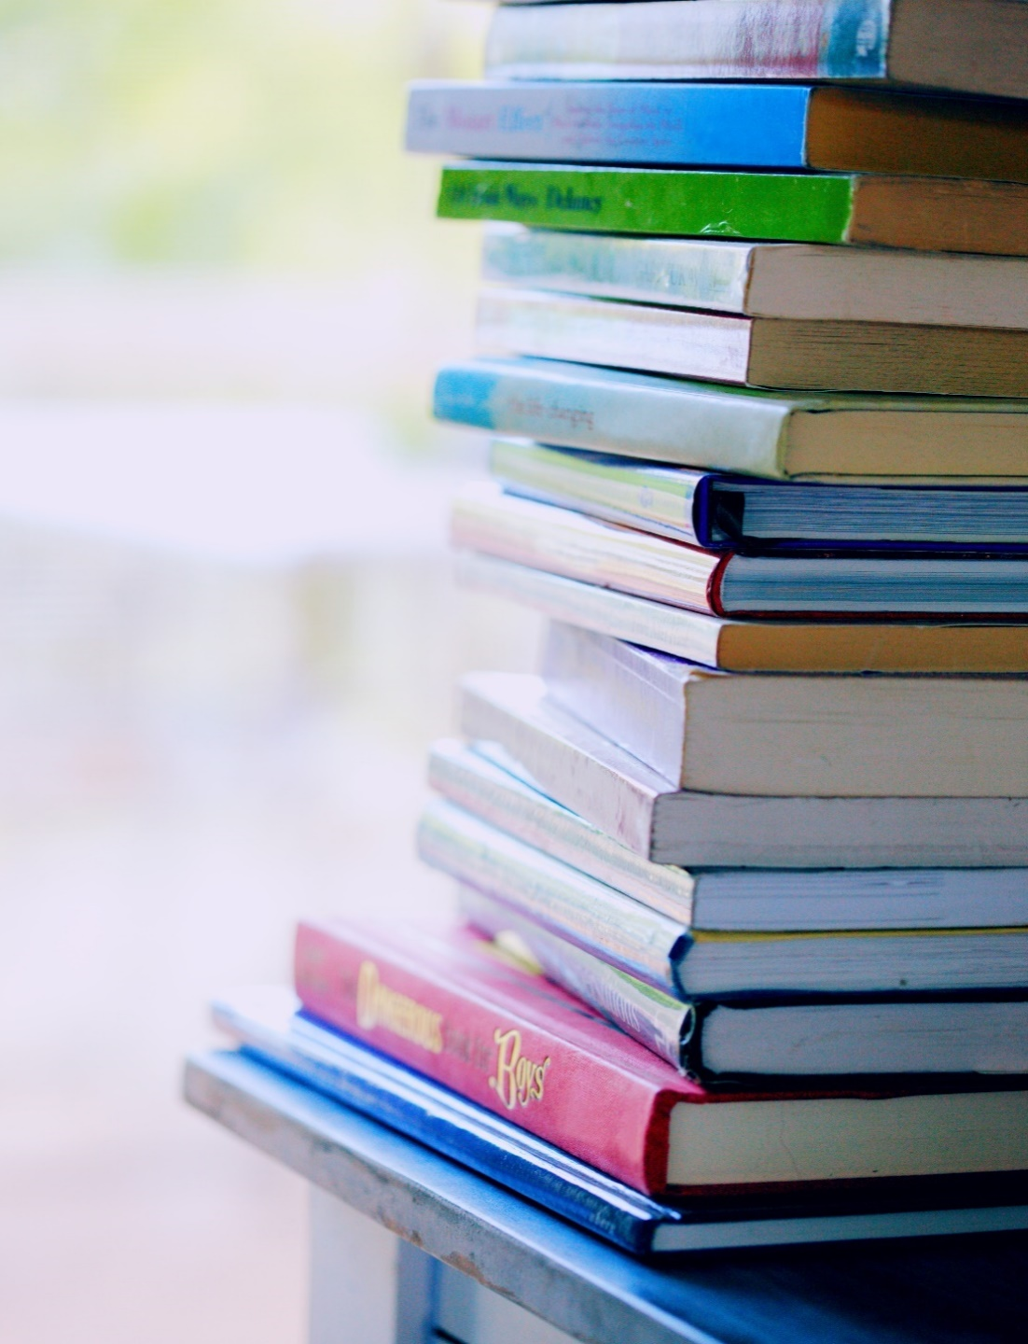

Crieff High School Broad General Education (S1, S2, S3) - “Reading to Enhance Your Subject Knowledge”

Becoming a stronger reader is the number one way to become a stronger learner. We would like to encourage our S1 – S3 pupils to “read around” their favourite subjects to strengthen both their literacy and their subject knowledge. The following books and links have been recommended by subject specialists to encourage wider reading in their subject.

Contents:
Art and Design
CDT
Drama
English
Geography and Modern Studies
History
Home Economics
Mathematics
Music
PE
RMPS
Science

Art and Design:

For Art and Design the link to our Pintrest page for all years is very useful for the pupils generating ideas for their work.

https://www.pinterest.co.uk/mairijohnstone5711/boards/

‘The Art Story’ (www.theartstory.org) A guide to Visual Art – gives you key information about artists and analyses artists’ work.

‘Student Art Guide’ (www.studentartguide.com) This website shows exemplar sketchbooks for inspiration.

‘Tate Modern’ (www.tate.org.uk) This website has a ‘Tate Kids’ section with quizzes and activities as well as great information on artists and exhibitions.

‘V&A Dundee’ (www.vam.ac.uk/dundee) As well as other information, there is a ‘Learn’ section with a ‘resources’ section which has a range of challenges for individuals and families.

‘V&A London’ (www.vam.ac.uk) Free access to online collections from the famous museum of Art & Design.

‘The Design Museum’ (www.designmuseum.org) An online design collection with video interviews.

‘Colossal’ (www.thisiscolossal.com) This is one of the biggest inspiring art, design and culture blogs.

The following Scottish Art & Design School’s are holding their graduate exhibitions online this year:
Duncan of Jordanstone College of Art & Design (www.dundee.ac.uk)
Gray’s School of Art (www.rgu.ac.uk)
The Glasgow School of Art (www.gsa.ac.uk)
Edinburgh College of Art (www.eca.ed.ac.uk)
Heriot-Watt School of Textile and Design (www.tex.hw.ac.uk)

CDT:

We would recommend the BBC Bitesize website for getting pupils thinking about our subject:
https://www.bbc.co.uk/bitesize/topics/z3ngjxs/resources/1

Drama:

- 33 Short Comedy Plays for Teens: Plays for Small Casts  Titles include: Crazy Hair Day, Flavor of the Week, Juliet Tryouts, Tornado Drill and Chatterbox. | 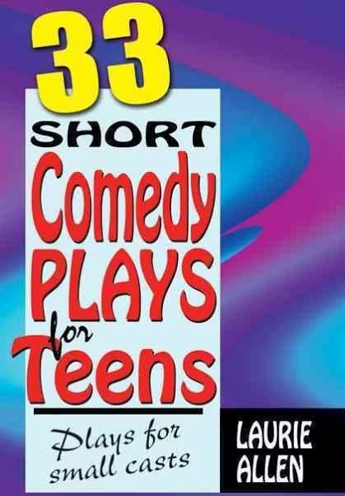
- Theseus and the Minotaur - Myths and Legends by Graeme Davis  Graeme Davis draws upon the classic sources to retell the great myths and legends of Theseus, the founder-king of Athens, and backs this narrative with a factual examination of the myth, its variations, and its development over time. | 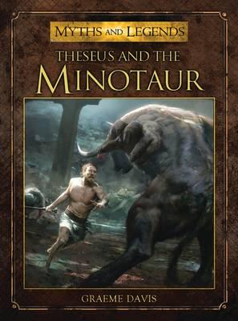
- The Curious Incident of the Dog in the Night-Time (play) by Simon Stephens  A murder mystery like no other, this novel features Christopher Boone, a 15 year-old who suffers from Asperger's syndrome. When he finds a neighbour's dog murdered, he sets out on a journey which will turn his whole world upside down.  Recommended for S3 and up | 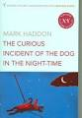
4.The Boy in the Striped Pyjamas (stage version) By John Boyne Adapted by Angus Jackson  Bruno has a friend called Shmuel. Like Bruno, Shmuel is nine years old. Their birthdays are on the same day. But Shmuel lives on the other side of a fence, and he's always wearing striped pyjamas...Based on the best-selling novel by John Boyne, The Boy in the Striped Pyjamas is a heart-wrenching tale of an unlikely friendship between two innocent boys. | 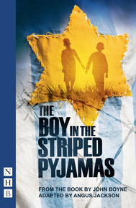
5.National Theatre: All About Theatre  Described by Benedict Cumberbatch as 'a brilliant introduction to theatre', this fascinating book by the National Theatre shows how plays like War Horse and many others are made. | 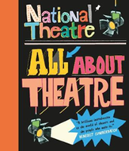
6.Introduction to Theatre Arts: Student Handbook: A 36-week Action Handbook Paperback – Student Edition, 1 Aug. 2003 by Suzi Zimmerman  At last! -- a student-friendly, teacher-friendly workbook with study units for an entire year of classroom drama activities. The entire spectrum of theatre is covered in ten sections: Getting started; Evaluation; Scene work; Acting; Characterisation; Publicity and other production business; Play production; Theatre history; Games and improvisation; Planning for the future. | 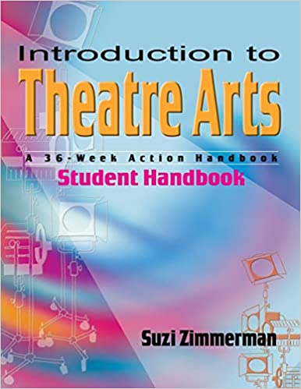

English:

Help your Kids with Spelling and Grammar by Carol Vorderman.  This excellent grammar book covers all the basics and is colourfully illustrated. This book is suitable for young people as well as parents. | 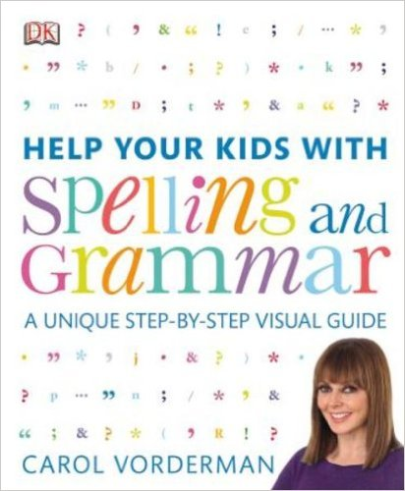
What’s so Special about Shakespeare by Michael Rosen. This is a lively and accessible book on the life and works of William Shakespeare by award-winning author Michael Rosen. | 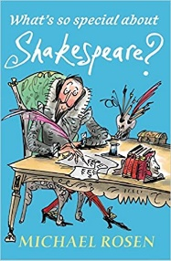
In “The Stories of English” linguist David Crystal writes brilliantly about the evolving English Language (suitable for confident readers) | 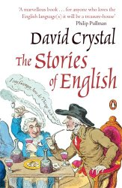
“A Velocity of Being: Letters to a Young Reader” edited by Maria Popova and Claire Bedrick is a compendium of writing about the joys of reading. | 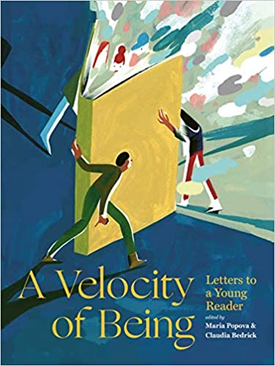
“Learning How to Learn” By Barbara Oakley is a engaging guide for teens on how to study effectively, grounded in neuroscience. | 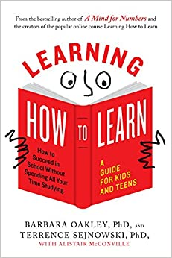
“Dyslexia is my Superpower” by Margaret Rooke uses more than 100 interviews with children and young adults where they reveal their personal tips and tactics for honing the creative benefits of dyslexia, enabling them to thrive in school and beyond. An inspiring read for young people with dyslexia. | 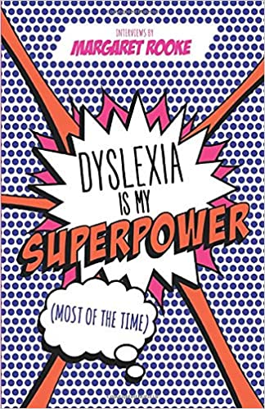
Dyslexia: A Teenager's Guide by Dr Sylvia Moody helps young adults tackle problems associated with their dyslexia with strategies uniquely suited to their needs. Clearly and simply written by a leading expert in the field, the book helps with reading, writing, spelling and memory, as well as giving tips on how to take notes, organise study, deal with examinations and use IT. It also shows how to improve confidence, deal with stress, and build on the creative talent that many dyslexics possess. | 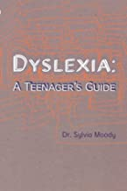

The Scottish Book Trust has lots of excellent reading recommendations for young people between the ages of 12-14:
https://www.scottishbooktrust.com/book-lists
BGE Geography and Modern Studies Further Reading/Activities

Reading
Explore these wonderful stories by authors campaigning for oceans. They make the perfect story for any child with a passion for ecology and the environment.
https://www.authors4oceans.org/our-books-1

The Centre for literacy in Primary Education has created their great booklist of books about the environment. It includes picture books for less confident readers, as well as fiction for more confident readers. Poetry and non- fiction (focusing on what actions young people can take to tackle environmental issues) are also included.
Click on the link and download the ‘Environment list’
https://clpe.org.uk/clpe/library/booklists/environment-booklist

A selection of graphic novels exploring human rights. Sensitive issues for less confident and confident readers
https://www.amnesty.org.uk/recommended-graphic-novels-children-and-young-adults

A selection of fiction books exploring human rights. Sensitive issues for confident and more confident readers.
https://www.amnesty.org.uk/fiction-secondary-school-teach-human-rights-literature

Two books by young people that are changing the world. Both have young readers editions available for less confident readers. The third book is a picture book that explains the history of countries borders (suitable for confident and more confident readers)

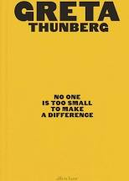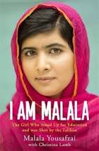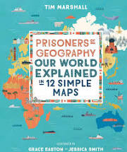
Other activities

Watch and visit the CBBC Newsround programme and website. Great for keeping up to date with current affairs both in the UK and abroad
https://www.bbc.co.uk/newsround

Google Arts & Culture is an online platform through which anyone can view high-resolution images and videos of artworks and cultural artefacts from galleries and museums throughout the world.
https://artsandculture.google.com/

Google Expeditions is an education app that allows you to explore the world through over 1000 virtual-reality (VR) and 100 augmented-reality (AR) tours. You can swim with sharks, visit outer space, and more without leaving the classroom.
https://support.google.com/edu/expeditions/answer/6335093?hl=en

Google Earth allows you to see 3D representation of Earth based primarily on satellite imagery. The program maps the Earth by superimposing satellite images, aerial photography, and GIS data onto a 3D globe, allowing users to see cities and landscapes from various angles.
https://earth.google.com/web/

Dollar Street on the Gapminder website is excellent at looking at different families from around the world and exploring the idea of development.
https://www.gapminder.org/dollar-street/

National Geographic free colouring sheets of maps and famous landmarks.
https://www.nationalgeographic.org/coloring-page/

A website that shows your different activities to do in different regions of the UK:
https://getoutside.ordnancesurvey.co.uk/

A huge selection of Geography games, from guess the flag to the highest mountain and everything in between:
https://world-geography-games.com/

What do you want to know about any country in the world? You will find the answer here.
https://knoema.com/atlas

Explore the planet of Mars, with real life footage
https://accessmars.withgoogle.com/

National Geographic Explorer Classroom’s live video events connect pupils with National Geographic Explorers across all seven continents to bring exploration to life. Free weekly videos with real explorers.
https://www.nationalgeographic.org/education/student-experiences/explorer-classroom/

Keep Scotland Beautiful offers a number of interactive courses that you can choose from to take part in on a whole host of environmental issues.
https://www.keepscotlandbeautiful.org/sustainable-development-education/learning-online/

Apply to Blue Peter to get a ‘green’ Blue Peter badge. More details are found on the website
https://www.bbc.co.uk/cbbc/findoutmore/blue-peter-apply-for-a-green-badge

History

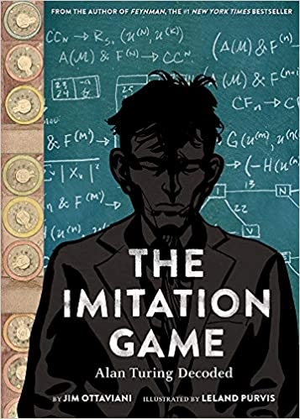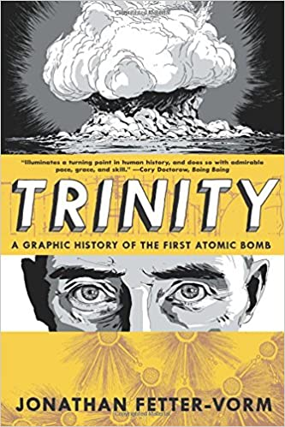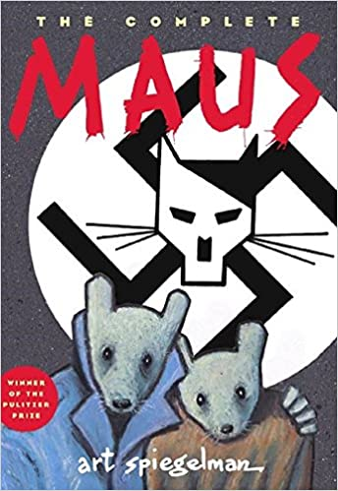
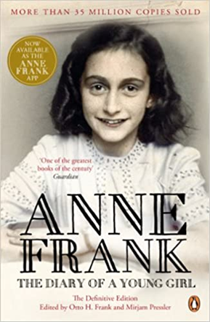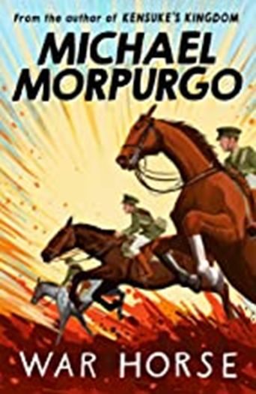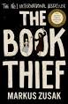
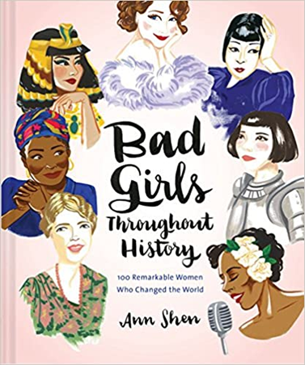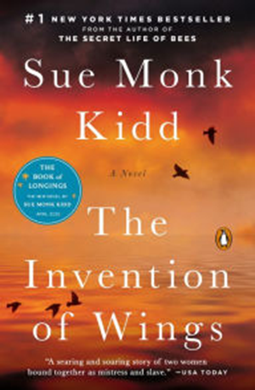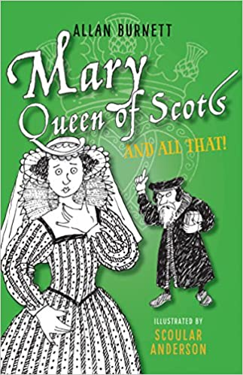
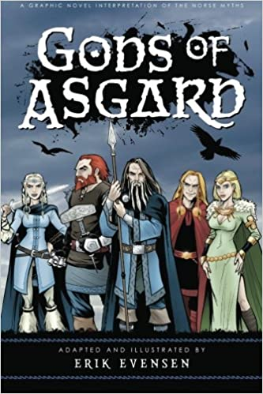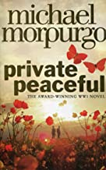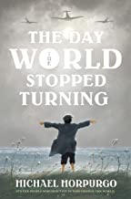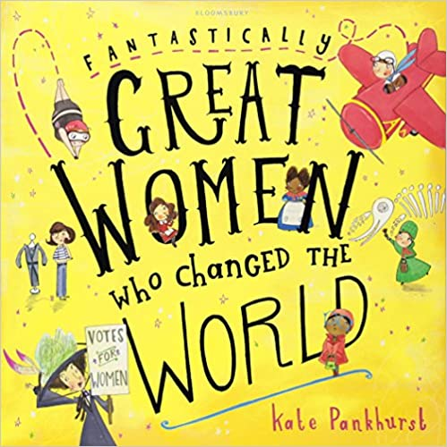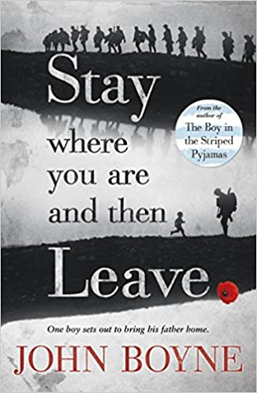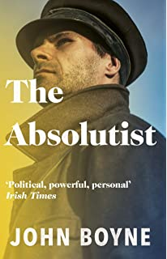
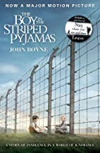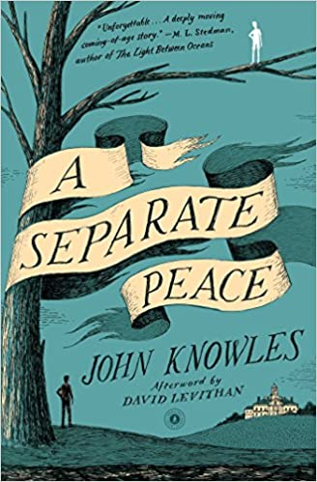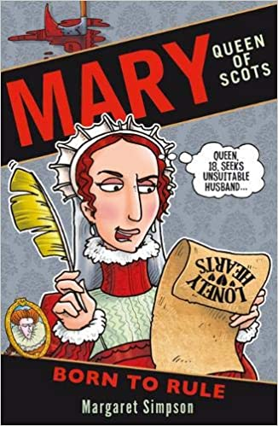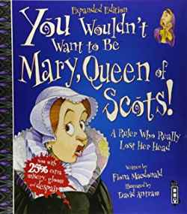

History Watchlist
(Parents are advised to check film certificates to decided if that film is suitable for their young person)

S2 BGE ( and also useful for new S1s to watch)
1. Horrible Histories – Mardy Mary, Queen of Scots (27 minutes)
https://www.bbc.co.uk/iplayer/episode/b05yt88s/horrible-histories-series-6-4-mardy-mary-queen-of-scots-special

2. Bloody Queens Elizabeth and Mary – BBC Documentary (57 minutes)
https://www.youtube.com/watch?v=G3F8iq7aT4Y

3. Dan Jones: Mary Queen of Scots, the Stewarts and Stirling (14 minutes)
https://www.youtube.com/watch?v=wbEX0gJQPyc

- Mary Queen of Scots (Film currently on Now TV)
- Vikings (Amazon series)
- The Help
- Remember the Titans (On Disney Plus)
- Selma
- Gladiator

Reading Around Home Economics:

One of the best ways to increase your knowledge of practical food is to browse through recipe books. They provide inspiration for practical creativity. We could not begin to provide a definitive list as creativity in the kitchen can be a very personal and individual activity, or a fun time with friends!
The best way to start is simply visit the cookery section in the library and see what you are drawn to.
- For fans of “The Great British Bake Off” anything by Mary Berry or Paul Hollywood is a must. Also explore the range of cake decorating books available – wow!!!
- For those of you who are eco-aware, anything by Hugh Fearnley-Whittingstall is a must. He writes great recipes based around sustainability and local produce. Saving the planet one mouthful at a time – yum!
- For those of you who enjoy foreign travel, the options are endless. I am currently exploring Middle Eastern cuisine and have found Yotam Ottolenghi to be a particularly interesting author.
- For those of you who are interested in current trends, Clean Eating is very topical. “Deliciously Ella” is a very accessible book – some authors of “diet” books can be a bit regimented and proscriptive in their approach – this suggests rather than dictates.
- For those toying with the idea of reducing their intake of animal produce - whether for health, ethical or environmental reasons – there are many books on vegetarianism and veganism.
- Planning on university? Explore cookery books for those on a budget, such as “The Credit Crunch Cookbook”.
- Finally “Meal in a Mug” – all you need is a mug and a microwave to make cakes, curries and everything in-between. Love it!

Guilia Enders - Gut: the inside story of our Body’s Most Underrated Organ is not a recipe book, but I loved it. Aimed more at seniors who are interested in medicine, microbiology, dietetics etc.
Miss McCully has also suggested a few of her current favourites:
- Marcus Wearing – New Classics
- Marcus Wearing – Marcus Everyday
There are also lots of fantastic websites out there which allow you to keep up-to-date with developments in Food & Nutrition. Some of our favourites are:
https://www.foodafactoflife.org.uk/
The brilliant thing about this website is that the information and resources are divided into different age groups, so if you decide to explore a new topic, you can start basic, and then move on as you feel ready. Recipes, videos, skills development – it has it all.
https://www.bbcgoodfood.com/
Recipes galore categorised by level of difficulty, cost, ingredient and time needed.
https://www.rhet.org.uk/
Interesting resources linked to Scottish Farming.
https://pinchofnom.com/
We wouldn’t normally recommend “Diet Books”, but this site is much more than that – tips and information on healthy eating.
https://www.recipetineats.com/
Miss McCully has recommended this Blog – quick, tasty recipes using storecupboard ingredients.

https://scotland.lovefoodhatewaste.com/
This website does exactly what it says on the tin! Provides lots of information and ideas for reducing food waste. Save the planet, save the pennies and enjoy great food!
https://www.greenpeace.org.uk/
Now whilst some people may disagree with Environmental Activism, Greenpeace is still a fantastic source of information on food sustainability, over-production of some foods and the overfishing of our seas, to name just a few topics.
https://www.qmscotland.co.uk/
Discover more about the fantastic red meat produced by Scottish Farmers. The section on Health & Education is probably the best place to start.
https://www.vegsoc.org/
Lots of information on vegetarianism.
https://www.vegansociety.com/
If you are a vegan – make sure that you are knowledgeable and skilled.
https://www.gardenersworld.com/
Firstly – I am no gardener; however, I do grow my own herbs and dabble with vegetables. If any of you are interested in growing your own food – sustainable, local, inexpensive and good exercise both physically and mentally, then I am assured this is the site for you. A fellow CHS teacher, and keen gardener recommended it – I have had a quick look and there is lots on developing a vegetable garden from scratch. I also found the information on wildlife gardening very interesting.

We hope you enjoy perusing some of these websites and books - Miss McCully and myself certainly do, and if you do cook something amazing, or grow your own vegetables – please let us know. We love pictures as we can tweet them!
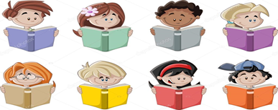
Take care and have fun!
The HE Team

Mathematics

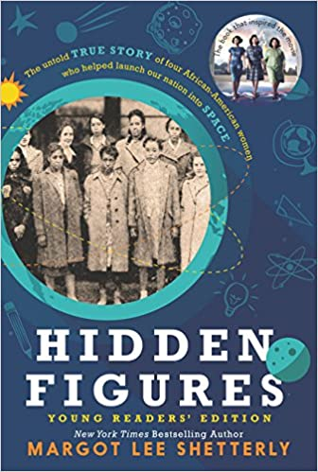
Hidden Figures (Young Reader’s Edition) by Margot Lee Shetterly
Before Yuri Gagarin orbited the earth, or Neil Armstrong walked on the moon, a group of dedicated female mathematicians known as "human computers" used pencils, slide rules, and adding machines to calculate the numbers that would launch rockets, and astronauts, into space.
This book brings to life the stories of Dorothy Vaughan, Mary Jackson, Katherine Johnson, and Christine Darden, who lived through the Civil Rights era, the Space Race, the Cold War, and the movement for gender equality, and whose work forever changed the face of NASA and the country.

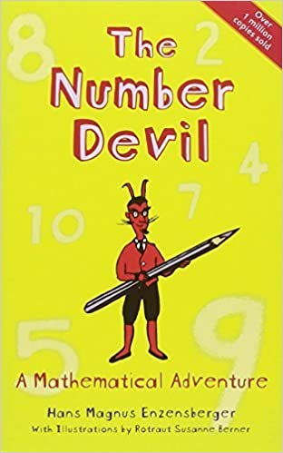
The Number Devil: A Mathematical Adventure by Hans Magnus Enzensberger
Twelve-year-old Robert hates his maths teacher: he sets his class boring problems and won't let them use their calculators. Then in his dreams Robert meets the Number Devil, who brings the subject magically to life, illustrating with wit and charm a world in which numbers can amaze and fascinate, where maths is nothing like the dreary, difficult process that so many of us dread. The Number Devil knows how to make maths devilishly simple.

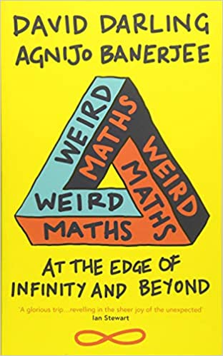
Weird Maths by David Darling and Agnijo Banerjee
Is anything truly random? Does infinity actually exist? Could we ever see into other dimensions?
In this delightful journey of discovery, David Darling and extraordinary child prodigy Agnijo Banerjee draw connections between the cutting edge of modern maths and life as we understand it, delving into the strange – would we like alien music? – and venturing out on quests to consider the existence of free will and the fantastical future of quantum computers. Packed with puzzles and paradoxes,
mind-bending concepts and surprising solutions, this is for anyone who wants
life’s questions answered – even those you never thought to ask.

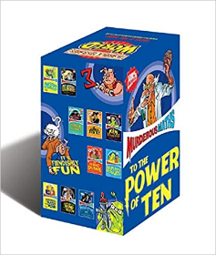
Murderous Maths Books – series by Kjartan Poskitt
There are ten books in the Series and an accompanying website
http://www.murderousmaths.co.uk/

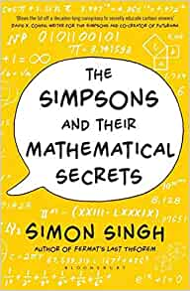
The Simpsons and their Mathematical Secrets – Simon Singh
You may have watched hundreds of episodes of The Simpsons without ever realising that they contain enough maths to form an entire university course. In The Simpsons and Their Mathematical Secrets, Simon Singh explains how the brilliant writers, some of the mathematicians, have smuggled in mathematical jokes throughout the cartoon's twenty-five year history, exploring everything from to Mersenne primes, from Euler's equation to the unsolved riddle of P vs. NP, from perfect numbers to narcissistic numbers, and much more.

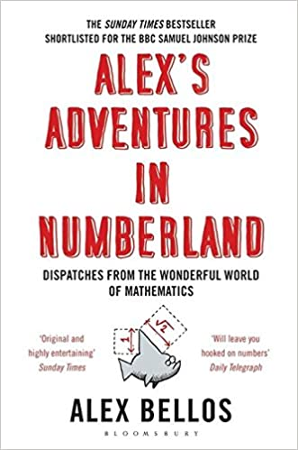
Alex’s Adventures in Numberland – Alex Bellos
The world of maths can seem mind-boggling, irrelevant and, let's face it, boring. This groundbreaking book reclaims maths from the geeks. Mathematical ideas underpin just about everything in our lives: from the surprising geometry of the 50p piece to how probability can help you win in any casino. In search of weird and wonderful mathematical phenomena, Alex Bellos travels across the globe and meets the world's fastest mental calculators in Germany and a startlingly numerate chimpanzee in Japan.

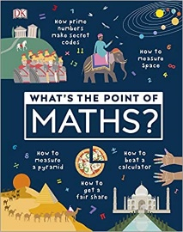
What’s the Point of Maths? – DK Children
This book unpacks how maths is an essential part of our everyday life in ways that you never thought of. Crazy facts, magic tricks, mathematical brainteasers and beautiful illustrations show you that maths is interesting, fun, and unintimidating! Ever wondered where maths originated from? This fantastic educational book unpacks all the curious questions that you may have about mathematics including intriguing historical stories that explore the often-surprising origins of maths that we use in our daily lives.
Learn about how the formation of number sequences began, to the origins of trigonometry and find out how to become a trillionaire! Maths in our daily lives is used in many things that might not even seem that obvious.
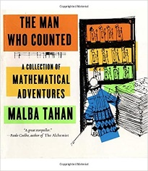
The Man Who Counted – A Collection of Mathematical Adventures – Malba Tahan, Leslie Clark and Alastair Reid
The adventures of Beremiz Samir, The Man Who Counted, take the reader on a journey in which, time and again, Samir summons his extraordinary mathematical powers to settle disputes, give wise advice, overcome dangerous enemies, and win for himself fame, fortune, and rich rewards. We learn of previous mathematicians and come to admire Samir’s wisdom and patience. In the grace of Tahan’s telling, these stories hold unusual delights for the reader."

Music :

Here you can find a range of reading suggestions on the topic of music and musicians:
https://www.startwithabook.org/summer-reading-learning/music-and-musicians

BBC bitesize has plenty to offer and has live lessons: https://www.bbc.co.uk/bitesize/tags/zf9yy9q/year-7-and-s1-lessons

We would also recommend the BBC Bitesize subject specific pages:
https://www.bbc.co.uk/bitesize/subjects/zc2ncdm

PE/Sport reading ideas:

Matthew Syed (UK table tennis champion) and Nico Rosberg (F1 world champion) discuss mental and emotional factors and “marginal gains”.
youtu.be/WoGi3XWwS9c

5 of the most iconic athletes and their stories (link to motivation):
https://greatperformersacademy.com/motivation/the-5-most-iconic-athletes-in-the-history-of-sports-and-their-inspirational-stories

Self Talk in Sport :
https://m.youtube.com/watch?v=qTtipLzFZyk
Roger Bannister’s 4 minute mile https://m.youtube.com/watch?v=q--UlymgZX4
Want to try a different sport? https://www.bbc.co.uk/cbbc/joinin/unusual-sports-to-try
Brian Mac Fitness Testing https://www.brianmac.co.uk/eval.htm
Autobiography/Biography - Fiction/Non-Fiction (All available to purchase as an - book or paperback)
Andy Murray: Seventy-Seven: My Road to Wimbledon Glory
Chris Froome – The Climb – The Autobiography
Tyson Fury - Behind the Mask: My Autobiography
Gymnastics Superstar Simone Biles
Rising Above: Inspiring Women in Sports Paperback
Soccer Stars on the Pitch: Biographies of Today's Best Players
Outcasts United – Paperback (Fiction)
RMPS - Book/Film/Resources for Secondary School Pupils

Title | Author/Director | Overview | Age Group
Holocaust
Boy in the Striped Pyjamas | John Boyne (book and film) | Forbidden friendship between 2 boys, one German one Jewish | All ages
The Diary of Anne Frank | Anne Frank (book and film) | In Nazi-occupied Holland in World War II, shopkeeper Kraler hides two Jewish families in his attic. Young Anne Frank keeps a diary of everyday life for the Franks and the Van Daans, chronicling the Nazi threat as well as family dynamics. | All ages
When Hitler Stole Pink Rabbit | Judith Kerr(book) | This book is about a girl named Anna, who lives in Berlin at the start of the story, just before the German election takes place. She is part of a wealthy family, as her father is an accomplished writer. The Nazi party are candidates for the election. | All ages
Jojo Rabbit | Taika Waititti (film) | Jojo is a lonely German boy who discovers that his single mother is hiding a Jewish girl in their attic. Aided only by his imaginary friend -- Adolf Hitler -- Jojo must confront his blind nationalism as World War II continues to rage on. | All ages
I am David | Anne Holm (Book and Film) | It tells the story of a young boy who, with the help of a prison guard, escapes from a concentration camp and journeys to Denmark. | All ages
The Book Thief | Markus Zusak(book) | Hiding and helping Jewish people during the Holocaust | All ages
Animal Rights
The Plague Dogs | Richard Adams(book) | Animal Rights  Two dogs escape from a laboratory and are hunted as possible carriers of the bubonic plague. There is an animated adaptation of Richard Adams' novel, about a pair of dogs (Snitter and Rowf) who escape from a research laboratory and try to survive in the wild with the help of a cunning fox. | All ages
Watership Down | Richard Adams (Book and film) | When a young rabbit named Fiver has a prophetic vision that the end of his warren is near, he persuades seven other rabbits to leave with him in search of a new home. | All ages
Animal Farm | George Orwell(book) | The book tells the story of a group of farm animals who rebel against their human farmer, hoping to create a society where the animals can be equal, free, and happy. | All ages
Human Rights
To Kill a Mockingbird | Harper Lee(book) | Atticus Finch attempt to prove the innocence of Tom Robinson, a black man who has been wrongly accused of raping a white woman in 1930s Alabama. | S3 Upwards
I am Malala | Book and Film | The story of a family uprooted by global terrorism, the fight for girls' education, of a father who, himself a school owner, encouraged his daughter to write and attend school, and of brave parents who have a fierce love for their daughter in a society that prizes sons. | S2 Upwards
The Moonlit Cage | Linda Holeman(book) | The story of a willful Muslim girl in this coming-of-age historical romance. Growing up in 19th-century Afghanistan where women are expected to be obedient and subservient, young Daryâ dreams of adventure and freedom. | S3 Upwards
Terror Kid Benjamin Zephaniah | Benjamin Zephaniah (book) | The story focuses on a teenage boy called Rico Federico, who has a passion for computers. The book takes place in London, where dozens of riots are occurring as a result of unfair treatment by police | S3 Upwards

Equality
Peanut Butter Falcon | Albert Berger Film | After running away from a residential nursing home to pursue his dream of becoming a pro wrestler, a man who has Down syndrome befriends an outlaw who becomes his coach and ally. | All ages
Wonder | RJ Palacio Book and film | Born with facial differences that, up until now, have prevented him from going to a mainstream school, Auggie Pullman becomes the most unlikely of heroes when he enters the local fifth grade. | All ages
Organ Donation/Medical Ethics
My Sisters Keeper | Jodi Picoult (book and film) | Conceived as a marrow donor for her gravely ill sister, Anna has undergone countless surgeries and medical procedures in her short life. Though their older daughter's life has no doubt been prolonged, the unorthodox decision of Anna's parents has cracked the entire family's foundation. | S3 upwards
Pig Heart Boy | Malorie Blackman(book) | Cameron is thirteen and in need of a heart transplant when a pioneering doctor approaches his family with a startling proposal. He can give Cameron a new heart - but from a pig. | All ages
Minus Me | Ingelin Rossland(book) | During a diving competition, Linda discovers that she has a rare heart condition and is told that her only hope of surviving is a heart transplant. | S3 Upwards
Miracles from Heaven | Patricia Riggen (film) | Based on a true story Anna Beam lives with a rare, incurable disorder that leaves her unable to digest food. Despite the dire diagnosis, devoted mom Christy searches for a way to save her daughter. Everything changes in an instant when Anna tells a story of a visit to heaven after surviving a headlong tumble into a tree. | S3 Upwards
Racism
The Colour Purple | Alice Walker(book and film) | A story spanning forty years in the life of Celie an African-American woman living in the South who survives incredible abuse and bigotry. | S3 upwards
Noughts and Crosses | Malorie Blackman(book) | Two young people are forced to make a stand in this thought-provoking look at racism and prejudice in an alternate society. | All ages
Roll of Thunder Hear My Cry | Mildred D Taylor (book) | A book about racism in America during the Great Depression and Jim Crow era. | All ages
Blood Runner | James Riordan(book) | Blood Runner is an inspirational story that portrays the hardships and prejudice that black people, like Samuel, faced in Apartheid South Africa. | S3 Upwards
To Kill a Mockingbird | Harper Lee(book) | Atticus Finch attempt to prove the innocence of Tom Robinson, a black man who has been wrongly accused of raping a white woman in 1930s Alabama. | All ages
Caught in the Crossfire | Alan Gibbons(book) | Set in a town, where right-wingers are determined to stir up hatred and racial prejudice the story is about six teenagers whose lives are woven together by a series of shocking and tragic events. | All ages
This Is Where I am | Karen Campbell (book) | This Is Where I Am is about a culture clash between two people who discover that while they may not always want one another, they come to need each other. Abdi Hassan is a Somalian refugee who has had to flee his home to save his, and his daughter Rebecca's, life | S3 Upwards
Existence of God
Truman Show-film | Peter Weir (film) | He doesn't know it, but everything in Truman Burbank's life is part of a massive TV set. The executive producer orchestrates "The Truman Show," a live broadcast of Truman's every move captured by hidden cameras.  As Truman gradually discovers the truth, however, he must decide whether to act on it. | All ages
Story of God - | Morgan Freeman  (series) | Morgan Freeman presents his quest in order to find how most religions perceive life after death, what different civilizations thought about the act of creation and other big questions that mankind has continuously asked. | All ages
Bruce Almighty | Tom Shadyac (film) | God contacts Bruce and offers him all of his powers if he thinks he can do a better job. Bruce accepts and goes on a spree, using his new-found abilities for selfish, personal use until he realizes that the prayers of the world are going unanswered. | All ages
Moral Issues
Lord of the Flies | William Golding(book) | The story of a group of young boys who find themselves alone on a deserted island. They develop rules and a system of organization, but without any adults to serve as a 'civilizing' impulse, the children eventually become violent and brutal. | All ages
Aesops Fables | Aesop (book) | A collection of stories credited to Aesop a slave and storyteller believed to have lived in Ancient Greece between 620 and 564 BCE. They were used as ethical guides and for the education of children. | All ages
Moana | Ron Clements (film) | An adventurous teenager sails out on a daring mission to save her people.  Along the way, Moana fulfills the ancient quest of her ancestors and discovers the one thing she always sought: her own identity. | All ages
Millions | Danny Boyle(Film) | When 9-year-old Damian finds a bag of money in his back yard, he and his brother Anthony decide to try to spend it without telling their father. Conflict of morals. | 12 upwards
Religion and belief
Around the World in 80 Faiths  BBC TWO/You tube | Peter Owen Jones | Pete Owen Jones presents the definitive guide to faith on earth, with eighty rituals across six continents in the space of a year. | All ages
Civilisations | Mary Beard BBCiplayer | Professor Mary Beard explores the controversial topic of religion and art. How, and at what cost, do different religions make the unseen visible? | All ages
Muslims Like Us | BBC 2 Daily Motion | Ten British Muslims with contrasting world views move into a house together. Their passionate debates, honest disagreements, humour and insights reveal what is like to be a British Muslim today. | All ages
Exodus Gods and Kings | Netflix | The defiant leader Moses rises up against Egyptian Pharaoh Ramses II, setting six hundred thousand slaves on a monumental journey of escape from Egypt and its terrifying cycle of deadly plagues | All Ages
Extraordinary Rituals | You Tube | Extraordinary Rituals explores the spectacular and emotional world of rituals. | All ages
Sacred Wonders | BBC iplayer | Find out what people do for faith in the most spectacular sacred places on the planet. | All ages
Witch Child | Celia Rees(book) | Witch Child tells the story of a girl whose grandmother was hanged for being a witch. | All ages
Sorceress | Celia Rees (book) | Agnes is a descendant of Mary's and has a special skill which allows her to be in touch with Mary in the spirit world. A story of love and friendship, sadness and loss | All ages
(Un)arranged Marriage | Bali Rai(book) | A teenage boy living in England whose strict Punbjabi parents are disappointed in him so they decide to arrange a marriage between Manny and a girl from India, whom he does not know. | All ages
Moonlit Cage | Linda Holeman | The story of a willful Muslim girl in this coming-of-age historical romance. Growing up in 19th-century Afghanistan where women are expected to be obedient and subservient, young Daryâ dreams of adventure and freedom. | S3 upwards
Miracles from Heaven | Patricia Riggen (film) | Based on a true story Anna Beam lives with a rare, incurable disorder that leaves her unable to digest food. Despite the dire diagnosis, devoted mom Christy searches for a way to save her daughter. Everything changes in an instant when Anna tells a story of a visit to heaven after surviving a headlong tumble into a tree. | S3 Upwards
Coco | Darla K Anderson(Film) | Despite his family's generations-old ban on music, young Miguel dreams of becoming an accomplished musician like his idol Ernesto de la Cruz. Desperate to prove his talent, Miguel finds himself in the stunning and colorful Land of the Dead. | All ages
Heaven is for Real | Todd Burqo (book) | Heaven Is for Real is the true story of Colton‚ the four-year old son of a small town Nebraska pastor who‚ during emergency surgery‚ slips from consciousness and enters heaven | S3 upwards
Good Omens | Terry Prachett/Neil Gaiman (Book and Film) | The plot focuses on the attempts of Heaven and Hell to bring about the Apocalypse and the efforts of two characters—an angel named Aziraphale and a demon named Crowley—to thwart attempts. | All ages
Life of Pi | Ang Lee (Film) | Life of Pi is about the mysteries which light up our lives and have no rhyme or reason on their own; the faith that enables us to make a leap into the dark. | All ages
The Lion, the Witch and the Wardrobe | CS Lewis (book) (Film) | Parallels to Christianity | All ages
Horse Boy | Rupert Issacson (Book and Documentary) | An autistic boy who rarely talks to family members, but he seems to have a special bond with horses. His parents take him on a journey from their home in Texas to a shaman's hillside abode in Mongolia. | All ages

War and Conflict
The Foreshadowing | Marcus Sedgewick  (book) | The Foreshadowing tells the story of seventeen-year-old Sasha Fox in England. It is 1915 and men from all over the country are being sent to fight across the English Channel. | S2 upwards
The Astonishing Life of Octavian Nothing Traitor to the Nation | MT Anderson (book) | It follows the main character, Octavian, through several years of his youth as a slave in eighteenth-century America | S3 Upwards
Anils Ghost | Michael Ondaatje (book) | Anil's Ghost is a story about love, family, identity, the unknown enemy, and the quest to unlock the hidden past | S3 upwards

Free Online RE Resources
www.natre.org.uk | Secondary RE Resources
www.reonline.org.uk | Secondary RE Resources
www.bbc.bitesize | Secondary RE Resources
www.truetube.co.uk | Secondary RE Resources
www.religiouseducationcouncil.org.uk | Secondary RE Resources
www.tes.religiouseducation.com | Primary and Secondary RE Resources
RMPS2017.WIXSITE>COM | RE Home Learning

Science Book List:

Bill Bryson’s Short History of Nearly Everything

The Science Book: Big Ideas Explained Simply: DK Publishing

Science Encyclopedia: National Geographic

The Periodic Table Book: A Visual Encyclopedia of the Elements by DK

5000 Awesome Facts about Everything (National Geographic Kids): National Geographic Kids

The Comic Strip History of Space: Tracey Turner and Sally Kindberg

100 Things to Know about Space: Alex Frith

101 Great Science Experiments: Neil Ardley

My Amazing Body Machine: A Colourful Visual Guide to How your Body Work: Robert Winston

Planet Earth: 1 Katie Daynes

John Emsley A Healthy, Wealthy, Sustainable World

Hugh Aldersey-Williams Periodic Tales

Ben Goldacre Bad Science

The New Scientist books, Why Don’t Penguins’ Feet Freeze? Do Polar Bears get Lonely? and Why Can’t Elephants Jump?

Brian Cox and Jeff Forshaw Why Does E=mc2?

Reto Schneider Mad Science: 100 Amazing Experiments from the History of Science : http://www.weirdexperiments.com

Horrible Science books : http://www.horrible-science.co.uk/
Eugenie Samuel Reich Plastic Fantastic: How the Biggest Fraud in Physics Shook the Scientific World

Stephen Hawking A Brief History Of Time: From Big Bang To Black Holes.

Randall Munroe What If?: Serious Scientific Answers to Absurd Hypothetical Questions

Nessa Carey: Junk DNA

Ernst Schrodinger: What is life?

Science online materials List:

BGE:
https://www.ducksters.com/science/ Great resource for all 3 areas of science

https://www.dkfindout.com/uk/science/ Great interactive resource

https://melscience.com/GB-en/ - an online subscription service where science experiments are delivered to the home.

https://www.nasa.gov/kidsclub/index.html
(Nasa kidsclub)

https://www.natgeokids.com/uk/category/discover/science/
(National Geographic)

http://www.esa.int/kids/en/home (European Space Agency for Kids)
News, Games , Multimedia

