Senior Phase Subject Reading Lists: Session 20-21

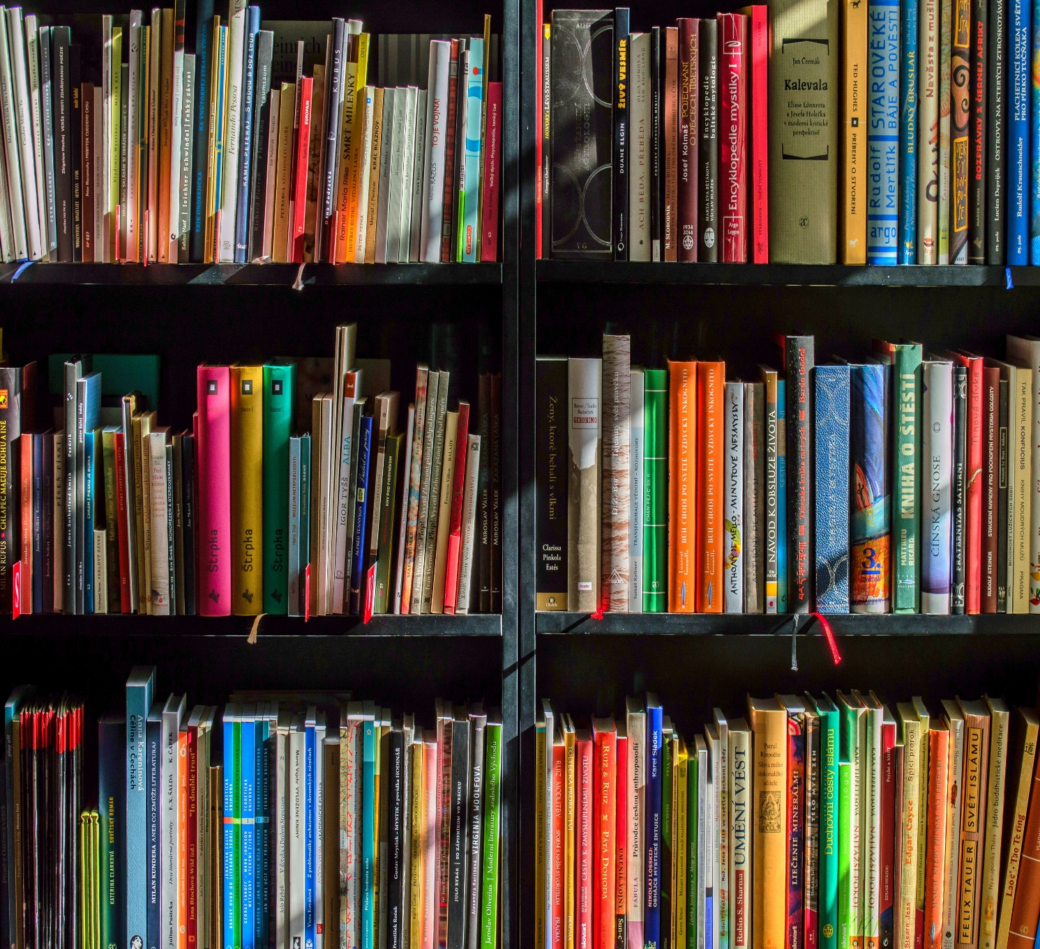

Crieff High School Senior Phase- Suggested Reading to Enhance Subject Knowledge

The following books and links have been recommended by subject specialists in order to develop subject knowledge and knowledge of exam technique. The subjects are organised in alphabetical order.

Contents:
Art and Design
CDT
Drama
English
Geography
History
Home Economics
Mathematics
Modern Studies and Sociology
Music
PE
RMPS
Science

Art
The following link is ideal for pupils who are looking to generate ideas for their work:
https://www.pinterest.co.uk/mairijohnstone5711/boards/

‘The Art Story’ (www.theartstory.org) A guide to Visual Art – gives you key information about artists and analyses artists’ work.

‘Student Art Guide’ (www.studentartguide.com) This website shows exemplar sketchbooks for inspiration.

‘Tate Modern’ (www.tate.org.uk) This website has a ‘Tate Kids’ section with quizzes and activities as well as great information on artists and exhibitions.

‘V&A Dundee’ (www.vam.ac.uk/dundee) As well as other information, there is a ‘Learn’ section with a ‘resources’ section which has a range of challenges for individuals and families.

‘V&A London’ (www.vam.ac.uk) Free access to online collections from the famous museum of Art & Design.

‘The Design Museum’ (www.designmuseum.org) An online design collection with video interviews.

‘Colossal’ (www.thisiscolossal.com) This is one of the biggest inspiring art, design and culture blogs.

The following Scottish Art & Design School’s are holding their graduate exhibitions online this year:
Duncan of Jordanstone College of Art & Design (www.dundee.ac.uk)
Gray’s School of Art (www.rgu.ac.uk)
The Glasgow School of Art (www.gsa.ac.uk)
Edinburgh College of Art (www.eca.ed.ac.uk)
Heriot-Watt School of Textile and Design (www.tex.hw.ac.uk)

CDT
The following link contains lots of course notes and small tasks for all our subjects:
https://www.designclass.co.uk/

Drama
National 5 Drama
Bright Red Study Guide  Guidehttp://www.brightredpublishing.co.uk/shop/wishlist/4e825bba-4de0-4c29-b541-c42ed04a236b | 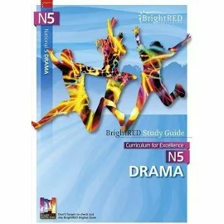

Higher Drama
Bright Red Study Guide  BrightRED Study Guide CfE HIGHER DRAMA (ORIGINAL EDITION)  http://www.brightredpublishing.co.uk/shop/wishlist/4e825bba-4de0-4c29-b541-c42ed04a236b | 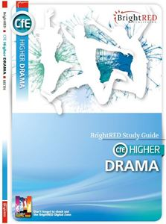

N5/Higher/Advanced Higher Drama
Introduction to Stage Lighting: The Fundamentals of Theatre Lighting Design  Charles Swift | 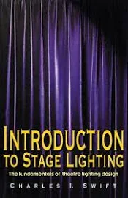

Other Drama suggestions:
Epic Theatre and Brecht by Bertolt Brecht
https://www.ru.ac.za/media/rhodesuniversity/content/facultyofeducation/creativearts/documents/Epic_Theatre_and_Brecht.pdf

An Actor Prepares by Constantin Stanislavski
https://lucian.uchicago.edu/blogs/praxestheory/files/2010/02/An-Actor-Prepares-Ch-31.pdf

English

National 5 English
National 5 English Success Guide: Revise for SQA Exams (Leckie N5 Revision) Paperback – 16 Aug. 2018  by Iain Valentine | 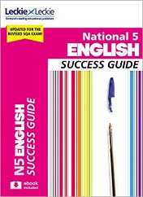
How to Pass National 5 English: Second Edition  by David Swinney | 23 Feb 2018 | 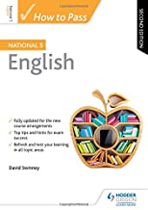
SQA National 5 English: Reading for Understanding, Analysis and Evaluation: Second Edition  by Nicola Daniel, Mary M. Firth, et al. | 26 Jun 2020 | 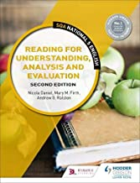
Bright Red Course Book National 5 English (Brightred Study Guide)  by Christopher Nicol and Andrew Leask | 2 Nov 2018 | 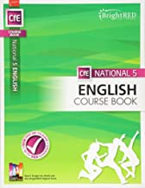

Higher English
Higher English: Revise for SQA Exams (Leckie Complete Revision & Practice)  by Catherine Travis, Mia Stewart, et al. | 14 Nov 2019 | 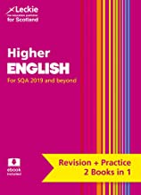
CfE Higher English (Bright Red Study Guide)  by Dr Christopher Nicol | 20 Aug 2014 | 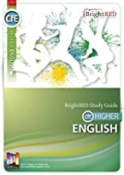
How to Pass Higher English: Second Edition (How To Pass - Higher Level)  by Ann Bridges | 25 Jan 2019 | 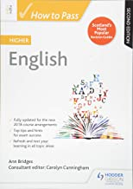

Advanced Higher English
CfE Advanced Higher English Study Guide Paperback – Illustrated, 8 Jun. 2018  by Dr Christopher Nicol (Author), Dr Sandra Percy (Author) | 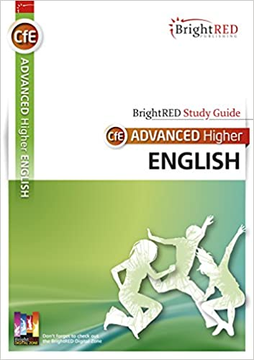
Advanced Higher English: Textual Analysis (with advice on Creative Writing)  by Ann Bridges and Susan MacDonald | 25 Nov 2016 | 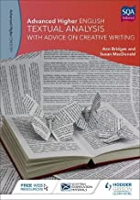

Other suggestions:
The Literature Book: Big Ideas Simply Explained Doring Kindersley. Designed for adults, but also suitable for teen readers, this book surveys the history of world literature in a clear and accessible format.
Studying Literature: The Essential Companion Paul Goring. This is particularly recommended for Advanced Higher pupils or Higher pupils who are considering studying English at university level.
The Scottish Book Trust has an excellent set of reading lists suitable for readers of 15-18:
https://www.scottishbooktrust.com/book-lists

Geography

Recommended Study Guides:
Bright Red Study Guide CfE Higher Geography New Edition (just published)
Leckie Higher Geography for SQA 2019 and beyond
Bright Red Study Guide CfE National 5 Geography
Leckie National 5 Geography Success Guide: Revise for SQA exams (2018)

Other suggested reading / viewing:
1) Sign up to the Guardian online newspaper app as it's free, they have some excellent "long reads" and interesting articles that will get them used to reading quality journalism
2) Sign up to the BBC app if they don't already have it and select from the menu what news they want sent to them (also free). Current Geographical and Environmental Issues
3) https://theday.co.uk/ Online newspaper
Google expeditions, artsandculture.google.com
Google Earth
Dollar Street on the Gapminder website is excellent at looking at different families from around the world
National Geographic free colouring maps and getotside.ordnancesurvey.com
World-Geography-games.com
World Data Atlas – knoema.com
Accessmars.withgoogle.com
National Geographic Explorer Classroom
4) Follow the Scottish Association of Geography Teachers, Royal Geographical Society, Royal Scottish Geographical Society, Time for Geography and National Geographic on Twitter
5) Books
Factfulness by Hans Rosling and Anna Rosling Ronnlund (Excellent book!)
Prisoners of Geography – Tim Marshall
There is no Planet B – Mike Berners Lee
How Bad are Bananas? – Mike Berners Lee
No one is too small to make a difference – Greta Thunberg
6) Any of the BBC Planet Earth, Human Planet, Frozen Planet or Blue Planet documentaries

7) Possible films and documentaries to watch
The Boy who Harnessed the Win’ – Development
The Man who Stopped the Desert – Development and Rural Land Degradation
An Inconvenient Truth – Climate change
A More Inconvenient truth – Climate change
Climate Change – The Fact’ – Climate Change
BBC Panorama Climate change – What Can We Do?
Slumdog Millionaire – Shanty towns in Mumbai
National Geographic Megacities – Mumbai
Lion – Shanty towns
Food Inc – changes in food production/development
Poverty Inc – Development
BBC Power of the Planet Ice – Glaciation
BBC Power of the Planet – Atmosphere
All4 – World’s Wildest Weather
Unreported World – Dying to Come to Britain – Forced migration
The Impossible – Aid, Impact of a natural disaster
The Mountain on BBC Scotland – Glaciation
Highlands, Scotland’s Wild Heart – BBC 4
Countryfile – BBC

History (Suggested Viewing List)

(Parents are advised to check film certificates to decided if that film is suitable for their young person)

National 4/5
- Race (about Olympian Jesse Owens during Nazi Germany)
- Roots
- Amazing Grace (about William Wilberforce, John Newton and the abolitionists)
- Scotland’s Hidden Shame (BBC)
- Amistad
- 12 Years a Slave (on Netflix)
- Lincoln

Higher
- Braveheart
- Outlaw King (about Robert Bruce and Elizabeth de Burgh, on Netflix)
- Suffragette
- Iron Jawed Angels (about US suffragettes) on you tube
- Robert Bruce – new release - was on Netflix
- Bridge of Spies
- Thirteen Days
- JFK

Advanced Higher
Most useful
- Into the Storm (Amazon Prime)
- Darkest Hour (currently on BBC Iplayer, Netflix)
- The Imitation Game ( about Alan Turing and the codebreakers of Bletchley Park)
- Dunkirk (on Netflix)
- Saving Private Ryan
- The Longest Day
- Carve her Name With Pride (1958 black and white, about Violette Szabo – S.O.E.)

Other films about the 2WW Period
- A Bridge Too Far
- Enigma
- Band of Brothers series
- Schindler’s List
- The Pianist
- Pearl Harbour
- Enemy at the Gates

Home Economics

Text Books:
Leckie & Leckie
National 4/5 Hospitality Course Notes for New 2019 Exams : For Curriculum for Excellence SQA Exams
£17.99
ISBN: 978-0-00-828225-7
We have a few copies of the previous edition of this book in school and have found it to be very useful for pupils following the course. It is a very accessible format.

BrightRED Study Guide
NATIONAL 5 PRACTICAL CAKE CRAFT
Pam Thomas
A brand New Edition of our popular National 5 Practical Cake Craft Study Guide. Fully up-to-date.
£12.99
ISBN: 978-1-84948-333-9, 96pp

We do not currently have this book in school, however I have seen a copy of it and it would be very useful for reinforcing the knowledge required for the practical exam. Also, the Bright Red Digital Zone is a very useful resource for reinforcing and revising knowledge and understanding.

One of the best ways to increase your knowledge of practical food is to browse through recipe books. They provide inspiration for practical creativity. We could not begin to provide a definitive list as creativity in the kitchen can be a very personal and individual activity, or a fun time with friends!
The best way to start is simply visit the cookery section in the library and see what you are drawn to.
- For fans of The Great British Bake Off anything by Mary Berry or Paul Hollywood is a must. Also explore the range of cake decorating books available – wow!!!
- For those of you who are eco-aware, anything by Hugh Fearnley-Whittingstall is a must. He writes great recipes based around sustainability and local produce. Saving the planet one mouthful at a time – yum!
- For those of you who enjoy foreign travel, the options are endless. I am currently exploring Middle Eastern cuisine and have found Yotam Ottolenghi to be a particularly interesting author.
- For those of you who are interested in current trends, Clean Eating is very topical. Deliciously Ella is a very accessible book – some authors of “diet” books can be a bit regimented and proscriptive in their approach – this suggests rather than dictates.
- For those toying with the idea of reducing their intake of animal produce - whether for health, ethical or environmental reasons – there are many books on vegetarianism and veganism.
- Planning on university? Explore cookery books for those on a budget, such as The Credit Crunch Cookbook.
- Finally Meal in a Mug – all you need is a mug and a microwave to make cakes, curries and everything in-between. Love it!

Guilia Enders - Gut: the inside story of our Body’s Most Underrated Organ is not a recipe book, but I loved it. Aimed more at seniors who are interested in medicine, microbiology, dietetics etc.
Miss McCully has also suggested a few of her current favourites:
- Marcus Wearing – New Classics
- Marcus Wearing – Marcus Everyday
There are also lots of fantastic websites out there which allow you to keep up-to-date with developments in Food & Nutrition. Some of our favourites are:
https://www.foodafactoflife.org.uk/
The brilliant thing about this website is that the information and resources are divided into different age groups, so if you decide to explore a new topic, you can start basic, and then move on as you feel ready. Recipes, videos, skills development – it has it all.
https://www.bbcgoodfood.com/
Recipes galore categorised by level of difficulty, cost, ingredient and time needed.
https://www.rhet.org.uk/
Interesting resources linked to Scottish Farming.
https://pinchofnom.com/
We wouldn’t normally recommend “Diet Books”, but this site is much more than that – tips and information on healthy eating.
https://www.recipetineats.com/
Miss McCully has recommended this Blog – quick, tasty recipes using storecupboard ingredients.

https://scotland.lovefoodhatewaste.com/
This website does exactly what it says on the tin! Provides lots of information and ideas for reducing food waste. Save the planet, save the pennies and enjoy great food!
https://www.greenpeace.org.uk/
Now whilst some people may disagree with Environmental Activism, Greenpeace is still a fantastic source of information on food sustainability, over-production of some foods and the overfishing of our seas, to name just a few topics.
https://www.qmscotland.co.uk/
Discover more about the fantastic red meat produced by Scottish Farmers. The section on Health & Education is probably the best place to start.
https://www.vegsoc.org/
Lots of information on vegetarianism.
https://www.vegansociety.com/
If you are a vegan – make sure that you are knowledgeable and skilled.
https://www.gardenersworld.com/
Firstly – I am no gardener; however, I do grow my own herbs and dabble with vegetables. If any of you are interested in growing your own food – sustainable, local, inexpensive and good exercise both physically and mentally, then I am assured this is the site for you. A fellow CHS teacher, and keen gardener recommended it – I have had a quick look and there is lots on developing a vegetable garden from scratch. I also found the information on wildlife gardening very interesting.

We hope you enjoy perusing some of these websites and books - Miss McCully and myself certainly do, and if you do cook something amazing, or grow your own vegetables – please let us know. We love pictures as we can tweet them!

Mathematics

Study Guides:
Study Guides Currently 99p on Kindle

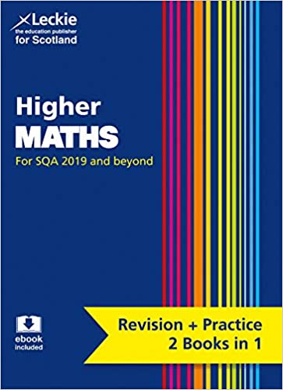
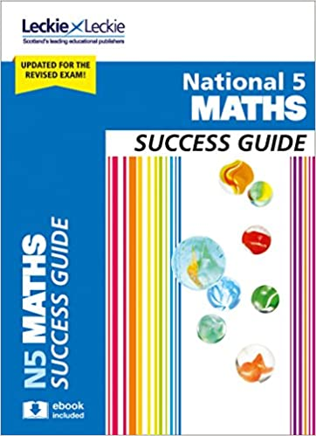

Other useful Resources for Senior Phase

Scholar (available via Glow)

https://www.national5maths.co.uk/free-all-courses/
(All levels and stages of courses, not just National 5)

BBC Bitesize https://www.bbc.co.uk/bitesize/subjects/z6vg9j6

Other suggestions:

The Man Who Counted – A Collection of Mathematical Adventures – Malba Tahan, Leslie Clark and Alastair Reid
The adventures of Beremiz Samir, The Man Who Counted, take the reader on a journey in which, time and again, Samir summons his extraordinary mathematical powers to settle disputes, give wise advice, overcome dangerous enemies, and win for himself fame, fortune, and rich rewards. We learn of previous mathematicians and come to admire Samir’s wisdom and patience. In the grace of Tahan’s telling, these stories hold unusual delights for the reader."

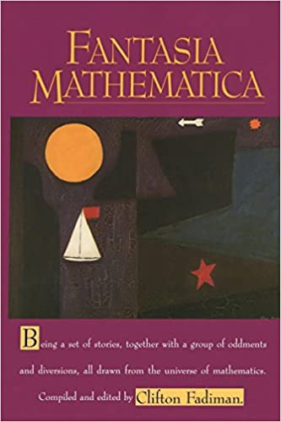
Fantasia Mathematica by Clifton Fadiman
Clifton Fadiman's classic collection of mathematical stories, essays and anecdotes ranges from the poignant to the comical via the simply surreal. These selections include writing by Aldous Huxley, Martin Gardner, H.G. Wells, George Gamow, G.H. Hardy, Robert Heinlein, Arthur C. Clarke, and many others. Humorous, mysterious, and always entertaining, this collection is sure to bring a smile to the faces of mathematicians and non-mathematicians alike.

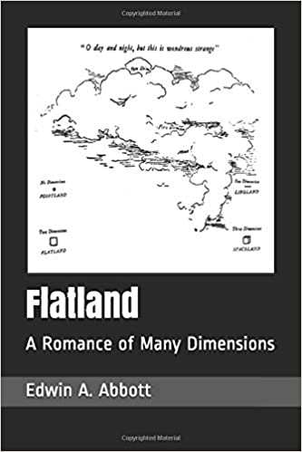
Flatland by Edwin Abbott
How would a creature limited to two dimensions be able to grasp the possibility of a third? Flatland imagines a two-dimensional world inhabited by sentient geometric shapes who think their planar world is all there is. But one Flatlander, a Square, discovers the existence of a third dimension and the limits of his world’s assumptions about reality and comes to understand the confusing problem of higher dimensions. The book is also quite a funny satire on society and class distinctions of Victorian England.

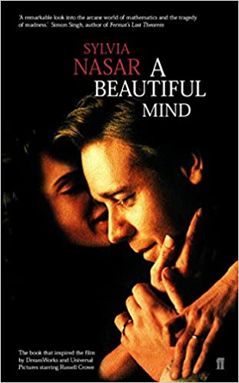
A Beautiful Mind – Sylvia Nasar
A Beautiful Mind is Sylvia Nasar's award-winning biography about the mystery of the human mind, the triumph over incredible adversity, and the healing power of love.
At the age of thirty-one, John Nash, mathematical genius, suffered a devastating breakdown and was diagnosed with schizophrenia. Yet after decades of leading a ghost-like existence, he was to re-emerge to win a Nobel Prize and world acclaim. A Beautiful Mind has inspired the Oscar-winning film directed by Ron Howard and featuring Russell Crowe in the lead role of John Nash.

Modern Studies and Sociology

Study Guides:
Leckie & Leckie National 4/5 Modern Studies Course Notes (New 2019 Exams edition)
Leckie & Leckie Higher Modern Studies: Revise for SQA Exams (Complete Revision and Practice) 2019 edition.

Modern Studies/Sociology (other reading and viewing):
Please be aware that some of the films/documentaries may be inappropriate for younger pupils and parents/guardians may want to watch them beforehand
1) Sign up to the Guardian online newspaper app as it's free, they have some excellent "long reads" and interesting articles that will get them used to reading quality journalism
2) Sign up to the BBC app if they don't already have it and select from the menu what news they want sent to them (also free).
3) https://theday.co.uk/ Online newspaper

4) Follow the Modern Studies Association on Twitter/FB, Simple Politics on Instagram/FB and allsociology on Instagram.
5) Watch these YouTube videos:
Scottish independence and Brexit - https://www.youtube.com/watch?v=igJgNluKzaE
Prisons - https://www.youtube.com/watch?v=mLRBpf-Ws6k (some swearing & violence)
Stacey Dooley – Homeless in Detroit
KKK – The Fight for White Supremacy
6) Netflix - Brexit - The Uncivil War
Trump - An American Dream
Michelle Obama – Becoming (they could read the book too - very good!)
Knock Down the House
American Factory
The Final Year
Get me Roger Stone
RGB
13th

Music

BBC bitesize has plenty to offer and has live lessons such as
https://www.bbc.co.uk/bitesize/tags/zf9yy9q/year-7-and-s1-lessons
There are also the BBC Bitesize Music subject specific pages:
https://www.bbc.co.uk/bitesize/subjects/zc2ncdm

PE/Sport reading ideas

National 5 PE https://www.bbc.co.uk/bitesize/subjects/zctsr82
Higher PE https://www.bbc.co.uk/bitesize/subjects/zhf3cdm
Higher & Advanced Higher PE https://www.satpe.co.uk/category/pupil-notes/higher-pe-support-notes/
Matthew Syed (UK table tennis champion) and Nico Rosberg (F1 world champion) discuss mental and emotional factors and “marginal gains”.
youtu.be/WoGi3XWwS9c

5 of the most iconic athletes and their stories (link to motivation)
https://greatperformersacademy.com/motivation/the-5-most-iconic-athletes-in-the-history-of-sports-and-their-inspirational-stories

Sel -Talk in sport
https://m.youtube.com/watch?v=qTtipLzFZyk
Roger Bannister’s 4 minute mile https://m.youtube.com/watch?v=q--UlymgZX4
Want to try a different sport? https://www.bbc.co.uk/cbbc/joinin/unusual-sports-to-try
Brian Mac Fitness Testing https://www.brianmac.co.uk/eval.htm

Autobiography/Biography - Fiction/Non-Fiction (All available to purchase as an e book or paperback)
Andy Murray: Seventy-Seven: My Road to Wimbledon Glory
Chris Froome – The Climb – The Autobiography
Tyson Fury - Behind the Mask: My Autobiography
Gymnastics Superstar Simone Biles
Rising Above: Inspiring Women in Sports Paperback
Soccer Stars on the Pitch: Biographies of Today's Best Players
Outcasts United – Paperback (Fiction)
RMPS
Free Online RE Resources
www.natre.org.uk | Secondary RE Resources
www.reonline.org.uk | Secondary RE Resources
www.bbc.bitesize | Secondary RE Resources
www.truetube.co.uk | Secondary RE Resources
www.religiouseducationcouncil.org.uk | Secondary RE Resources
www.tes.religiouseducation.com | Primary and Secondary RE Resources
RMPS2017.WIXSITE>COM | RE Home Learning

RMPS Book/Film/Resources for Secondary School Pupils

Title | Author/Director | Overview | Age Group
Holocaust
Boy in the Striped Pyjamas | John Boyne (book and film) | Forbidden friendship between 2 boys one German one Jewish | All ages
The Diary of Anne Frank | Anne Frank (book and film) | In Nazi-occupied Holland in World War II, shopkeeper Kraler hides two Jewish families in his attic. Young Anne Frank keeps a diary of everyday life for the Franks and the Van Daans, chronicling the Nazi threat as well as family dynamics. | All ages
When Hitler Stole Pink Rabbit | Judith Kerr(book) | This book is about a girl named Anna, who lives in Berlin at the start of the story, just before the German election takes place. She is part of a wealthy family, as her father is an accomplished writer. The Nazi party are candidates for the election. | All ages
Jojo Rabbit | Taika Waititti (film) | Jojo is a lonely German boy who discovers that his single mother is hiding a Jewish girl in their attic. Aided only by his imaginary friend -- Adolf Hitler -- Jojo must confront his blind nationalism as World War II continues to rage on. | All ages
I am David | Anne Holm (Book and Film) | It tells the story of a young boy who, with the help of a prison guard, escapes from a concentration camp and journeys to Denmark. | All ages
The Book Thief | Markus Zusak(book) | Hiding and helping Jewish people during the Holocaust | All ages
Animal Rights
The Plague Dogs | Richard Adams(book) | Animal Rights  Two dogs escape from a laboratory and are hunted as possible carriers of the bubonic plague. There is an animated adaptation of Richard Adams' novel, about a pair of dogs (Snitter and Rowf) who escape from a research laboratory and try to survive in the wild with the help of a cunning fox. | All ages
Watership Down | Richard Adams (Book and film) | When a young rabbit named Fiver has a prophetic vision that the end of his warren is near, he persuades seven other rabbits to leave with him in search of a new home. | All ages
Animal Farm | George Orwell(book) | The book tells the story of a group of farm animals who rebel against their human farmer, hoping to create a society where the animals can be equal, free, and happy. | All ages
Euthanasia
Me Before You | Jojo Moyes (Book and Film) | Louisa Clark moves from one job to the next to help her family make ends meet. She becomes a caregiver for Will Traynor a wealthy young banker left paralyzed from an accident two years earlier. | S3 upwards
Million Dollar Baby | Clint Eastwood (Film) | The film follows Maggie Fitzgerald an underdog amateur boxer who is helped by an underappreciated boxing trainer to achieve her dream of becoming a professional. | PG
Human Rights
To Kill a Mockingbird | Harper Lee(book) | Atticus Finch attempt to prove the innocence of Tom Robinson, a black man who has been wrongly accused of raping a white woman in 1930s Alabama. | S3 Upwards
I am Malala | Book and Film | The story of a family uprooted by global terrorism, the fight for girls' education, of a father who, himself a school owner, encouraged his daughter to write and attend school, and of brave parents who have a fierce love for their daughter in a society that prizes sons. | S2 Upwards
The Moonlit Cage | Linda Holeman(book) | The story of a willful Muslim girl in this coming-of-age historical romance. Growing up in 19th-century Afghanistan where women are expected to be obedient and subservient, young Daryâ dreams of adventure and freedom. | S3 Upwards
Terror Kid Benjamin Zephaniah | Benjamin Zephaniah (book) | The story focuses on a teenage boy called Rico Federico, who has a passion for computers. The book takes place in London, where dozens of riots are occurring as a result of unfair treatment by police | S3 Upwards

Equality
Peanut Butter Falcon | Albert Berger Film | After running away from a residential nursing home to pursue his dream of becoming a pro wrestler, a man who has Down syndrome befriends an outlaw who becomes his coach and ally. | All ages
Wonder | RJ Palacio Book and film | Born with facial differences that, up until now, have prevented him from going to a mainstream school, Auggie Pullman becomes the most unlikely of heroes when he enters the local fifth grade. | All ages
Organ Donation/Medical Ethics
My Sisters Keeper | Jodi Picoult (book and film) | Conceived as a marrow donor for her gravely ill sister, Anna has undergone countless surgeries and medical procedures in her short life. Though their older daughter's life has no doubt been prolonged, the unorthodox decision of Anna's parents has cracked the entire family's foundation. | S3 upwards
Pig Heart Boy | Malorie Blackman(book) | Cameron is thirteen and in need of a heart transplant when a pioneering doctor approaches his family with a startling proposal. He can give Cameron a new heart - but from a pig. | All ages
Minus Me | Ingelin Rossland(book) | During a diving competition, Linda discovers that she has a rare heart condition and is told that her only hope of surviving is a heart transplant. | S3 Upwards
Miracles from Heaven | Patricia Riggen (film) | Based on a true story Anna Beam lives with a rare, incurable disorder that leaves her unable to digest food. Despite the dire diagnosis, devoted mom Christy searches for a way to save her daughter. Everything changes in an instant when Anna tells a story of a visit to heaven after surviving a headlong tumble into a tree. | S3 Upwards
Racism
The Help | Kathryn Sockett (book and film) | In 1960s Mississippi, Southern society girl Skeeter returns from college with dreams of being a writer. She turns her small town on its ear by choosing to interview the black women who have spent their lives taking care of prominent white families. | All ages PG
The Colour Purple | Alice Walker(book and film) | A story spanning forty years in the life of Celie an African-American woman living in the South who survives incredible abuse and bigotry. | S3 upwards
Noughts and Crosses | Malorie Blackman(book) | Two young people are forced to make a stand in this thought-provoking look at racism and prejudice in an alternate society. | All ages
Roll of Thunder Hear My Cry | Mildred D Taylor (book) | A book about racism in America during the Great Depression and Jim Crow era. | All ages
Blood Runner | James Riordan(book) | Blood Runner is an inspirational story that portrays the hardships and prejudice that black people, like Samuel, faced in Apartheid South Africa. | S3 Upwards
To Kill a Mockingbird | Harper Lee(book) | Atticus Finch attempt to prove the innocence of Tom Robinson, a black man who has been wrongly accused of raping a white woman in 1930s Alabama. | All ages
Caught in the Crossfire | Alan Gibbons(book) | Set in a town, where right-wingers are determined to stir up hatred and racial prejudice the story is about six teenagers whose lives are woven together by a series of shocking and tragic events. | All ages
Fried Green Tomatoes | (book and Film) | The book explores themes of family, aging, lesbianism, and the dehumanizing effects of racism on both blacks and whites. | All ages PG
This Is Where I am | Karen Campbell (book) | This Is Where I Am is about a culture clash between two people who discover that while they may not always want one another, they come to need each other. Abdi Hassan is a Somalian refugee who has had to flee his home to save his, and his daughter Rebecca's, life | S3 Upwards
Artifical Intelligence and Morality
Ex Machina | Alex Garland(Film) | Caleb wins a contest that enables him to spend a week at the private estate of Nathan Bateman When he arrives, Caleb learns that he has been chosen to be the human component in a Turing test to determine the capabilities and consciousness of Ava a beautiful robot. | 16+
I am Mother | Grant Sputore (Film) | A teenage girl is raised by a robot designed to repopulate Earth. Their bond is tested when a stranger arrives with alarming news. | 14+
Terminator | James Cameron (film) | Disguised as a human, a cyborg assassin known as a Terminator travels from 2029 to 1984 to kill Sarah Connor | PG
Existence of God
Truman Show-film | Peter Weir (film) | He doesn't know it, but everything in Truman Burbank's life is part of a massive TV set. The executive producer orchestrates "The Truman Show," a live broadcast of Truman's every move captured by hidden cameras.  As Truman gradually discovers the truth, however, he must decide whether to act on it. | All ages
Story of God - | Morgan Freeman  (series) | Morgan Freeman presents his quest in order to find how most religions perceive life after death, what different civilizations thought about the act of creation and other big questions that mankind has continuously asked. | All ages
Good Omens | Terry Pratchett and Neil Gaiman now also a mini series on Netflix | The plot focuses on the attempts of Heaven and Hell to bring about the Apocalypse and the efforts of two characters—an angel named Aziraphale and a demon named Crowley—to thwart attempts.
Bruce Almighty | Tom Shadyac (film) | God contacts Bruce and offers him all of his powers if he thinks he can do a better job. Bruce accepts and goes on a spree, using his new-found abilities for selfish, personal use until he realizes that the prayers of the world are going unanswered. | All ages
Moral Issues
The Light Between The Oceans | ML Stedman | A couple desperate to have a baby think their prayers are answered when an infant washes up on shore in a rowboat. | All ages PG
Lord of the Flies | William Golding(book) | The story of a group of young boys who find themselves alone on a deserted island. They develop rules and a system of organization, but without any adults to serve as a 'civilizing' impulse, the children eventually become violent and brutal. | All ages
The Island | Michael Bay(Film) | Futuristic thriller about a contained, seemingly utopian facility in the mid-21st century. The residents hope to be chosen to go to the Island - the last uncontaminated place on Earth | PG
Aesops Fables | Aesop (book) | A collection of stories credited to Aesop a slave and storyteller believed to have lived in Ancient Greece between 620 and 564 BCE. They were used as ethical guides and for the education of children. | All ages
Moana | Ron Clements (film) | An adventurous teenager sails out on a daring mission to save her people.  Along the way, Moana fulfills the ancient quest of her ancestors and discovers the one thing she always sought: her own identity. | All ages
Alive | Frank Marshall(Film) | Stranded after a plane crash in the Andes mountains, individual members of Uruguay's rugby team respond differently.  Once all available food stuffs run out, the group faces a terrible dilemma: eat one or more of their deceased teammates or die. | 15 upwards
Touching the Void | Kevin Macdonald(Film) | In 1985, two young climbers, set out to be the first to reach the summit of the Siula Grande in the Peruvian Andes. When a storm threatens both their lives, Yates must decide whether to cut the rope and risk Simpson's likely death | 15 upwards
Millions | Danny Boyle(Film) | When 9-year-old Damian finds a bag of money in his back yard, he and his brother Anthony decide to try to spend it without telling their father. Conflict of morals. | 12 upwards
Gender
Bend it like Beckham | Gurinder Chadna(Film) | Jess the daughter of a strict Indian couple is not permitted to play organized soccer, even though she is 18. When Jess is playing for fun one day, her impressive skills are seen by Jules who then convinces Jess to play for her semi-pro team. | PG
Religion and belief
Around the World in 80 Faiths  BBC TWO/You tube | Peter Owen Jones | Pete Owen Jones presents the definitive guide to faith on earth, with eighty rituals across six continents in the space of a year. | All ages
Civilisations | Mary Beard BBCiplayer | Professor Mary Beard explores the controversial topic of religion and art. How, and at what cost, do different religions make the unseen visible? | All ages
Muslims Like Us | BBC 2 Daily Motion | Ten British Muslims with contrasting world views move into a house together. Their passionate debates, honest disagreements, humour and insights reveal what is like to be a British Muslim today. | All ages
Strictly Soulmates | You Tube | Series in which members of different faiths look for their perfect partner. | S3-6
The Good Place | Netflix | Four people and their otherworldly frenemy struggle in the afterlife to define what it means to be good. | S4-6
Exodus Gods and Kings | Netflix | The defiant leader Moses rises up against Egyptian Pharaoh Ramses II, setting six hundred thousand slaves on a monumental journey of escape from Egypt and its terrifying cycle of deadly plagues | All Ages
Two Popes | Netflix | Behind Vatican walls, the conservative Pope Benedict XVI and the liberal future Pope Francis must find common ground to forge a new path for the Catholic Church. | S3 Upwards
Extraordinary Rituals | You Tube | Extraordinary Rituals explores the spectacular and emotional world of rituals. | All ages
Sacred Wonders | BBC iplayer | Find out what people do for faith in the most spectacular sacred places on the planet. | All ages
Witch Child | Celia Rees(book) | Witch Child tells the story of a girl whose grandmother was hanged for being a witch. | All ages
Sorceress | Celia Rees (book) | Agnes is a descendant of Mary's and has a special skill which allows her to be in touch with Mary in the spirit world. A story of love and friendship, sadness and loss | All ages
(Un)arranged Marriage | Bali Rai(book) | A teenage boy living in England whose strict Punbjabi parents are disappointed in him so they decide to arrange a marriage between Manny and a girl from India, whom he does not know. | All ages
The Da Vinci Code | Dan Brown (book and film) | A murder in Paris' Louvre Museum and cryptic clues in some of Leonardo da Vinci's most famous paintings lead to the discovery of a religious mystery. | All ages PG
Angels and Demons | Dan Brown (book and film) | Harvard symbologist Robert Langdon discovers the resurgence of an ancient brotherhood known as the Illuminati, he flies to Rome to warn the Vatican | All ages PG
Moonlit Cage | Linda Holeman | The story of a willful Muslim girl in this coming-of-age historical romance. Growing up in 19th-century Afghanistan where women are expected to be obedient and subservient, young Daryâ dreams of adventure and freedom. | S3 upwards
Miracles from Heaven | Patricia Riggen (film) | Based on a true story Anna Beam lives with a rare, incurable disorder that leaves her unable to digest food. Despite the dire diagnosis, devoted mom Christy searches for a way to save her daughter. Everything changes in an instant when Anna tells a story of a visit to heaven after surviving a headlong tumble into a tree. | S3 Upwards
Coco | Darla K Anderson(Film) | Despite his family's generations-old ban on music, young Miguel dreams of becoming an accomplished musician like his idol Ernesto de la Cruz. Desperate to prove his talent, Miguel finds himself in the stunning and colorful Land of the Dead. | All ages
Heaven is for Real | Todd Burqo (book) | Heaven Is for Real is the true story of Colton‚ the four-year old son of a small town Nebraska pastor who‚ during emergency surgery‚ slips from consciousness and enters heaven | S3 upwards
Good Omens | Terry Prachett/Neil Gaiman (Book and Film) | The plot focuses on the attempts of Heaven and Hell to bring about the Apocalypse and the efforts of two characters—an angel named Aziraphale and a demon named Crowley—to thwart attempts. | All ages
Life of Pi | Ang Lee (Film) | Life of Pi is about the mysteries which light up our lives and have no rhyme or reason on their own; the faith that enables us to make a leap into the dark. | All ages
The Lion, the Witch and the Wardrobe | CS Lewis (book) (Film) | Parallels to Christianity | All ages
Horse Boy | Rupert Issacson (Book and Documentary) | An autistic boy who rarely talks to family members, but he seems to have a special bond with horses. His parents take him on a journey from their home in Texas to a shaman's hillside abode in Mongolia. | All ages

War and Conflict
The Foreshadowing | Marcus Sedgewick  (book) | The Foreshadowing tells the story of seventeen-year-old Sasha Fox in England. It is 1915 and men from all over the country are being sent to fight across the English Channel. | S2 upwards
The Astonishing Life of Octavian Nothing Traitor to the Nation | MT Anderson (book) | It follows the main character, Octavian, through several years of his youth as a slave in eighteenth-century America | S3 Upwards
Anils Ghost | Michael Ondaatje (book) | Anil's Ghost is a story about love, family, identity, the unknown enemy, and the quest to unlock the hidden past | S3 upwards
The Other Hand/Little Bee | Chris Cleave (book) | It is a dual narrative story about a Nigerian asylum-seeker and a British magazine editor, who meet during the oil conflict in the Niger Delta, and are re-united in England several years later. | S5 upwards

Philosophy
Sophie’s World | Jostein Gaarder(book) | A history of the great philosophers | 15 upwards
The Philosophy Files | Stephen Law (book) | Introduction to some of philosophy's biggest questions. Easy to read and conversational in tone | 15 upwards
The Philosophy Gyn | Stephen Law (book) | Some of the most important philosophical issues of today. Light-hearted questions about whether a pickled sheep is really art rub shoulders with more profound questions about whether God exists. | 15 upwards
The Sage Train | Nicky Hansell (book) | Comparison of philosophers, and how ideas are relevant | 15 upwards

Science

Online Course Reading:

https://blogs.glowscotland.org.uk/er/SNHBiologyWebsite/files/2015/01/National-5-Biology-Textbook.pdf - Online N5 Biology textbook.

http://www.oronsay.org/Nat5.htm - lots of fun tasks to complete for N5 Biology

http://nat5biopl.edubuzz.org/ - Nat 5 Biology online text book

Scholar – access through Glow for all science N5, H and AH. Has sets of notes and activities

BBC Bitesize – notes and activities for N5 and H Sciences

Wider Reading:

Bill Bryson’s Short History of Nearly Everything

The Science Book: Big Ideas Explained Simply: DK Publishing

Science Encyclopedia: National Geographic

The Periodic Table Book: A Visual Encyclopedia of the Elements by DK

5000 Awesome Facts about Everything (National Geographic Kids): National Geographic Kids

The Comic Strip History of Space: Tracey Turner and Sally Kindberg

100 Things to Know about Space: Alex Frith

101 Great Science Experiments: Neil Ardley

My Amazing Body Machine: A Colourful Visual Guide to How your Body Works: Robert Winston (LC)

Planet Earth: 1 Katie Daynes

John Emsley A Healthy, Wealthy, Sustainable World

Hugh Aldersey-Williams Periodic Tales

Ben Goldacre Bad Science

The New Scientist books, Why Don’t Penguins’ Feet Freeze? Do Polar Bears get Lonely? and Why Can’t Elephants Jump?

Brian Cox and Jeff Forshaw Why Does E=mc2?

Reto Schneider Mad Science: 100 Amazing Experiments from the History of Science http://www.weirdexperiments.com

Horrible Science books : http://www.horrible-science.co.uk/
Eugenie Samuel Reich Plastic Fantastic: How the Biggest Fraud in Physics Shook the Scientific World

Stephen Hawking A Brief History Of Time: From Big Bang To Black Holes.

Randall Munroe What If?: Serious Scientific Answers to Absurd Hypothetical Questions

Nessa Carey: Junk DNA

Ernst Schrodinger: What is life?

