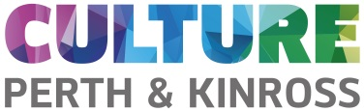

Saturday Morning “Exploring Egypt “Workshops

Enjoy our kids “Exploring Egypt “Workshops at the museum and find out about the life of our mummy Takerheb. See the objects she might have used, how she would have written, the art around her and how we are conserving her for the future. Suitable for children ages 7+ to find out more about Egyptian life and if you attend 2 or more workshops you become our own Egyptian Young Heritage Ambassadors and are awarded a certificate. Free

Dates | Activity:: All will run 11am-1pm
Sat 8th Feb | Our Mummy: How you make a mummy,  Find out about how Takerheb was mummified and see some of the artefacts the Egyptians took into their tombs. Make your own mummy mask to take home with you.
22nd Feb | Our Mummy: Writing, pots and papyrus:  Learn about hieroglyphs-the Egyptian form of writing. Using papyrus make a bookmark and stamp your name in hieroglyphs. Mould clay make your own cartouche-the symbol used to write the pharaohs name.
Sat 7th March | Our Mummy: Egyptian wall art  Tombs contained amazing paintings. Find out the stories behind the paintings. Paint your own panel inspired by our displays.
14th March | Our Mummy: Behind the scenes tour  Be a curator and see behind the scenes at the museum. Find out about the wider collections in the museum including natural history, other periods of history and art.

All workshops are free: Due to limited places available booking is essential.
Booking info on our web page through Eventbrite
www.culturepk.org.uk

