RWE Innogy UK’s Take Your Child to Work Day – Case-Study
RWE Innogy UK’s Mary Drury, Hydro Development & Projects Manager shares her tips for organising a successful Take Your Child to Work Day based on the company’s experience in 2015.
How did you organise the day for the pupils?
In the morning we created an exercise for the pupils to carry out in small teams. This was a simplified process based on how we actually choose the site for a hydro scheme, negotiate the land purchase, cost up the project and gain board approval. The teams had a coach to support them as they chose a location on the map and worked up a costing. We included role plays where colleagues played the parts of the landowner and board members.
In the afternoon we organised a trip for the pupils to visit our operational Lochelbank Wind Farm in order that they could also experience another form of renewable energy close up.
How many pupils did you host?
We had six pupils, five girls and a boy, working in two teams. Three were children of staff and three were friends who had expressed an interest in engineering. Working in groups with their peers, with an element of competition, meant they were less intimated by the office environment and happy to interact.
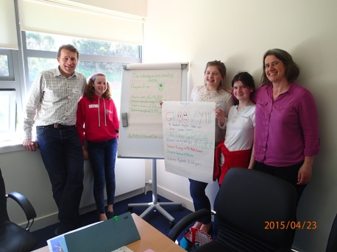
Why did you decide to do this?
As parents, we wanted to show our children what work looks and feels like as well as give additional insight to those that are genuinely interested in engineering as a career. From a company perspective, we feel that the day was a worthwhile investment so that local children understand more about the renewables sector and what we do at RWE Innogy UK.
What was the feedback from the day?
Our staff enjoyed the day and were truly impressed by the work the pupils achieved in such a short time. Back at Methven Primary School my daughter wrote in her school profile, where she records all her achievements,” It showed me the whole process of planning and designing hydro schemes, rather than the everyday work of one person.”
How could other companies adapt your approach for their sector?
Easily! Take a simple process that illustrates the purpose of your organisation or team and set the pupils a challenge. Use your knowledge as parents to set the level. If members of staff can take turns working with the group it shares out the responsibility and makes it more interesting than each child only shadowing their own parent.
Any other tips?
Make a simple visual plan. Buddy the pupils up. Make sure they have a space to break out and vary the activities so that they get a good overview.

