A Shared Vision  At Coupar Angus Primary we ensure that all children develop the attributes, knowledge and skills they will need to achieve of their best in life, learning and work.  They will be able to demonstrate the four capacities to become –  - Successful Learners  - Confident Individuals  - Effective Contributors  - Responsible Citizens  Children will learn through the four contexts for learning –  - Interdisciplinary Learning  - Opportunities for Personal Achievement  - Ethos and Life of the School as a Community  - Curriculum Areas and Subjects  Our curriculum reflects the seven Principles of design –  Breadth Progression Depth Personalisation and Choice  Challenge and Enjoyment Coherence Relevance | 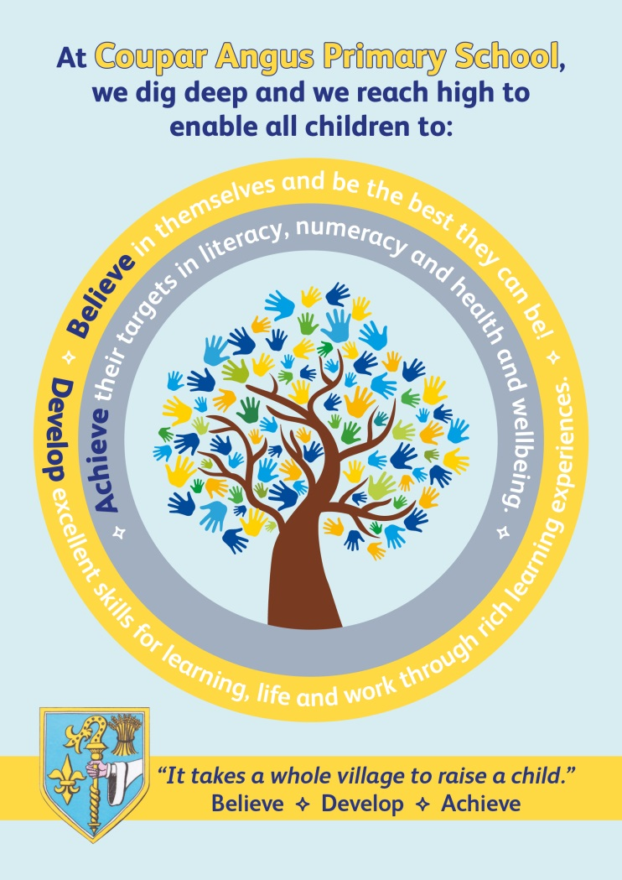  Coupar Angus Primary School Curriculum Rationale | School Values  Throughout the school, in a number of different ways, we encourage children to practise the school values. These are:  Respect Yourself Respect Others Respect the Environment  Article 29 (Rights Respecting School) “Education must develop every child’s personality, talents and abilities to the full. It must encourage the child’s respect for human rights, as well as respect for their parents, their own and others cultures and environments.”  Our strengths:  - High-quality partnership working which is embedded in the work of the school and which supports effective and productive links with the local community.  - Very effective practice in forest schools education in the early years.  - The work of all staff in providing a high level of pastoral care and nurturing ethos across the school  - Commitment to improving our school

School Aims  - To raise attainment and achievement for every child  - To encourage children to be independent learners  - To support creativity, ambition and enterprise  - To promote and foster the ethos of Global Citizenship  - To respect each other as individuals and provide effective support to meet the emotional, physical and mental wellbeing of all. We aspire to play our part in encouraging a healthy and active lifestyle throughout the whole school community  - To be a restorative and inclusive school, where positive relationships flourish.  - To have highly effective reciprocal partnership and co-operation with parents and the wider community | Coupar Angus Primary School Curriculum Rationale  We enable all children to:  - Believe in themselves and be the best they can be.  - Develop excellent skills for learning, life and work through rich learning experiences.  - Achieve their targets in literacy, numeracy and health and well-being. | Our school curriculum will:  - Allow pupils to contribute to the ethos and life of the school community  - Provide opportunities for personal achievement.  - Support all learners in developing skills for learning, life and work.  - Have a continuous focus on literacy, numeracy and health and well-being with all staff having a responsibility to develop, reinforce and extend learning in these areas  - Provide opportunities for mixed-stage learning which is well planned, coherent and relevant  - Provide a broad general education using Curriculum for Excellence Experiences and Outcomes and Significant Aspects of Learning  - Provide progression that is consistent with pupils’ learning needs and prior achievement  - Take into account the wider achievements of children both in and out of school and provide personalisation and choice

