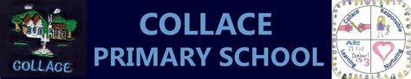

Headteacher’s Newsletter – May 23

Dear pupils, parents/carers and friends of Collace,

Term 4 has already been busy here at Collace Primary School and we are racing towards the end of this school year with a jam-packed schedule! We are enjoying making the most of our wonderful school grounds in the ever-improving weather and thoroughly enjoying the excitement of term 4.

Please do take the time to read through it and as always, if you have any queries or concerns, please get in touch via our school office 01250 871420 or collace@pkc.gov.uk.

Warmer Weather
At Collace we love to be outside and use our fabulous grounds as often as possible to enhance our learning. Please remember to apply suncream to your child before coming to school to give protection in the sun. They are welcome to bring their suncream with them and re-apply, if required, throughout the day however, school staff are not permitted to apply it for them. Pupils should also bring a sunhat/ cap that can be worn on brighter days.

P.E. Days
A gentle reminder that all pupils should come to school on P.E. days (Monday and Thursday) dressed for P.E.
P.E. kits should be dark tracksuit bottom or leggings, a plain white t-shirt or polo shirt and a school jumper.

Plant Sale
We are delighted to be holding our Collace Primary School Plant sale on Monday 29th May in Kinrossie Village Hall at 1pm. The pupils have been busy looking after the selection of plants we will have available. This is a highlight of our yearly calendar, and we look are looking forward to it.

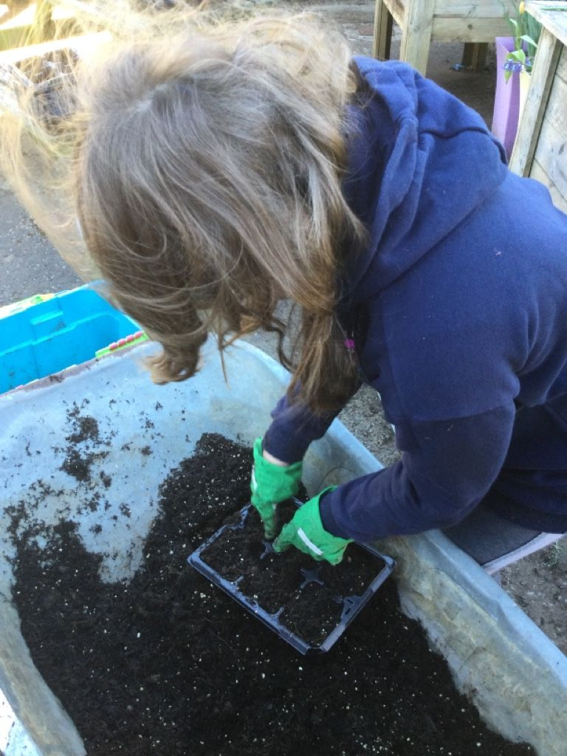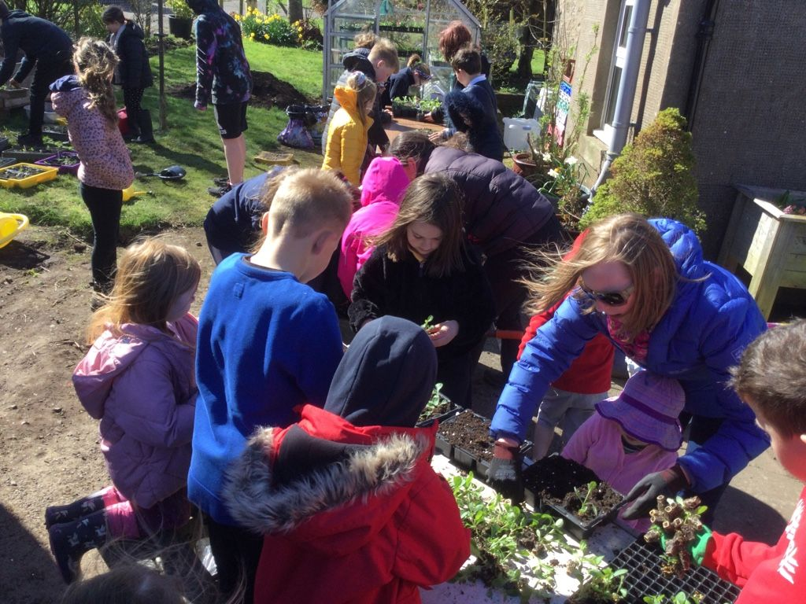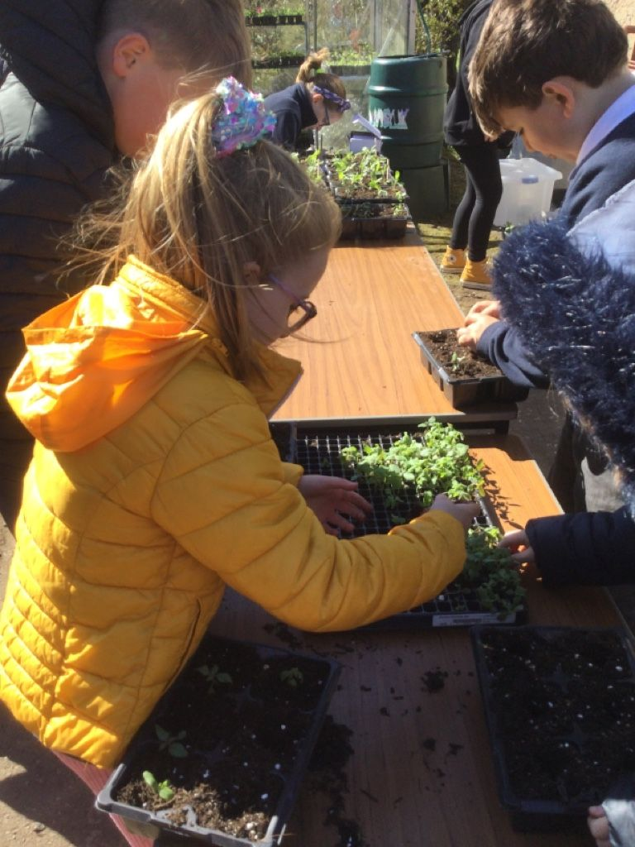

Reports and Parent Contact
You should now have received your child’s end of year report. If you have not already done so, please return the acknowledgement slip to school as this helps us be certain that no reports are loitering in trays or school bags!
Parent Contact evening on 30th May will give you the opportunity to discuss the report with your child’s teacher. The link to book a parent contact appointment has been sent out via the school app, if you are having any issues booking an appointment, please get in touch with the school office.

Swimming
This term, our P4-7 class have been enjoying swimming sessions every Friday morning at Perth Leisure Pool. The pupils have been thoroughly enjoying their time at the pool and have been display our school values of being Ready, Respectful and Safe when out in the community. These sessions will continue until the end of term.

Reporting Absences
If your child is going to be absent, please call the school office (01250871420) or email collace@pkc.gov.uk to let us know. Please do not use Seesaw to communicate absences as it may not be pick up before the day starts.

Digital Schools
This year we have been working towards our Digital Schools Accreditation. Mrs Hamilton has been busy gathering evidence and our bid will be submitted shortly. Part of our work towards this has been the introduction of using Seesaw to enhance our learning. Homework is set through the app, in-school work and achievements are shared regularly and Our Learning Journeys have been adapted so they are saved on Seesaw.
Parents were invited to attend a launch night for Seesaw, and we have also used an online questionnaire to gather parental comments around its use. Please see the results of our survey below:

I like the ability to see what my child is doing, as without the pictures I would not know week to week what they had been up to.
Easy to use, I enjoy seeing what the kid's are doing in the school.
The visual aspect of what the children are doing is good.

Six parents completed the questionnaire. This following information was gathered:

4/6 parents felt positive about the move to Seesaw.
2/6 parents felt positive about how easy Seesaw was to use.
4/6 parents felt their child enjoys using Seesaw.

The staff would like to thank all parents and carers for their support in the use of Seesaw. We will keep you up to date on our Digital School’s journey.

Inter-School Sports
Last Thursday, our P4-7 class attended the Inter-School Sports event at Burrelton Primary. The weather was kind to us and we had a fantastic afternoon competing in a variety of sporting events. Well done to all those who took part!

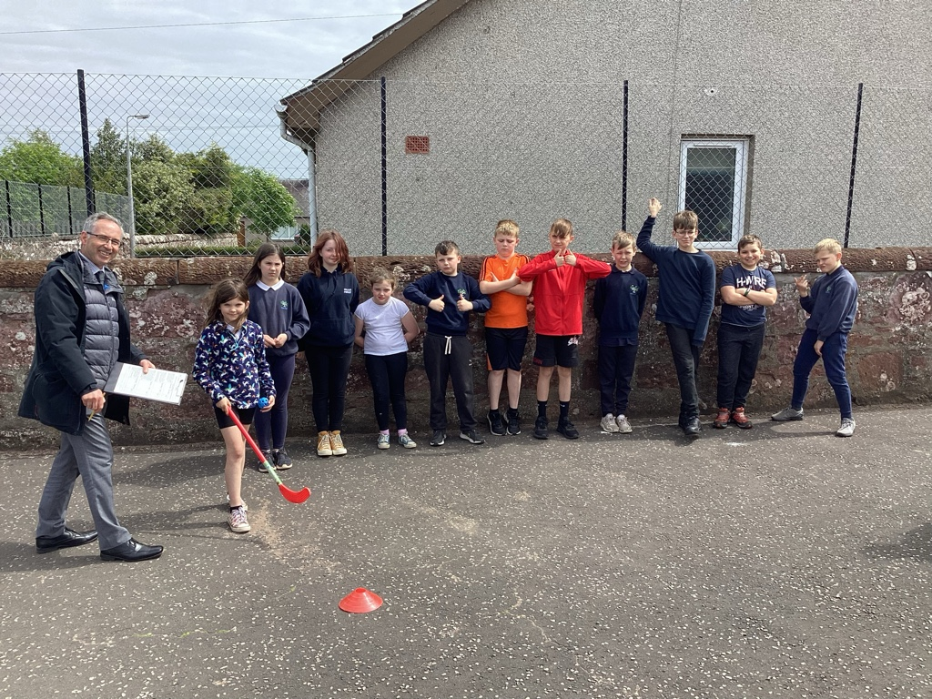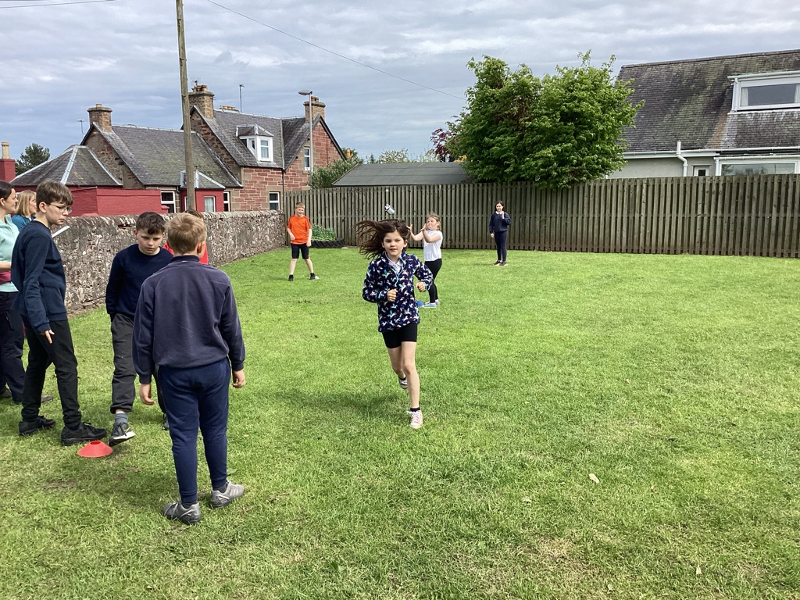

And Finally…
A reminder that our end of term Prize Giving will be held in Kinrossie Village Hall on Thursday 29th June. Please arrive at 10:45 for an 11am start. All pupils will be dismissed for the hall at 12noon to start the summers holidays.

As always, thank you for the support you show our school.
Yours faithfully

Diane Johnstone
Acting Headteacher
collace@pkc.gov.uk
01250 871420

Collace Primary School Key Dates
Please note these dates are provisional and may be subject to change.
Other dates may also be added.

May
Wb 22nd – Health Week
Friday 26th – Sports Day (12noon: picnic lunch, 1pm: races begin)
Monday 29th – Plant Sale
Tuesday 30th – Parent Contact

June
Tuesday 6th – P1 Parent information Session 3pm
Thursday 8th/ Friday 9th – P7 Transition Days at Perth Academy
Thursday 8th/ Friday 9th – ‘Bump Up’ Day
Monday 12th – P7 Leaver’s Party (more information to follow)
Wednesday 14th – BBQ Lunch by Tayside Contracts
Friday 16th – P7 Trip to Willowgate (depart Collace 8:15am return 3:45pm)
Thursday 29th – Prize Giving in the Village Hall (am) Families Welcome
Thursday 29th – Summer Holidays 12noon

