February 2024



*achieving- happy- healthy-responsible- resilient*

Auchtergaven Primary School Newsletter

Dear Auchtergaven Families

We hope this news update find you all well and enjoying seeing the signs of spring- we are so looking forward to brighter days in the playground.

**Staffing**

We welcome Ellie Grandison to the Auchtergaven Team. Ellie is a Play Assistant working in the nursery to support our pupils over lunch and with their play. Ellie is already a big hit with the pupils and has settled into The Auchtergaven Way with ease.

We also welcome back Mr Thomson who is fulfilling some teaching absence in P5/6. Mr Thomson will also be teaching every class while teachers have their non-contact time. The ukuleles have been dusted down and we look forward to Mr Thomson sharing his musical talents with classes throughout the school.

**Seesaw**

Perth and Kinross have made the decision to transition away from the use of Seesaw. GDPR compliance is a PKC priority, and the authority are seeking alternatives that better serve the needs of learners within PKC. **Therefore, as of 31 May 2024 we will no longer user Seesaw within PKC.**

If you wish to download your child(ren)’s journal before the 31 May 2024 please follow the steps on the following link or contact your child’s school for support. [How do families and students save and download student work – Seesaw Help Center](https://help.seesaw.me/hc/en-us/articles/208754866-How-do-families-and-students-save-and-download-student-work#:~:text=1%20Sign%20into%20your%20Family%20or%20Student%20account,how%20many%20posts%20your%20child%20has%20in%20Seesaw.)

Two alternative learning platforms are currently piloting within PKC that will be available for schools to choose between. We have had some opportunities to explore these platforms and will do so further over the coming weeks and make a choice based on the needs of our whole school community. We will be in touch to confirm what the next steps will be.

**Attendance**

National and local trends of school attendance show that the rate of absence from school increasing. We can see this at Auchtergaven. We understand there are a range of reasons why children can be absent from school and some of these are unavoidable, but it is important that parents understand the impact of absence from school and that we are working together to ensure children are attending school as often as possible. The infographic below shows some information about the impact of absence from school. There is a range of information available to support parents if their child is anxious about aspects of their school experience and this is making it difficult to attend. We hope to send individual updates on your child’s attendance and information about how to use the Parent Portal to check your own children attendance soon and we would encourage you to get in touch if you are struggling to get your children to attend as there are ways that we can support you and your children.

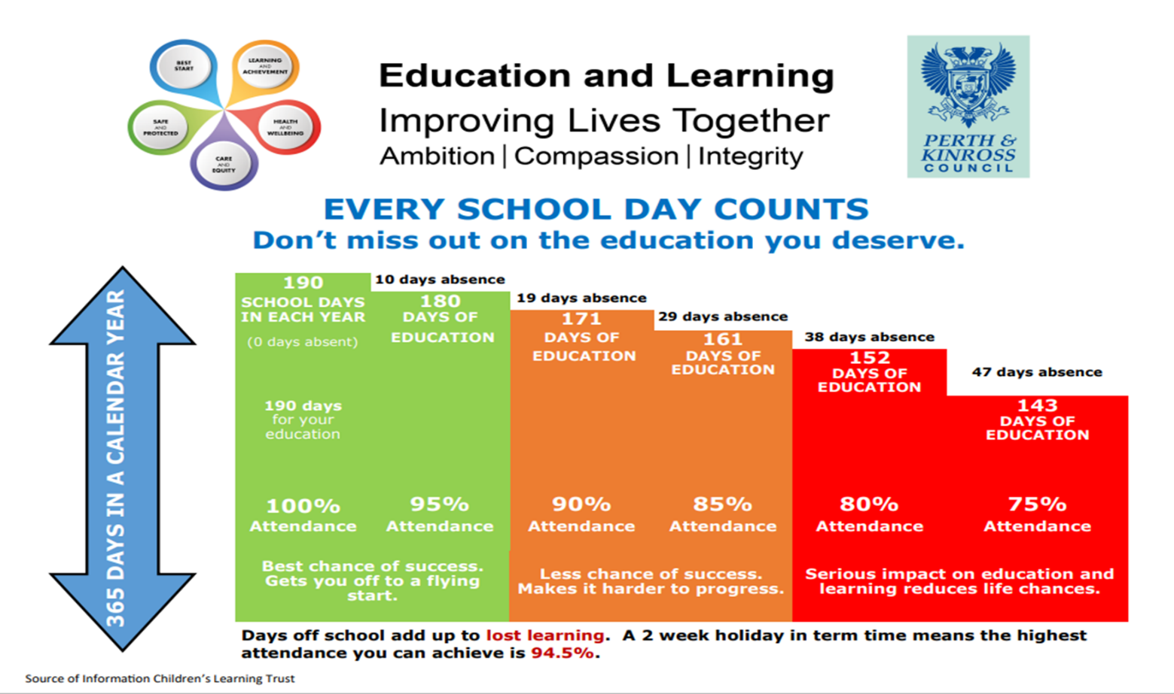

**Perth Strathtay Harriers**

We enjoyed celebrating the success of some of our pupils at a Strathtay Harriers athletics competition and some of our pupils asked about the club. Information about the club can be found here [Perth Strathtay Harriers](https://strathtayharriers.co.uk/).

We love hearing about your children’s wider achievements so please do send in photos and/or a message about anything worth celebrating from learning a new skill, persevering with a task, helping others or winning races…. everything deserves a mention.

**To help you plan, please find a list of diary dates below.**

Best wishes

*Catharine Findlay*

Head Teacher

|  |  |  |
| --- | --- | --- |
| **Diary Dates for Parents and Carers** | | |
| **Saturday 24th February** | **Parent Council Bingo Tea** | **Bankfoot Church Centre 6:30pm – eyes down 7pm**  **£7 for a book of 6 games. Bring your own pen and mug.**  **Donations of prizes and baking gratefully received.** |
| **Tuesday 5th March** | **Parent contact** | **Appointment booking information to follow.** |
| **Thursday 7th March** | **World Book Day** | **Information to follow from our Reading Owls about events planned for the day.** |
| **Tuesday 12th March** | **Parent Council 7pm** | **Face to Face in school.** |
| **Tuesday 12th March** | **Parent Contact** | **Appointment booking information to follow** |
| **Tuesday 12th March** | **Parent open afternoon P5/6** | **P5/6 parent open afternoon in lieu of Parent Contact evenings.** |
| **Wednesday 13th and Thursday 14th March** | **Heartstart CPR workshops in school** | **Pupil sessions during class time.** |
| **Tuesday 19th March** | **Parent Council Meeting** | **7pm on Teams.** |
| **Monday 25th March** | **Heartstart CPR session for Parents** | **Parent session 6pm – information to follow.** |
| **Tuesday 19th March** | **P5/6 Trip to Black Watch Museum** | **TBC** |
| **Tuesday 26th March** | **Cross Country Championships** | **Selected pupils competing from P6 & P7** |
| **Thursday 28th April** | **Last day of term** | **Easter holidays from 29.4.24- 16.4.2024 (16.4.24 is an in-service day, school closed to pupils).** |
| **Monday 15th April** | **Inservice** | **School closed to pupils.** |
| **Monday 6th May** | **Holiday** | **School closed to pupils.** |
| **Thursday 9th May** | **PKC Quality Improvement visit** | **Quality Improvement Officers and Education Support officers to visit Auchtergaven to look at progress in improvement plans.** |
| **Saturday 18th May** | **Bankfoot Gala** | **Community event at the church centre.** |
| **Tuesday 28th May** | **Parent Council 7pm** | **Face to face in school.** |
| **Wednesday 5th June** | **Sports Day** | **Parents invited to spectate at 9:30am for morning races.** |
| **Thursday 6th and 7th June** | **P7-S1 transition days** | **P7s to attend Secondary School for 2 transition days.** |
| **Friday 7th June** | **Moving up morning** | **All classes to visit new classrooms and meet teachers for session 2024-2025.** |
| **Friday 7th June** | **Annual Pupil Progress Reports** | **Reports issued today.** |
| **Tuesday 25th June** | **End of session service and P7 celebration** | **All parents welcome to Bankfoot Church for our end of year service and celebration of our P7s. Time TBC.** |
| **Thursday 27th June** | **Last day of term** | **Summer holidays commence at 12 noon.** |
| **Wednesday 14th August** | **Session 2024-2025 begins.** | **School term and holiday dates for session 24-25 can be found here** [School term and holiday dates - Perth & Kinross Council (pkc.gov.uk)](https://www.pkc.gov.uk/schoolholiday) |
| **Week commencing 16th August** | **P7 Activity Week** | **P7 Activity week at Willowgate Centre, Perth** |