

Aberuthven Primary School
Travel Plan
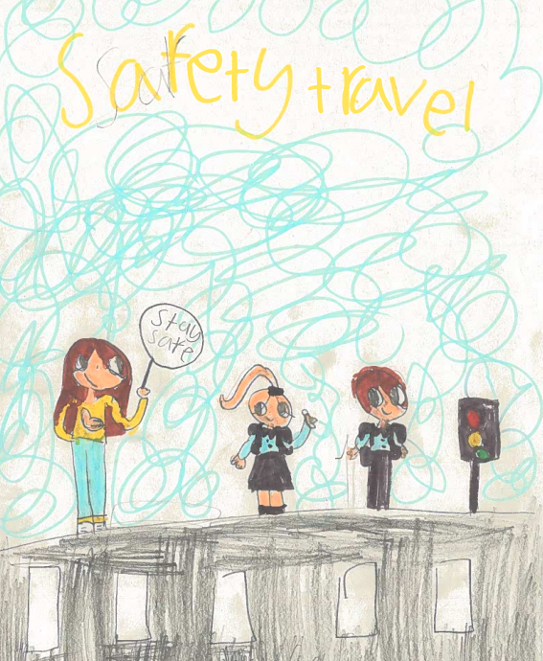

Cover Picture by Amelie Millar P4, 2025

March 2026
Contents

Introduction 3
Aims of the Travel Plan 3
Our School 4
Roads and Traffic around the school 4
School Travel Survey 5
How Much Difference does Speed Make? 6
Parking Outside the School 7
Road Safety in the Curriculum 8
What we have done so far 10
Action Points 11
When will we do our next Travel Plan? 11

Introduction

At Aberuthven Primary School, we aim to equip all of our pupils with the knowledge and skills necessary to keep themselves safe when travelling to and from School. The safety of all within our school community is paramount.

We believe in supporting pupils to make good choices to both support their physical and emotional wellbeing, as well as explore the benefits to our environment. We encourage our pupils and parents to consider the possible ways to travel to school to gain these benefits.

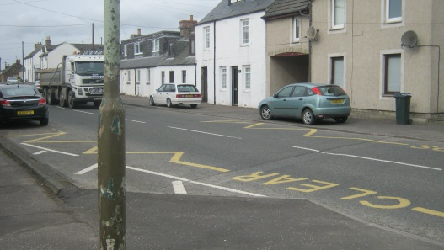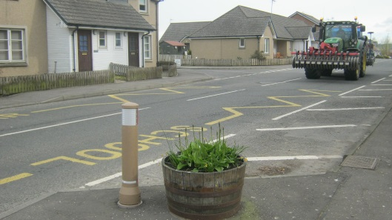

We welcome any feedback from all within our school community. Please contact our School to share any comments or additional information with us. Your support is always greatly appreciated.

Aims of our Travel Plan

- To encourage pupils and parents to travel safely and healthily to school.
- To encourage parents to include road safety guidance into their family life.
- To encourage children to take an active part in their own road safety.
- To make sure all the routes we travel to and from school are as safe as they can be.
- To cut down traffic around the school as much as possible.
- To make the main road outside the school safer, especially at the times when children are arriving and leaving.

Our School

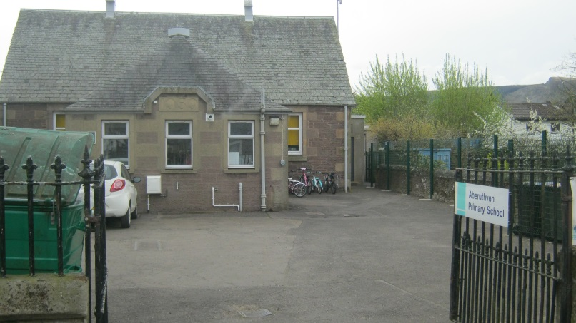
Aberuthven is a small rural primary school in Perthshire. We have 34 pupils aged from 5 to 12 and 11 members of staff in total. We have support teachers who visit the school on occasion. All teachers and almost all other members of staff live outside the village and therefore drive or cycle to the school.

Roads and Traffic around the School

Aberuthven is just off the A9 near Auchterarder. A very busy main road runs past the main entrance and there are 2 small lanes that go to the left and back of the school.

Cars can get into the school grounds through either the front main entrance gates or through a side gate, which leads down a track to the rear playground.
There is a pathway from the front playground which leads around the right-hand side of the school to the back playground. There is a tall, metal gate at the side of our school building, which is kept padlocked to ensure the safety of our pupils throughout the school day. It is unlocked at the beginning of the day to allow children access to the playground. It locked again at 9.10am. It remains locked until the next morning. There is a small gate from the road at the back of the school, which leads into the back playground. This is kept padlocked at all times to ensure the safety of our pupils throughout the school day.
School Travel Survey

Pupils completed a survey in March 2026 to find out how our pupils are currently travelling to school.

Results of Travel Survey March 2026

30 of our 34 pupils completed their survey in class.

How are pupils travelling to and from school?
Our pupils
Fourteen children walk to school when the weather is good and three children park and stride to School. One pupil comes by bike, with five others coming by scooter. The remaining seven children come all the way to school by car. All of those children who come to school by car live further away. The survey asked the seven children if they would like to park and stride instead of coming all the way by car. None of the seven children said they would like to do this and would rather have the entire journey to school in the car.

Eighteen of our pupils are brought to school by someone. Two children come to school on their own and ten with a sibling or with a friend.

Of the fourteen children who walk to school, only a few said that they need to cross the road. All said they use the school crossing patroller, when available, to cross the road safely. Some have to cross quieter roads closer to their houses before they read the main road.

Summary
It seems that almost all pupils who live near enough, walk to school. We could encourage the children who are driven all the way to school, to park a little way from the school building and walk the remaining journey to school where possible.

Problems in travelling to school
Some pupils shared their concerns around the high speed of traffic in Aberuthven despite the newly appointed 20MPH zone throughout the main road in the village.

Given a free choice, how would our pupils prefer to travel to and from school?

Car | Bike | Scooter | Walk | Park &Stride
10 | 11 | 1 | 7 | 1

How much difference does speed make?

- If children are hit by a car travelling at 20 mph, nearly all of them survive the accident.
- If children are hit by cars travelling at 30 mph, half of them are likely to be killed.
- If children are hit by cars travelling at 40 mph, most of them will be killed.

These are figures worked out by the Department for Transport that looks after all our roads and traffic. It is important that cars go slowly when there are children around.

Parking Outside the School

The yellow line markings around the school entrance are there to prevent anyone parking or stopping just outside the school where children will be trying to cross the road.

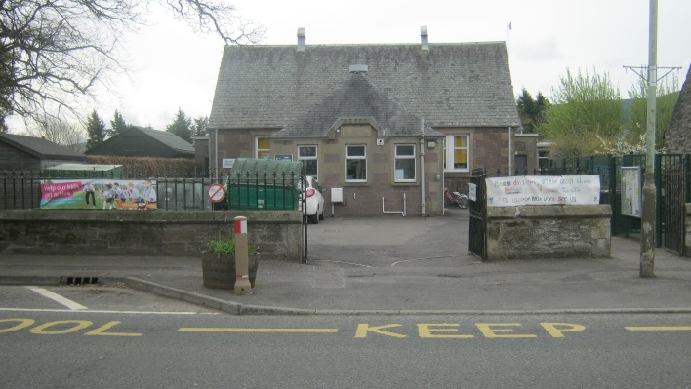

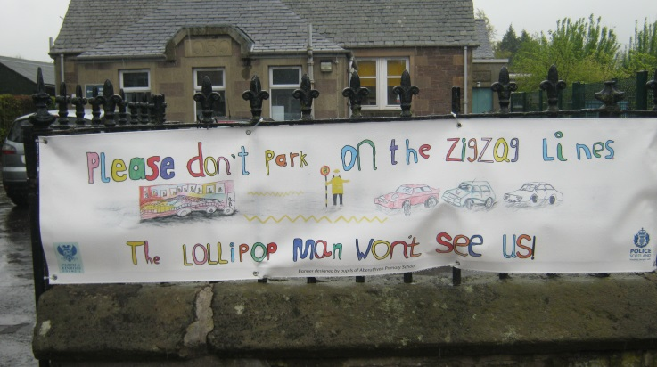

Our School Crossing Patroller, Mr Foulkes, shared that most people are parking in appropriate places which have no impact on visibility for crossing the road outside of our School. All members of our school community wait to cross safely with our School Crossing Patroller.
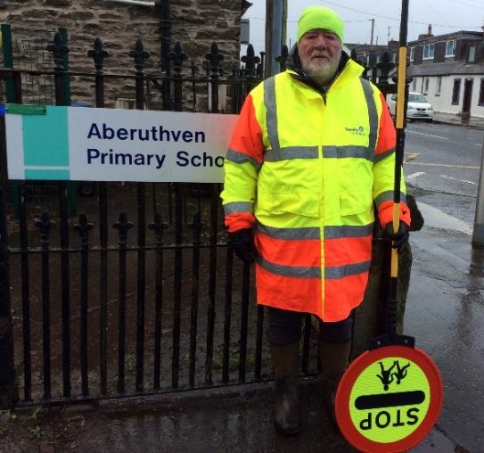

Road Safety in the Curriculum
Lessons

Road Safety is explored with our pupils every year during Health Week through a variety of resources, videos and discussion.

Staff Visits

We have a very supportive School Janitor and School Crossing Patroller within our school community. Both Mr Martin and Mr Foulkes have joined us for Road Safety Assemblies to discuss safety when crossing the road to and from school and give frequent, ongoing updates to support the safety of all where needed.

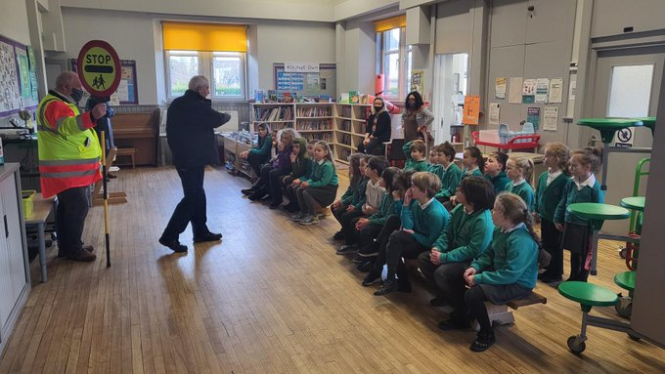

Bikeability

P5-7 pupils have the opportunity to take part in a six-week training course to help them cycle safely. These sessions will be led by trained volunteers and Staff through Bikeability Levels 1 and 2. Skills taught include how to check your bike and helmet are safe plus how to do a safe start and stop, left and right turns.

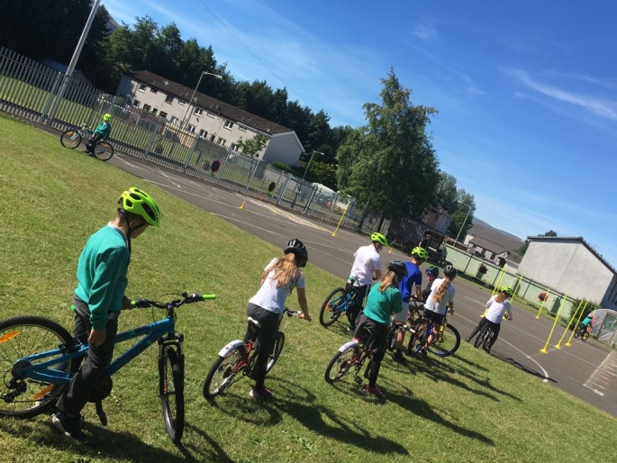

We also promote additional workshops/ sessions ran by Bikeability to encourage our pupils to further develop their safe cycling skills on our School website, Newsletters and Twitter feed.
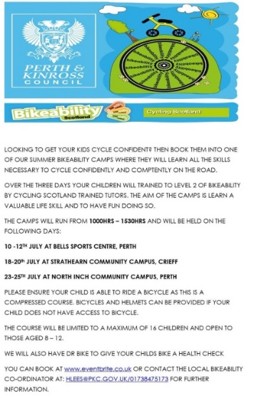

What has been done so far in Aberuthven to deal with the problems caused by traffic on the main road?

- 20 MPH speed limit is in place throughout the village of Aberuthven.

- Twenty’s plenty signs have been put up on the road outside the school.

- The pavements outside the school have been made wider to help the crossing patroller see better and make crossing the road safer.

- We have encouraged people not to park on the yellow and white road markings on the main road outside the school by getting a new banner.
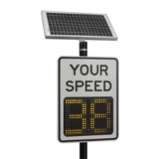
- Speed awareness signs have been added to the top of Main Road targeting cars as they enter the village to deter speeding.

- Frequent Police Speed Checks on Main Road throughout the year to deter speeding

What effect has this had?

The parking has improved but the speed of the traffic passing the school may still be faster than 20mph and that means cars cannot always stop safely when the lollipop person steps out or a child starts to cross the road.

The speed of traffic on the Main Road could still be dangerous for children coming to and leaving school. This is especially important at times when our School Crossing Patroller is unable to be there or when children are leaving school after 3.30pm, when the crossing patroller has gone home and there are no staff or parents.

What other issues do we need to deal with?

We need to continue to encourage our families to use our School Crossing Patroller when crossing the road outside the school both in the morning before the start of the school day and in the afternoon at the end of the school day. This will help to ensure all are able to cross safely to school.

We need to continue to work with members of our local community to encourage all road users to adhere to the speed limit currently in place throughout Aberuthven village.
Action Points

These are the things we need to do to achieve our aims:

- Continue to raise awareness of every child’s right to ‘be protected’ in line with Article 19 of the UNCRC.
- Keep checking that everyone is parking properly on the main road outside the school – communication with the School Crossing Patroller if any problems.
- Check what Road Safety is being taught in the classes biannually during Health Week to make sure pupils are learning everything they need between Primary 1 and Primary 7.
- Share our updated Travel Plan and make this available on our website to allow continuous access for all within our school community.

When will we do our next Travel Plan?

We will continue to observe and share information within our School Community throughout the year which will support the ongoing road safety of all.
Our Travel Plan will be reviewed March 2027.

