Dates for the Diary 2026  A warm welcome to Miss Byrne  Miss Ailish Byrne who is a Student Teacher from the University of Dundee will be in Class 1 from January – March. Our pupils have given her a warm welcome.  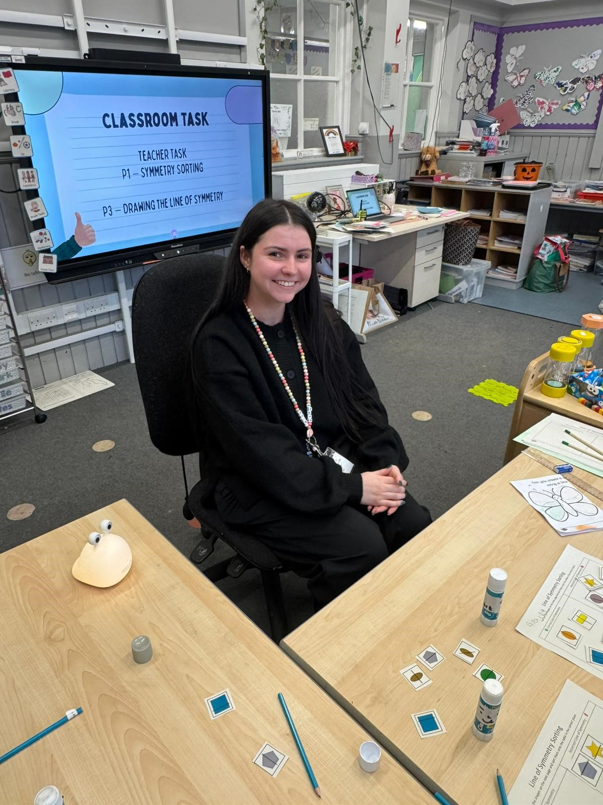 |  | Parent Partnership News  Our Parent Partnership will meet in School on the following dates and times between now and the end of 2025. All are welcome to attend.  - 26.02.26 @3:15  Upcoming Events  - Easter Movie Night after School  Looking for more information you can email  parentpartnershipaberuthvenps@gmail.com
  Date | Details
  10.02.26 | School Finishes for February break 3:15pm
  16.02.26 | School returns after break
  05.03.26 | World Book Day
  09.03.26 @ 1:30pm | School Show
  10.03.26  @1:30pm | School Show
  16.03.26 | Interim Reports to Parents
  23.03.26 3:30 – 7pm | Parents Night
  23.03.26 | P7 Pupils Nethybridge
  03.04.26 | Spring Break
  20.04.26 | School Open to all Pupils
 | The Birds really enjoyed the feeders the children made

Aberuthven Primary School

February 26

Newsletter
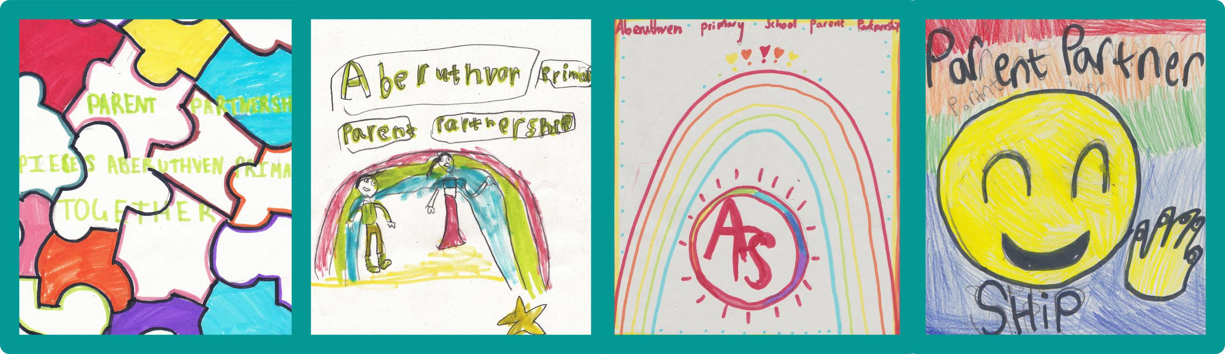

A message from Mrs Tyrrell |  | Please see a reminder of our clubs below:  We are in the process of reinstating our Intergenerational Group, with meetings due to take place this week with potential volunteers. More information to follow soon on this exciting initiative!  Don’t forget our February In Service Day, Wednesday 11th February. School will be closed Thursday 12th and Friday 13th for Mid-Term holidays.  Kind regards,  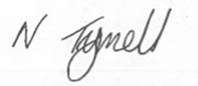 |  | Parent Zone
  Monday | P1-7 Art Lunchtime Club  Mrs Spark
  Wednesday | P1-7 Homework Club  Mrs Gallagher  P1-7 Lego Club Michelle
  Thursday | Drama Club Lunchtime  Mrs Murray  Quiz Afterschool Club  Mrs Boyle
Dear Parents, Guardians, and Friends,  What a fantastic start we’ve had to the year!  We’ve enjoyed a lovely Burns Afternoon and were incredibly proud of the hard work and huge effort our pupils had put into learning and presenting their Burns poems. Thank you to our guest panel for joining us. Rehearsals are well under way for our school Pantomime ‘Aladdin Trouble’, with tickets still currently available for both days- Monday tickets are selling fast!  Our pupils are thoroughly enjoying all the lunchtime and afterschool clubs currently on offer.  We also have P4-7 Curling & P1-3 Gymnastics Afterschool Clubs due to start after Feb break. Please complete and return permission slips should your child wish to sign up to either opportunity. |  |  |  | Are your details up to date?  We need to make sure your household / Emergency contact details are up to date and correct. If you could email any changes to Aberuthven@pkc.gov.uk. It would be much appreciated. Our Annual Data check will be sent home in the New Year.  Swap Shop  The children have brought home a list of clothing items available. If you would like an item that is listed, please email the school at Aberuthven@pkc.gov.uk.  Book Sale  

