Dates for the Diary 2025  Date Details  8th, 9th, 10th October No hot food service for School Lunches  10.10.25 Interim Reports out to Parents  10.10.25 Term finishes at the end of the school day.  13.10.25 Phase 1 Roof Works begin  27.10.25 Term 2 begins and we welcome all our pupils back to school.  31.10.25 Halloween Disco (Parent Partnership)  10.11.25 @3:30-7pm) Parents Night  13.11 & 14.11 25 School Closed (Pupil Holidays)  18.12.25 Christmas Party  19.12.25 Christmas Jumper Day  23.12.25 Term finished at 12 noon  Hello and Welcome to Mrs Gilfillan  Mrs Gilfillan is our new Pupil Support Assistant and will be in School Monday to Friday  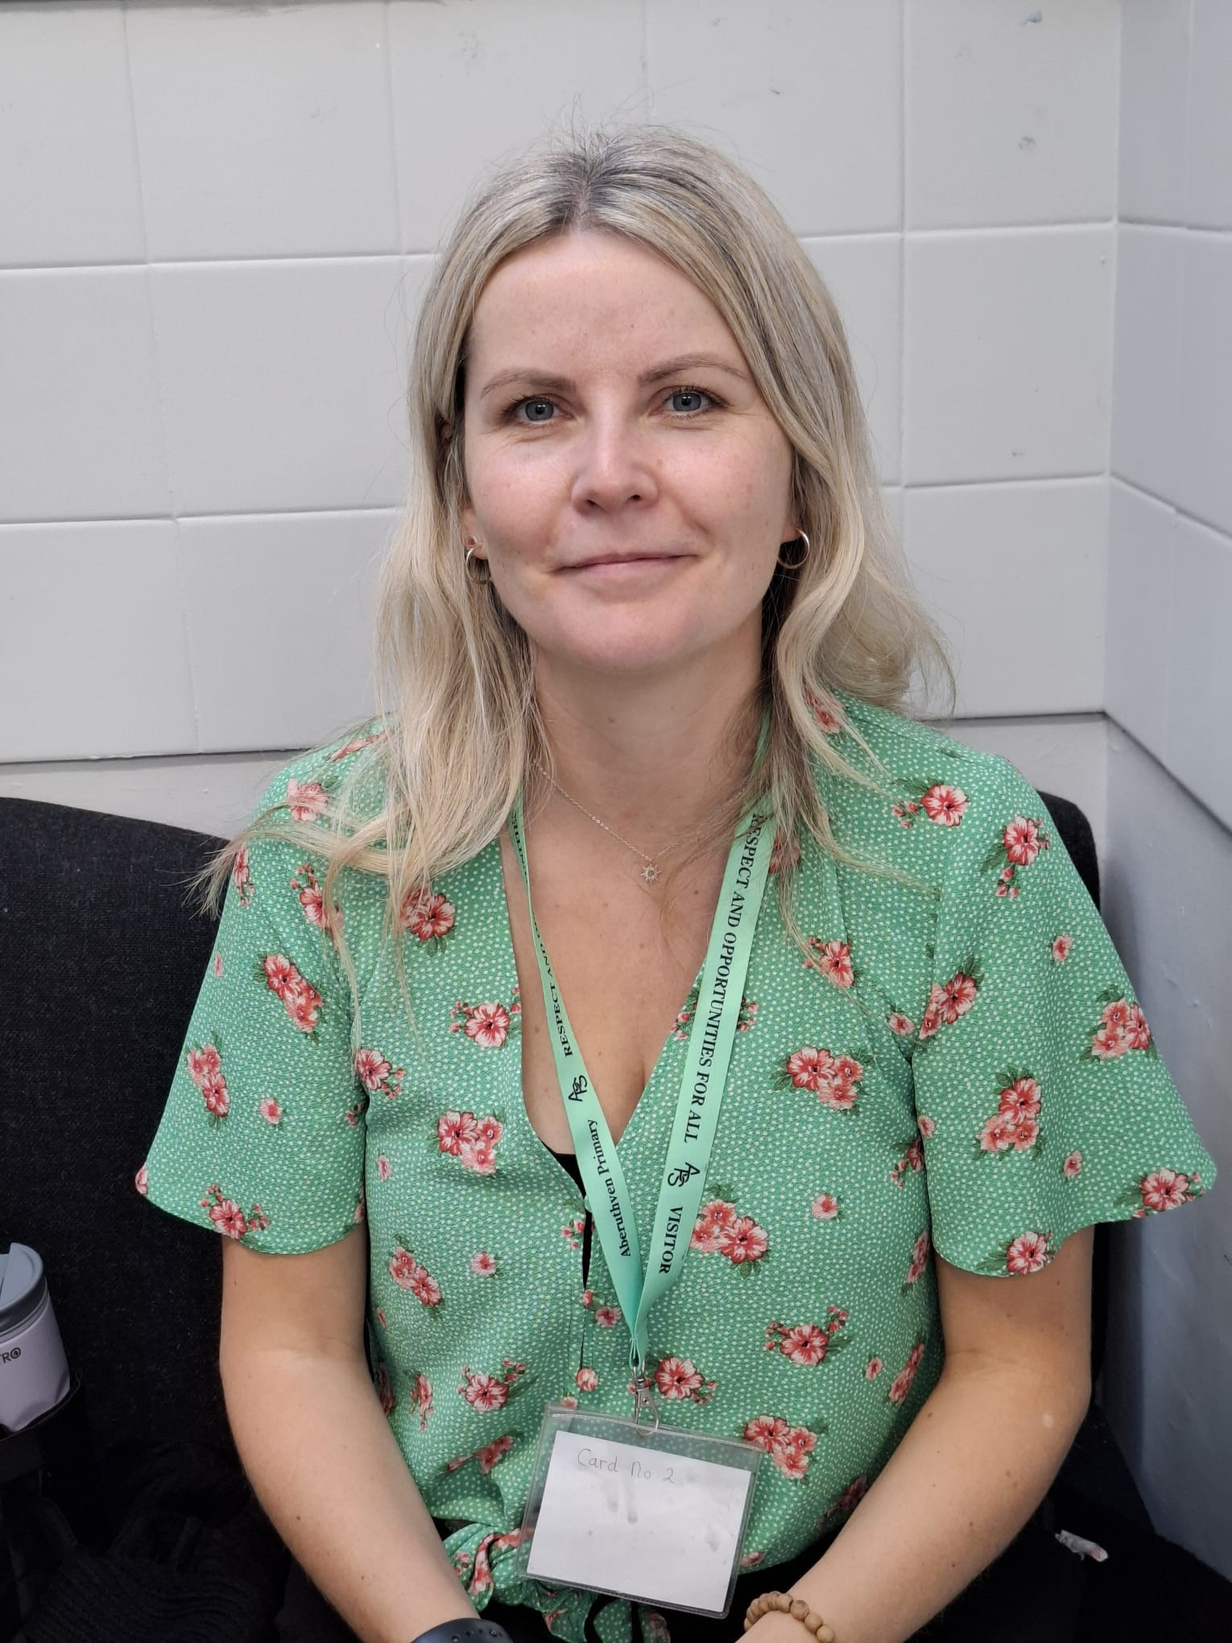 |  | Parent Partnership News  Our Parent Partnership will meet in School on the following dates and times between now and the end of 2025. All are welcome to attend.  - Friday 10.10.25 @3.15pm  - Thursday 06.11.25 @ 6pm  - Monday 01.12.25 @ 5.30pm  Upcoming Events  - Halloween Disco Friday 31.10.25 @ 6-7pm & 7.30-8.30pm  - Movie Night Friday 5.12.25 @ 3.15-5:30pm  Looking for more information you can email  parentpartnershipaberuthvenps@gmail.com
 | Our Primary 1 Pupils have enjoyed their first term in School

Aberuthven Primary School

October 25

Newsletter
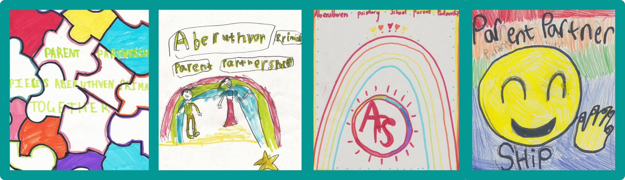
 |  | It is hard to believe that our first term is coming to an end over the next few weeks. Our pupils have worked incredibly hard this term so far- I am sure they will enjoy a very well-earned rest during the October break.  We thank you in advance for your support next term, particularly over the period of essential works due to commence during the October break on our school roof.  We wish all within our school community for relaxing and enjoyable October break. We look forward to welcoming our pupils back to school on Monday 27th October 2025.  Kind Regards  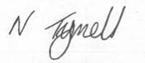  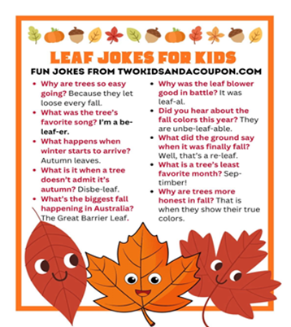 |  | Parent Zone
A message from Mrs Tyrrell  Dear Parents, Guardians, and Friends,  It was lovely to see such a large and positive response to our Parent Decider Skills session in September. Thank you to all who took the time to attend and share their feedback.  There are 2 apps which can be downloaded to support Decider Skills at home. For further information please visit https://pwa.thedecider.org.uk/ and https://thedecider.org.uk/resources-downloads/stopp/.  Further information about Decider Skills can also be found at The Decider Skills | The Decider. |  |  |  | Bug Busting  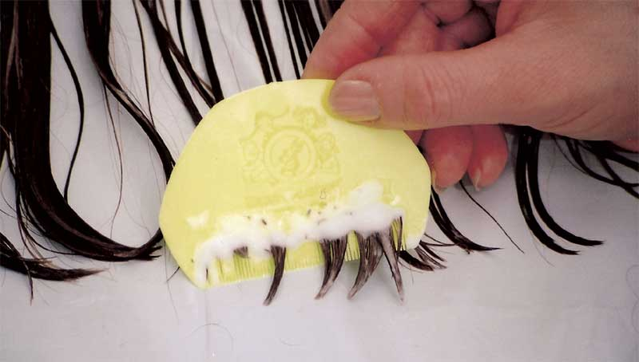  Click on the link below for useful information on preventative and treatment of head lice.  Head lice and nits - NHS  Temporary changes to School Dinners  You have been informed about no hot dinner options taking place on the 8th, 9th, 10th October. If you have not placed a pre order for packed lunches you will need to provide a packed lunch from home for your child on the dates above.  Essential Roof Refurbishment  Just a wee reminder following on from the Head Teachers letter, roof works are due to start Monday 13th October 2025 for approximately 11 weeks. Please take time to familiarise yourself with the temporary changes which will be in place during this time.

