Dates for the Diary 2025  PKC Cross Country Championships  Well done to all of our runners who took part, they did really well.  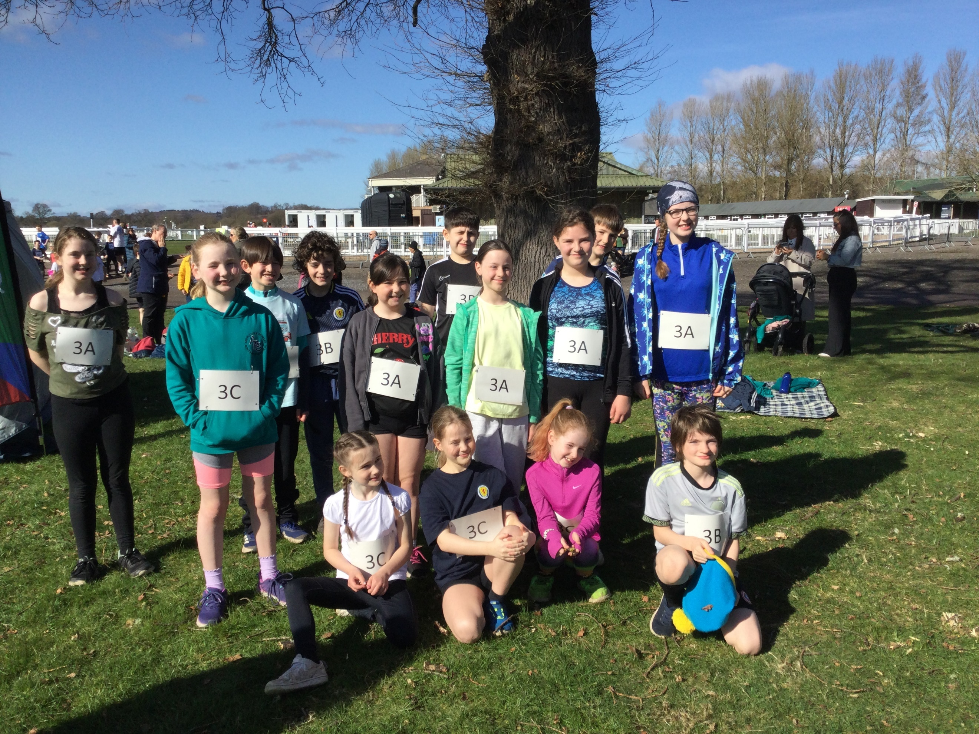  Quiz Team News  Our fantastic Quiz Team are through to the next round which will take place on 3rd May, they are practising hard, we wish them the best of luck. |  | Parent Partnership News  Dates for the Diary (more detail to follow)  Family Quiz 11th May from 1pm  Summer Fayre 14th June 11:30 – 1:30pm  Pupil Portrait & Merchandise (online shop)  Every pupil will receive a pin code personalised to them (hopefully by the end of term) that will enable families to order various items tea towels, coasters bags etc. The online ship closes on the 13th May.  Looking for more information you can email  parentpartnershipaberuthvenps@gmail.com
  31st March – 4th April | Nethybridge Residential
  4th April – 21st April | Spring Break
  22nd April | In Service Day
  23rd April | Pupils return to School after Spring break
  24th April @6pm | Parent Partnership Meeting
  5th May | May Day Holiday, School closed
  3rd June @1:30pm | Sports day (weather permitting)
  15th June | National Bug Busting Day
  19th June | School Trip – Active Kids
  23rd June | End of Year
  24th June @ 1:30pm | Celebration of Success & Leavers Assembly
  26th June | Summer Holidays
 | Have fun girlies at Nethybridge look forward to hearing all about it on your return.

Aberuthven Primary School

April 2025

Newsletter
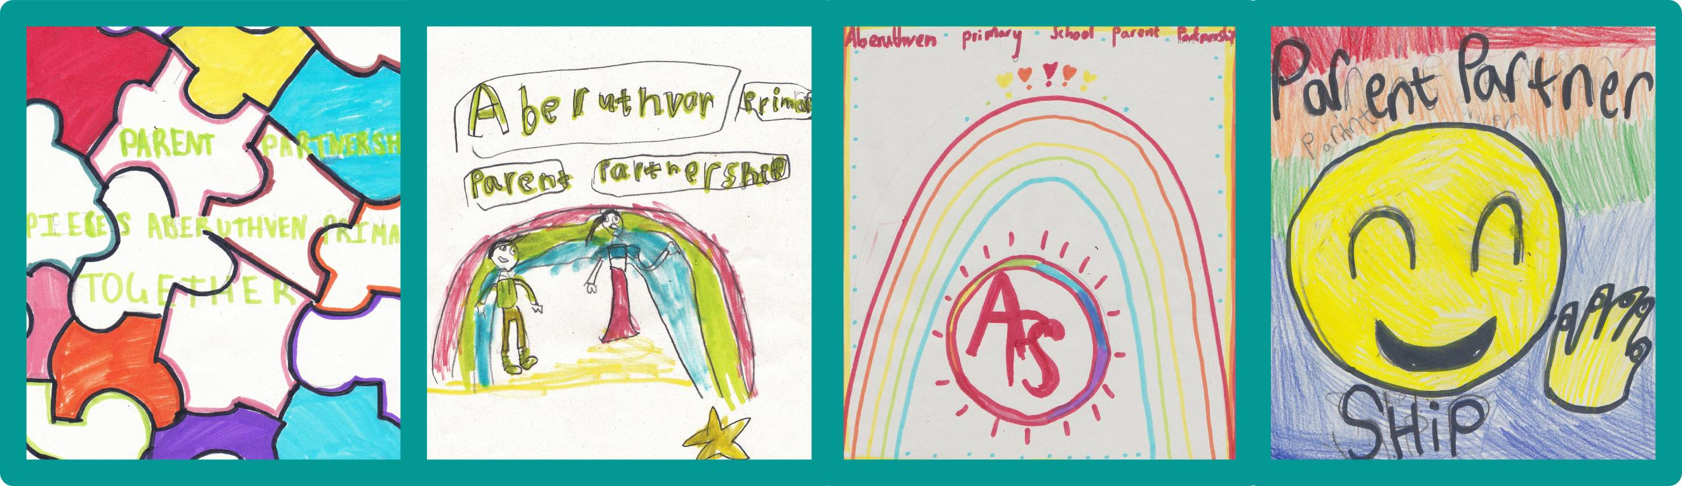
 |  | Our work experience volunteers Charlotte & Carlie have continued to be a wonderful help in school on a Wednesday & Friday afternoon. We would like to wish both of them luck as they attend interviews for College and University this month!  It was great to see so many of our Parents in school to meet with our Class Teachers for Parents Night- there were many proud pupils and parents that evening I am sure!  We wish all our families a lovely Easter break and look forward to welcoming our pupils back to school on 23rd April 2025 for the start of the summer term.  Kind regards,  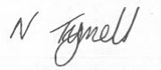 |  | Parent Zone
A message from Mrs Tyrrell  Dear Parent/Carers  What a busy term it has been! Classes have been working hard this term learning about Space & Life Cycles. We enjoyed a book week filled with fun activities and learning based on the classic tale of ‘The Hungry Caterpillar’ by Eric Carle. Pupils enjoyed taking part in lunchtime Drama Club and Football Games led by our lovely helpers, Norma and Jay! We had a lovely trip to the Mosque in Glasgow, followed by a workshop in St Mungo’s Museum of Religious Life & Art. Once again, the behavior of our pupils was outstanding! Class 2 blew us away with their participation and enthusiasm during their Music Project this term, culminating in a wonderful performance of ‘Happy’ and ‘Mamma Mia’ during our Easter Service. Class 1 reminded us of the importance of unity and acceptance in their wonderful retelling of the tale of ‘Neeps & Tatties’ too. |  |  |  | Active Kids 19th June 2025  Don’t forget to complete the consent form live on Parentpay as soon as you can. We need to put our order in for pack lunches by Wednesday 11th June 2025.  Primary Lunch Menu  A wee reminder that the Lunch Menu choices will change Week 1 starts on the 21st April. Further copies can be obtained from the School Office.  Lost Property  Lost property looking for their forever home! If you recognise or are missing an item do get in touch and we will do our best to reunite you  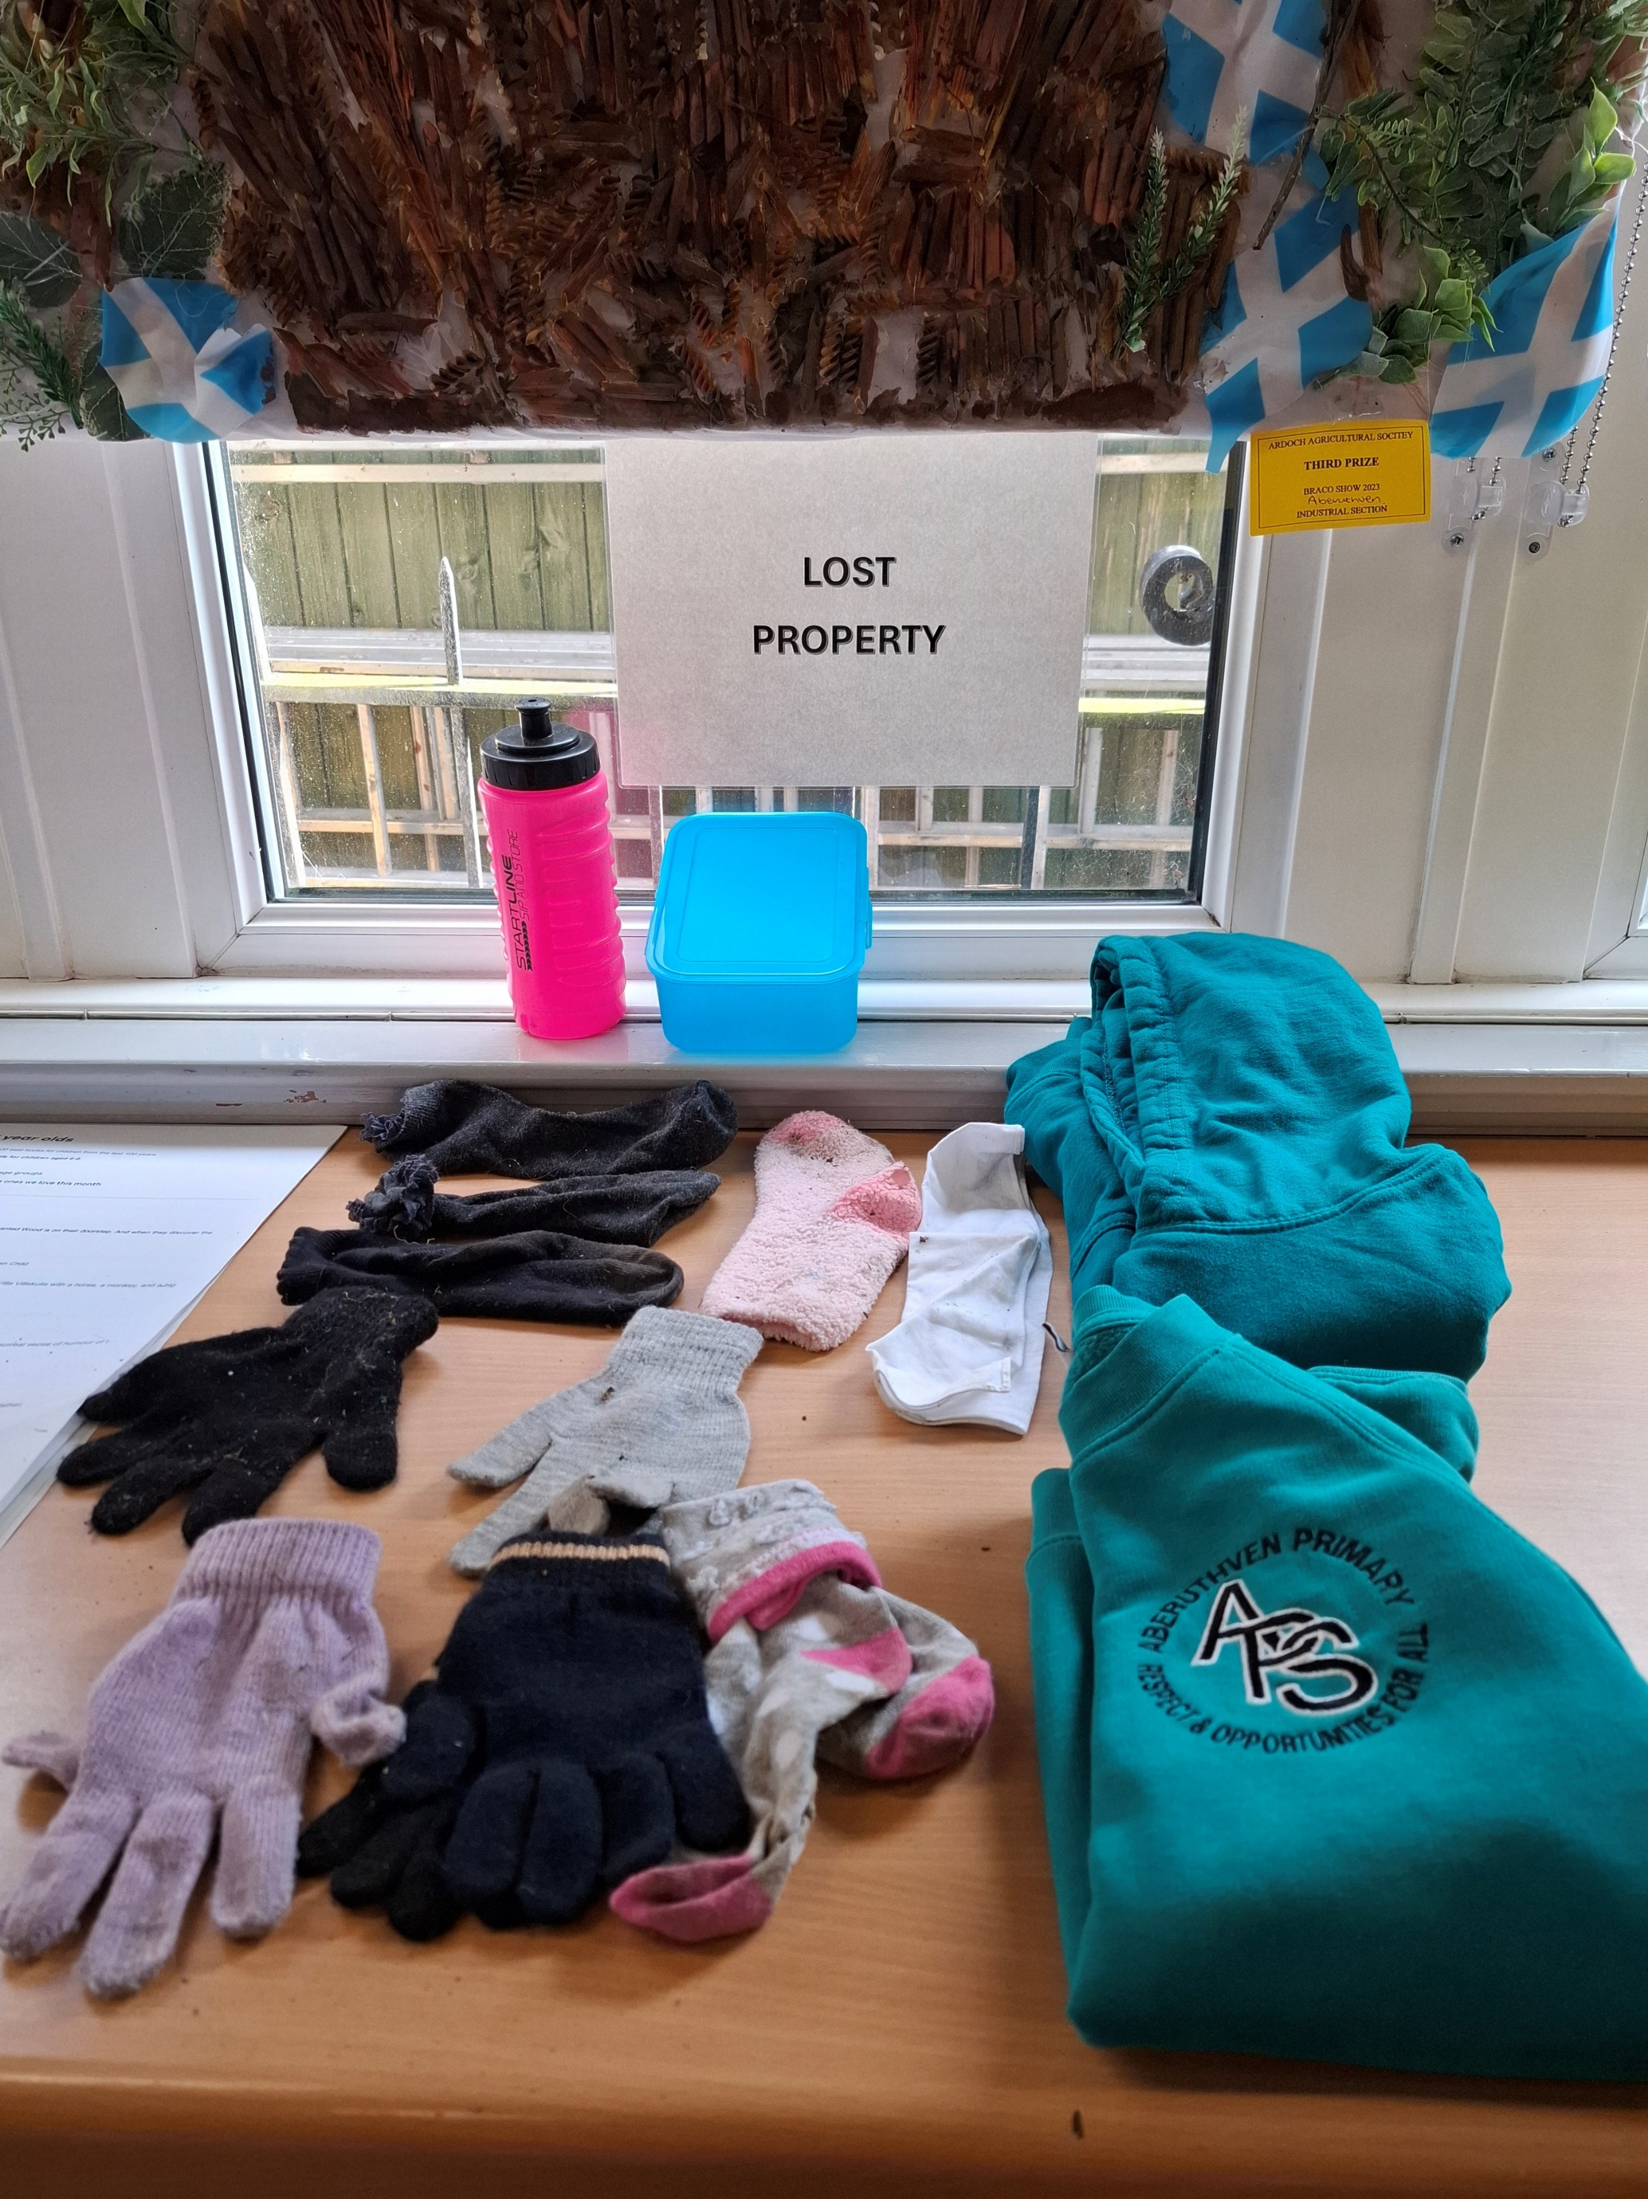  The Art of Sleeping  Mindspace are running a two-session course to learn how to get the best sleep and feel more refreshed.  Monday 7th April 10:30am – 12:00pm sign up using the link The Art Of Sleeping - Mindspace (https://mindspacepk.com/services/the-art-of-sleeping/)    We would welcome your suggestions or feedback on our latest newsletter. Either complete our form or email us Aberuthven@pkc.gov.uk

