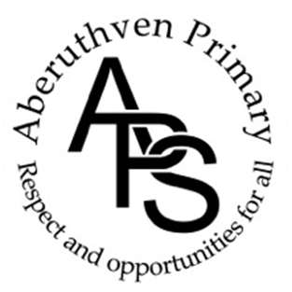

Aberuthven Primary School
Christmas Events & dates
December 2024

Christmas Dates for Your Diary
Thurs 5 Dec – Singing at Pensioners’ Lunch
Tuesday 10 Dec- Christmas Jumper Day
Tues 10 Dec – School Christmas Lunch
Thurs 12 Dec- Trip to Pantomime – ‘Mother Goose’
Mon 16 Dec – ‘ Cinderella & Rockerfella’ Show, in School at 1.30pm, admission by ticket only
Tues 17 Dec – ‘ Cinderella & Rockerfella’ Show, in School at 1.30pm, admission by ticket only
Wed 18 Dec – Christmas Party
Fri 20 Dec – School closes at 12 noon.

Singing at Pensioners’ Lunch
Children will be singing at the pensioners’ Lunch on Thursday 5 December in the village hall. They may wear Christmas headwear if wished e.g. Santa hats, reindeer antlers, or other Christmassy headwear. If you do not wish your child to take part in this please let us know by Monday 25 November.

Christmas Party
Our school Christmas party will be on Wednesday 18th December from 1.30 – 3.00 p.m. Children going home for lunch should change before returning to school. As usual please inform us by a note or phone call that your child is expected home for lunch. Those not going home for lunch should bring their party clothes to school and change in school at the end of the lunch break. We are hoping Santa will have time to visit the party.

School Christmas Lunch
Christmas Lunch will be served in school on Tuesday 10th December. There will be traditional turkey, chipolatas etc. There will also be a vegetarian option of quorn fillet with quorn Sausage etc. Dessert is a chocolate coated ice cream tree.

Christmas Jumper Day
We would like to invite pupils to wear their Christmas Jumpers to School on Tuesday 10th December.

Perth Pantomime
Our pantomime visit to ‘Mother Goose’ at Perth Theatre on Thursday 12th December will leave school about 9.45 a.m. We will be travelling by a Docherty’s coach. Children will receive a small ‘mix up’ at the interval.
Children will require a packed lunch that day. If you have ordered a school packed lunch your child will be given it on return to school. Would you please provide your child with a packed lunch from home if you have not ordered one from school.

School Christmas Show – ‘Cinderella & Rockerfella’
Our Christmas Show ‘Cinderella & Rockerfella’ will take place in our school assembly hall on both Monday 16th December at 1.30pm and again on Tuesday 17th December at 1.30pm . Tickets are available to purchase on ParentPay. Our Parent Partnership will be selling refreshments during the interval.

End Of Term
School will close at 12 noon for the Christmas holidays on Friday 20th December 2024.

