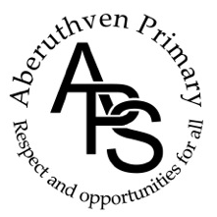

To face the challenges of the 21st century, each young person needs to have confidence in using mathematical skills, and Scotland needs both specialist mathematicians and a highly numerate population.
(Building the Curriculum 1, PKC Numeracy Strategy 2-18 )

Numeracy & Mathematics

Policy

November 2023

In Aberuthven Primary School we aim to:

Ensure all children and young people experience a numeracy rich curriculum at all stages of their primary education, led and supported by developmentally appropriate learning and teaching within a real life context for their learning where appropriate.

Planning

The Curriculum for Excellence Experiences and Outcomes in Numeracy and Mathematics are planned for in three phases; long-term, medium-term and short-term.
-The long term planning is included within the Numeracy & Mathematics Overview, collated alongside our Curriculum Map.
-The medium term planning is completed detailing Topics to be covered in Class during each School term.
-The Short term planning is completed on a weekly timetable in which they plan for a daily maths lesson.

All planned work caters for pupils in all ability groups and takes into account the targets set for individual children. Pupils within a class all experience the same aspect of Numeracy and Mathematics within a lesson. For example a whole class will be completing activities on division within a lesson.

Numeracy and Mathematics lessons are planned to include a:
Starter: Maths Talks or Mental Activity (approx. 5-10 mins)
Main: Teaching Activity (approx. 15-20 mins)
Individual/Group Work Activities (approx. 20-25 mins)
Plenary: (approx. 5-10 mins)

Accompanying daily lessons on Numeracy and Mathematics we ensure Numeracy Across Learning is planned for across the curriculum and will be included where appropriate in the planning of all subject areas. E.g. Links to Literacy- Children enjoy stories and rhyme that rely on counting and sequencing etc. This is planned for through our Curriculum Map.

Resources

We use a variety of resources to support the teaching and learning of Numeracy. Our core resource is Primary Maths for Scotland, alongside a variety of complimentary resources. Mental Maths is planned for using resources such as New Wave Mental Maths and Maths on Track etc. Problem Solving is taught within real-life context through a variety of resources, as well as Primary Maths for Scotland.

Pupils have the opportunity to use a wide range of active learning resources such as number lines, number squares, whiteboards, digit cards and small apparatus to support their work. Children and teachers incorporate digital learning within mathematics lessons, where it enhances learning and assists with modelling ideas and methods where possible and appropriate.

Learning at Home

Working alongside parents is an essential part of improving pupil’s numeracy skills. Homework is given out weekly. The tasks issued directly link with the current unit of learning and are differentiated for each maths group.

Monitoring

There is a programme of monitoring and supporting the teaching of Numeracy and Mathematics consisting of analysis of classroom planning, observed lessons (including peer observations/ self observations) and monitoring of pupil work.

Assessment

Daily work in maths is assessed using ‘Assessment is for Learning’ activities including self and peer assessment, staff observations, monitoring of pupil work and ‘show me’ activities. Assessment check ups are used during and after Numeracy and Mathematics topics taught. Evidence and pupil work is collated in pupil jotters(P1-7) and Pupil Assessment Jotters (P4-7 only). SNSA is used to assess pupil’s annual progression (P1,4,7) and are filed in Class Assessment Folder.

At the beginning of the maths topic in P4-7, goals are shared with pupils via ‘assessment starbursts’. On completion of Topic area, pupils complete a topic ‘check-up’ to demonstrate their understanding of targets within the topic assessing the goals outlined at the beginning of the topic. Teachers then mark and feedback to pupils. This then helps to form a discussion between pupil and teacher around progress and targets for next time. Targets are written in Pupil Assessment Jotters.

All assessments are used to help us form pupil next steps and inform our future planning.

Progression Pathway (Appendix 1)

We have devised a Progression Pathway to support Teacher judgement both in planning and assessment of Numeracy. Within the pathway there is a bank of mathematical strategies which can be applied to support the solving of problems including the four main functions: addition, subtraction, multiplication and division. These strategies are taught, discussed and explored consistently across both classes. Our ‘strategy pathways’ are as follows:

Addition
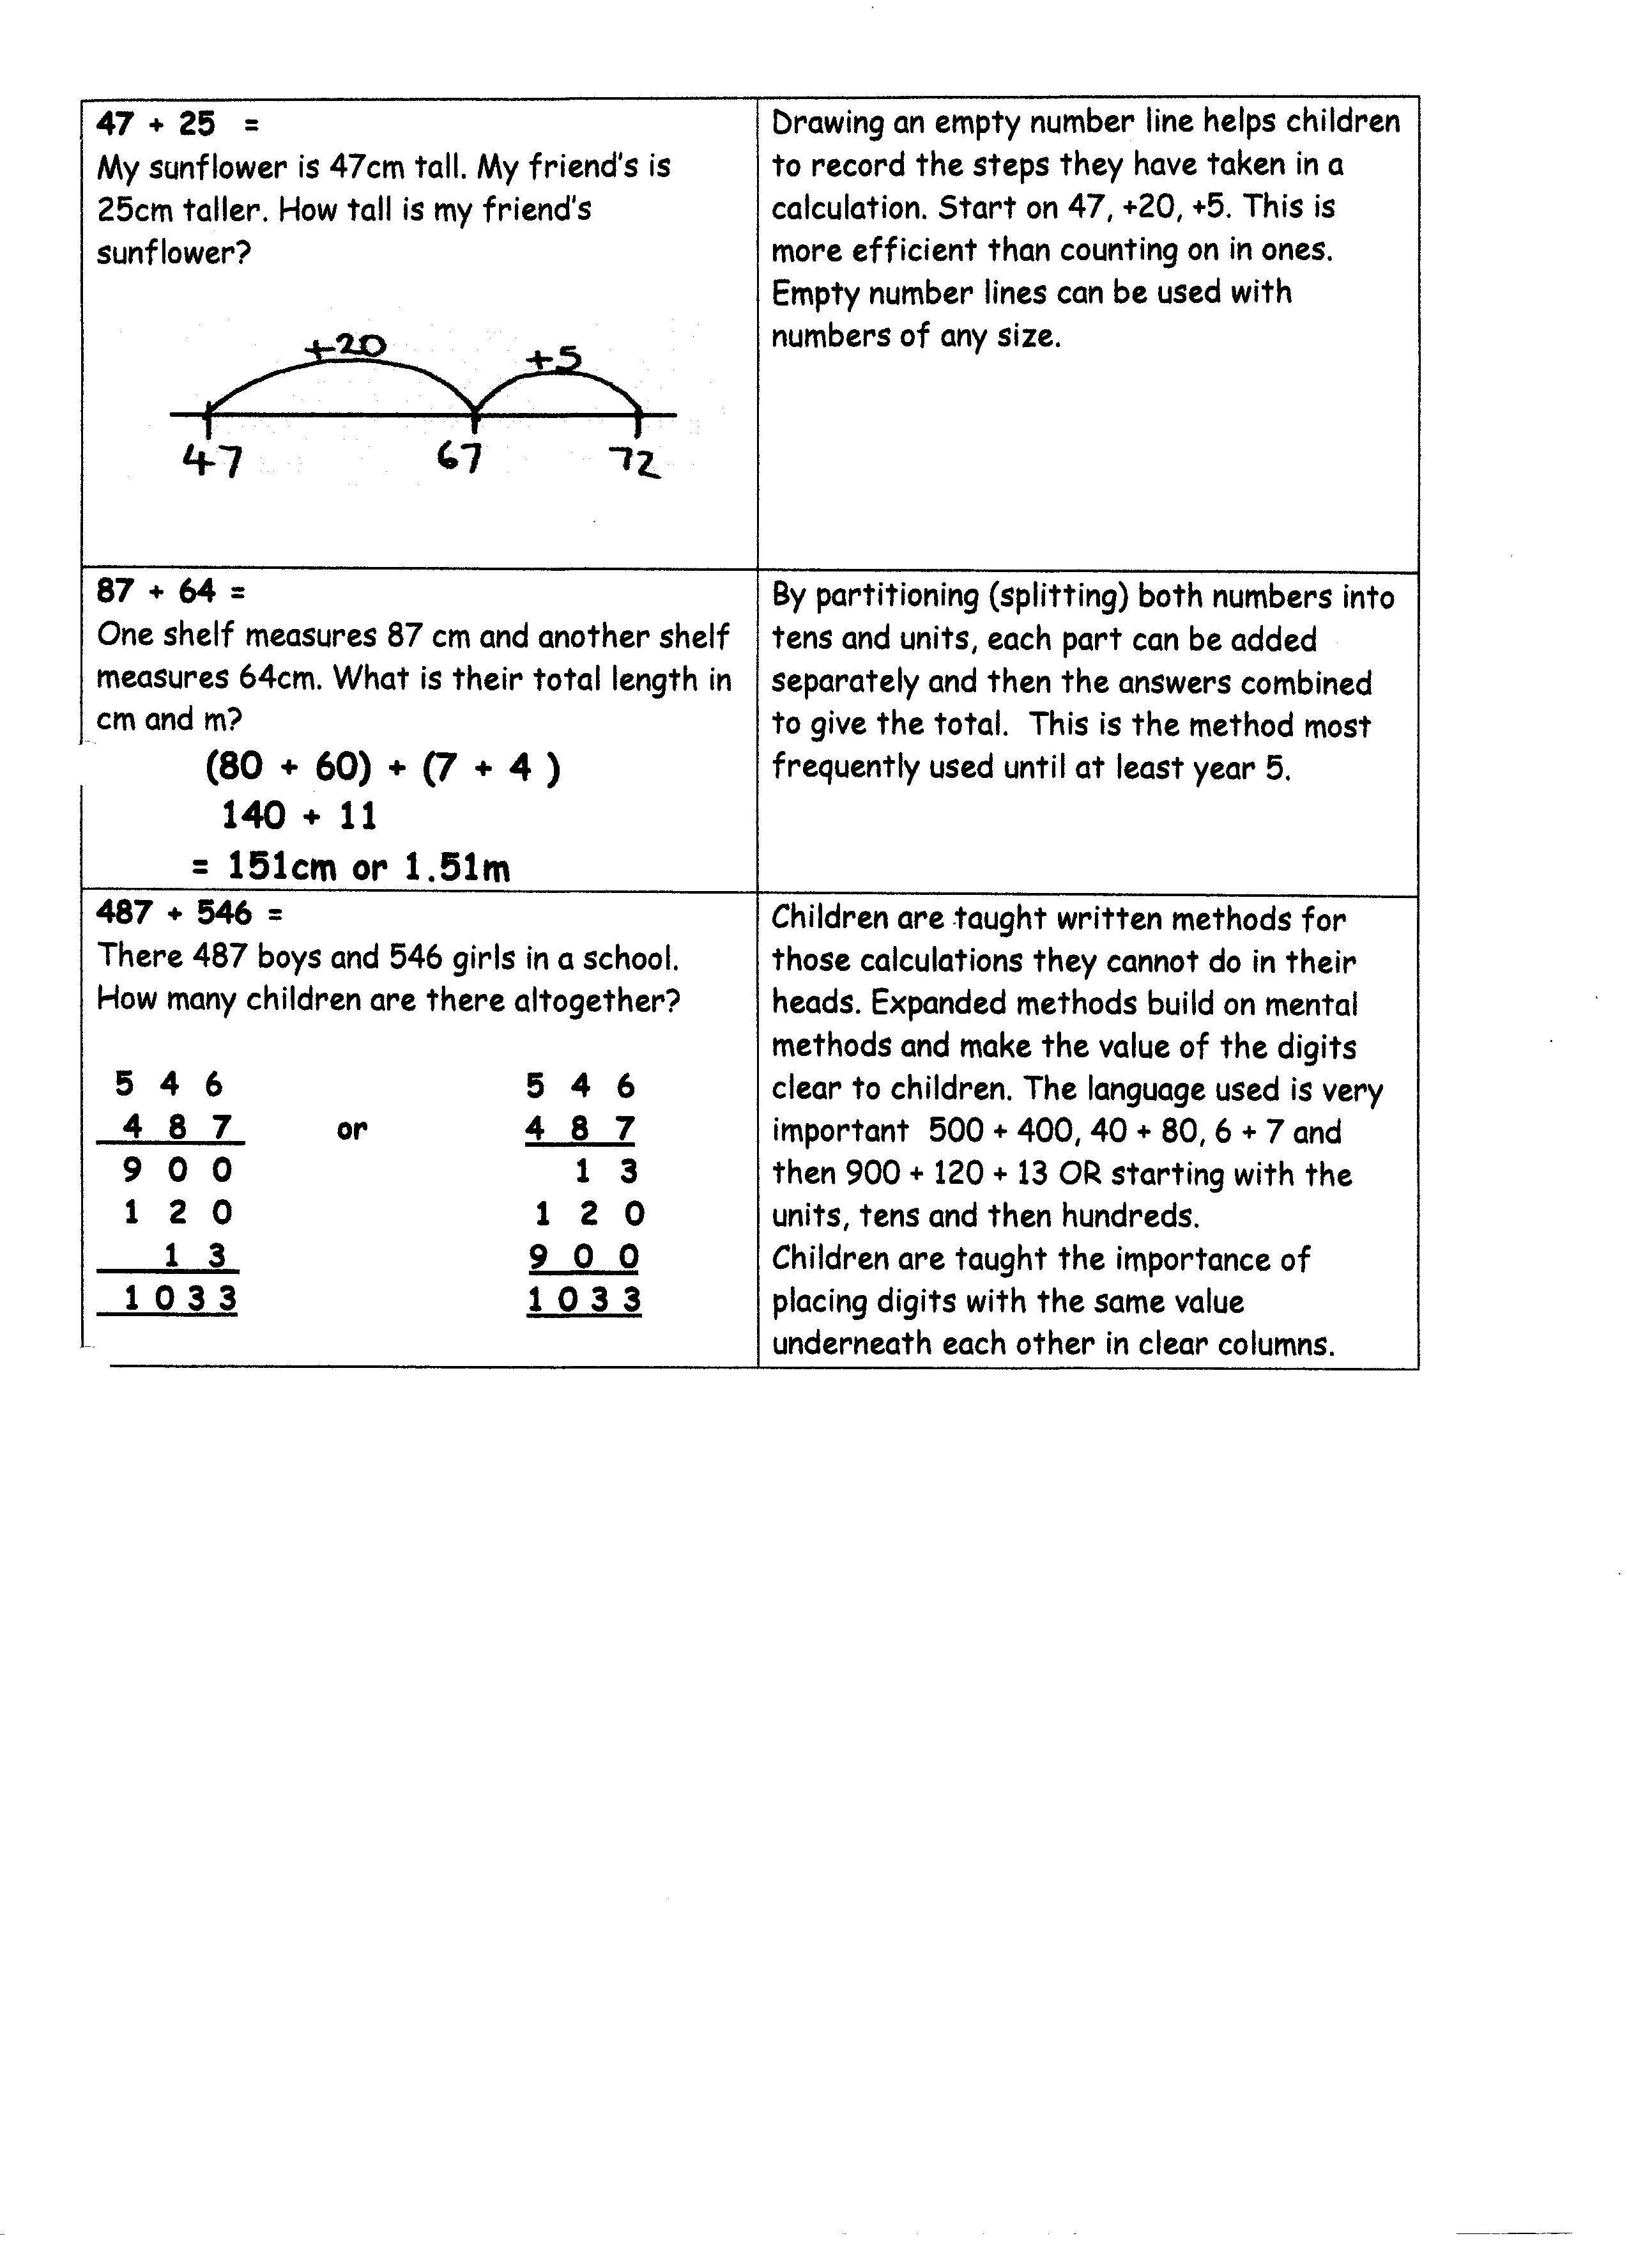
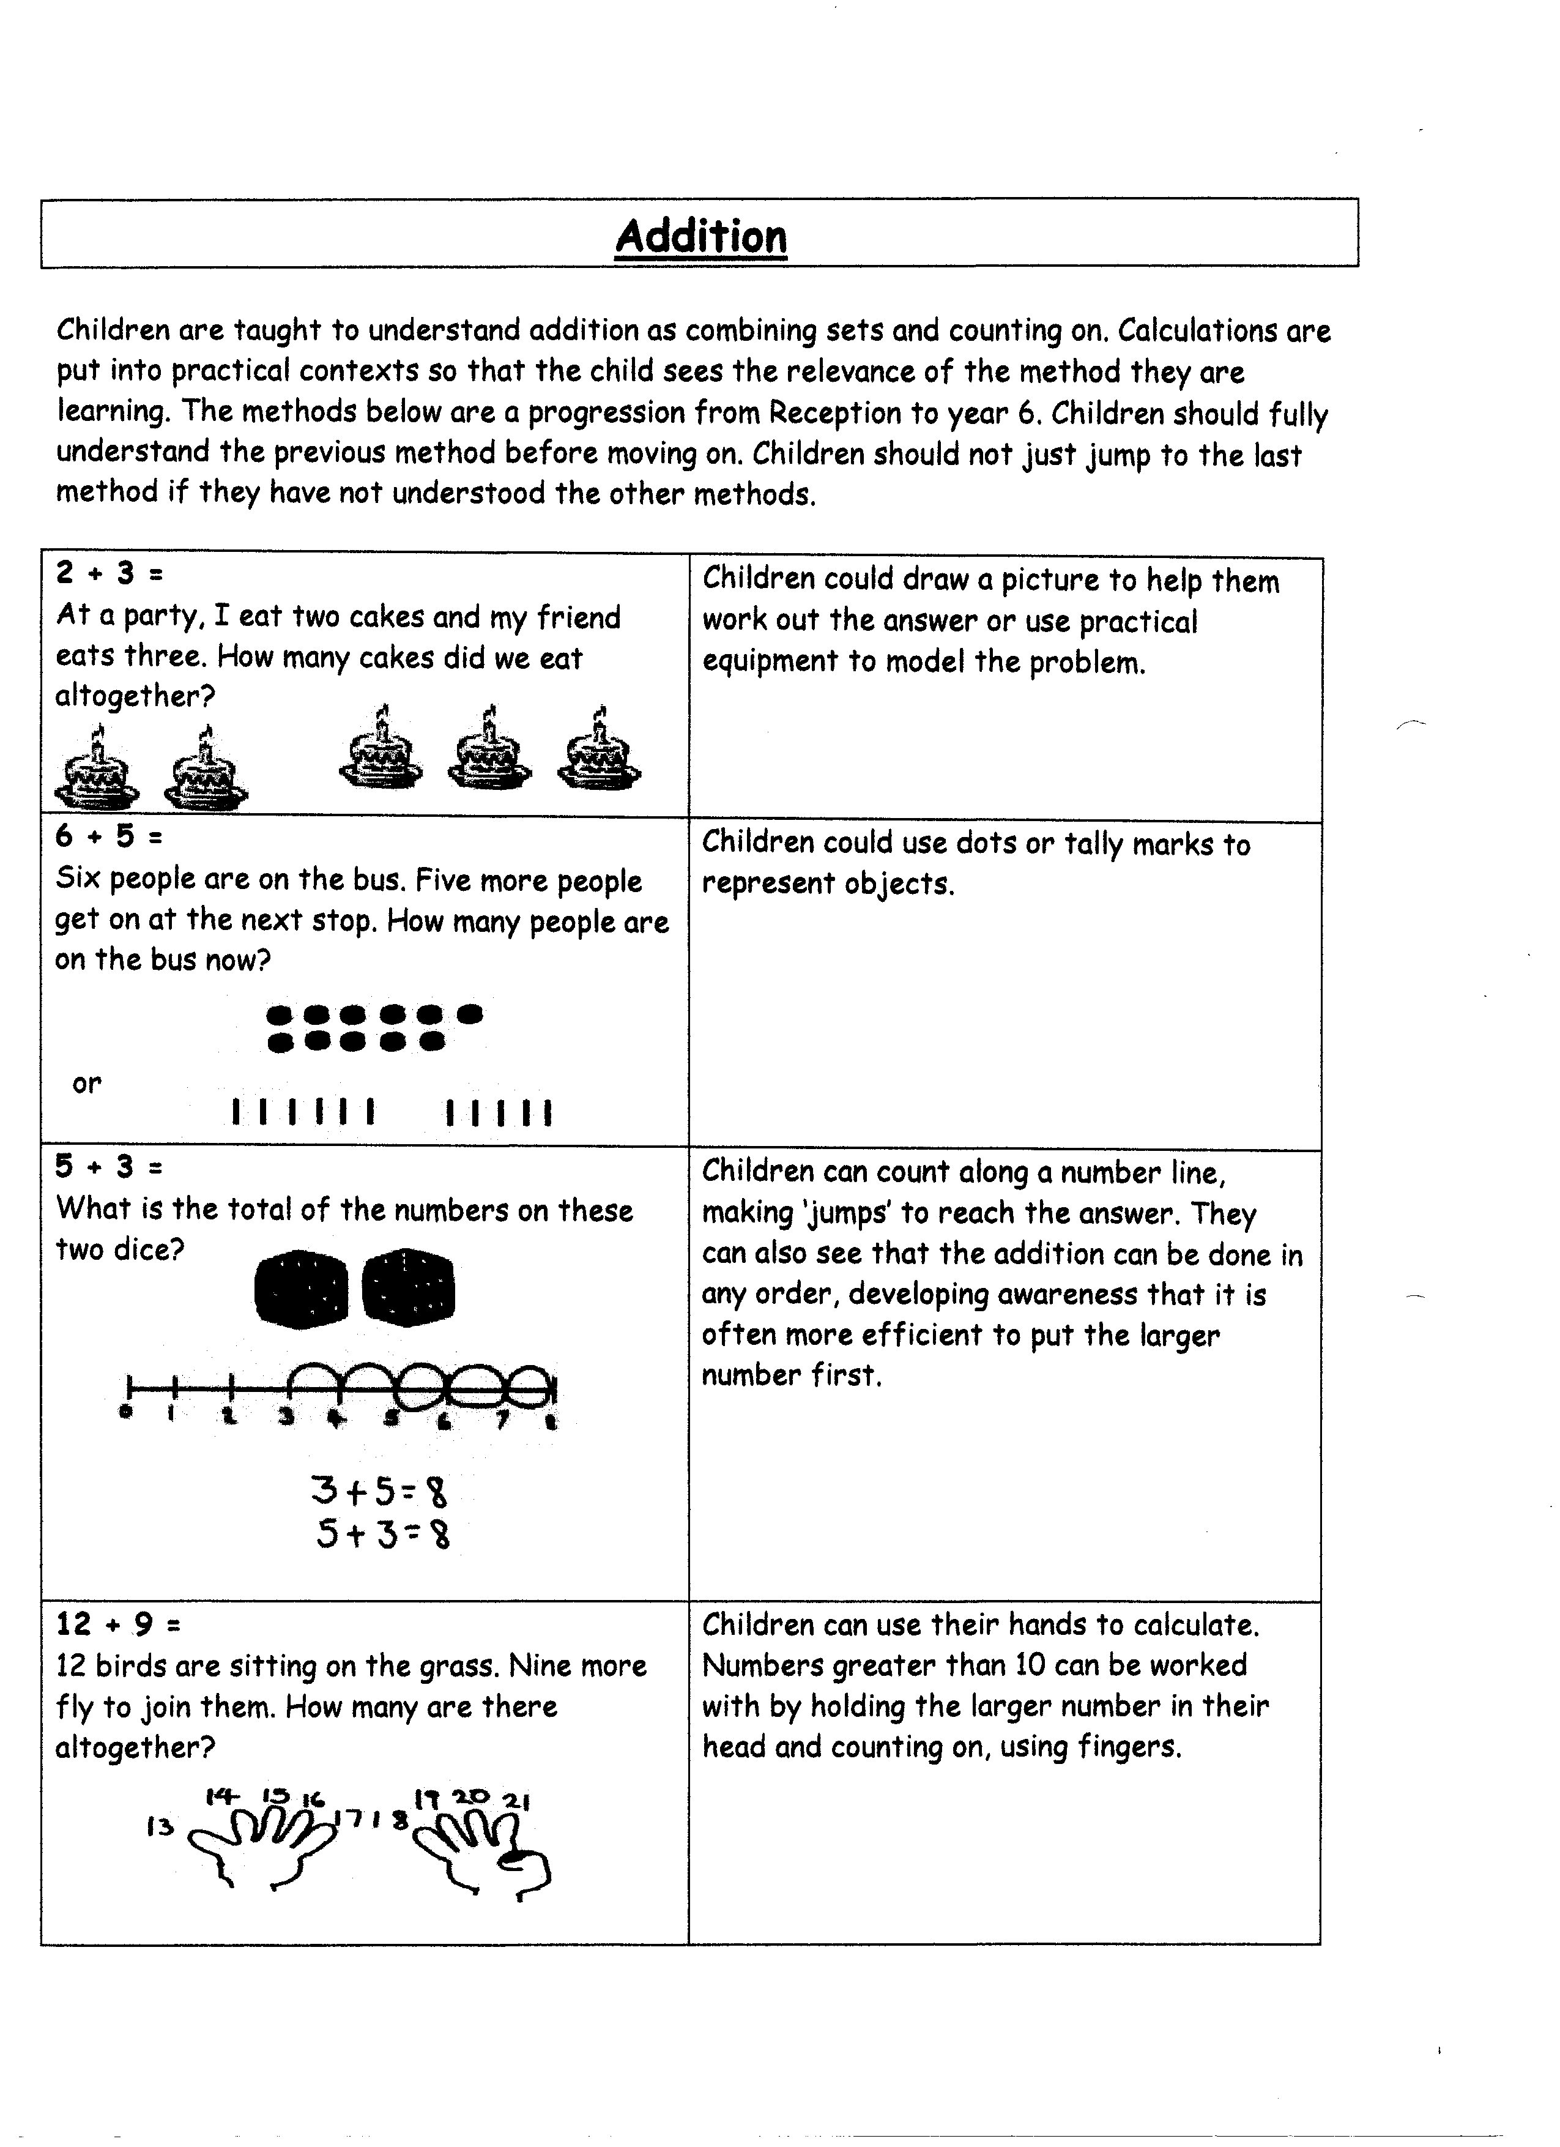

Subtraction

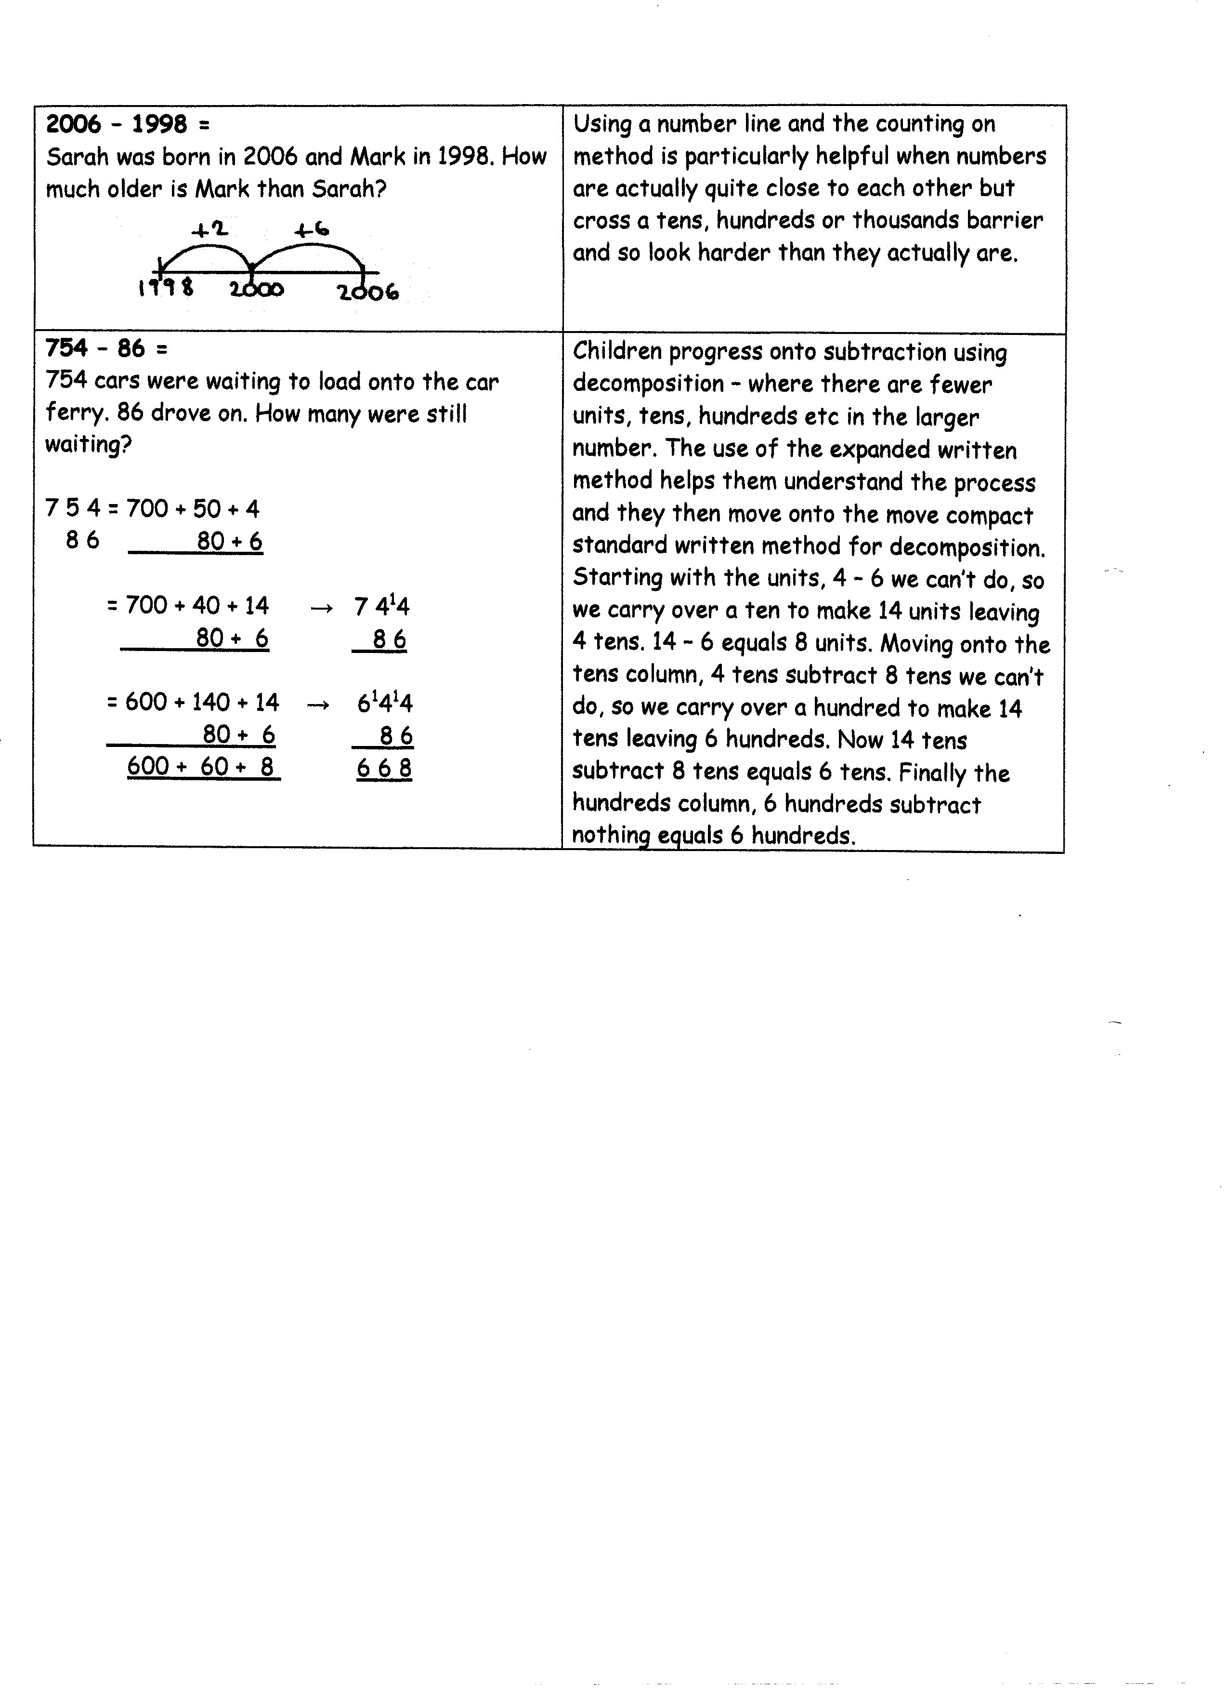
Subtraction
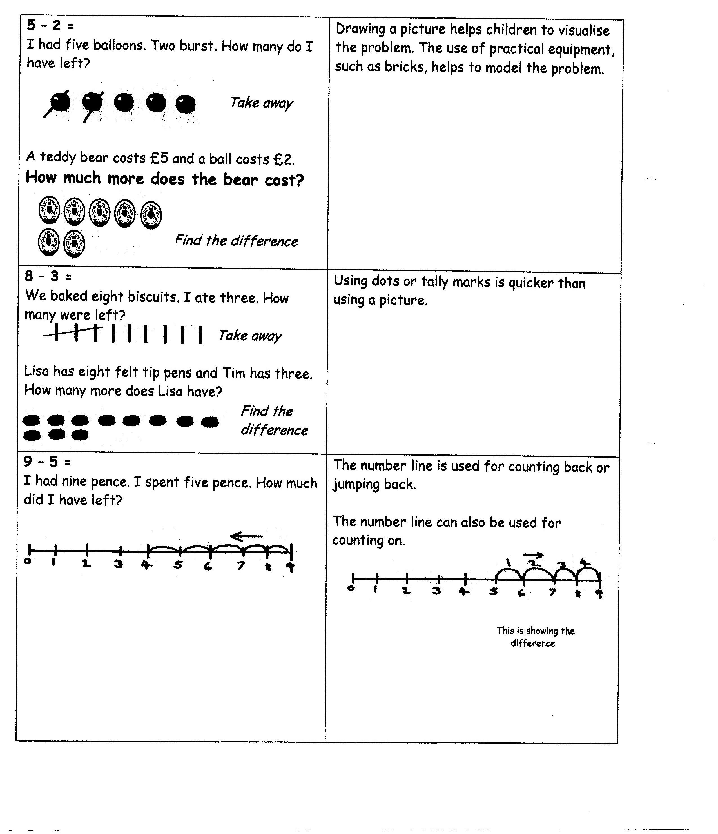

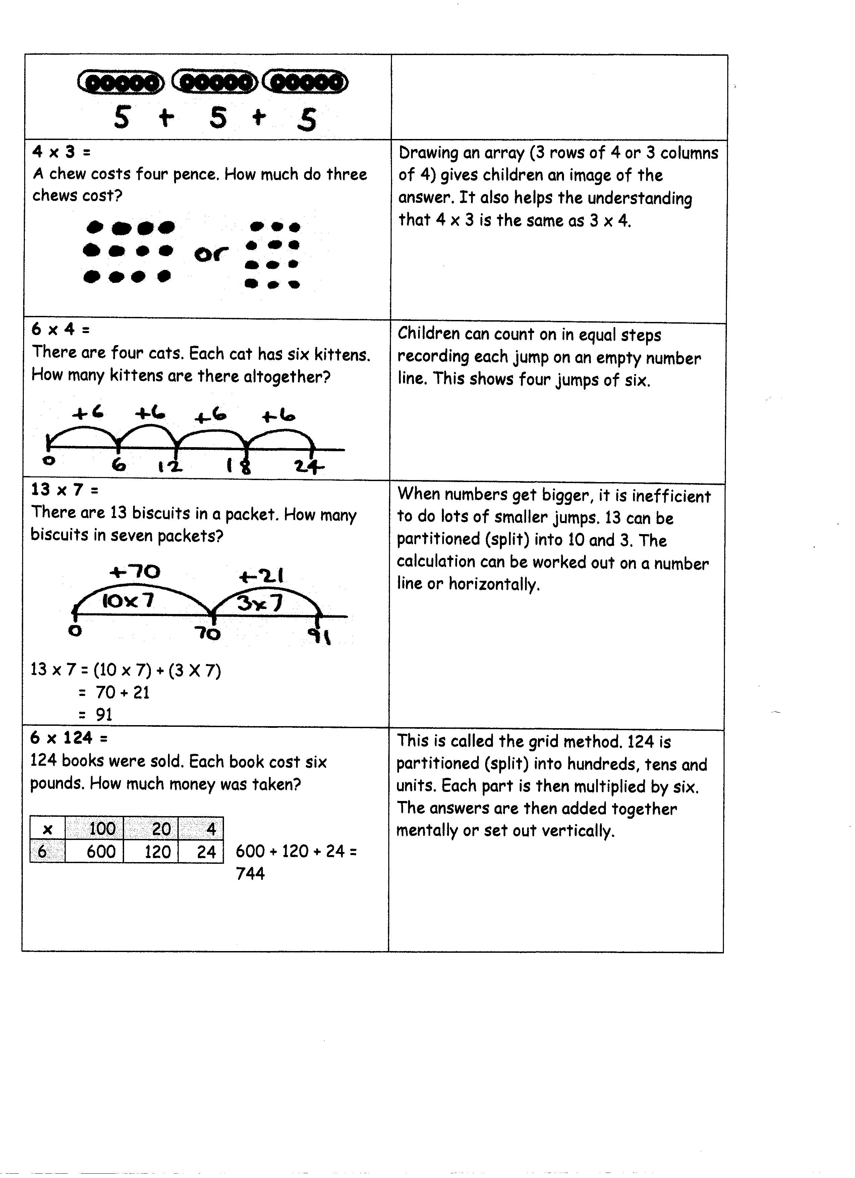
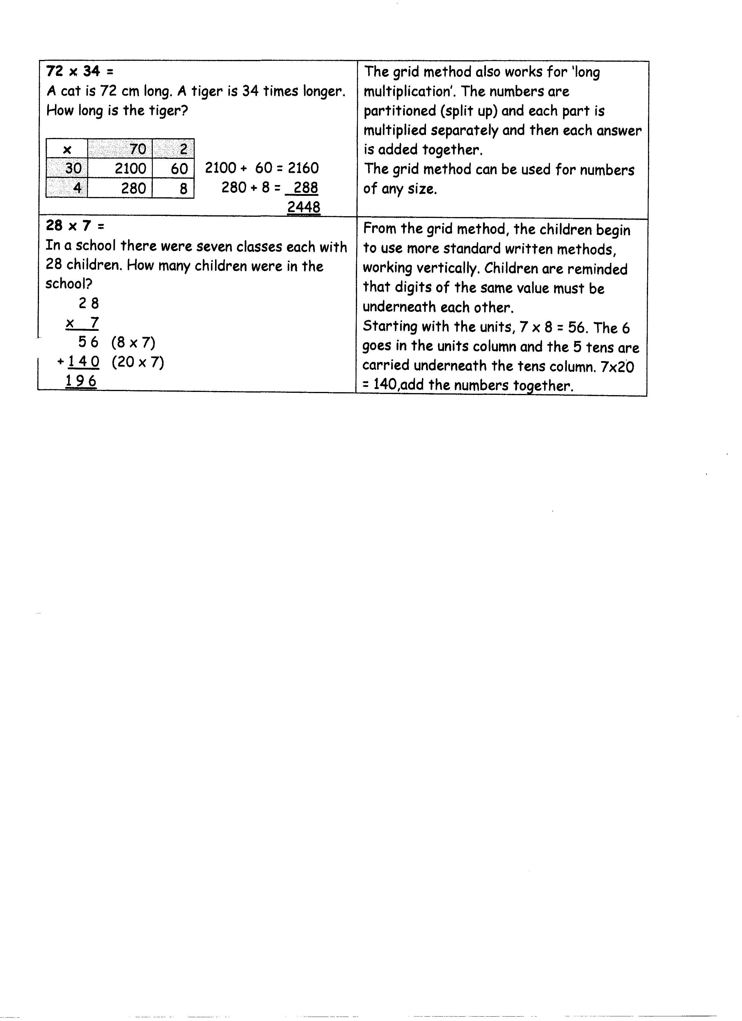
Multiplication

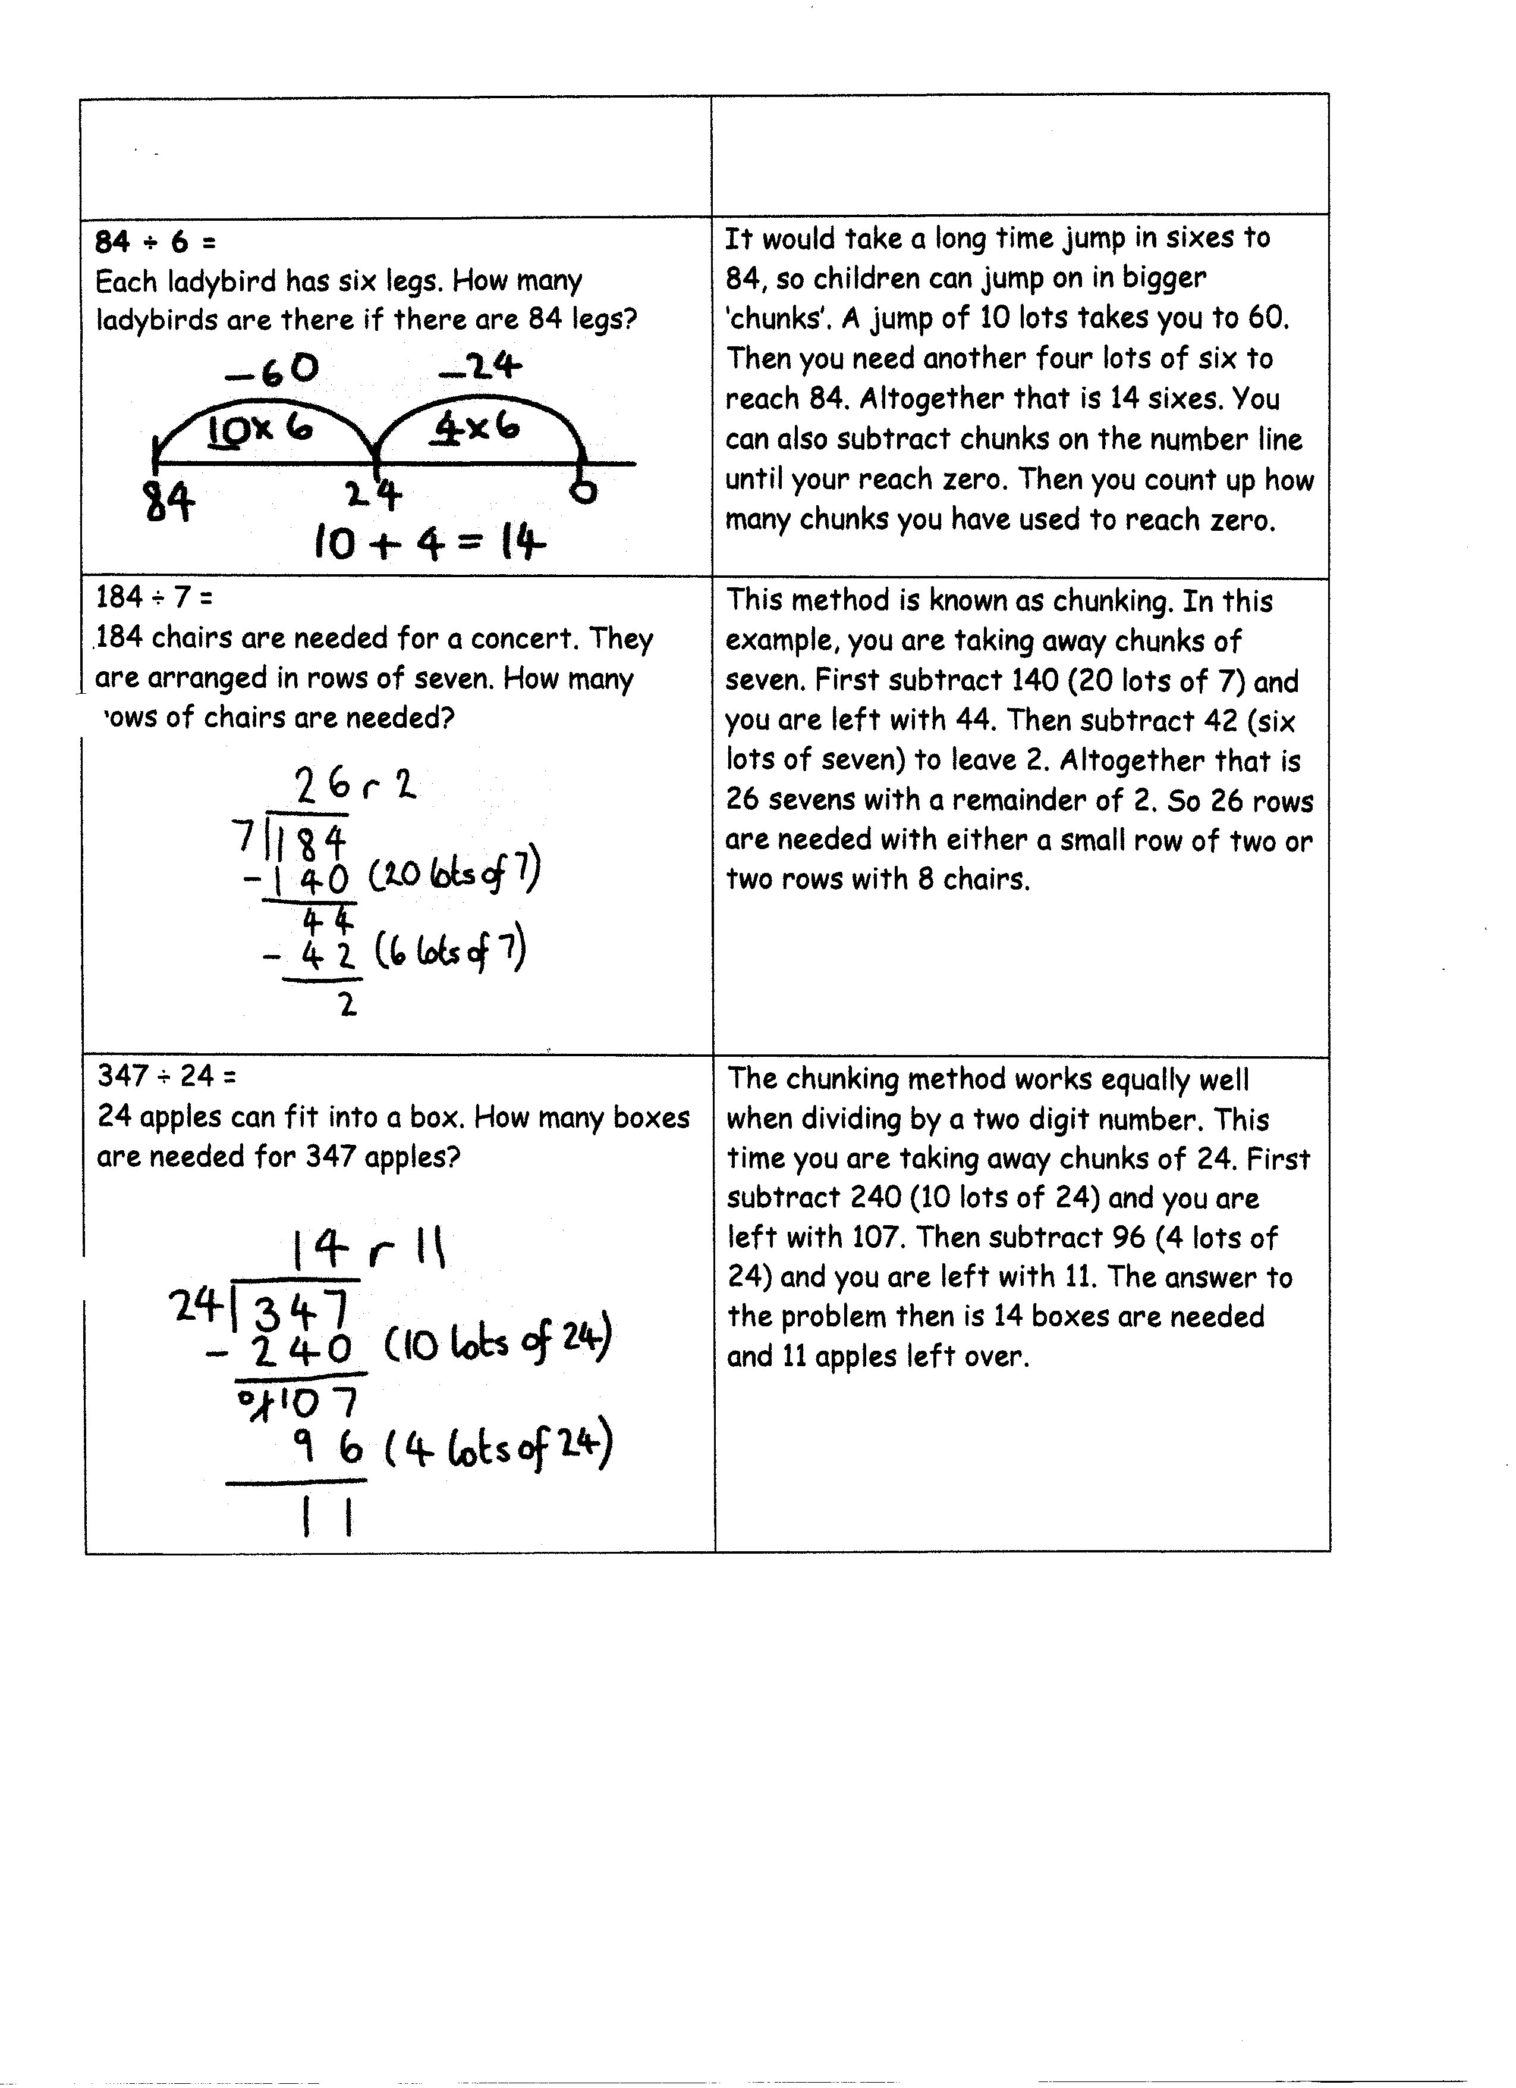
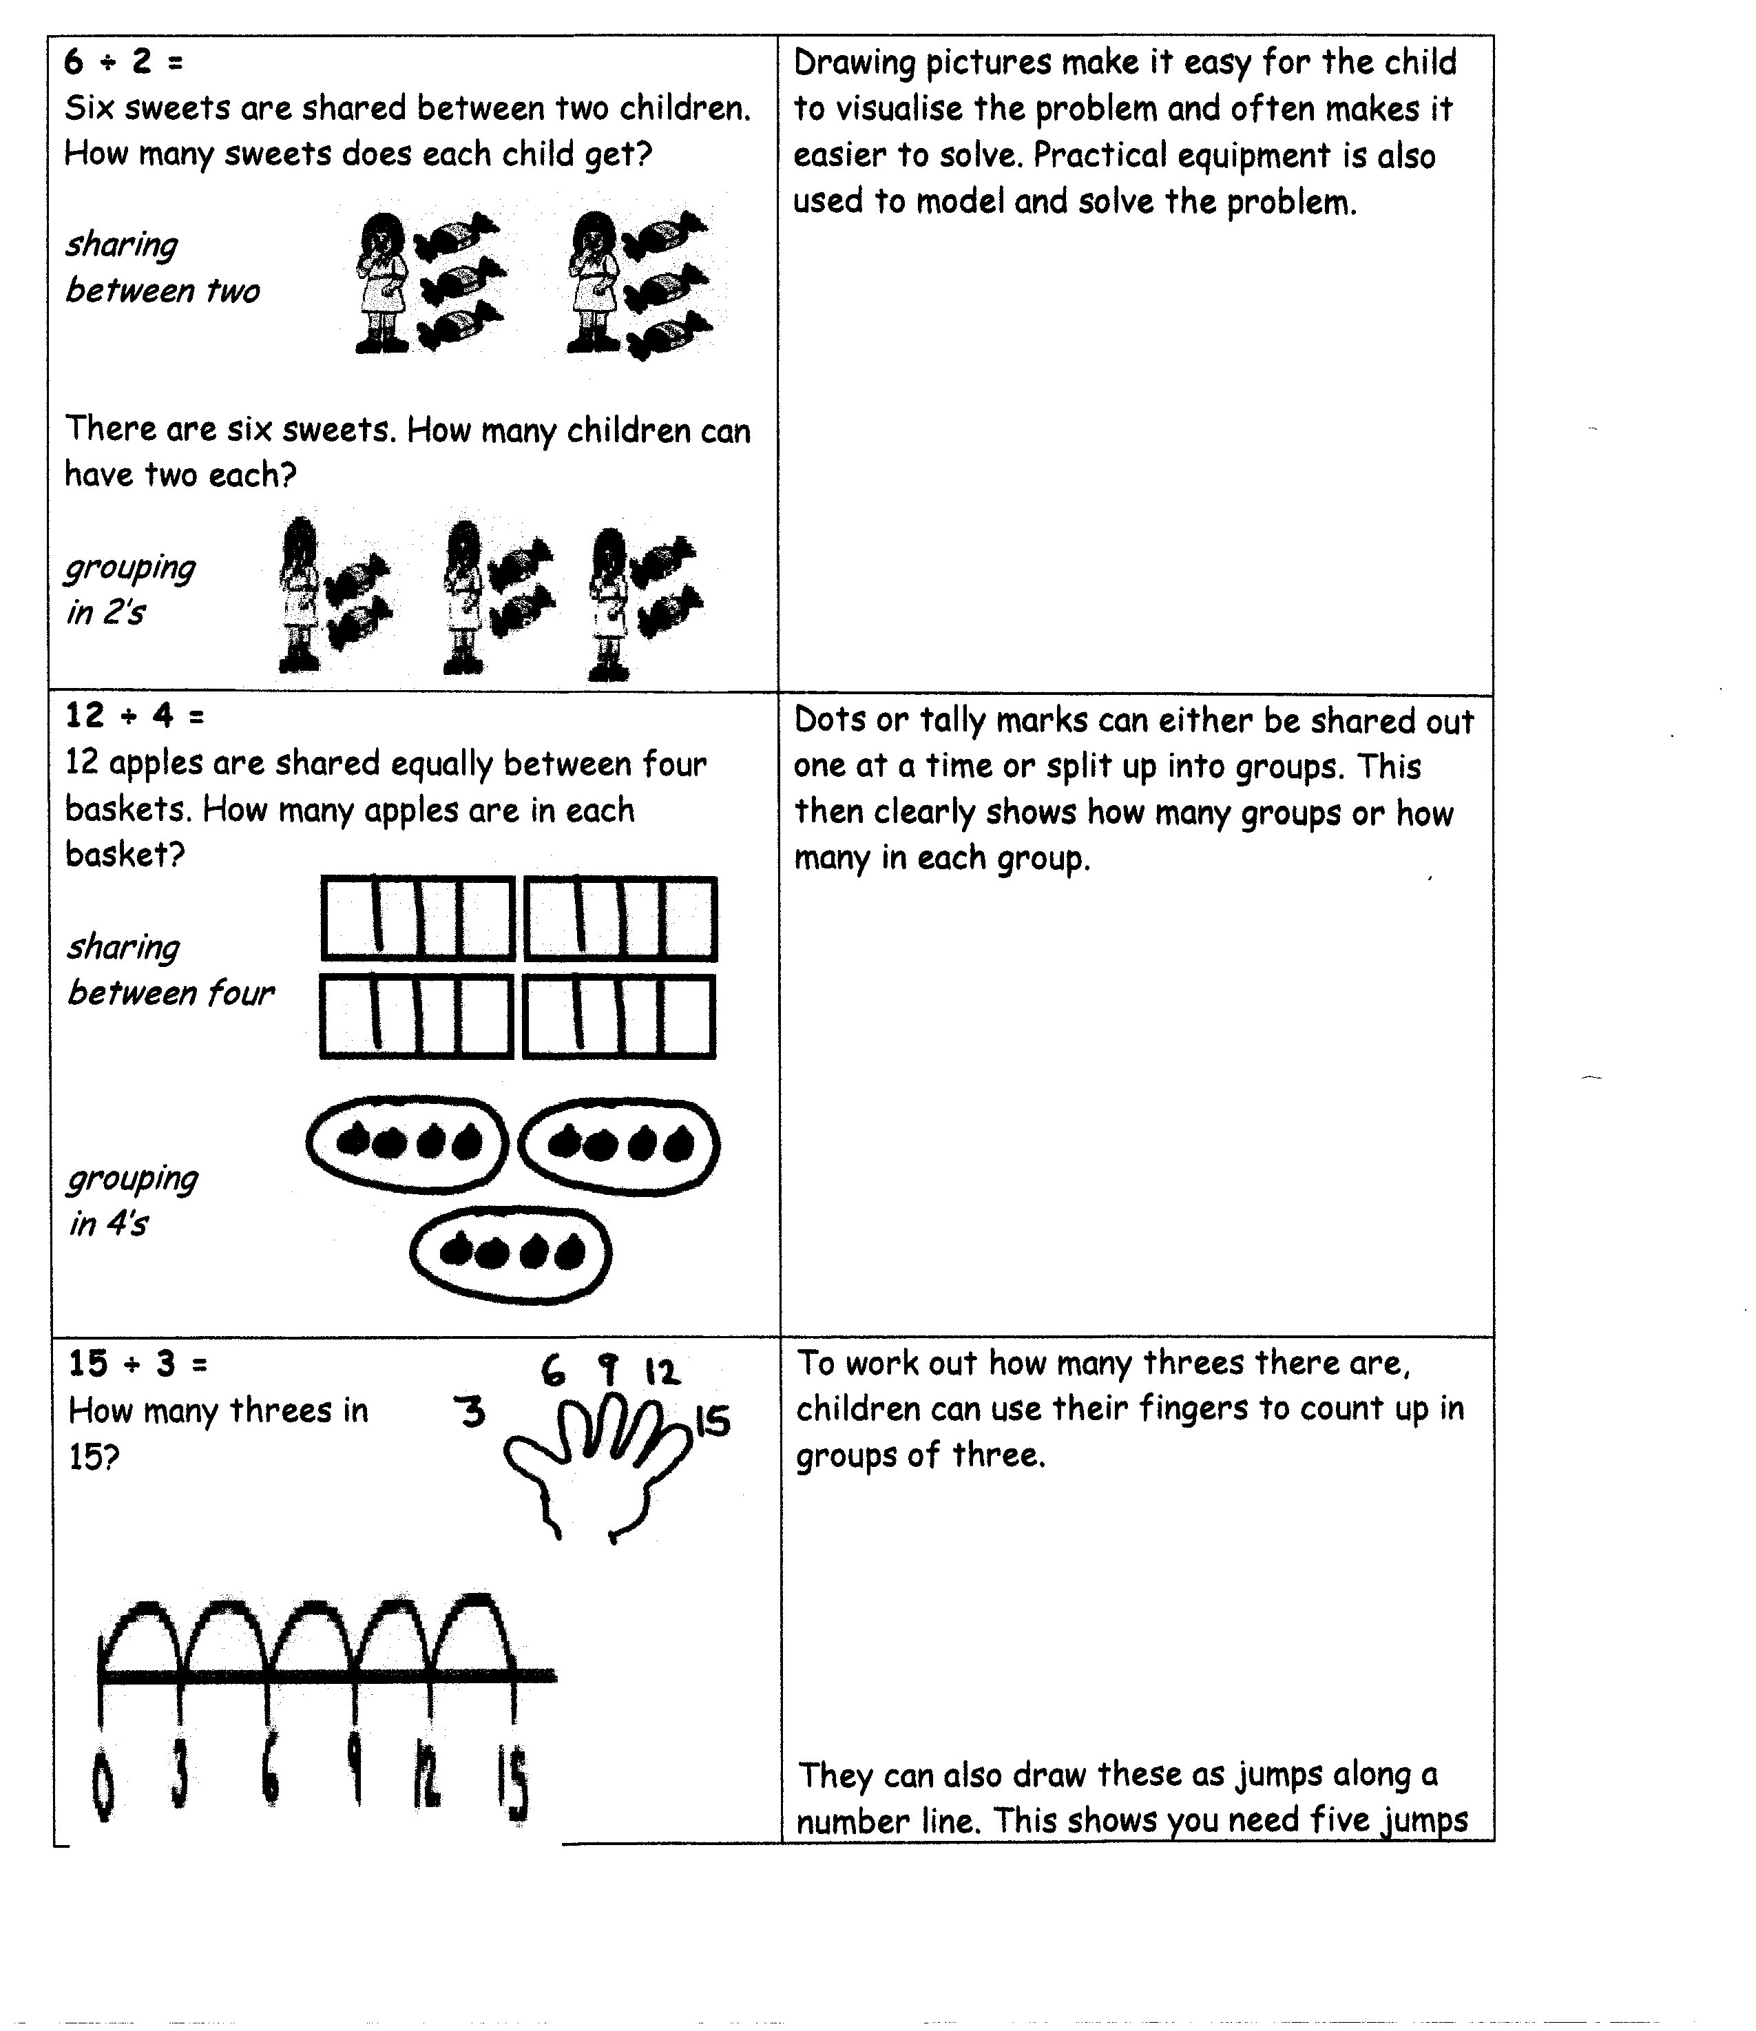
Division

