28th November 2022

Dear Mrs Nicola Tyrell

Following your Digital Schools Award Scotland validation visit by Karen Doherty, I am delighted to inform you that Aberuthven Primary School has been successful in its application to become a Digital School in Scotland.

On behalf of all the partners involved in the Digital Schools Award Scotland I would like to congratulate the whole school on achieving this award.

I enclose the validation report which summarises the validator’s view of the extent to which the school addressed the award criteria.   The Digital School Award is recognised by Education Scotland.

We are confident that Aberuthven Primary School will be a pioneer among schools where digitally enhanced teaching and learning is helping our children and young people prepare for living and working in the 21st Century.

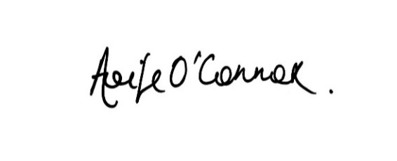Kind regards

Aoife O’Connor  
Programme Coordinator  
Digital Schools Award Scotland