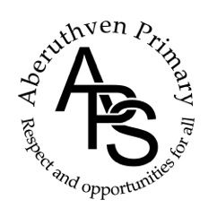

Aberuthven Primary School

Travel Plan

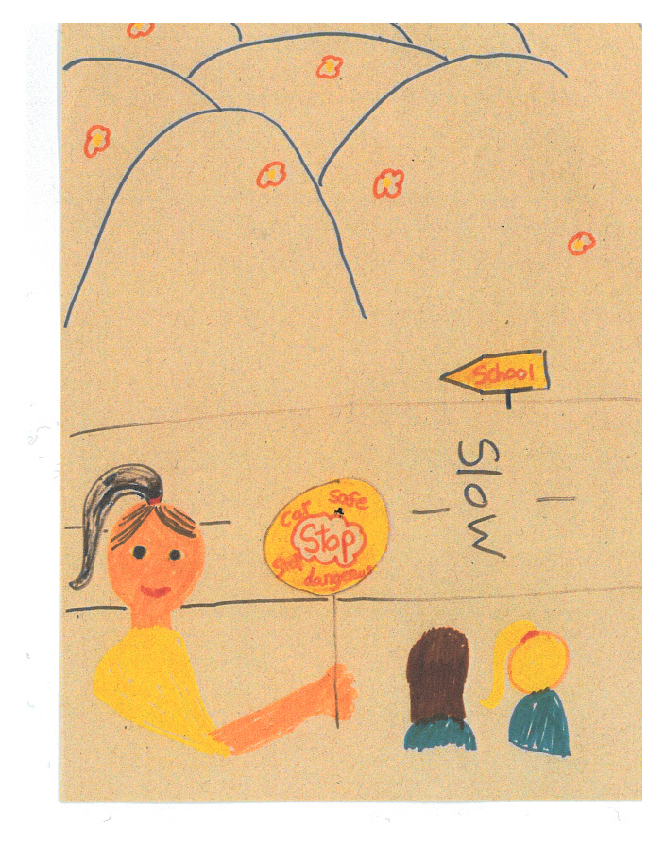

Cover Picture by Zoe Watson, 2019

March 2021

***Contents***

Introduction 3

Aims of the Travel Plan 3

Our School 4

Roads and Traffic around the school 4

School Travel Survey 5

How Much Difference does Speed Make? 6

Parking Outside the School 7

Road Safety in the Curriculum 8

Health & Wellbeing Committee 9

What we have done so far 10

Action Points 11

When will we do our next Travel Plan? 11

**Introduction**

At Aberuthven Primary School, we aim to equip all of our pupils with the knowledge and skills necessary to keep themselves safe when travelling to and from School. The safety of all within our school community is paramount.

We believe in supporting pupils to make good choices to both support their physical and emotional wellbeing, as well as explore the benefits to our environment. We encourage our pupils and parents to consider the possible ways to travel to school to gain these benefits.

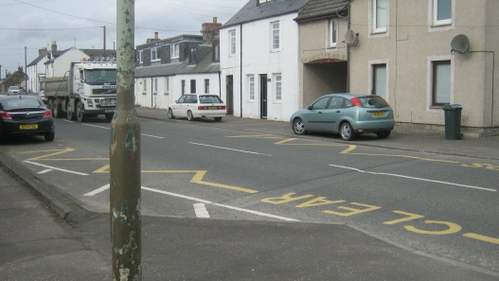 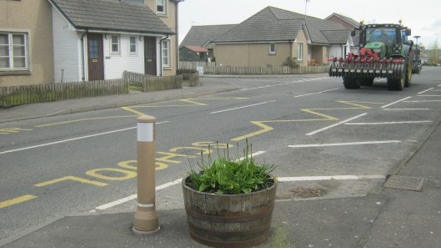

We welcome any feedback from all within our school community. Please contact our School to share any comments or additional information with us. Your support is always greatly appreciated.

**Aims of our Travel Plan**

* To encourage pupils and parents to travel safely and healthily to school.
* To encourage parents to include road safety things into their family life.
* To encourage children to take an active part in their own road safety.
* To make sure all the routes we travel to and from school are as safe as they can be.
* To cut down traffic around the school as much as possible.
* To make the main road outside the school safer, especially at the times when children are arriving and leaving.

**Our School**

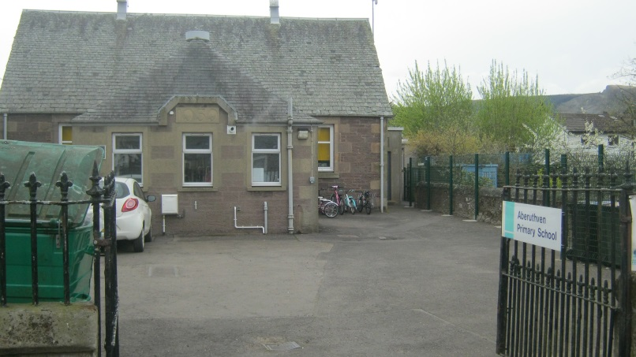

Aberuthven is a small rural primary school in Perthshire. We have 25 pupils aged from 5 to 12 and 7 members of staff, janitor, school crossing patroller and catering assistant. We have support teachers who visit the school on occasion. All teachers and almost all other members of staff live outside the village and therefore drive or cycle to the school.

**Roads and Traffic around the School**



Aberuthven is just off the A9 near Auchterarder. A very busy main road runs past the main entrance and there are 2 small lanes that go to the left and back of the school.

Cars can get into the school grounds through either the front main entrance gates or through a side gate which leads down a track to the rear playground.

There is a pathway from the front playground which leads around the right-hand side of the school to the back playground. There is a tall, metal gate half way round which is kept padlocked to ensure safety of our pupils throughout the school day. It is unlocked at the beginning of the day so children can get into the playground, and then locked again at 9.10am. It remains locked until the next morning. There is a small gate from the road at the back of the school, which leads into the back playground. This is kept padlocked at all times to ensure the safety of our pupils throughout the school day.

**School Travel Survey**

Pupils completed a survey in March 2021 to find out how our pupils are currently travelling to school.

**Results of Travel Survey March 2021**

24 of our 25 pupils completed their survey in class.

**How are pupils travelling to and from school?**

**Our pupils**

Eight children walk to school when the weather is good and four children cycle to School. The remaining twelve children come all the way to school by car. 90% of those children who come to school by car live further away. The survey asked the twelve children if they would like to park and stride instead of coming all the way by car. Ten children said they would like to do this. Two children shared they would rather have the entire journey to school in the car.

Eighteen of our pupils are brought to school by someone. Four children come to school on their own, with a sibling or with a friend. One child is brought to school part of the way and walks the last part to school on their own.

Of the eighteen children who walk to school, eight said that they need to cross the road. All said they use the school crossing patroller, when available, to cross the road safely.

**Summary**

It seems that almost all pupils walk to school if they live near enough to do so. We could encourage the children who are driven all the way to school to park a little way from the school building and walk the remaining journey to school.

**Problems in travelling to school**

Some pupils shared that the trickiest part of their journey to school was crossing the road. All shared that they cross the road with adult support or supervision.

**Given a free choice, how would our pupils prefer to travel to and from school?**

|  |  |  |  |  |
| --- | --- | --- | --- | --- |
| **Car** | **Bike** | **Scooter** | **Walk** | **Park &Stride** |
| **6** | **9** | **2** | **6** | **1** |

**How much difference does speed make?**

* If children are hit by a car travelling at 20 mph, nearly all of them survive the accident.
* If children are hit by cars travelling at 30 mph, half of them are likely to be killed.
* If children are hit by cars travelling at 40 mph, most of them will be killed.

These are figures worked out by the Department for Transport that looks after all our roads and traffic. It is important that cars go slowly when there are children around.

**Scooter Parking Spaces**

In November 2015 we received scooter parking spaces which are situated at the front of the school.

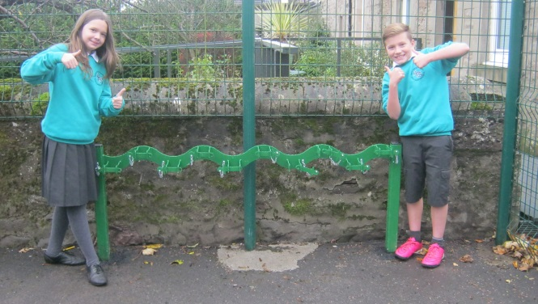

Our 2015-16 JRSOs beside the Scooter Parking spaces

**Parking Outside the School**

The yellow and white line markings around the school entrance are there to prevent anyone parking or stopping just outside the school where children will be trying to cross the road.

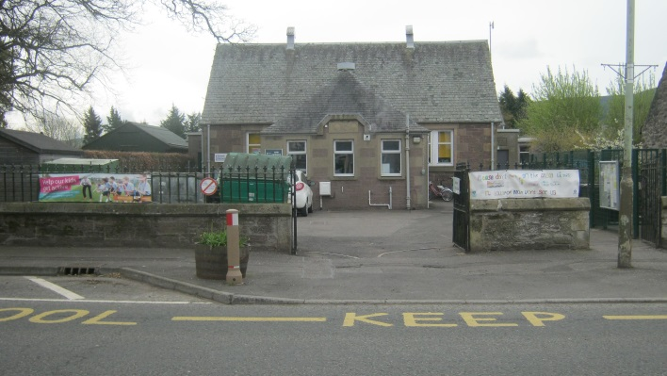

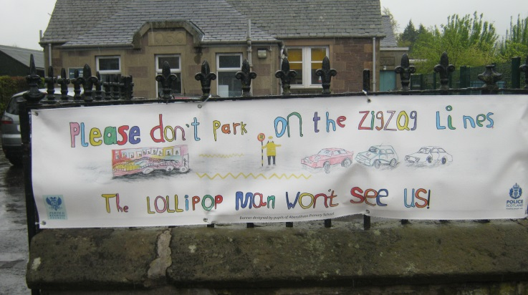

Our School Crossing Patroller, Mrs Weymms, shared that most people are parking in appropriate places which have no impact on visibility for crossing the road outside of our School, however at times she has to remind people not to park o the markings. All members of our school community wait to cross safely with our School Crossing Patroller.

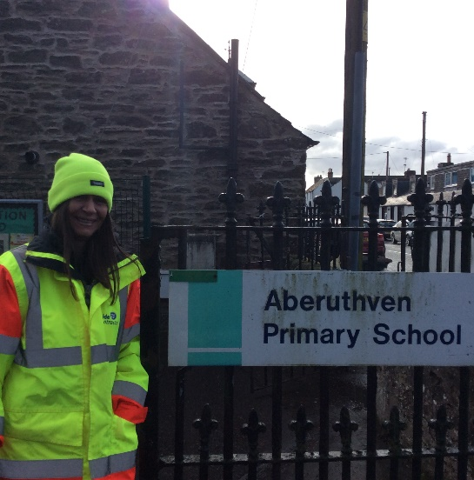

**Road Safety in the Curriculum**

Lessons

Road Safety is explored with our pupils every year during Health Week through a variety of resources, videos and discussion.

Bikeability

P5-7 pupils have the opportunity to take part in a six-week training course to help them cycle safely. These sessions will be led by trained volunteers and Staff through Bikeability Levels 1 and 2. Skills taught include how to check your bike and helmet are safe plus how to do a safe start and stop, left and right turns.

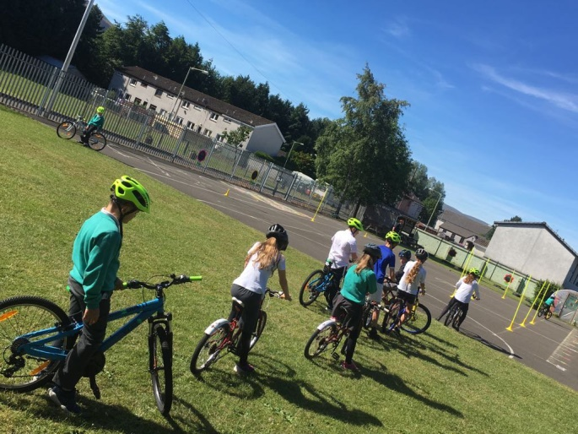

We also promote additional workshops/ sessions ran by Bikeability to encourage our pupils to further develop their safe cycling skills on our School website, Newsletters and Twitter feed.

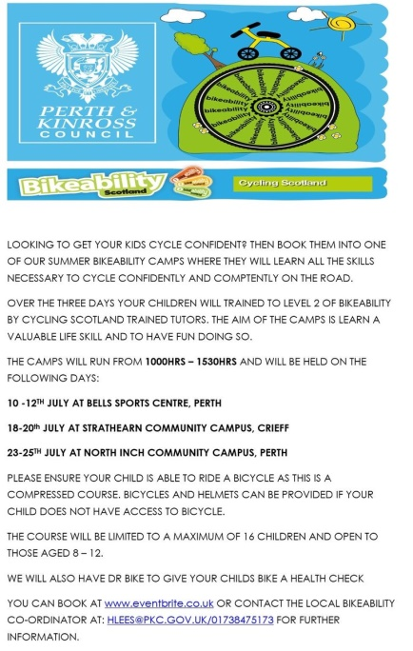

**Our Wellbeing & Eco Committee**

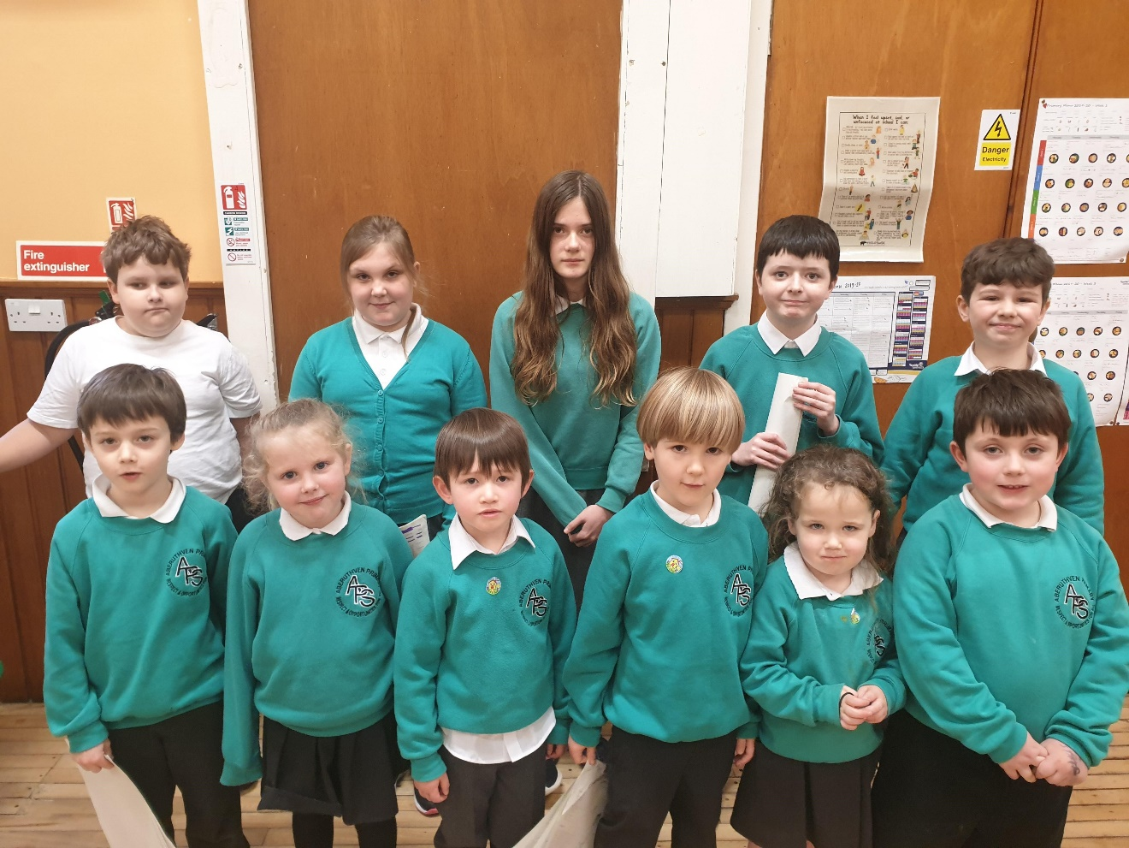

Wellbeing & Eco Committee 2019-2020

Our Wellbeing & Eco Committee promote Road Safety throughout the year by organising competitions and information Assemblies.

**What has been done so far in Aberuthven to deal with the problems caused by traffic on the main road?**

* Twenty’s plenty signs have been put up on the road outside the school.
* The pavements outside the school have been made wider to help the crossing patroller see better and make crossing the road safer.
* We have encouraged people not to park on the yellow and white road markings on the main road outside the school by getting a new banner.

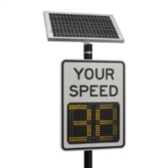

* Speed awareness signs have been added to the top of Main Road targeting cars as they enter the village to deter speeding.
* Frequent Police Speed Checks on Main Road throughout the year to deter speeding

**What effect has this had?**

The parking has improved but the speed of the traffic passing the school may still be faster than 20mph and that means cars cannot always stop safely when the lollipop person steps out or a child starts to cross the road.

**The speed of traffic on the Main Road could still be dangerous for children coming to and leaving school. This is especially important at times when the lollipop person is unable to be there or when children are leaving school after 3.30pm, when the crossing patroller has gone home and there are no staff or parents.**

**What other issues do we need to deal with?**

We had a discussion during Assembly around road safety. Many of our pupils were unaware of how serious it could be when it hit a car even at a slow speed. Many thought that if a car was going slower they would be almost unharmed.

**Action Points**

These are the things we need to do to achieve our aims:

* Teach children about road crossings and stopping distances of vehicles. Share repercussions of what could happen as a result of being struck by a car even at a slower speed.
* Raise awareness of every child’s right to ‘be protected’ in line with Article 19 of the UNCRC.
* Keep checking that everyone is parking properly on the main road outside the school – keep checking with the School Crossing Patroller that this is still okay.
* Check what Road Safety is being taught in the classes each year during Health Week to make sure pupils are learning everything they need between Primary 1 and Primary 7.
* Support the Health & Wellbeing Committee to help spread the Road Safety message within the School using wall displays, posters and competitions.
* Get parents, school staff, pupils and other people to look at the travel plan regularly between now and its next review.

**When will we do our next Travel Plan?**

We will continue to observe and share information within our School Community throughout the year which will support the ongoing road safety of all.

Our Travel Plan will be reviewed March 2022.