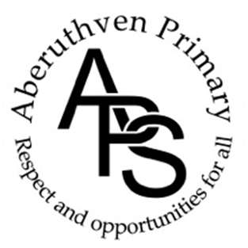
Aberuthven Primary School
Newsletter
November 2020

Dear Parents, Guardians, and Friends,

Crossing Safely to School
We request that all Parents, Guardians and Family members refrain from parking on the zig-zag lined area at the front of our School building during drop off and pick up times. Parking in these areas reduces the vision of our crossing patroller and increases the chances of injury to others. We appreciate your support in this matter. The safety of all within our school community is paramount.

Head Lice
Bug Busting Sunday is on 1st November Please check your child(ren)’s hair for any signs of headlice. If treatment is required you should continue to check hair for several days afterwards to monitor if you will need to treat again. Treatment should be continued until all signs of head lice and eggs have disappeared.

Flu Immunisation
The Flu Immunisation Team will be in school on Tuesday 10 November to immunise the children who have had consent forms returned to school by parents.

Languages Week
We will be celebrating Languages Week in School from Monday 16th – Friday 20th November 2020. Pupils will take part in lessons immersing them in a variety of different languages over the course of the week.

‘Severe Weather’ Plan
You should have received our severe weather arrangements prior to October break. All information regarding severe weather procedures can be found on our website

In Service Days
The school will be closed to pupils on Thursday 12th November and Friday 13th November for Staff Training.

Rotary Young Writer & Photographer Competitions
Any pupil in P4-7 who wishes to enter the competitions this year, please see posters for further information and entry forms attached at the end of our Newsletter. Entries for both competitions should be submitted from home this year rather than through school.

Rag Bag Collection
We have sent a rag bag collection bag home with your child. These can be put in the green rag bag container at the school gate. The money raised from the Rag Bag collection gives a very welcome to school funds. The container will be emptied on Monday 9 November.

Poppy Scotland Appeal 2020
We are selling remembrance poppies before Remembrance Sunday to raise money for Poppy Scotland. If you would like to make a donation please add the donation amount and number of poppies required on Parentpay and we will send poppies home with your child. The poppies will be quarantined before sending them home.

Digital Pantomime- ‘Oh Yes It Is…’
I am delighted to share that pupils will have the opportunity to view Perth Theatre’s Pantomime production this year in School via Zoom on Thursday 17th December 2020. Costs to ‘attend’ per pupil will be met by School funds. We are so pleased to still be able to provide this experience for our pupils this year!

Parent Appointments
If you have requested an appointment either by telephone or via Microsoft Teams with your child’s teacher on Monday 9 November, your appointment will be attached to this newsletter.

Parent Zone – Rights Respecting Schools
We are currently working towards our Rights Respecting Schools Gold Award and have been exploring the UN list of Rights of the Child. We would appreciate your support in discussing the rights of the child with your children at home. A full list of the articles (rights of the child) can be found by following the link below.
https://downloads.unicef.org.uk/wp-content/uploads/2010/05/UNCRC_united_nations_convention_on_the_rights_of_the_child.pdf?_ga=2.205940055.530213901.1569246900-770741945.1553855835

Our focus for RRS for Term1 and 2 is how we celebrate everyone’s unique qualities which make us each who we are. This has been met through various stories, discussion, videos, lessons around genetics and recent news stories during Assembly.

The Rights that we are currently exploring as a School are:

Article 2- You have rights whatever your race or skin colour, whether you are a boy or a girl, whatever language you speak, whatever your religion, political beliefs, nationality or ethnic group, whether you are rich or poor, and whether you are disabled.

Article 8- You have the right to an identity.

Further information can be found on our school website. https://blogs.glowscotland.org.uk/pk/aberuthvenprimaryschool/rights-respecting-schools/

Diary Dates
Mon 9 Nov – Rag Bag Collection
Mon 9 Nov – Parents’ Appointments
Tues 10 Nov – Flu Immunisation
Thurs 12 Nov – In Service Day
Fri 13 Nov – In Service Day
Thurs 17 Dec- Digital Pantomime

Please do not hesitate to get in touch should you require any further information.

Warmest wishes

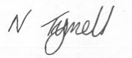
Nicola Tyrrell
Headteacher

If you have any comments or suggestions which you wish to make us aware of please complete this slip and place it in the suggestions box in the school foyer.

Pupil’s name:_________________ Class:___________ Signed:_______________ Date:___________

Aberuthven Primary School
Parent Suggestions –
November 2020

Young Photographer Competition 2021

How good is your photography?
Entries can be either in black & white or colour, as long as the photographs’ relate to the theme:
Wild Nature
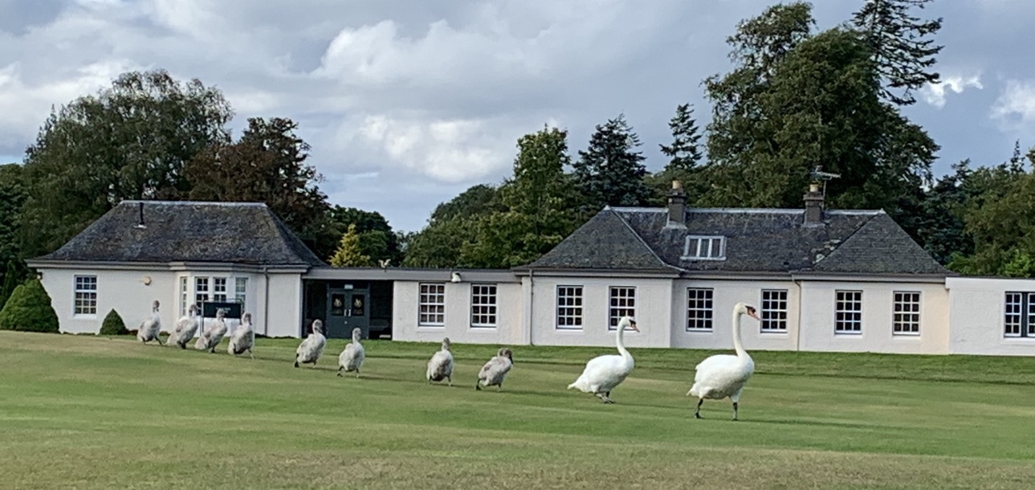
The three images can be emailed with a maximum size of 1MB or entered on a memory stick.
Junior: 7 - 10yrs
Intermediate: 11 - 13yrs
Senior: 14 - 17yrs
Age, is as on the 31st August 2020 and the Winner in each group will progress to the District Finals.
Members of Auchterarder Camera Club will judge our local entries.
FOR MORE INFORMATION & ENTRY FORMS
PLEASE SEE THE AUCHTERARDER ROTARY WEBSITE OR CONTACT YOUR SCHOOL.

Mr Graham Jackson Auchterarder Camera Club. Email: grahamj@uwclub.net

Closing date: Thursday 14 January 2021

2021 Young Writers Competition
My Happiest Day
Your entry should be completed and returned with an entry form by Friday 18 December 2020.
Fiona Mitchell – Auchterarder & District Rotary Club. fionafr7@aol.com
Task:
To produce a written or typed story in prose entitled, My Happiest Day.
The written entry could be fiction or non-fiction, a story or a poem, as long as the piece relates to the theme. Questions have been asked about spelling and although this is not an issue the only advice to be given are that judges of this competition have made comment upon spelling in the past.
An A4 page or up to 500 hundred words is a suggested suitable submission and up to a maximum of 40 lines for poetry.

