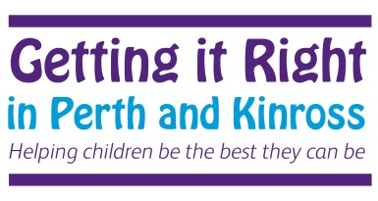

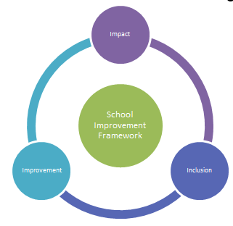

Mutual Trust and
Respect
Openness, Honesty and Integrity
Fairness and Compassion

Pa

School Improvement Plan 2020-2021
Aberuthven Primary School

The School Improvement Framework Map
The Scottish Government’s vision for education:  • Excellence through raising attainment:  • Achieving equity  NIF Key Priorities:  • Improvement in attainment, particularly in literacy and numeracy  • Closing the attainment gap between the most and least disadvantaged children  • Improvement in children and young people’s health and wellbeing  • Improvement in employability skills and sustained, positive school-leaver destinations for all young people | National Improvement Framework –Drivers for Improvement  - School Leadership  - Teacher Professionalism  - Parental Engagement  - Assessment of Children’s progress  - School Improvement  - Performance information  The ECS Strategic Implementation Plan – Raising Attainment for All 2016 - 2019 will be a key document in supporting schools to use the NIF expectations as part of their improvement journeys. | Tayside Plan for Children, Young People and Families 2017-2020  - Our children will have the best start in life, they will be cared for in nurturing environments and ready to learn;  - Our children, young people and their families will be meaningfully engaged with learning and combined with high quality learning experiences, all children and young people will extend their potential;  - Our children and young people will be physically, mentally and emotionally healthy;  - Our children and young people who experience particular inequalities and disadvantage will achieve health, wellbeing and educational outcomes comparable with all other children and young people;  - Our children and young people are safe and protected from harm at home, school and in the community.
Education Services  - ELAVs / LAVs  - Professional Learning  - Professional Dialogue  - Building Capacity in Partnership  Schools & Centres  - Strategic 3 Year Plan  - Outcomes and measures of Impact  Actions 2018  - Self-evaluation / Standards and Quality  - LMG Action Plans will detail the work around outcomes for session 2019-20 | NIF Key Priorities  Tayside Plan  PKC Plan  PKC Outcomes  Schools & Centres  Stakeholders | PKC Statement of Intent:  Our vision is of a confident and ambitious Perth and Kinross with a strong identity and clear outcomes that everyone works together to achieve. Our area will be vibrant and successful; a safe, secure and healthy environment; and a place where people and communities are nurtured and supported.
Support and Scrutiny  - Education Scotland – Inspection  - Care Inspectorate  - Validated Self Evaluation  - Services for Children’s Scrutiny (Child Protection) | PKC Outcomes  - Raising achievement for all;  - Supporting vulnerable children and  - families;  - Improving the quality of life for  individuals and communities; and  - Enabling the delivery of high quality  public services | P & K Community Plan 2017-2027  - Giving every child the best start in life  - Developing educated, responsible and informed citizens  - Promoting a prosperous, inclusive and sustainable economy  - Supporting people to lead independent, healthy and active lives  - Creating a safe and sustainable place for future generations
2
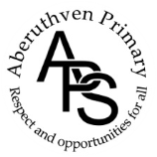
Aberuthven Primary School
Curriculum Rationale

Values  The totality of learning experienced by all our children enables them to develop the knowledge, skills and attributes to be lifelong successful learners, confident individuals, responsible citizens and effective contributors in a global society.  All stakeholders effectively work together to provide a nurturing, inclusive, relevant and motivating learning environment for all.  Each child is actively involved in planning and assessing their own learning and next steps and their achievements are celebrated. | Totality of the Curriculum  All members of our School community are involved in both planned and spontaneous opportunities which develop the life and ethos of the school.  Our pupils are discrete subject development and interdisciplinary learning designed around contexts which are relevant and meaningful to our children.  Opportunities are planned for all children to develop and achieve their potential as individuals. | Learning and Teaching  All staff have a shared understanding of effective learning and teaching approaches which are embedded in practice consistently across the school. A variety of high quality strategies and tools are employed appropriately and effectively to ensure that each child is engaged, challenged and enjoying their learning. These include cooperative learning, active learning, outdoor learning and use of appropriate technologies.
Experiences and Outcomes  All the Experiences and Outcomes are used to plan relevant meaningful learning experiences for every child. This ensures consistent, progressive development of their knowledge, skills and attributes. | 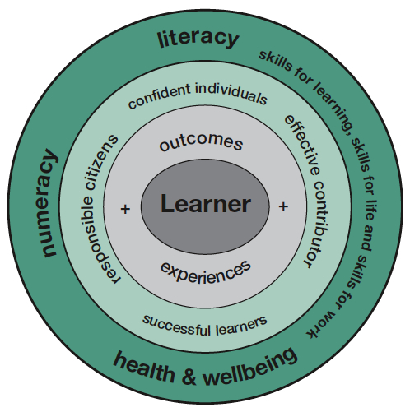 | Entitlements  Each child experiences a broad, coherent, relevant curriculum which meets their needs. All children have appropriate opportunities to develop the skills for learning, life and work, including the skills and attributes of the four capacities, and can talk about their progress in this area.  All our children engage in learning experiences which enable them to develop their understanding of our world and Scotland's place in it, supported by their families and our community.  Our children, families, staff and community have high expectations of themselves and the school and play a significant role in improving our school. Every child experiences success.
Support  Transition support at all levels and stages demonstrates best practice in ensuring each child is supported appropriately.  All stakeholders are clear about agreed policy and practice in this area. Support needs for each child are identified, addressed and reviewed as needed to ensure that learning experiences meet their needs and that we make best use of all available resources. | Principles  The seven principles of curriculum design underpin all planned learning experiences and are consistently used as an integral part of the quality assurance process. | Assessment  The continuous cycle of learning, teaching and assessment is built on a sound foundation underpinned by the principles of Assessment for Learning. School, LMG, PKC and national moderation processes enable us to make sound judgements about each learner's progress which is supported by a bank of good quality evidence demonstrating breadth, challenge and application of knowledge, skills and attributes.

School Improvement Plan - Priorities and Outcomes
What are the outcomes that you plan to achieve for your children, young people and families for this session?
SIP Priorities – Term 1 2020/2021
We will prioritise Improvement Outcome 2 along with Recovery Planning in the interim, focusing on the safe re-opening of our School in line with PKC and Scottish Government guidance.

Improvement Outcome 2: Feedback at all Levels
To further empower pupil voice at all levels across our whole school community.
NIF Priority:  -Closing the attainment gap between the most and least disadvantaged children  -Improvement in children’s health and wellbeing  -Parental Engagement | NIF Driver(s):  -School Leadership  -Teacher Professionalism  -Parental Engagement  -Assessment of Pupil Progress  -Performance Information  -Local Community Engagement | HGIOS4 QI(s):  1.3 Leadership of Change  2.4 Personalised Support  2.5 Family Learning  2.7 Partnerships  3.1 Ensuring Wellbeing, equality and inclusion
School Lead: Headteacher  Class Teachers  PSAs | Completion Date: May 2021 | Review Date: November 2020  February 2021  April 2021
What impact will you measure? | How will you measure it? |  | Progress at Review Date
Pupils feel that their voice is heard in shaping the future of our School.  Pupils taking part in self-regulation lessons to support their ability to share their opinions in a calm and constructive manner.  Ensure that restorative practise is embedded across our School community consistently.  The readiness of a core group of pupils to access their learning. | - Pupils participation in ‘Rights Respecting School’ activities, exploring their own Rights and embracing the opportunity to share their ideas, opinions through a variety of feedback methods.  - Pupils using RRS language in restorative discussions, in class and throughout their school/home life.  - Nurturing conversation and approaches taking place throughout the School.  - Planned opportunites for pupils to practise using their voice. sharing opinions eg. Pupil groups, committees, pupil council, visitors, intergenerational volunteers etc.  - Pupils will feedback to staff through questionnaire their ability to self- regulate in August and again in January.  - Pupils will share in HGIOS feedback whether the feel their voice helps to shape the future of our school and whether they feel they are listened to and have their opinions taken on board.  - Pupil ‘refresher’ in restorative practise via Assembly and Circle Time discussion.  - All Staff to use restorative practise in supporting pupil behaviour and choices.  - Use of Wellbeing Webs/ HGIOS feedback, pupils check ins, assembly reflective discussion, rights respecting Schools as a forum for discussion to obtain pupil feedback. These should be completed in an ongoing cycle throughout the year to accumulate a picture of pupil confidence and readiness to access their learning.

School Improvement Plan - Priorities and Outcomes
Improvement Outcomes which are currently on hold
Improvement Outcome 1: Digital Learning
To embed the use digital technology across our school community to support and enhance learning.
NIF Priority:  -Closing the attainment gap between the most and least disadvantaged children. | NIF Driver(s):  -School Leadership  -Teacher Professionalism  -Parental Engagement  -Assessment of Pupil Progress  -Performance Information | HGIOS4 QI(s):  1.2 Leadership of Learning  2.2 Curriculum  2.3 Learning, teaching and assessment  3.2 Raising Attainment and achievement
School Lead: Headteacher, Class Teachers | Completion Date: May 2021 | Review Date: November 2020  February 2021  April 2021
What impact will you measure?  What’s going to be different or better? | How will you measure it?  What and by when? |  | Progress at Review Date
Use of Digital technology to enhance the learning in all curricular areas.  Isolated Teaching of Digital skills.  Relevant, individualised applications and resources used to support ASN pupils.  Pupils will be able to share their learning using Seesaw. Seesaw embedded as an additional tool to evidence progression and support Teacher judgement.  Moderation opportunities across both classrooms.  Raised levels of attainment in all pupils.  Parental are aware of how Digital learning is used to complement and enhance learning across our School. | - All Staff/Pupil/Parents completed Digital agreement stating how IPads should be used in Class in a safe and effective way.  - Staff use of School Digital Strategy, Digital Pathway and Benchmarks to assist planning and assessment of Digital Learning.  - Digital experience to be incorporated into lessons for a minimum amount of lessons every week.  - Staff to teach stand alone Digital Skills lesson once per week per class, using Digital Pathway and Benchmarks to assist in planning and assessing learning.  - Review Digital resources available in School  - Access support from IT services, Chris Wright to find appropriate digital applications to trial and implement.  - Both Teachers and Pupils to use Seesaw to record learning experiences.  - HT/ Peer/Self-observation of Digital lessons as per Monitoring and Moderation timetable. HT to sources Digital specialists within the council to support Staff development .  - Collegiate discussion to share experiences, expertise and progress in embedding technology in class lessons.  - Review the attainment of all pupils using a variety of assessment tools including eg. Incas and PIPs in August 2019 and August 2020 to measure the impact.  - Parent ‘drop-in’ sessions.  - Information shared with Parents regarding our whole School approach to Digital learning.  - Promote the use of Seesaw and encourage Parental participation.

Improvement Outcome 3: Teaching & Learning
To embed consistent Teaching & Learning Strategies and Assessment techniques across our whole School.
NIF Priority:  -Teaching, Learning & Assessment  -Closing the attainment gap between the most and least disadvantaged children | NIF Driver(s):  -School Leadership  -Teacher Professionalism  -Parental Engagement  -Assessment of Pupil Progress  -Performance Information | HGIOS4 QI(s):  1.2 Leadership of Learning  2.2 Curriculum  2.3 Learning, teaching and assessment  3.2 Raising Attainment and achievement
School Lead: Headteacher | Completion Date: May 2021 | Review Date: November 2020  February 2021  April 2021
What impact will you measure? | How will you measure it? |  | Progress at Review Date
Consistent approach to planning, teaching and assessment across our whole School.  Agreed quality resources used to support the planning, teaching and assessment across our whole School.  Wide range of formative and summative assessment tools used to support Teacher judgement.  Raised levels of attainment in a core group of pupils.  Parents are aware of how learning is planned, taught and assessed in our School. | - Use of a variety of agreed assessment tools.  - Use of Tracking & Monitoring and Tracking Grid sheet.  - Staff to discuss and agree whole school planning methods- weekly, termly, annual planners.  - HT to feedback on planning and assessment tracking as per Monitoring and Moderation timetable.  - Collegiate discussion to ensure continuity of approach in planning, teaching and assessment.  - Staff to agree strategies used across the whole school community.  - Review the attainment of a small cohort of pupils and additional support need to close the attainment gap.  - Information Open Evenings for Parents.  - Information shared with Parents regarding our whole School approach to Teaching, Learning and Assessment.

