Mrs Nicola Tyrrell
Headteacher

Aberuthven Primary School
Main Road, Aberuthven
AUCHTERARDER PH3 1HE
Tel 01764 661410 • Fax 01764 660087
Email aberuthven@pkc.gov.uk
Twitter @AberuthvenPS

Contact

Our ref

Your ref

Date 1/03/19

Dear Parents,
I am delighted to share that local Author David MacPhail will be joining us in School to help us with the Official Opening of our School Library on Monday 4th March at 2,30pm.

More information about David’s career and his books can be found at http://www.scottishbooktrust.com/profile-author/108801.

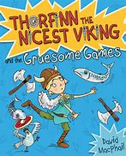

David will be signing copies of his books, “Thorfinn the Nicest Viking’ and ‘Yeti on the Loose’. Both will be available to purchase in School on the day for £5 each.

We hope that you will be able to join us!

Yours sincerely,

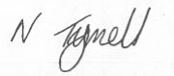

Nicola Tyrrell
Headteacher

