

Aberuthven Primary School

Travel Plan

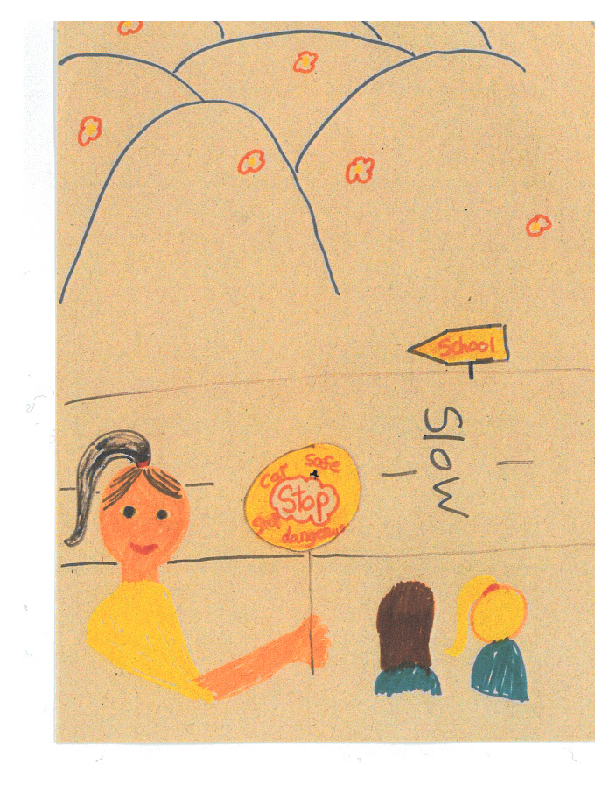

Cover Picture by Zoe Watson

March 2019

***Contents***

Introduction 3

Aims of the Travel Plan 3

Our School 4

Roads and Traffic around the school 4

School Travel Survey 5

How Much Difference does Speed Make? 6

Parking Outside the School 7

Road Safety in the Curriculum 8

Health & Wellbeing Committee 9

What we have done so far 10

Action Points 11

When will we do our next Travel Plan? 11

**Introduction**

The first Aberuthven Primary School Travel Plan was made up in 2005. Every school was asked to make up a Travel Plan in 2005 because the Scottish Government had decided to try to improve the safety of pupils when travelling to and from school.

Since 2005, we have had more Travel Plans and what we want to do with our Travel Plan has grown bigger. It is not just about safety now but also health and wellbeing and being eco – friendly in how we travel. We want to make our pupils and parents think more about how they travel to and from school.

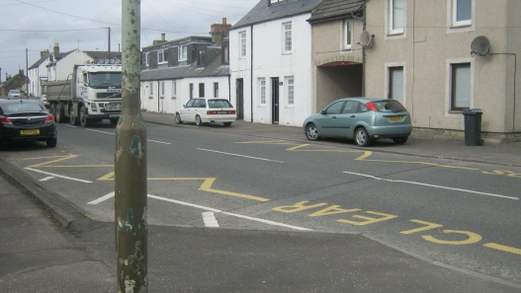 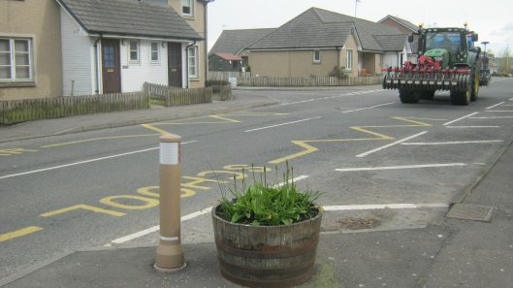

We welcome any comments that parents, carers or members of the village community would like to make about the Travel Plan and/or any information you think we should include. Please contact the school via the Head Teacher, Mrs Nicola Tyrrell.

**Aims of our Travel Plan**

* To encourage pupils and parents to travel safely and healthily to school.
* To encourage parents to include road safety things into their family life.
* To encourage children to take an active part in their own road safety.
* To make sure all the routes we travel to and from school are as safe as they can be.
* To cut down traffic around the school as much as possible
* To make the main road outside the school safer, especially at the times when children are arriving and leaving.

The latter is really important for the safety of the children and is always our main focus. There have been “near misses” on the main road outside the front of the school. Our aim is prevent this as far as possible.

**Our School**

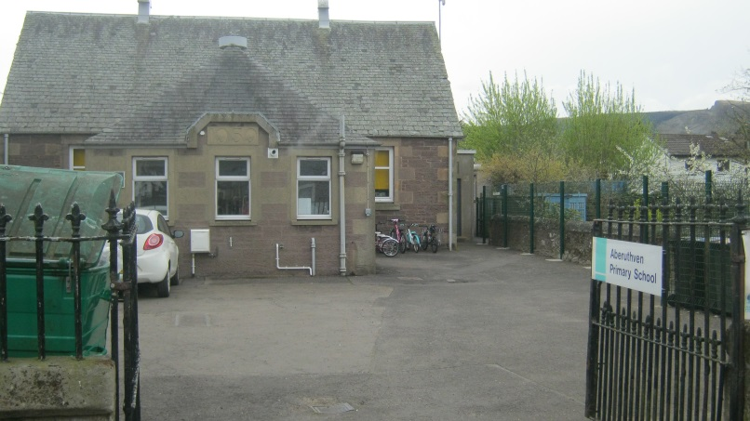

Aberuthven is a small rural primary school in Perthshire. We have 14 pupils aged from 5 to 12 and 6 members of staff, janitor, school crossing patroller and catering assistant. We also have other support teachers who visit the school to teach. All teachers and almost all other members of staff live outside the village and therefore drive to the school.

**Roads and Traffic around the School**

Aberuthven is just off the A9 near Auchterarder.



A very busy main road runs past the main entrance and there are 2 small lanes that go to the left and back of the school.

Cars can get into the school grounds through either the front main entrance gates or through a side gate which leads down a track to the rear playground.

From the front playground you can walk round the right hand side of the school to the back playground but there is a tall metal gate half way round which is kept padlocked. It is unlocked by the lollipop person at the beginning of the day so children can get into the playground, and then locked again.

There is a small gate from the road at the back of the school into the back playground which is kept padlocked.

**School Travel Survey**

We did a survey in April 2018 to find out how children were travelling to school, whether we needed to encourage more of them to walk or use bikes or scooters and if there were any problems for them on their journeys to and from school.

**Results of Travel Survey March 2019**

14 of our 14 pupils completed their survey in class.

**How are pupils travelling to and from school?**

**Our younger pupils (7 children)**

In P1 - 4, three children walk to school when the weather is good. The remaining four children come all the way to school by car. The majority of those children come to school by car because they live too far away. The survey asked the children if they would like to park and stride instead of coming all the way by car. One child said they would not like to do that and prefer coming the car. Three children were unsure whether they wanted to do this.

Six of our younger pupils are brought to school by someone. The remaining one child comes to school with a friend.

**Our older pupils (7 children)**

In P5 – 7, there are no children brought all the way to school by car. One child uses park and stride. The five children walk to School. One pupil comes by Taxi so is unable to park and stride.

One of our older pupils are brought to school by someone. The remaining six children come to school on their own.

**Summary**

It seems that almost all pupils walk to school if they live near enough to do so. We could encourage the children who are driven all the way to school to park a little way from the school building and walk the remaining journey to school.

**Problems in walking, biking or scootering to school**

None of our pupils said they had problems with their journey to school.

**Given a free choice, how would our pupils prefer to travel to and from school?**

|  |  |  |  |  |
| --- | --- | --- | --- | --- |
| **Car** | **Bike** | **Scooter** | **Walk** | **Park&Stride** |
| **3** | **5** | **-** | **6** | **-** |

**How much difference does speed make?**

* If children are hit by a car travelling at 20 mph, nearly all of them survive the accident.
* If children are hit by cars travelling at 30 mph, half of them are likely to be killed.
* If children are hit by cars travelling at 40 mph, most of them will be killed.

These are figures worked out by the Department for Transport that looks after all our roads and traffic.

It is important that cars go slowly when there are children around.

In recent years we were kindly given a speed gun by the Police to use to measure the speed of cars passing the school. Unfortunately, the speed gun has been returned to the Police and decommissioned. We will now need to arrange for the police to carry out speed checks outside the school.

**Scooter Parking Spaces**

In November 2015 we received scooter parking spaces which are situated at the front of the school. We also received a visit from Big Strider in December 2015 to promote walking to school.

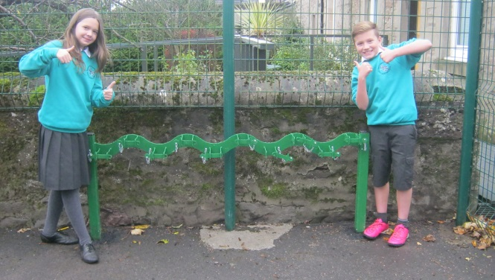

Our 2015-16 JRSOs beside the Scooter Parking spaces

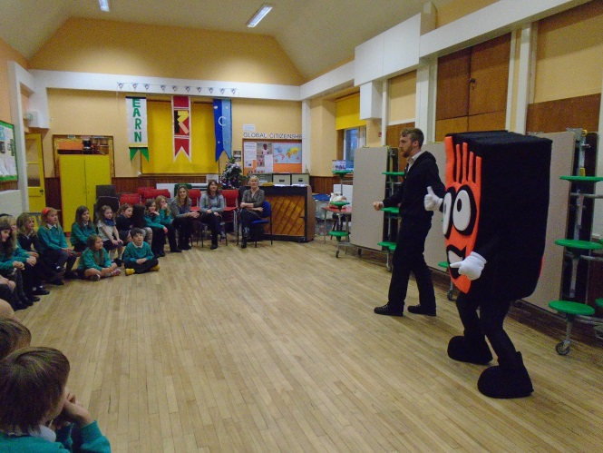 visit by Big Strider

**Parking Outside the School**

The yellow and white line markings around the school entrance are there to prevent anyone parking or stopping just outside the school where children will be trying to cross the road.

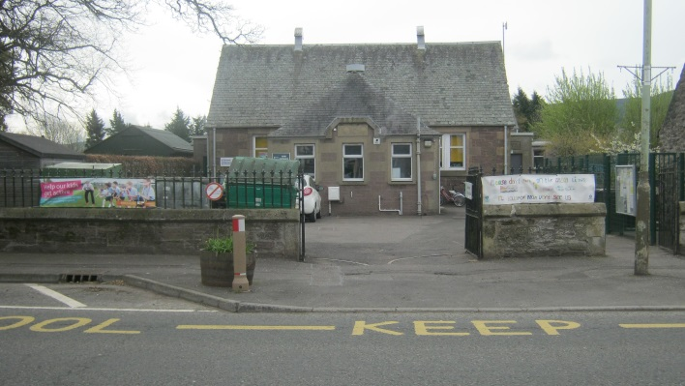

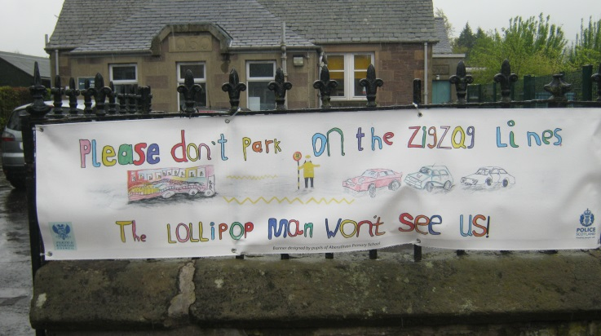

Our School Crossing Patroller shared that people are parking I appropriate places and are no parking in places which have an impact on visibility for crossing the road outside of our School.

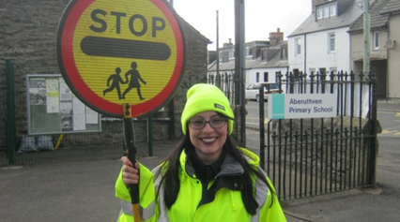

**Road Safety in the Curriculum**

Lessons

Road Safety is explored with our pupils every year during Health Week through a variety of resources, videos and discussion.

Bikeability

P5-7 pupils have the opportunity to take part in a six-week training course to help them cycle safely. These sessions will be led by trained volunteers and Staff through Bikeability Levels 1 and 2. Skills taught include how to check your bike and helmet are safe plus how to do a safe start and stop, left and right turns.

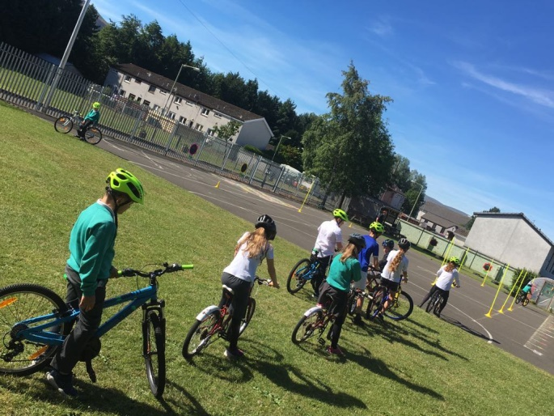

We also promote additional workshops/ sessions ran by Bikeability to encourage our pupils to further develop their safe cycling skills on our School website, Newsletters and Twitter feed.

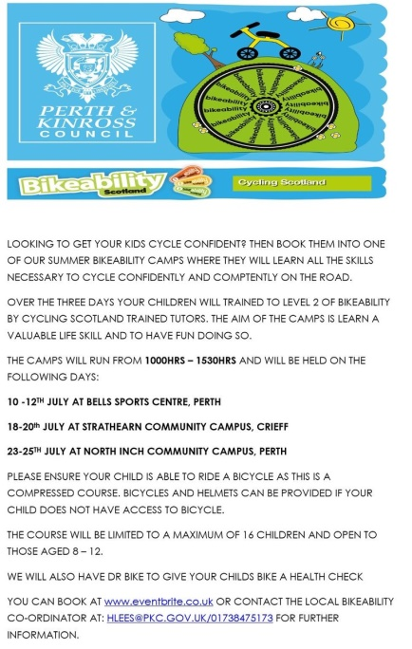

**Our Health & Wellbeing Committee**

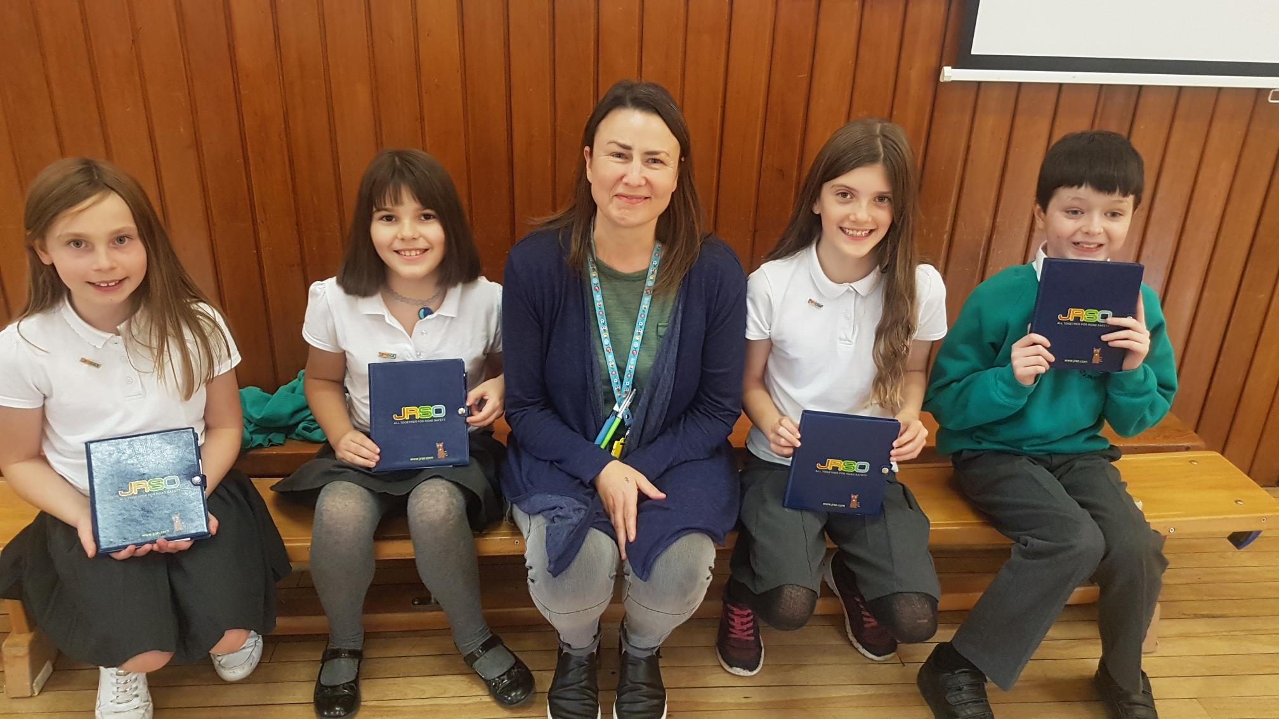

Our Health & Wellbeing Committee promote Road Safety throughout the year by organising competitions and information Assemblies. They have displayed a variety of Road Safety information, including competitions on their committee Notice Board.

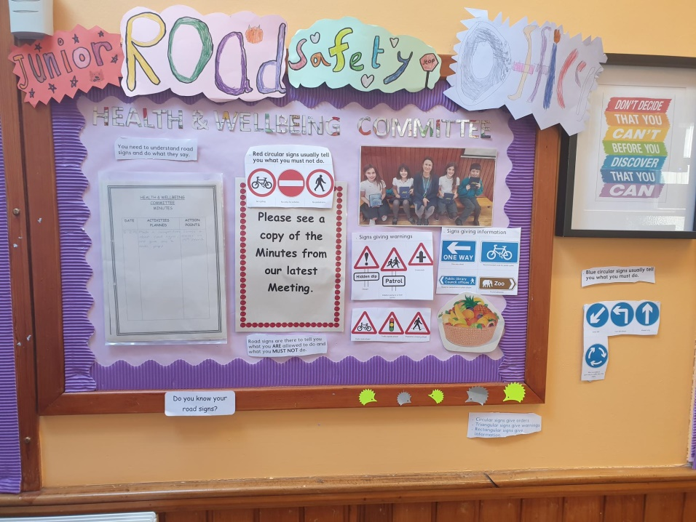

**What has been done so far in Aberuthven to deal with the problems caused by traffic on the main road?**

* Twenty’s plenty signs have been put up on the road outside the school.
* The pavements outside the school have been made wider to help the crossing patroller see better and make crossing the road safer.
* We have encouraged people not to park on the yellow and white road markings on the main road outside the school by getting a new banner.

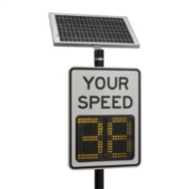

* Speed awareness signs have been added to the top of Main Road targeting cars as they enter the village to deter speeding.
* Frequent Police Speed Checks on Main Road throughout the year to deter speeding

**What effect has this had?**

The parking has improved but the speed of the traffic passing the school may still be faster than 20mph and that means cars cannot always stop safely when the lollipop person steps out or a child starts to cross the road.

**The speed of traffic on the Main Road could still be dangerous for children coming to and leaving school. This is especially important at times when the lollipop person is unable to be there or when children are leaving school after 3.30pm for some reason, the lollipop person has gone home and there are no mums and dads around.**

**What other issues do we need to deal with?**

We had a discussion during Health Week around road safety. Many of our pupils were unaware of how serious it could be when it hit a car even at a slow speed. Many thought that if a car was going slower they would be almost unharmed.

**Action Points**

These are the things we need to do to achieve our aims:

* Teach children about road crossings and stopping distances of vehicles. Share repercussions of what could happen as a result of being struck by a car even at a slower speed.
* Keep checking that everyone is parking properly on the main road outside the school – keep checking with the School Crossing Patroller that this is still okay.
* Check what Road Safety is being taught in the classes each year during Health Week to make sure pupils are learning everything they need between Primary 1 and Primary 7.
* Support the Health & Wellbeing Committee to help spread the Road Safety message within the School using wall displays, posters and competitions.
* Get parents, school staff, pupils and other people to look at the travel plan regularly between now and its next review.

**When will we do our next Travel Plan?**

We will continue to observe and share information within our School Community throughout the year which will support the ongoing road safety of all.

Our Travel Plan will be reviewed March 2020.