## Viewlands Primary School

Oakbank Crescent Perth

PH2 1BU 01738 473080

[viewlands@pkc.gov.uk](mailto:viewlands@pkc.gov.uk)

**Viewlands Primary**

**School**

**Parent Handbook**

##### This handbook was produced in partnership and consultation with Viewlands Primary School Parent Council and Senior Leadership Team.

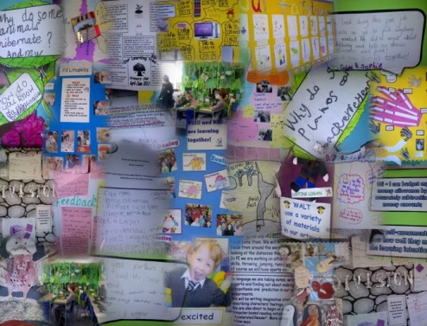

**Welcome** to Viewlands Primary School.

## Ethos

Here at Viewlands we recognise that every child is a unique individual with a wide range of abilities and needs.

We celebrate each child as an individual with their own strengths and learn- ing needs and endeavour to support, guide and teach all children to be the best they can be. We aim to make a happy, relaxed and fun environment which supports each child’s learning including the development of their social, moral, spiritual and cultural values. All children are given the opportunity of shared experiences regardless of gender, ability, religion or race.

A good relationship between home and school is vitally important to us here at Viewlands. We actively seek to work closely with you as parents / carers to ensure smooth progression for your child throughout their time with us. The journey for some begins at Nursery, for some at P1 and for others at a variety of stages throughout the school. No matter where your child’s journey starts we will plan with you and your child the best route in order for the experiences that you have with us to be positive.

We hope that you find Viewlands to be an effective, supportive and caring environment for you and your child.

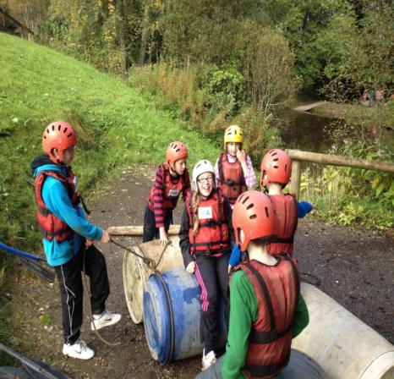Please do not hesitate to contact us if you would like further information on any matter relating to your child or the school.

Claire Allan Headteacher

P7 trip to Dalguise

## Fund Raising:

We also have a fantastic fund raising sub group of the Parent Council. They meet regularly to discuss and organise fund raising events for the school which are a great way to get involved.

Typical events throughout the session are:

* Fayres
* BBQ
* Disco’s
* Ladies Nights
* Peel 2 Save
* Scholastic books
* Penny Post

Each year events vary; new parents are always welcome to join the fund raising group or volunteer to support events.

The monies raised are a great support to the school. They have helped:

* update IT equipment
* Purchas library books
* Purchase reading / numeracy schemes
* Playground equipment
* Classroom blinds

All of the above would not be feasible without the fundraising that the Sub group do and we are very grateful.

## View lands Parent Council:



#### Parents make a real difference

Parents and carers are the most important influ- ence throughout a child’s education and parental involvement in learning makes a real difference to children’s achievements.

Everyone benefits (children, parents and teachers) when parents and schools work effectively together to support learning.

#### What are Parent Councils for?

Parent Councils help parents and carers to become more actively and effec- tively involved in their children’s learning. They were established in recogni- tion of the important role that parents can play, both in their own children’s learning, and in the life of a school.

#### What does the Parent Council do?

The role of the Parent Council is to:

* Support the school in its work with pupils
* Represent the views of parents and carers Parent Councils can:
* Provide a voice for parents in schools and in their local authority on is- sues that are important to them and their children
* Help the school to understand how to most effectively involve parents in their children’s learning and in the life of the school
* Support the school and Headteacher in developing strong home/school partnerships
* Support the school in its development and improvement, and in under- standing and making links with the wider community
* Capture the unique and varied skills, interests, knowledge and experi- ence that parents can offer

Viewlands Parent Council tends to meet termly. They vary the meeting

night . Meetings usually run from 7pm until about 8:30pm. They are usually held in the school. All parents are very welcome to attend, it is always lovely to see new faces.

Our current Office Bearers for the Parent Council are: **Chair Person**: Mrs Nicola Acford - Children in P3, P5 & P6 **Secretary**: Mr McKay - child in P4

**Treasurer**: Mrs Helen Still – children in P2 & P4

## Rationale

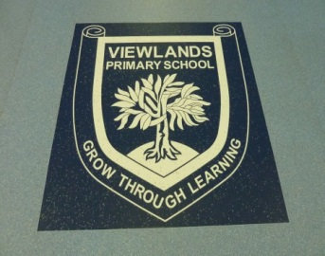Our School Motto (vision) is:

### Grow Through Learning

Our Core Values are:

☺Respect ☺Honesty ☺Fairness ☺Support

☺Cooperation ☺Acceptance of differences ☺Friendship

**Our aim** is that everyone at Viewlands has the opportunity to develop attitudes, skills and knowledge that will enhance their future lives.

### We will:

* provide a happy, safe and stimulating environment in which everyone can learn effectively and become confident individuals;
* promote and actively encourage independent learning through a balanced curriculum, enabling children to become successful learners;
* establish and maintain effective relationships between home, school and the wider community;
* foster citizenship, mutual respect and co-operation ensuring equal opportunities for all.

### Organisation of the School Day:

* **8:55 – 9:05am** – All doors will be opened by a member of School staff to allow all pupils to enter the school and start their day with a ***Soft Start***.
* **Break Time: - 10.40 -11.00 am** - learners are sent out to break by their teachers at 10.40am. They are brought back in by class teachers at 11.00am.

• **Lunchtime:- P1 & P2: 12.15 -1.10pm / P3 – P7: 12:30 – 1:25pm (**Only pupils who register for a home lunch are permitted to leave school grounds at lunchtime)

* **School finishes:- 3.15 pm**, all children are escorted to their respective exit doors by class teachers.

## School Uniform:

We are very proud of our school uniform at Viewlands and encourage all children to wear our uniform with pride.

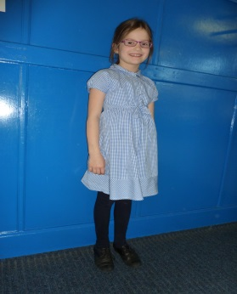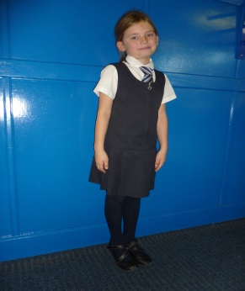

## Physical Education:

As part of a Scottish Government directive schools across Scotland are be- ing asked to deliver **2 ½ hours** of Physical Education within the school week.

In order to attempt to meet this directive we use our outdoor spaces regular- ly. We have some great spaces on our doorstep, including Perth Academy plying fields and also the local reservoir.

We therefore encourage all children to have an outdoor PE kit at school. This can be made up from a warm pair of tracksuit bottoms, warm top, and trainers that you don’t mind getting dirty and remaining in school.

Some of the activities the children might be involved in could be: Orienteer- ing; Cross country; Team Skills; Running; Athletics.

Indoor PE Kit should consist of:

* White T-Shirt
* Navy shorts
* Socks
* Gym Shoes / indoor trainers

## Reporting on your child’s curriculum and

**Progress:**

* ***Learning Trees:*** Produced termly to highlight the intended learning of that term. It will highlight areas that you can support at home.
* ***Parent Contact***: Twice yearly - November / March; opportunity to dis- cuss with your child's class teacher the progress your child is making and next steps
* ***Learning Logs***: issued home three times per session; highlights your child's learning journey; shows examples of Literacy, Numeracy and where your child has had the opportunity to apply their skills.
* ***Learning Show Cases***: planned opportunities throughout the session for you to come into school and see the work / experiences that your child has been offered. These may take the form of a show, tour of classroom, interactive activities that you can get involved in, presentation by pupils / staff.
* ***End of Session Report***: this is a summary of your child's progress throughout the academic session. It highlights strengths and next steps.

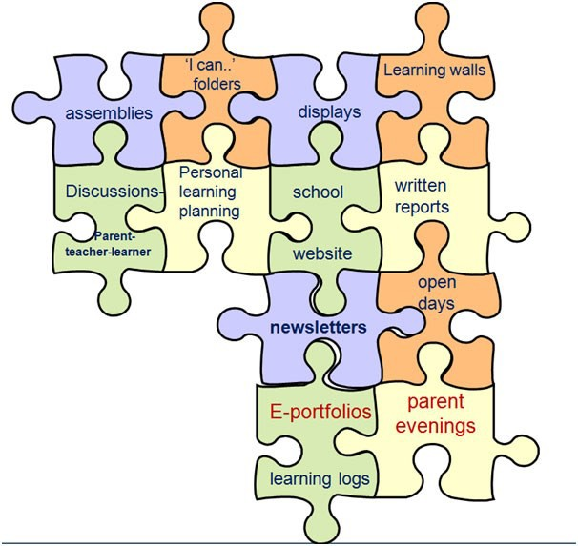

* ***Applying learning and skills development***: planned opportunities for children to use a range of skills, including literacy, numeracy and health & wellbeing, when engaging in tasks; engage in challenging topics to study open-ended investigations and topic in depth; explore current developments and issues that impact on themselves and soci- ety; be open to new ideas and develop the ability to think creatively and critically; and see the relevance of learning to society and future employment, including learning through the use of the outdoors, field trips and the opportunities they experience in their lives outside school.

These happen at ***ALL*** stages of the school, Nursery through to P7.

As a school we recognise the importance of ***wider achievements*** that hap- pen out with the school day and celebrate these with the children. The skills gained from these experiences / achievements can be applied to the tasks they are asked to do throughout the school day - Team work; leadership skills; commitment; organisational skills, etc. As a school knowing the whole child is key, a truly responsive curriculum can then be planned for.

## Homework:

Homework is generally issued weekly. It will reflect learning that has taken place in the classroom and allow your child an opportunity to apply skills independently or extend knowledge.

Each class teacher will communicate their homework routine and their expectations.

There is a school expectation that any written homework is signed by an adult and that opportunities are created for books to be shared regularly at home.



## Crumbs Café:

We have a fantastic healthy tuck shop which is run in the form of a café. Each class has an allocated slot each week that they can come along and have toast, cereal, pancakes, fruit, yoghurts or breadsticks. Each item cost ***30p***—all funds raised go towards **café improvements, Eco Committee resources** and **healthy school initiatives.** The children are encouraged to socialise during their visit to Crumbs Café and if they do not wish to pur- chase items from the café they can bring their own snack.

## School Lunches:

School lunches are provided by Tayside Contracts and made on the prem- ises. There is a wide variety of choice and sample menus can be found on our school website.

Current daily cost £1.90 per day

## School Clubs:

We have a variety of clubs that run throughout the school session. These include:

* Netball (afterschool)
* Football (afterschool)
* Chess (lunchtime)
* Craft Club (lunchtime - generally p6)
* Orienteering (lunchtime)
* Cross Country (lunchtime)
* Technology / Construction club
* Brass Band (P5, P6 & P7)
* Choir
* Gardening Club

Many of our clubs are run by staff and parents. If you have a spare half hour and a hidden talent, we would love to hear from you!

## Our Curriculum

Our aim in **VIEWLANDS** is to provide every learner with a coherent experience, where a broad range of learning activities and experiences combine to create a meaningful and valuable education - developing skills, deepening understanding, relevant to their aspirations, extending their world view. To that end the learning we provide is often structured in an inter-disciplinary manner within a motivating context, ensuring meaningful connections are made.

#### Every child is offered a wide range of learning opportunities in:-

Literacy & English – including Spanish in our Early Years and French from P5 Numeracy & Mathematics

Expressive Arts – Drama, Music and Art Health and Wellbeing – including PE

RME; Science; Social Studies; Technologies

We are very fortunate to have a **PE** and **Music** specialist who work with all classes weekly. They deepen and enhance the curriculum in these areas for our learners.

##### CfE is divided into Levels:

* **Early Level** – pre-school – P1, or later for some
* **First Level** – children in P2 – P4, or later for some
* **Second Level** – children P5 – P7, or later for some

In **VIEWLANDS,** we are committed to seeing all our children become successful learners, developing the particular skills and attitudes that will help them to become responsible citizens and effective contributors. We work hard to offer challenging, enjoyable and relevant learning activities, often involving active learning, and requiring skills for independent or co-operative engagement. In all our learning we aim to enhance children’s self- esteem so that they become confident individuals, offering opinions and exercising personal choice in their learning and through our Broad General Education - the curriculum we design.

## Broad General Education - w hat does this

**mean for your c hild?**

Broad General Education is a term used to describe the curriculum that will be planned for your child. Curriculum should be designed to open up the ways in which children learn so that they become better equipped with the skills they need to support further learning, skills for life and work.

Therefore our curriculum will continually evolve as different groups of children journey with us through the primary stages of their education.

There is not a set curriculum for any stage of the school and therefore topics / contexts will change when appropriate to ensure we are meeting the needs of the children we are currently working with.

Teachers will use a variety of approaches to hook the children in. Some of these approaches are:

* ***Independent Learning***: planned opportunities for children - to take decisions, initiate and organise tasks; ask questions and find information; demonstrate independence & self-manage; be clear about their own learning needs; and have opportunities to reflect on and understand what has been learned.
* ***Taking responsibility for learning***: planned opportunities to - take personal control of their learning; influence and contribute to planning their own learning; develop an increased awareness of themselves as a learner; seek out opportunities linked to their own interests and aspirations; be willing to take on challenges; make informed choices and decisions; monitor their own progress and, as appropriate modify strategies.
* ***Active Learning***: planned opportunities for children to - develop skills such as problem solving by testing out their ideas and learning from experiences; develop logical and creative thinking skills through doing; exploring and taking initiative. Be actively involved in their learning, understanding the learning intention and the steps to achieving that and being able to identify and set next steps.
* ***Collaborative / Shared Learning***: planned opportunities to work in partnerships or teams; take initiative and lead; act as learning re- sources for one another; work on team challenges and research tasks; take on roles and responsibilities; demonstrate awareness and respect for others; debate to develop informed views; and discuss learning and provide explanations to others.