RME

Pupils will continue their topic of ‘Light and Dark’ and focus on the festival of Hanukkah.

They will also study how Christmas is celebrated around the World.

Literacy

Roald Dahl’s ‘Charlie and the Chocolate Factory’ will be our class novel. Our focus will be on character and setting description. Our knowledge of VCOP will be enhanced and developed further.

In addition, we will look at newspaper articles, adverts and recipes.

We will continue to work on spelling, reading and grammar.

Numeracy and Mathematics

Pupils will learn about shape, money and measurement. Some activities will include constructing 3D boxes, tiling using 2D shapes, accurately measuring and estimating different objects, looking at money through enterprise events and many more exciting activities !

We will also continue to work on our number bonds, addition and subtraction, and place value.

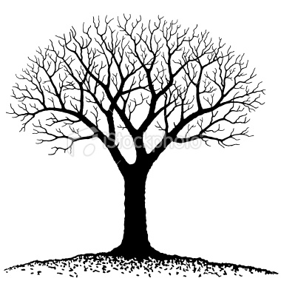

Expressive Arts

Miss Ballantine will be teaching us how to play the recorder.

Some activities in art will involve creating and designing chocolate bars, delicious sweets, sticky lollipops and many more !

In drama we will create, adapt and sustain different roles associated with Charlie and the Chocolate Factory.

Health and Wellbeing

Pupils will look at ways of keeping safe in the dark nights, bonfire and firework safety, crossing roads safely and playing safely independently and with peers.

Pupils will focus on social dance this term and participate in the ‘Day of dance’ at Bells Sports Centre.

Technology

Pupils will look at ways of keeping safe when using the internet.

The CEOP website will be used to teach and inform children of how to use the internet safely.

Technology will continue to be used in and around the classroom.

Context For Learning

This term will focus on ‘Wonka World’ based on Roald Dahl’s book.

Using the book as a stimulus we will transform our learning environment into a sweetie factory !

We will cover all areas of the curriculum with a strong literacy emphasis.

Viewlands Primary School

Primary 4’s Learning Tree

October – December

2013 ~ 2014